**Primary School Maths Teaching Aid**

**The idea:**

I’m making an app and writing a dissertation for my final year in college and I need to do some background research before I get going so I was just wondering if you could take a look at this and let me know if you have any suggestions, comments or ideas about anything I have so far!  
  
The app, hopefully, could be used as a teaching aid for primary school teachers to use when going through the math curriculum. The idea behind this is that every student goes at their own pace and so if the teacher moves on too fast for some students or is going to slow for other students that they can use this app to further their education one way or another.  
  
This app will be similar to Duolingo (but for maths obviously) in the sense that there is a hierarchy of topics/pathways. They will have to complete earlier tasks before they can move on to the more difficult ones.

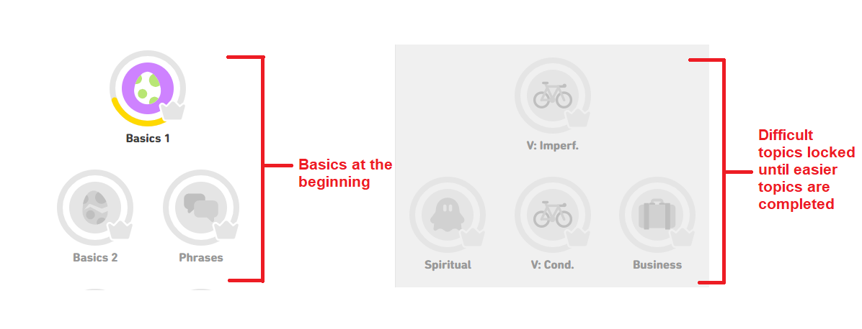 *Hierarchal System in Duolingo*

Below is an example of a question in Duolingo.  
The app I’m developing will follow a similar structure but with basic equations.

For example it could be something like:  
[ ] + 7 = 10  
  
[1] [2] [3] [4]  
  
Choose the correct number to complete the equation.

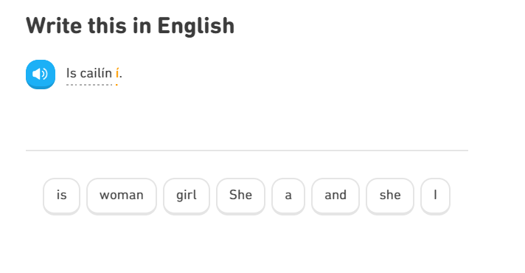Example of Duolingo Questions

The students will progress through levels, making mistakes and getting correct answers and at the end of the week the app will send the parent, teacher or both an easy-to-read report listing all of the progress the student has made and all of the mistakes that they have made so that revision can be done either in class or at home with a parent depending on where the teacher is in the curriculum.

**Your Input:**

1. [a] Do you think the app could be useful for you as a primary teacher? Yes   
   [b] Would students use it? Yes
2. Do you think there are any problems with the idea and if so what do you think could be done to correct them?

Will the app work without internet access

1. Do you know of any resources (websites, books or both) that I could look into to access the curriculum for primary school maths?

[www.nccaplanning.ie](http://www.nccaplanning.ie) – online access to the aims/objectives of the maths curriculum for each class level

[www.ixl.ie](http://www.ixl.ie) – maths games linked to the Irish primary maths curriculum (check out some ideas for questions for your own app)

Maths textbooks – Busy at Maths Programme by CJ Fallon (Teacher books contain clear aims & objectives for each topic & class level)

1. What form of device are primary school students most comfortable with? (e.g Desktop Computer, Laptop, iPad/Tablet, mobile phone)

Very dependant on the school – desktop computers, laptops & tablets

1. Off the top of your head do you think there is any other kind of minigame-esque questions that would be helpful (and hopefully fun) to engage students more with the app?

Extra challenges/points/beat the clock activities

1. [a] Do you think having a section of the app dedicated to times tables would be worthwhile creating? Definitely!

[b] Is there anything else in the same vein as this idea that you think could be essential to have in the app?

Incorporate word problems linking to the topic

1. Is there a specific age the app should NOT be aimed at (junior, senior, 1st class)? Is there any point in targeting students this young?

Possibly target 1st – 6th class children (focus on topics from 1st – 6th class)

1. Do you have any suggestions for the name of this app?
2. Can you think of any ideas that would keep the students more engaged in the app?

Let the children design an icon for their profile

Let the children see a graph showing their own progress

1. Are there any common difficulties students have with maths that I could address with the app?

Understanding word problems

Mathematical language specific to each topic

**Other Suggestions & Additional Feedback:**

Sounds like a great idea!