ts1_202407100743

# open browser edge.

PASSED

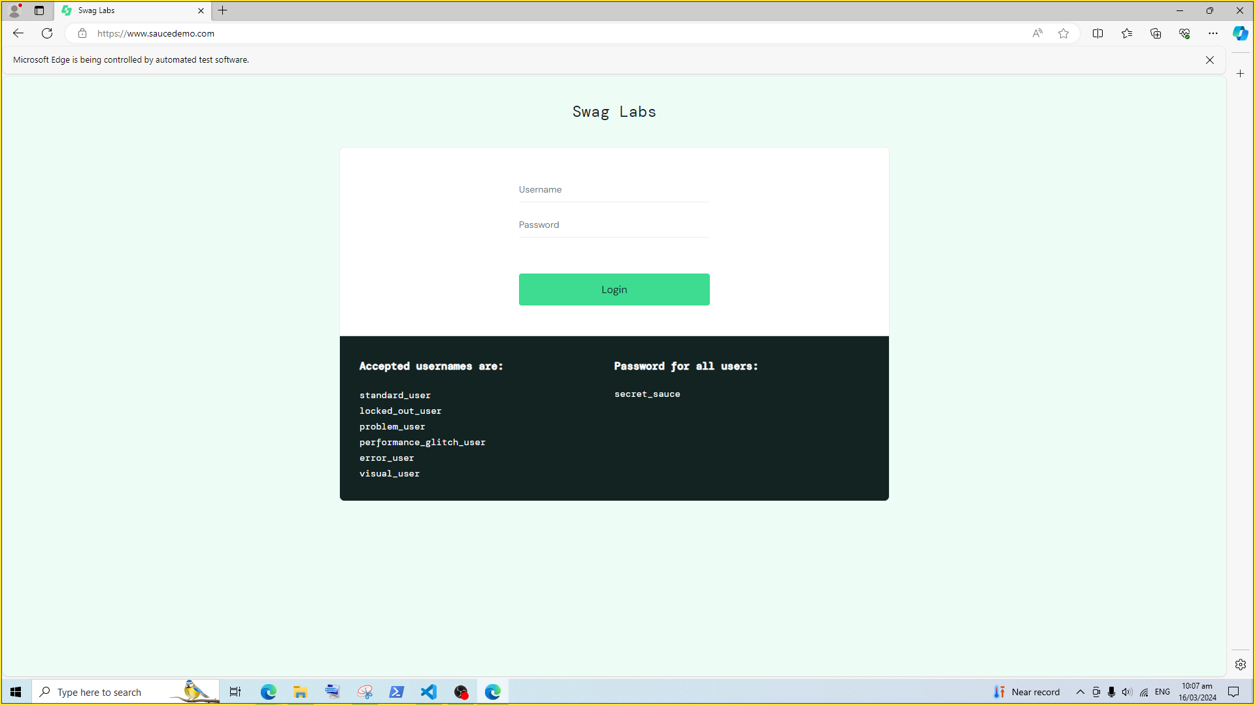

# sendkey browser_textbox user-name.

PASSED

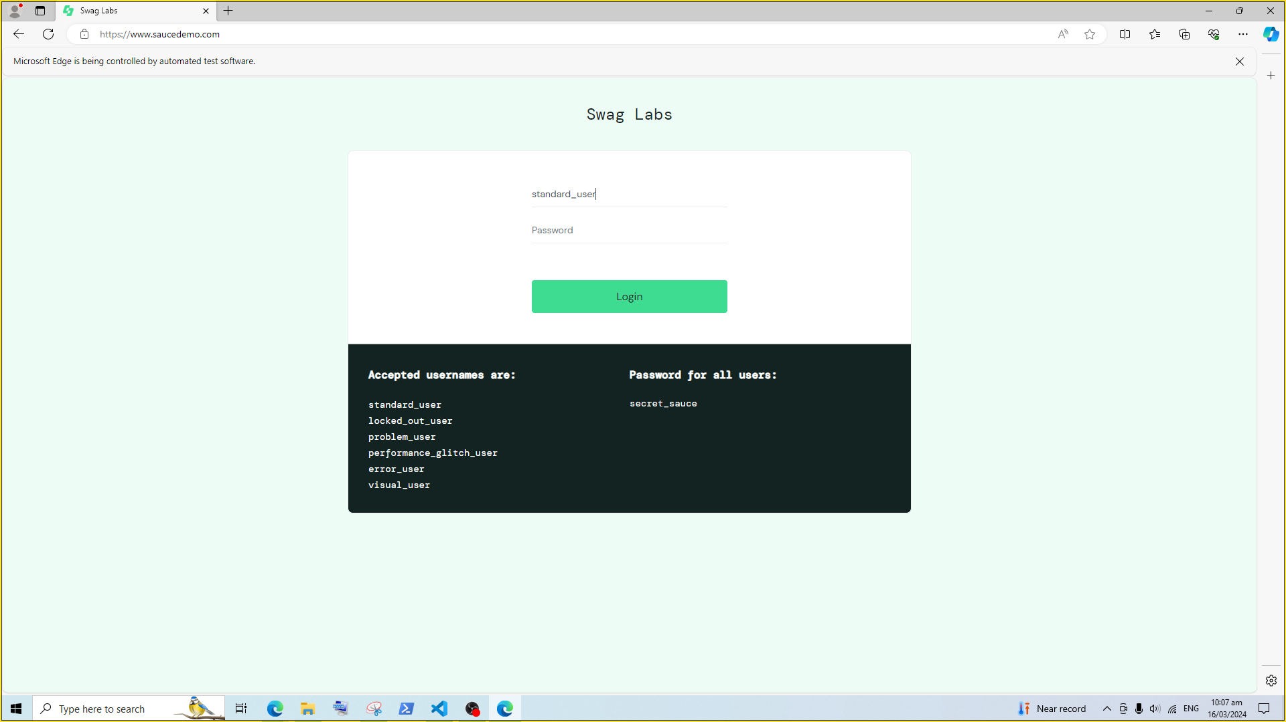

# sendkey browser_textbox password.

PASSED

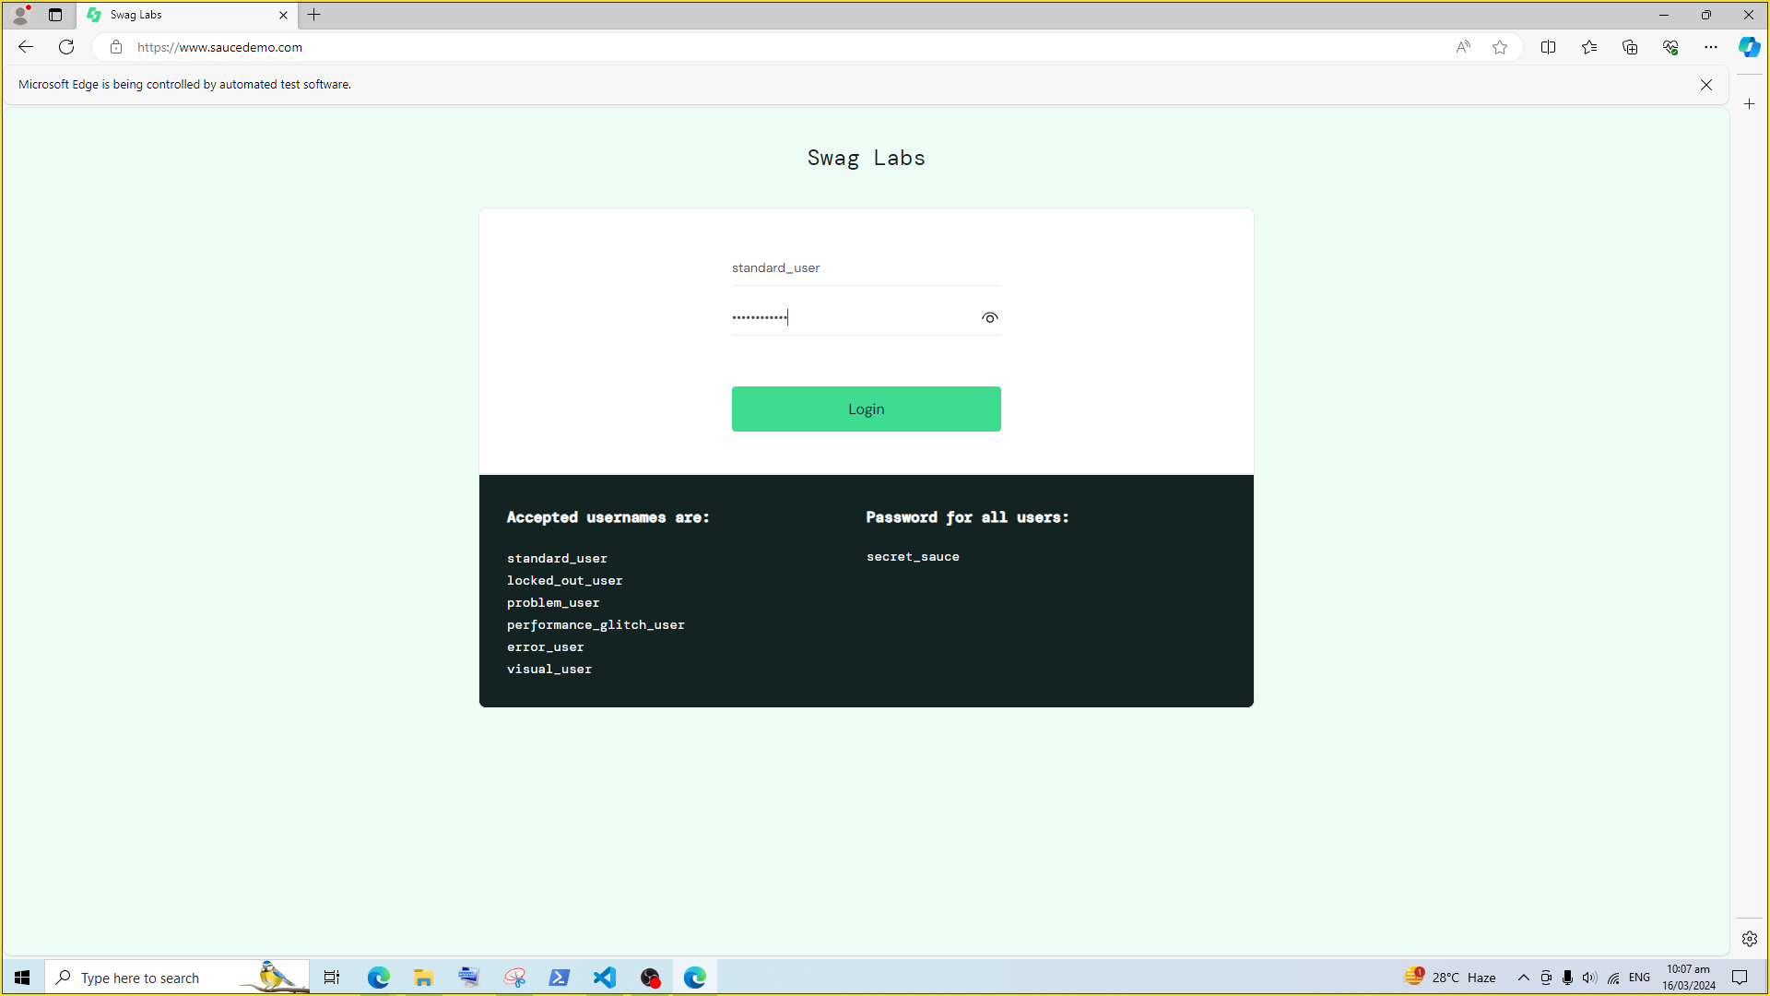

# click browser_button login-button.

PASSED

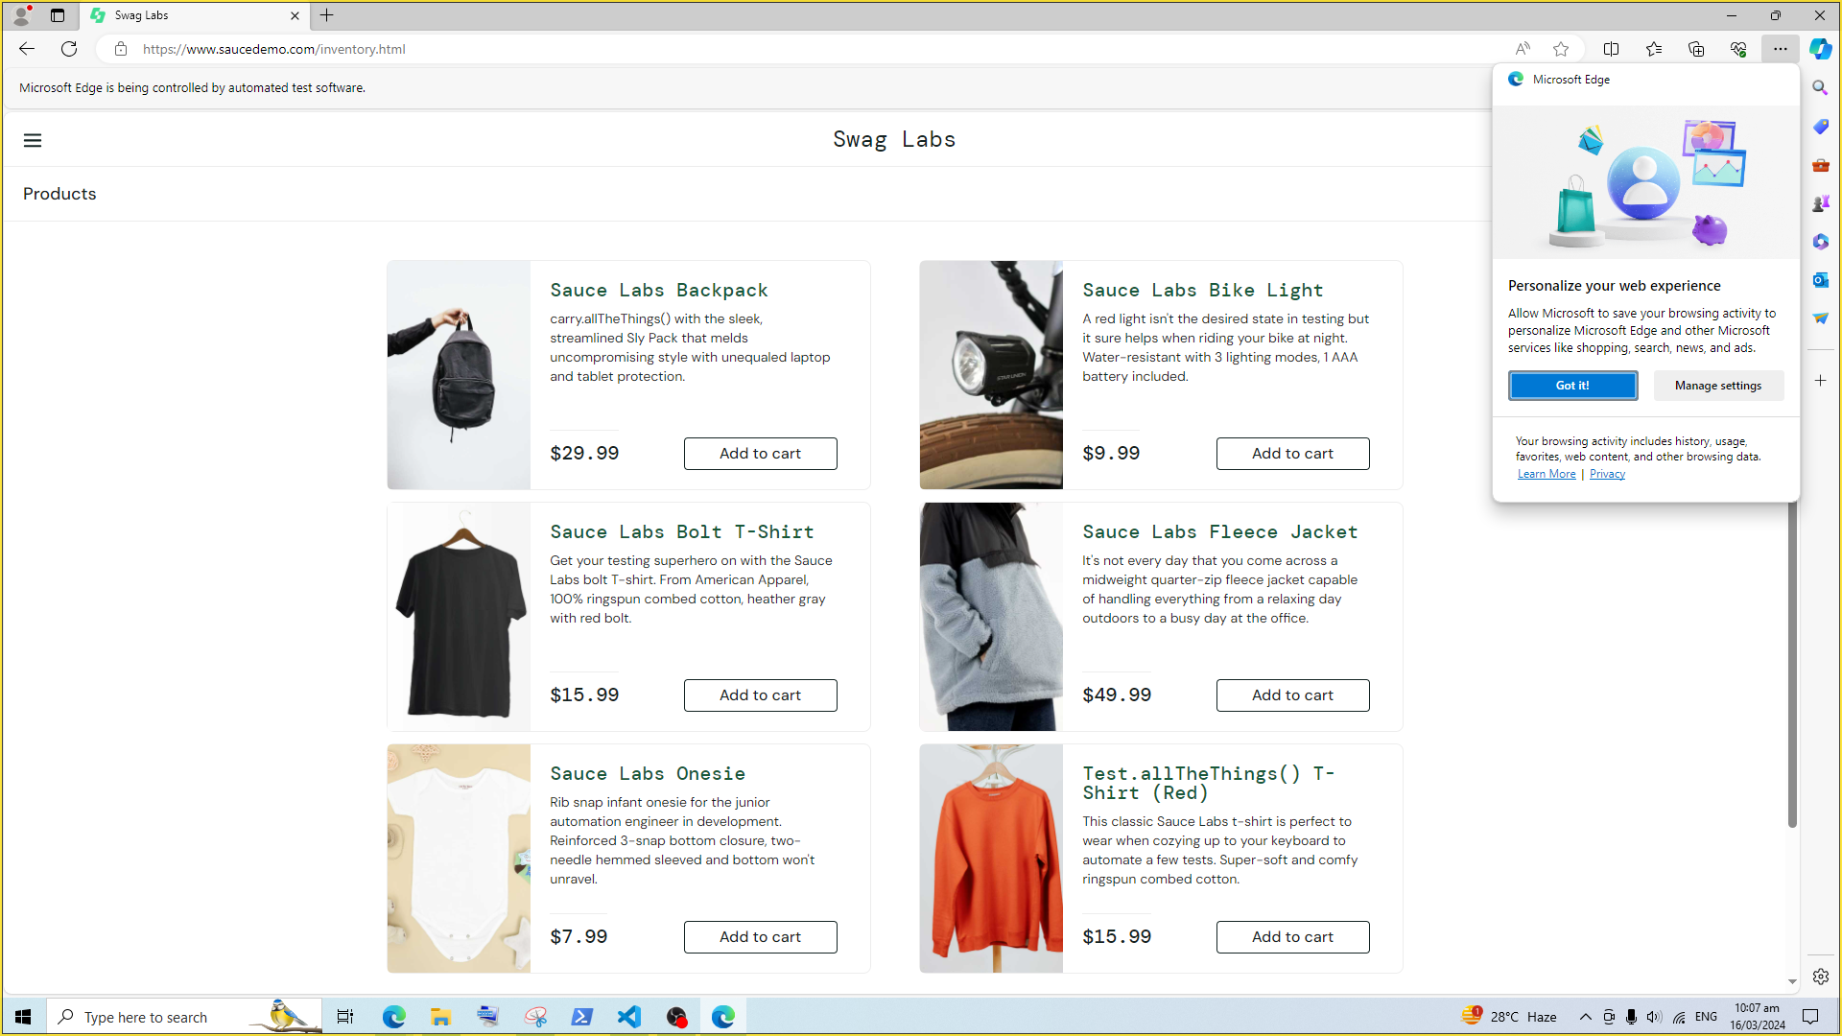

# verify text header_container.

FAILED

