ts1_202408100804

# open browser edge.

PASSED

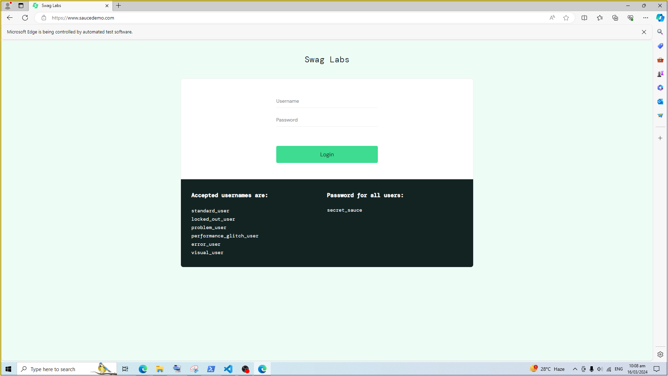

# sendkey browser_textbox user-name.

PASSED

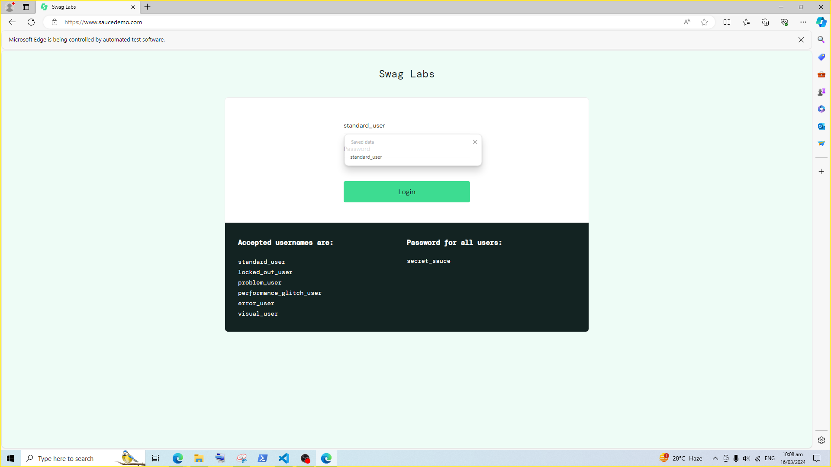

# sendkey browser_textbox password.

PASSED

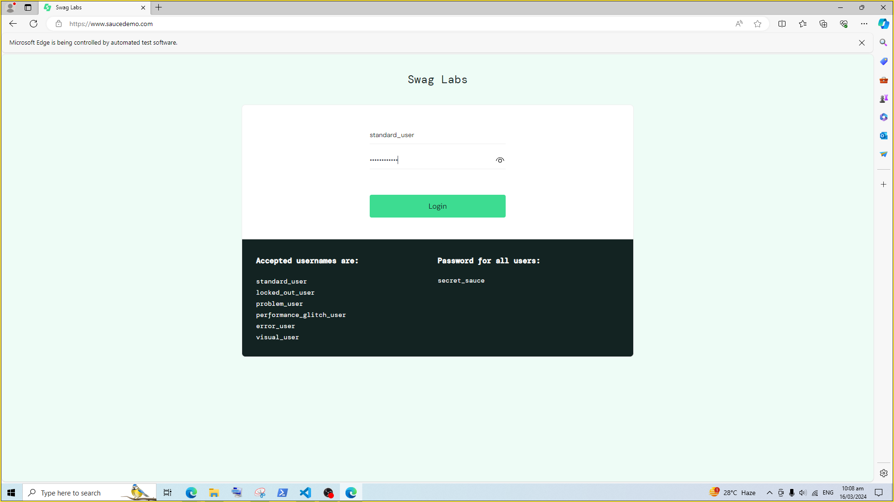

# click browser_button login-button.

PASSED

