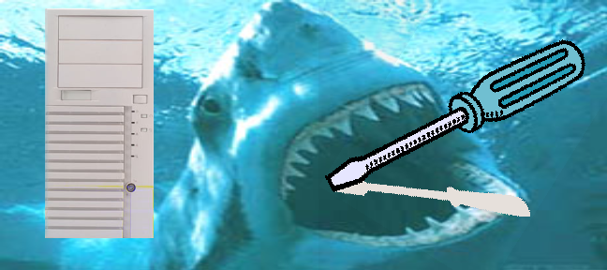
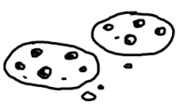
Help us put these together!
jhuacm
acm.jhu.edu | blogs.jhu.edu | the.jhu.edu | wiki.jhu.edu

