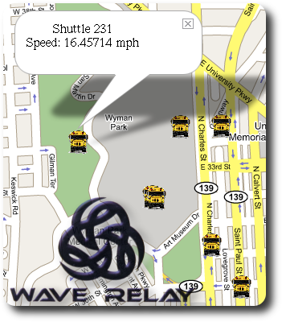




Wireless Everywhere!
acm.jhu.edu the.jhu.edu blogs.jhu.edu wiki.jhu.edu
Herbert Rubens

The CS Wireless lab has covered the campus completely with Internet - and has plans for all of Baltimore.

Come hear how the security vans now have Internet access – and get free cookies!

