



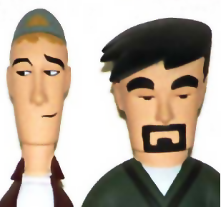
acm.jhu.edu the.jhu.edu blogs.jhu.edu wiki.jhu.edu
Clerks!

Two young clerks.
One classic movie.
Free pizza.

