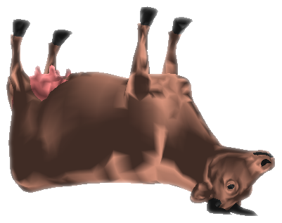
Free acm bbq!
Like computers?
0xdeadbeef

