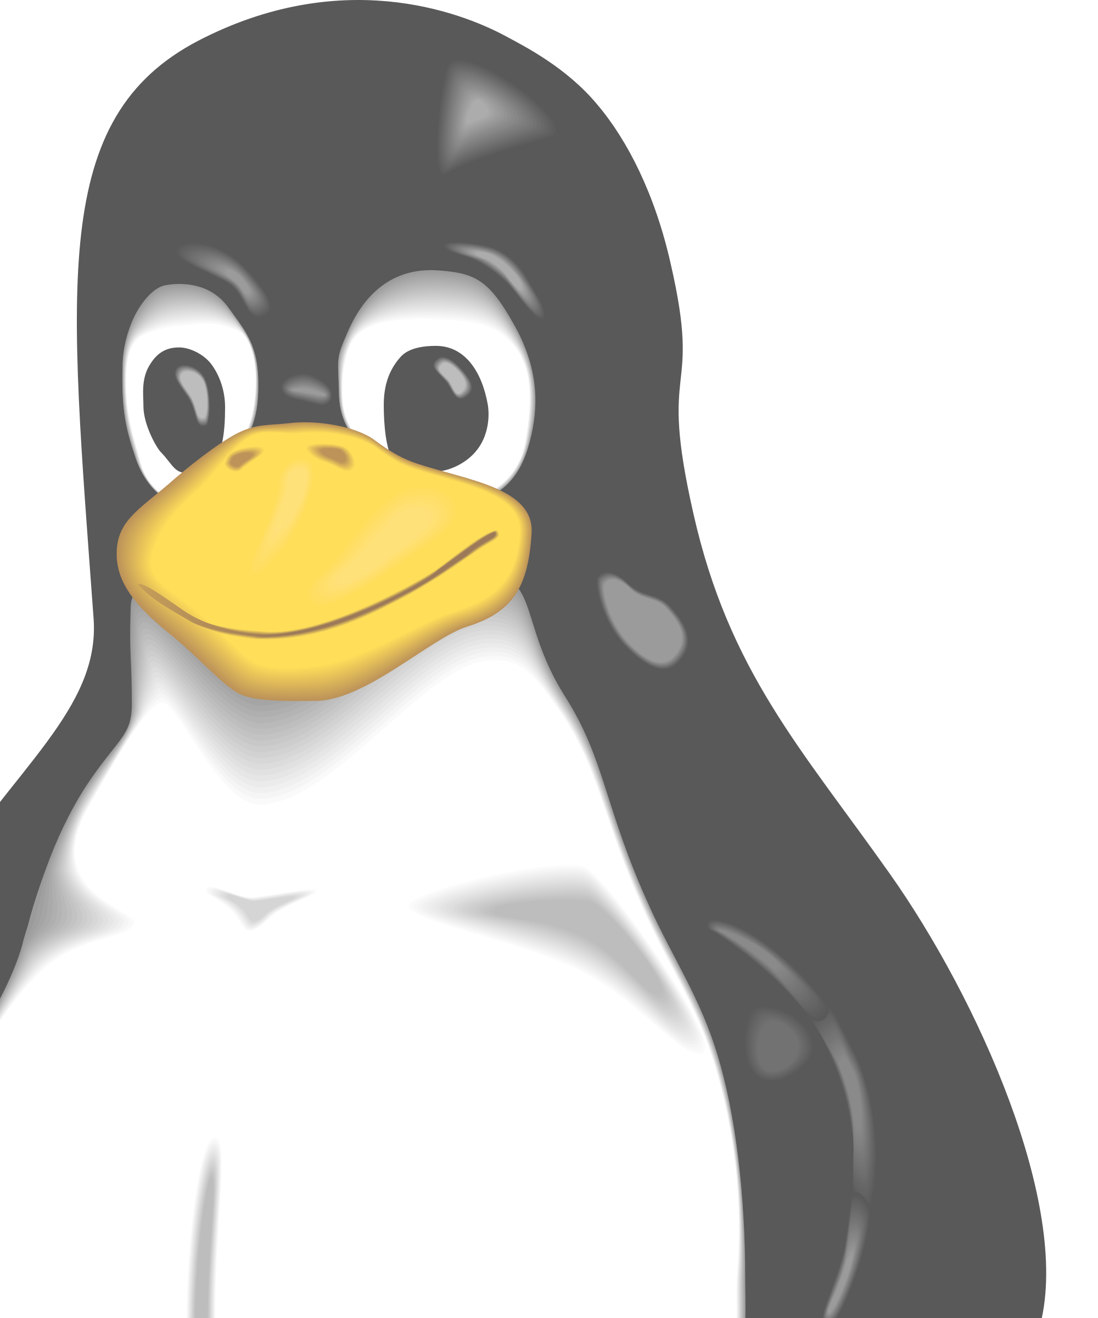
Like Linux or another free OS?
Want to try it out or get help installing?
Bring your computer, get pizza!

