
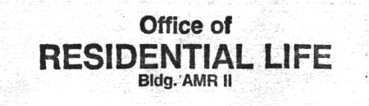
import
skillz;

Think you have what it takes to tackle some tricky programming puzzles?

Go head-on with your friends, classmates, and colleagues this Saturday, and find out!

Chug free soda as you pound out code in this two-hour test of wits (and maybe some skill).

Free food for all, and prizes include a video iPod!
jhuacm

contest.acm.jhu.edu

jhu acm
2006 Local Programming Contest
Saturday 2 PM | NEB 227
Information Session
Thursday 5 PM | Shaffer 303
iPod is probably even virus-free. ;-)

