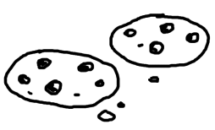
HELP
Data Structures
Intro Java
CSF
Automata
Ethics
USP
OS
Compilers
CNF

Get free advice
Also cookies!

No idea what courses
to take next semester?


