Connecting to the VPN
iOS Instructions

Step 1: Download the OpenVPN Client from the App Store

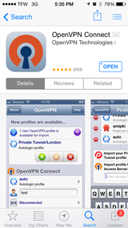

Step 2: Open the email from your administrator with the .ovpn attachment – Open in OpenVPN
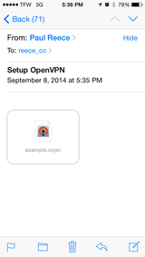
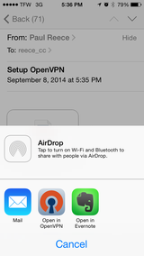

Step 3: Import the Profile – Green + Button

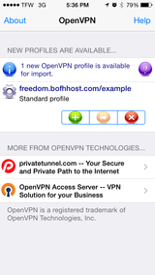

Step 4: Enter the Credentials Given by your Admin, click Save and Connect

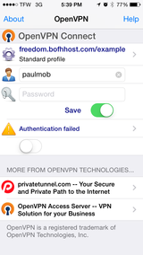
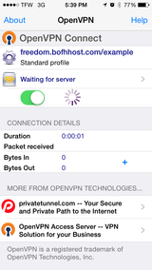
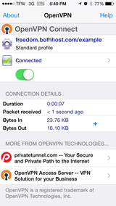

Done – you should see the "VPN" icon at the top of your screen whenever you're connected to the VPN. If you clicked save, it will most likely re-connect when your phone comes out of sleep

