Connecting to the VPN
Android Instructions

Step 1: Download and install the OpenVPN Connect app using the Google Play store
You will have to accept the permissions, and so on
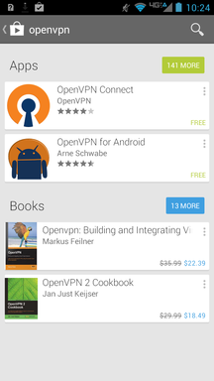
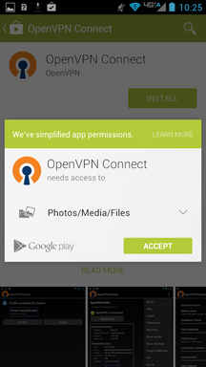

Step 2: Save the .ovpn email attachment onto your SD card
When I click "save", it goes to my SD card automatically. Your mileage may vary.

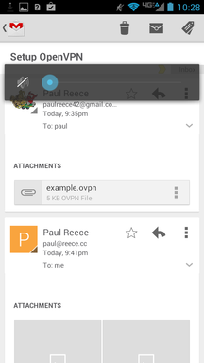

Step 3: Go to OpenVPN Connect Program, Import Cert
Use the options button -> Import, Import Profile from SD Card, browse to the .ovpn profile you saved
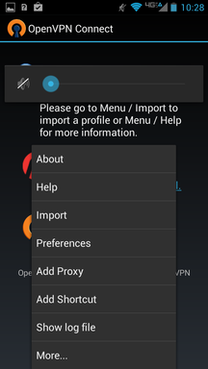
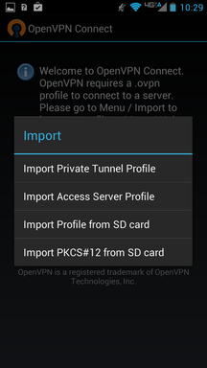
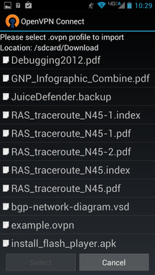

Step 4: Enter Username & Password and Connect
You will need to accept the "I trust this application" dialog. After you connect you will have a key and OpenVPN "O" symbol at the top to let you know you're connected
