Stormborn

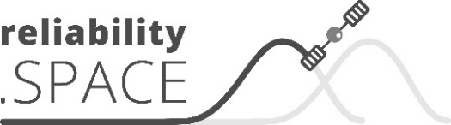

Adaptation of the NRPM Handbook into an ESA Handbook following the ECSS
MIS Handbook

Part of TN-02
Consortium:

Matrisk GmbH  Alte Obfelderstrasse 50  CH – 8910 Affoltern a.A.  Switzerland  Tel.: +41 43 340 04 27  contact@matrisk.com  www.matrisk.com | Technical Note | Status: Draft | Rev. A
 | Classification:  confidential | Date: | 2022-02-24
 | ESA Contract: 4000121065/17/NL/PS | Authors / Contributors | BOURBOUSE S. (ADS)  SCHUBERT M. (Matrisk)
 |  | Checked:
 |  | Approved esa:
 |  | Pages: | 10
Send to | Revision: | Date: | By:

Change Log

ESA Handbook issue 1A July 2022 | First issue

Table of Contents

Requirements for the Table of Contents
Expected contents:
The table of contents is included for a quick reference to the contents of the standard. It includes the sections and clauses in the order that they appear in the standard, and then a list of Figures and a list of Tables.
Requirements:
REQ_TOC_01: The table of content shall include first all the sections and clauses in order in which they appear in the [handbook], and then a list of figures and a list of tables.
REQ_TOC_02: The table of contents shall be automatically (electronically) generated.
REQ_TOC_03: The table of contents shall not contain requirements.
REQ_TOC_04: The layout of the table of contents shall be as in the following example.
Example:
Change log……………………………………………………………………….3
Introduction……………………………………………………………………..8
1. Scope……………………………………………………………………………9
2. Normative references………………………………………………….11
3. Terms, definitions and abbreviated terms……………………13
3.1 Terms from other standards/handbooks……………………13
3.2 Terms specific to the present handbook…………………….14
3.3 Abbreviated terms and symbols…………………………………16
3.4 Conventions and nomenclature………………………………….18
3.4.1 Convention………………………………………………………………18
3.4.2 Nomenclature………………………………………………………….19
4. General Methodology…………………………………………………..20
5. Detailed analysis……………………………………………………………23
6. Conclusion……………………………………………………………………150
ANNEX A…………………………………………………………………………..156
ANNEX B……………………………………………………………………………170
Bibliography………………………………………………………………………211
Figures
Figure 1-1: a correctly formatted entry……………………………….12
Figure 1-2: example…………………………………………………………….13
Tables
Table 1-1: a correctly formatted entry……………………………….20
Table 1-2: example…………………………………………………………….25
Table A-1: example 2……………………………………………………….157

Table of Contents 2
1 Introduction 3
1.1 Study overview 3
1.2 Logic and content of this Technical Note 4
1.3 Documentation 4
1.3.1 Reference Documents 4
1.3.2 Applicable Documents 6
2 Survey 7
3 Requirements 9
3.1 Failures taxonomy 9
3.1.1 Insurers data 10

ADD TABLE OF FIGURES
ADD TABLE OF TABLES

Introduction
From NRPM: Goal of this chapter: To provide guidance (methodology, methods and models) for the modelling of miscellaneous items, as defined hereafter.

Requirements for the Introduction
Expected contents:
Introduction is an optional element, and therefore this section can be deleted if not used. The following are examples of subjects that can be included in the Introduction:
- Specific description on the technical content
- Reasons prompting the preparation or the update of the [handbook]
- History of the [handbook]
- Relation with other ECSS standard [or handbooks]
REQ_IN_02: The introduction, if present, shall: 1. Not contain sub-sections and sub-headers and 2. Have the layout of the “introduction” of the following example.

Scope
xxxx

Requirements for the Scope
Expected contents:
The purpose of the scope clause is to describe, in a few lines, the [handbook] as a whole in such a way that the reader can assess if the [handbook] is applicable or not to a particular case. The scope clause does not intend to recreate an expanded version of the TOC, chapter by chapter.
With this view, only a brief description of the subject of the [handbook] and statements of applicability are expected to appear in the scope clause. Statements of applicability state explicitly in which kind of projects or situations the standard is applicable (and for which is not applicable).
Any other descriptive material can be included in the introduction, e.g. history of the standard, rationale behind its preparation or relationships with other standards.
Requirements:
REQ_SC_01: The scope clause shall only describe: 1. The subject of the [handbook] and aspects covered by it and 2. The applicability of the [handbook].
REQ_SC_02: The scope clause shall not contain requirements.
REQ_SC_03: The scope clause shall have the layout of the “scope” of the example.
Example:
The present template sets the actual layout and specifies the requirements for drafting an ECSS handbook. It is applicable for the draft of the ESA handbook related to the reliability.space study.
It is only applicable for this specified handbook.

Normative References
TO BE TAKEN FROM TN8

Requirements for Normative References
Expected contents:
The purpose of the Normative References clause is to list the documents referred to in requirements. Availability of the documents referred to is, which are therefore necessary to apply the [handbook] in drafting.
Documents called for the non-normative parts are included in the bibliography section.
Requirements:
REQ_NR_01: The “normative references” clause shall include an introductory sentence containing the following text:
“The following normative documents contain provisions which, through reference in the text, constitute provisions of this ECSS [handbook]. For dated references, subsequent amendments to, or revisions of any of these publications do not apply. However, parties to agreements based on this ECSS [handbook] are encouraged to investigate the possibility of applying the most recent editions of the normative documents indicated below. For undated references, the latest edition of the publication referred to applies.”
REQ_NR_02: The “normative references” clause shall list only the documents which 1. In whole or in part, are made applicable by explicit references in normative statements (requirements, recommendations and permissions) and 2. Contain definitions made applicable to this [handbook] (i.e. included in clause 3.1 “terms from other standards/handbooks”).
REQ_NR_03: Normative references to non-ECSS documents shall be dated, or the number of the version included.
REQ_NR_04: Normative references to ECSS documents shall be undated.
REQ_NR_05: The documents listed in “normative references” shall be published and publicly available. Note: publicly available does not necessarily mean available for free.
REQ_NR_06: The normative references clause shall not contain requirements.
REQ_NR_07: The normative references clause shall have the layout of the normative references of the example.
Example:
The following normative documents contain provisions which, through reference in the text, constitute provisions of this ECSS [handbook]. For dated references, subsequent amendments to, or revisions of any of these publications do not apply. However, parties to agreements based on this ECSS [handbook] are encouraged to investigate the possibility of applying the most recent editions of the normative documents indicated below. For undated references, the latest edition of the publication referred to applies.
ECSS-S-ST-00-01 ECSS system – Glossary of terms
ECSS-D-00-01 Drafting rules and template for ECSS standards

Bibliography for the Miscellaneous chapter (SEE WHERE TO PUT IT)
- DFMEA, PFMEA
SAE J1739 (2009)
- Bruceton statistical method
GTPS 11C (2011)
- Statistical Method of PROBIT
GTPS 11A (2014)
- Severe test statistical method
GTPS 11F (2012)
- One-shot Statistical method
GTPS 11B (2002)
- Improvements to the Neyer method of estimating reliability of one-shot systems used in pyrotechnic
LambdaMu n°20 (2016)
- Process Failure Mode and Effects Analysis (PFMEA) and Control Plans
AS13004™

Terms, definitions and abbreviated terms
TO BE ADAPTED FROM WHAT IS IN TN8

Terms from other standards

Requirements for Terms from other standards
Expected contents:
The purpose of the “Terms from other standards” clause is to list the terms used in requirements in the current document that are already defined in the ECSS-S-ST-00-01 “ECSS system - glossary of terms” or in the other ECSS standards.
Requirements:
REQ_TE_01: The “terms from other standards/handbooks” clause shall include: 1. The sentence: “for the purpose of this [handbook], the terms and definitions from ECSS-ST-00-01 apply, in particular for the following terms.” And 2. The terms from ECSS-S-ST-00-01 used.
REQ_TE_02: If terms from other ECSS standards/handbooks are used, for each ECSS standard/handbook used a sub-clause shall be added and include 1. The sentence “for the purpose of this [handbook], the following terms and definitions from “reference of the [handbook]” apply, and 2. The terms from the ECSS standard.
REQ_TE_03: The layout of the “terms from other standards/handbooks” clause is compliant with the example below.
REQ_TE_04: The “terms from other standards/handbooks” clause shall not contain requirements.
Example:
For the purpose of this handbook, the terms and definitions from ECSS-S-ST-00-01 apply, in particular for the following terms:
      - Recommendation
      - Requirement
      - Standard
      - State of the art

Requirements for Terms specific for the present handbook
Expected contents:
The purpose of the “terms specific for the present handbook” clause is to define terms specific to the [handbook].
Requirements:
REQ_SP_01: The following logic for deciding whether a term needs defining shall apply:
1. The term is either used in a requirement or in the definition of another term. (Y/N)
If Yes, go to 2. If No, then informative term are explained in an informative Section 4 of this document
2. The term is defined in the Oxford English Dictionary. And the definition is sufficient (Y/N)
If Yes, no further action is needed. If no, go to 3.
3. The term is defined in ECSS-S-ST-00-01 “ECSS Glossary” and the definition is suitable (Y/N)
If Yes, do not generate new entry in 3.2, instead list term in 3.1. If No, go to 4.
4. The term is already defined elsewhere in ECSS and the definition is suitable (Y/N)
If Yes, list term in 3.1 and prepare a proposition for the raise of a CR to move the definition to ECSS-S-ST-00-01” ECSS Glossary for the case the handbook becomes an ECSS handbook eventually. If No, go to 5.
5. The term is already defined in an SDO document and the definition is sufficient (Y/N)
If Yes, include term and definition in Section 3.2 with reference to SDO source. If No, go to REQ_SP_02.
REQ_SP_02: In creating a term, the following shall apply; 1. Terms is to be in the singular form and 2. Term consisting of more than one word is only valid when the definition provided is other than the collective definitions of the words of the term and 3. Synonymous terms are not to be defined and 4. A term cannot be a unit or a physical phenomenon already commonly defined.
REQ_SP_03: In creating a definition, the following shall apply: 1. A definition provides the meaning of a term; Note: the objective is to provide the meaning of the term and not to detail a specification or explanation, and 2. A definition is a partial single sentence; Note: the sentence starts in the lower case and is not punctuated at the end of the sentence, and 3. A definition is worded so it can be directly substituted into the text instead of the term; Note: a definition that fails this criteria may be a convention that is entered in clause 3.4 and not clause 3.2. And 4. The definition cannot contain formal verbs “shall”, “should”, “may” and “need not” as defined in 3.4.2, and 5. A definition of a term does not repeat the term, nor any word used in the term, and 6. If 5. Cannot be met, all or part of a term may be used in the definition where the term is a category (e.g. “Class 1 change” is a category of “change” with a unique definition in ECSS).
REQ_SP_04: Section 3.2 formatting shall comply with 1. Definitions being listed in alphabetical order, and 2. Words used in a definition that are existing ECSS defined terms appear in bold, and 3. Abbreviation of the term is not included after the term; Note: abbreviations are listed separately in “Abbreviated terms” (see 3.3) and 4. The layout of the “terms specific to the present handbook” clause is compliant with the example.
Example:
Recurring product
Product which conforms to a qualified design and is produced according to the corresponding production master file.

Requirements for Abbreviated Terms and Symbols
Expected contents:
The purpose of the “abbreviated terms and symbols” clause is to include in a single list:
- The abbreviations used uniquely in the [handbook], and their expanded meaning
- The symbol used in the standard, and their meaning.
Requirements:
REQ_AB_01: The list of abbreviated terms and symbols shall be introduced by the following boilerplate sentence: “for the purpose of this [handbook], the abbreviated terms and symbols of ECSS-S-ST-00-01 and the following apply:”
REQ_AB_02: A term from which an abbreviation is derived shall be understood as a collection of words which together represent an understandable single concept or idea.
REQ_AB_03: An abbreviated term or a symbol shall be defined and listed in this clause 3.3 when 1. It is used in the [handbook], and 2. Its meaning is not included every time that the abbreviated term or the symbol is used and 3. The use of an abbreviation assists with the formatting, reading and understanding of the document.
REQ_AB_04: The same abbreviated term or symbol shall not be used within a document for two different concepts.
REQ_AB_05: The abbreviated term or the symbol shall appear in bold and the expanded meaning shall be written using lowercase letters (unless they are proper names) and in regular.
REQ_AB_06: For abbreviations derived from an ECSS defined terms, the expansion is given in italic font.
REQ_AB_07: The layout of the “abbreviated terms and symbols” shall be as in the example provided in the example.
REQ_AB_08: The “abbreviated terms and symbols” clause shall not include requirements.
REQ_AB_09: Abbreviated terms already listed in ECSS-S-ST-00-01 “ECSS system – glossary of terms” are not to be repeated in the [handbook] where these have the same meaning as in ECSS-S-ST-00-01.
REQ_AB_10: The same abbreviation shall not be used within a document for two different terms.
REQ_AB_11: Abbreviations shall consist of 1. At least two consecutive letters or more, 2. Taken from the first letter of each term they are replacing, and 3. Letters.
REQ_AB_12: Abbreviations shall not 1. Be a statement of a unit (e.g. N = Newton), 2. Contain another abbreviation, 3. Consist of characters other than letters from the English alphabet, 4. Contain slashes or parenthesis.
REQ_AB_13: Parameters may be defined as Abbreviations
REQ_AB_14: Abbreviations shall be in line with normal industry practice and be commonly applied.
Example:
For the purpose of this standard, the abbreviated terms and symbols from ECSS-S-ST-00-01 and the following apply:
Abbreviation Meaning
DRD document requirements definition
ECSS European Cooperation for Space Standardization
ITT invitation to order
SEP system engineering plan

Requirements for Convention and Nomenclature
Expected contents:
The purpose of the “convention” clause is to explain the specific conventions used in the standard, if any.
A convention provides a “rule-set”, generally in the form of a formulae, typology and logic, that establishes the relationship between at term and desired outcome or process. Examples would be:
- Graph indicating the relationship of terms expressed on the axes
- Equation or formulae expressing the terms and their relationship
- Choice of units for the significant terms or associated
This clause also includes the mandatory aspect of “nomenclature” where the meaning of the formal words that are used in ECSS to differentiate between informative and normative provisions.

Requirements:
REQ_CO_01: If specific conventions not included in the present requirements are used within the standard, these conventions shall be explained in clause 3.4.
REQ_CO_02: A convention shall provide a “rule-set” (formulae, typology or logic) that establishes the relationship between a term and desired outcome or process.
REQ_CO_03: A convention shall state the formal relationship between entities (e.g. an expression of an equation).
REQ_CO_04: A convention shall not comply with 3.2 REQ_SP_03. Note: a convention differs from a definition, as a convention is to be understood as means to express how something shall be derived whilst a definition is a statement of the exact meaning of a term.
REQ_CO_05: A convention shall provide a reference or source, from which this rule-set is adopted in other than ECSS.
REQ_CO_06: Each convention shall be included in a separate sub-clause within clause 3.4.
REQ_CO_07: The “conventions” clause shall not include requirements.
Hereafter is the table of the EPPL components:

Reliability prediction for miscellaneous items
For the four different sections (System, EEE, Mechanical and Miscellaneous), the same principle will be applied with for each section a clear definition of the objective(s) and then a clear explanation of the choices. When relevant, examples will be used to illustrate.
The level of recommendation/rule or permission will be clearly indicated so that it is easy for the user to adapt its application of the method based on its needs.

This chapter deals with the miscellaneous items which are represented by all parts/item (or sets of parts) which are not fully electrical parts, nor fully mechanical parts nor fully structural parts. The current reliability models (EEE parts, mechanical parts) are not adapted and are not the preferred way to support reliability predictions for these items. Therefore, other ways to provide reliability estimates are proposed in this chapter and are detailed in the next sections.
The following figure represents examples of some miscellaneous parts/items:
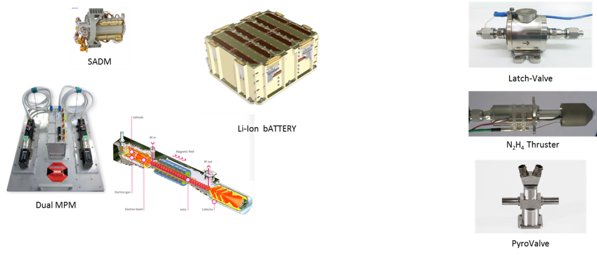
Figure 4-1: Examples of some miscellaneous items.
The list provided below may contain some items that are in fact EEE or mechanical type items, but which are classified as “miscellaneous” because the modelling approach for EEE/mechanical is not considered as completely suitable.
One of the major characteristics of miscellaneous parts/items is that they are various (functions, technologies, nature) and very specific in the sense they are designed to support dedicated and usual functions (e.g. battery) in a satellite:
- They cover a wide range of Technologies (e.g. Chemical, fluidic…) apart “simple” electrical or mechanical technologies,
- They are not fully covered by elementary « EEE or Mechanical » models (e.g. a battery cathode is not a pure EEE part),
- The failures may originate from particular failure mechanisms (e.g. catalytic bed degradation for N₂H₄ thrusters),
- They may be supported by « Innovative » technology (e.g. Plasmic propulsion) with reduced in-orbit return,
- They can be submitted to Wear-out process (e.g. battery calendar aging) depending on their nature.
Note: Software is, by nature, a miscellaneous item. Due to its specificity, a dedicated Section (§12.10) in the system chapter addresses software reliability modelling and therefore software reliability is not considered in the present chapter.
The Current document defines guidance to model reliability of most of the typical miscellaneous items implemented aboard the satellites:
- A “standard model” is defined, per family of miscellaneous items (generic items), based on IOR data, to provide a framework for the reliability prediction with room for adaptation through tailoring criteria in order to cope with the contributing factors to the reliability. The reliability data are provided in Table 11-8;
- When there is no “standard model” (specific items), the Current document provides general guidance to support the reliability model building based on available technical data. In that case, referred to as “non-standard model”, the reliability model is developed by the user, based on experience and tests results and/or manufacturers data and/or IOR data, as available. The user will formally justify and submit the reliability model to the prime contractor for approval. Refer to Section 11.4.2.
- When the two previous model categories are not useable, a holistic model can be used, as per existing reliability handbooks and/or literature. It is a general model which does not represent exactly the design of the items and which is generally not applicable for Space systems, which means the level of confidence is not high.
However, whatever the model is, it is the responsibility of the supplier to justify the selected reliability model enriched with any valuable improvement based on available data (tests data, manufacturer data, IOR data).
The process used to define a Miscellaneous (MIS) item reliability model is presented in Figure 4-2.
Note: MIS-X, below, addresses the miscellaneous chapter sections. e.g. MIS-5.5 refers to Section 11.5.5
Figure 4-2 Miscellaneous (MIS) items reliability modelling logic.

4.1 List of miscellaneous items
Table 4-1 presents the miscellaneous items for which a reliability “standard model” is defined (refer to Sections 11.7 and 11.8).
The reliability model derived from IOR data gathers in fact all the elements related to an “equivalent class” and is only valid for this class of miscellaneous items. The related numerical values are provided in Table 11-8.
To use the reliability model it is, first, necessary to assess that the miscellaneous item considered falls in the scope of the model definition. The “standard model” refers to a class of miscellaneous item identified by the main functions which are supported, the parameters reflecting the reliability (quality…) and the operating conditions.
Table 4-2 provides additional information for the miscellaneous items for which no “standard model” is provided (the list is not exhaustive, refer to Section 11.7).

Table 4-1 List of Miscellaneous items with “standard model”
REF | SUBSYSTEM | UNIT / ITEM | RELIABILITY DATA
RF - Radio Frequency
STD_001 | PAYLOAD | TWTA, Single MPM | Constant failure rate
STD_002 | PAYLOAD | TWTA, Double MPM | Constant failure rate
PWR - Power
STD_003 | POWER | BATTERY CELL GEO | Constant failure rate
STD_004 | POWER | BATTERY CELL LEO | Constant failure rate
STD_005 | POWER | SOLAR ARRAY CELL Si | Constant failure rate
STD_006 | POWER | SOLAR ARRAY CELL GaAs | Constant failure rate
STD_007 | POWER | SADM (Solar Array drive Mechanism) GEO | Constant failure rate
STD_008 | POWER | SADM (Solar Array drive Mechanism) LEO | Constant failure rate
PROP - Propulsion
STD_009 | PROPULSION | THRUSTER | Constant failure rate
STD_010 | PROPULSION | TANK TUBING | probability of failure
AOCS – Attitude and Orbit Control System
STD_011 | AOCS | RW (Reaction Wheel) GEO | Constant failure rate
STD_012 | AOCS | RW (Reaction Wheel) LEO | Constant failure rate
DEP – Deployment
STD_013 | DEPLOYMENT | DEPLOYMENT DEVICE  Antenna, boom | Probability of failure
STD_014 | DEPLOYMENT | DEPLOYMENT DEVICE  Solar Array | Probability of failure

Table 4-2 List of Miscellaneous items with “non-standard model” (not exhaustive)
REF | SUBSYSTEM | UNIT / ITEM | RELIABILITY DATA
RF – Radio Frequency
N-STD_001 | PAYLOAD | RF PASSIVE | Refer to user experience
PWR - Power
N-STD_002 | POWER | CONNECTORS | See EEE
PROP - Propulsion
N-STD_003 | PROPULSION | HET (Hall Effect Thruster) | Refer to user experience
N-STD_004 | PROPULSION | VALVE LV (Latching Valve) | Refer to Manufacturer data
N-STD_005 | PROPULSION | VALVE FCV (MONO STABLE) Flow Control Valve | Refer to Manufacturer data
N-STD_006 | PROPULSION | VALVE PYRO VALVE | Refer to Manufacturer data
N-STD_007 | PROPULSION | PT (Pressure Transducer) | Refer to Manufacturer data
N-STD_008 | PROPULSION | FILTER | Refer to Manufacturer data
THER - Thermal
N-STD_009 | THERMAL | HEAT PIPES | Refer to Manufacturer data
N-STD_010 | THERMAL | THERMO SWITCH | Refer to Manufacturer data
N-STD_011 | THERMAL | HEATER
PYRO - Pyrotechnics
N-STD_012 | AOCS | Pyro Actuator | Based on Tests results (Bruceton, PROBIT, severe, one-shot, Neyer tests)
DEP - Deployment
N-STD_013 | NEA | Non Explosive Actuator
Other
N-STD_014 | PAYLOAD | OPTICS | Based on Manufacturer data.  Mechanical models for structural failure mechanisms and radiation degradation (wear-out).
N-STD_015 | ALL | OPTRONICS | See EEE

Root causes coverage
The failure mechanisms of the miscellaneous parts result from the four categories of failure root causes already introduced and reminded in Table 4-3
Table 4-3 Coverage of failure root causes by the Miscellaneous reliability prediction methodology.
Root cause category | Coverage by the miscellaneous reliability prediction methodology
Random failure | Random failures are “one-off” events. They are modelled by a constant failure rate. In the frame of the Current document, a basic failure rate is attributed to a class of miscellaneous item, derived from IOR data and valid in a certain range of parameters. The model is only valid for the design lifetime. It can be used beyond the design lifetime in the case there is no wear.
Systematic failures | All physical failures are related to Design errors / manufacturing errors.  When the errors are sufficiently minor inducing a “One-shot” event/situation with typical failure mechanisms in line with the item quality level, they are modelled as random failures.  When it is no longer the case (obvious weakness in design, or actual design characteristics changed by manufacturing defect, premature wear-out before the end of the specified lifetime, weakness regarding the space environment) it is necessary to address and to model systematic failures. This is done based on statistics and not considering the human factor as an initial root cause.
Wear‐out failures | Considered by the process described in Section 11.5 (Wear-Out modelling), only for miscellaneous items considered as lifetime-limited items. Safe life qualification is used to address wear-out failure based on probability distribution (parameters derived from the duration for qualification). The model addresses nominal lifetime and lifetime extension.
Extrinsic failures | Foreseen extrinsic effects due to the launch environment (vibrations, shocks) and physical conditions in‐orbit (e.g. temperature) are assumed to be covered by design and adequate qualification (to be verified before modelling). Any design/manufacturing errors are represented by Systematic failures modelling.  A separate modelling may be required if the probability of additional failure mechanisms induced by the space environment cannot be neglected – e.g. space debris impact.

Data sources
The inputs data constitute the basis of any reliability model.
First, building a reliability model requires pertinent data regarding the specificity of the item (technology, complexity, materials, quality, qualification…) and the operating conditions in order to characterize the item.
Then, different inputs for reliability characteristics are defined and classified in Chapter 6 (Part II) of the Current document.
The order of preference for the use of these inputs for miscellaneous parts reliability prediction is as follows:
Statistical data
- In-orbit return (IOR) or space heritage data
- Manufacturer reliability data
- Qualification / Reliability / life test data
The added-value of this estimation is that the data represent directly the behaviour of the item under operational conditions w.r.t. failures. There are two major conditions: (1) the data represent the design/manufacturing characteristics of the miscellaneous item under consideration, (2) the cumulated data (time, number of failures) are sufficient enough to provide a realistic reliability prediction.
Analysis of the failure mechanisms
- Engineering / Physics of failure: analysis of the failure mechanisms,
- DFMEA (Design FMEA) and/or PFMEA (Process FMEA).
The knowledge of the failure mechanisms and the processes supporting these failure mechanisms provide valuable information to build a reliability model. This information is not easy to collect and to adapt and is subject to criticisms from experts leading to disagreement except when the model is justified by technical arguments.
Combined approach – Bayesian updating
The initial prediction can be refined, combining prior knowledge and IOR or tests results.
A preliminary model (constant failure rate), either PoF-based or an engineering model, provides a failure rate which is, then, assumed to a be a random variable. The distribution of this random variable is the “prior” knowledge. The expected value of the failure rate knowing additional information is the Bayesian estimator.
This approach allows using prior engineering knowledge combined with IOR data or test data which does not require a large number of cumulated hours of operations. This could be a good solution when the data background is rather reduced.
Reliability handbooks methods / supplier Model: existing model
The reliability handbooks providing valuable information for miscellaneous items reliability prediction are limited to some technologies or to some specific applications.
Even though it is possible to use such reliability handbooks or existing models (in the literature), most of time the applicability to space domain is inappropriate mainly due to the fact the space designs are very specific with a rigorous quality frame.
Any reliability model, whatever the data sources are, needs to be justified (with technical arguments) and submitted to system level for approval.

In-orbit return data
For “generic equipment” that is similar from one mission to the other, it is valuable to take benefit from the use of in-orbit return data. This can provide direct statistics on the related items used in a typical environment. No model with theoretical implications would meet such level of relevance as far as the items are “equivalent” to those being used in-orbit.
Consequently, use of in-orbit return constitutes the basis for “miscellaneous items” that meet the following two conditions:
- items involved in generic “miscellaneous” functions, provided they address similar perimeters and under similar operational conditions. Technology, complexity and quality (in a wide sense) are other parameters to be checked with accuracy.
Besides, the use of in-orbit return is possible on a case by case basis, in the frame of the assessment of a given spacecraft family for example, where functional features are the same and supported by a generic product.
- items with enough in-orbit return, thus excluding those devices that might have become widely used recently (low cumulated time in operation, new technology). This may also impact the level at which miscellaneous items are defined.

Manufacturer reliability data
Miscellaneous items are designed, manufactured and procured by suppliers generally specialized in space domain and for some categories of miscellaneous products, e.g. Solar Array cells manufacturer.
As designers, the suppliers have a deep knowledge of their products and it is their interest to master the reliability, especially in the case of product streamlined with a long heritage. However, the behaviour of these items in-orbit is better known by the prime contractors and the customers (and insurers as well) than by the manufacturers. Nevertheless, apart these operational data, the items are qualified and specific reliability tests may be conducted on ground prior to any development.
Any relevant data (e.g. failure events, nominal behaviour, cumulated time under tests) should be considered to support the item reliability modelling. A balance should be found between generic IOR data (Current document data) and dedicated manufacturers’ data.
The case of one-shot devices
A “one-shot” device is defined as a product that can be used only once.
It works (success) or it does not (failure) but once it has been activated and used (providing the function for which it is designed) it is destroyed, e.g. pyrotechnic device used to cut a cable in order to deploy a solar array after injection in-orbit.
“One-shot” devices typically spend their life in dormant storage until they are activated.
Their reliability is therefore not a function in time (with possible observation of a time to failure through appropriate monitoring) but a constant probability of success (or failure resp.), likely to depend on one or several physical parameters, e.g. current in the case of a pyrotechnic device.

Reliability test data
Test data for miscellaneous items tested under operational conditions would be a relevant source of information for reliability prediction, but is not in most cases available in sufficient quantities to derive any quantitative reliability metrics. Generally, elements constituting the miscellaneous items are tested in larger quantities but do not represent the whole and assembled item. Nevertheless, this information can be valuable in order to derive contributing factors to failure or to confirm design assumptions.
Physics of Failure models may use these elementary tests and resulting data to identify the failure mechanisms and the related design characteristics. Major failure mechanisms are identified per miscellaneous item and mastered as necessary through appropriate design rules. All this is qualitative information and is used as support to any reliability model, as relevant
Reliability tests for One-shot devices
Several tests are recommended to verify the reliability of the one-shot devices: Bruceton [BR96], PROBIT [BR97], severe tests [BR98], one-shot tests [BR99], Neyer tests [BR100]. The resulting statistical data are useful to characterize the reliability of these items with regard to functional parameters.
Wear-Out characterization
Regarding wear-out, the miscellaneous items should be qualified versus specified lifetime and ground lifetime as per [RD7] , implementing a safety factor (number of elements, number of tests). The results of these tests are considered as evidence, with a certain level of confidence, that no wear occurs before the end of the specified lifetime (or better that no performances degradation impacts the mission of the item).

Engineering / Physics of failure
Physics of Failure can be used to identify the dominating failure mechanisms of the miscellaneous items. This approach should be used when no data are available and pertinent enough to populate a reliability model with accuracy. It is the case for a new development with innovative technology for which no statistical data exist.
Use of DFMEA / PFMEA could be helpful, and is recommended, to identify the causes (design, manufacturing) of the failure mechanisms and their criticality in terms of mission severity, failure occurrence likelihood and detectability on ground. A RPN metric (Risk Priority Number) is derived (refer to standard BR7) and risk mitigation actions set up in order to reduce the RPN to an acceptable level, i.e. under a certain level of probability of occurrence.
When it is not possible to derive the probability of occurrence of a failure mechanism based on PoF, engineering judgement, with experts, is recommended with associated justification.
The probability of occurrence ranking defined by categories could be translated in the frame of the operational conditions of the items but there is no suitable method able to support this process. It is the responsibility of engineering to justify the probability ranking.

Engineering data combined with observations
In some cases, there are valuable data mainly produced by engineering which could be considered as “prior” data. These data can be combined with either IOR data (reduced cumulated time) or test data to provide “posterior” information.
A combined approach based on one of the methods listed above and Bayesian updating with relevant data (additional and independent from the prior estimate) is the preferred approach whenever suitable data is available, but not in sufficient quantity for a pure statistical approach.

Reliability handbooks / models
There are no dedicated reliability handbooks really addressing exhaustively miscellaneous items. Therefore, it is not recommended to use such a method, unless when the available data source and the data use is justified.

Reliability Models for miscellaneous items
There are three reliability models for miscellaneous items:
- “Standard model”, for generic miscellaneous items,
- “Non-standard model”, for specific miscellaneous items.
- “holistic model”, for miscellaneous items which are not supported by “standard model” nor by a “non-standard model”.

Standard model for generic miscellaneous items
A “generic” miscellaneous item is an item classified as “miscellaneous” (refer to the definition provided at the beginning of this chapter) AND for which a reliability model based on IOR is defined as a reference in this Current document (see Table 4-1).
The reliability model is either (1) an exponential distribution (constant failure rate) or (2) a constant probability of success or constant probability of failure ( = 1- Probability of success) supported by Binomial model, depending on the nature of the item.
The basic reliability data are provided in Table 11-8 with the associated framework.
The reliability “standard model” is then calculated based on the process presented in Section 11.5.

Non-standard model for specific miscellaneous items
A “specific” miscellaneous item relates to a product which is not fully modelled by EEE parts and/or mechanical parts and which is not listed in the equivalent classes of miscellaneous items in Section 11.4.1
e.g. Hold Release Mechanism Low Shock presented in Figure 4-3.
The item is neither a mechanism, nor an assembly of EEE parts. It is constituted by different parts such as spring, glue, expansion unit. Since the design is very specific without any IOR data it is necessary to define a dedicated reliability model.
The Current document provides general guidance to define such a reliability model: The approach to calculate the basic reliability data is presented in Section 11.7. The “specific” reliability model is then calculated based on the process presented in Section 11.5.
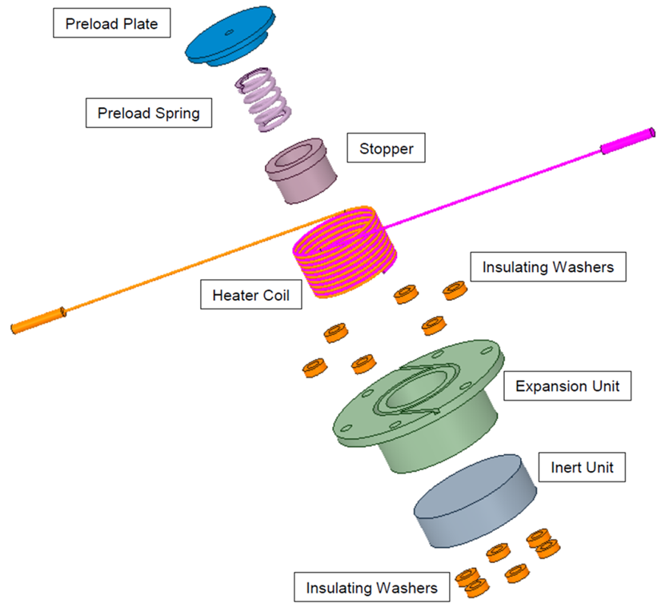
Figure 4-3: Example of "non-standard" miscellaneous item

Holistic model
A holistic model refers to a model based on the existing reliability handbooks and/or literature without detailed justification related to the design.
The holistic reliability model is then calculated based on the process presented in Section 4.5.

Dormant failures
Currently no reliability model is provided to support failure modelling in dormant mode for miscellaneous items. The miscellaneous items are from different nature (mix of EEE and mechanics, passive components, tubing, piping…) and it is not relevant to provide a generic rule to derive a dormant failure rate from the active miscellaneous item failure rate.
In case, depending on the mission and on the operations, it is necessary to use a reliability model in dormant mode (no power supply during certain storage duration, no activation for “maintenance”) the user will define a dedicated reliability model (refer to the different methods listed previously) accounting for the specific conditions in storage.

Process for Reliability modelling
This Section details how to build a reliability model for miscellaneous item.
Figure 4-4 provides the general process to apply whatever the basic model is: (1) the “standard model”, or (2) the “non-standard model” or even (3) the “holistic model”.
Note: on Figure 4-4, the basic model is a failure rate but it could also be a probability of failure.
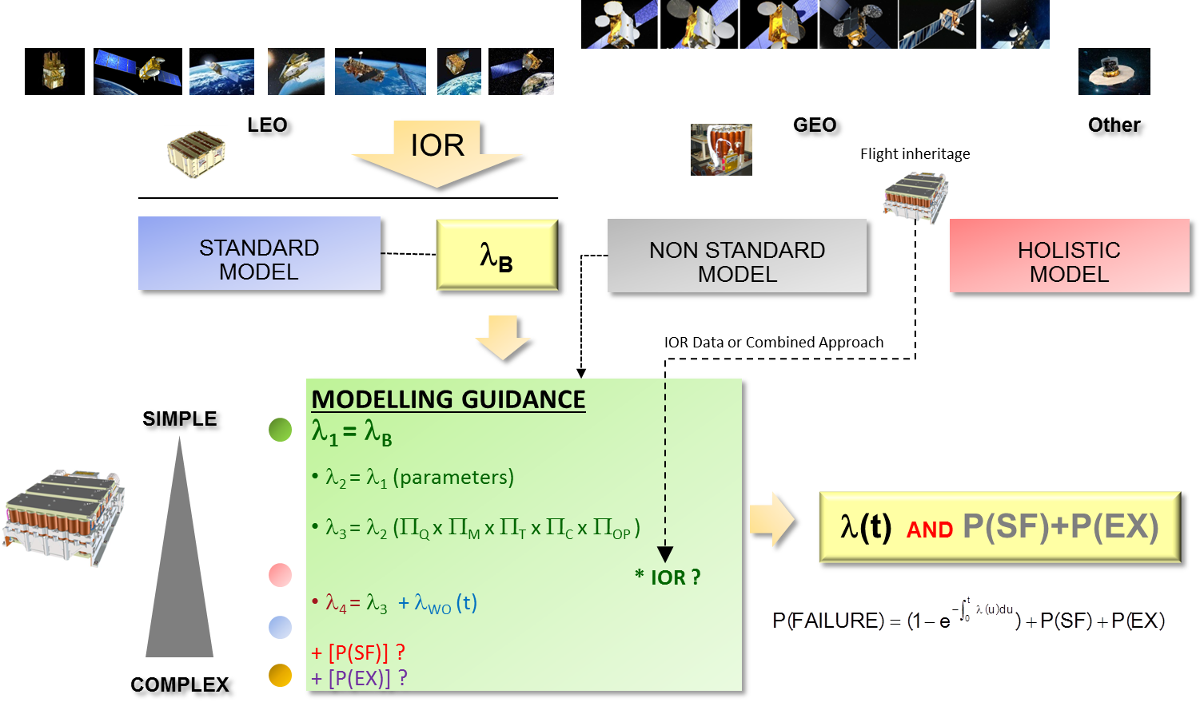
Figure 4-4: General process for miscellaneous items reliability prediction.
First, it is necessary, before starting anything, to collect/define all technical information about the miscellaneous item in order to select the category of miscellaneous item which will be used, if relevant, as a “standard model”:
- Functional analysis: list of all the main functions supported by the item,
- Technical performances: list of all the specified performances regarding the nominal mission / the reduced mission,
- Hardware description: functional breakdown and hardware architecture as per reliability block diagram (refer to the reliability analysis and associated FMEA),
- Trajectory (GEO, LEO, MEO, Interplanetary orbit) on which the item is intended to be used,
- Operating conditions
  - Duty cycle
  - Voltage, current
  - Thermal environment
- Flight experience: the maturity of the item regarding in-orbit background.
The basic principle is to provide through a reference failure rate (or a probability of failure for one-shot devices) and to up-date this reference failure rate as relevant considering the contributors (multiplying corrective factors) to the probability of failure.
In the following Section the general process is described.
Note that it is considered that the multiplying corrective factor is also used to up-date the probability of failure in the case of a one-shot device, based on the fact that, for constant failure rate, when the probability of failure can be approximated by λt (i.e. for exponential distribution in the case λt <10⁻²) the corrective factor K leads to a new probability = Kλt, which means the probability of failure is multiplied by the corrective factor.
As a result, the same applies for the probability of failure P_{F} for a one-shot device: the basic probability can be amended by a factor K, leading to KP_{F}.
So, what is discussed in the following Sections, addressing directly the failure rate, applies for the probability of failure for one-shot device.

Step 1: selection of the initial model
The basic principle is to start from a reference failure rate, either derived from in-orbit data in the frame of the Current document or from a “non-standard model” duly justified by the supplier.
J01_rule: The supplier justifies the rationale supporting the use of a “model” (functional analysis, hardware configuration, operating conditions) providing as a minimum:
- Miscellaneous category
- List of the main functions / main performances
- Operating conditions range
The failure rate is referred to as basic failure rate λ₁ =λ _{B}. It is defined at 60% level of confidence.
$$λ_{1}=λ_{B}$$ | Equation 4-1

Step 2: normalization of the basic failure rate
The major contributors to the reliability are identified in
Table 4-8.
In the case the actual parameters are different (either higher or lower quality levels, additional stresses, specific technology, specific contributors to the reliability) a tailoring factor is recommended to account for the item’s specificities.
J02_rule: The supplier identifies the physical parameters contributing to the reliability and accounting for the item specificities.
The resulting failure rate is
$$λ_{2}=λ_{1}*K_parameters$$ | Equation 4-2
By default, K_parameters is set to 1, under the condition that the major contributors are sufficiently close to those defined for the basic failure rate.
It is the responsibility of the user (the supplier) to adapt and/or define the K_parameters as relevant with appropriate technical justification.

Step 3: consideration of reliability contributors
The basic failure rate which is derived from IOR relates to a certain set of assumptions likely to impact the reliability. It is therefore necessary to amend as relevant the basic failure rate to account for the real conditions of the item under consideration.
- Π_{Q} = QUALITY factor
This factor covers the quality level used to design/manufacture the miscellaneous item. It addresses the quality process, as a whole, as defined in the ECSS framework.
A three level scale is used:
  - Level 1 = HIGH Quality (e.g. most of Telecommunications satellites)
The technical risk is mitigated / cancelled as necessary. This level refers to the high quality standard used for space (refer to ECSS).
  - Level 2 = MEDIUM Quality (e.g. New Space paradigm)
The technical risk is optimized. This level is an intermediate level between High quality level and Low quality level.
  - Level 3 = LOW Quality (e.g. COTS without quality space standard requiring specific qualification)
The technical risk is mitigated up to the cost target, otherwise accepted.
J03_rule: The supplier justifies with technical argument the quality level of the miscellaneous item providing the quality reference as define in the Product Assurance requirements applicable to the miscellaneous item.
- Π_{M} = MATURITY factor
This factor addresses the maturity level of the supplier.
A three-level scale is used:
  - Level 1 = HIGH MATURITY, the supplier is a specialist providing the space stakeholders with the miscellaneous item,
  - Level 2 = MEDIUM MATURITY, the item is a new development for the supplier,
  - Level 3 = LOW MATURITY, the supplier is a newcomer on the market to develop such a product.
J04_rule: The supplier justifies with technical arguments the maturity level of the miscellaneous item providing evidences of the related ranking.
- Π_{T} = TECHNOLOGY factor
This factor relates to the “technology” supporting the item. “Technology” is considered in a wide sense and is already addressed in the IOR equivalent class from which the basic failure rate is derived.
No assumption can really be defined to account for the use of a new technology or a technology slightly different.
The supplier justifies with technical arguments the reason why the technology of its product matches the technology accounted in the basic failure rate. If it is not the case, a “non-standard model” is developed by the supplier.
e.g. SSPA implements a different technology than TWTA and therefore the reliability model used for TWTA will not be used for SSPA.
J05_rule: The supplier justifies that the technology supporting the item is consistent with the IOR data used as a basis to determine the basic failure rate.
- Π_{C} = COMPLEXITY factor
Reliability depends on the complexity of the item. The assessment of the complexity is difficult.
The supplier justifies with technical arguments the reason why the complexity of its product is consistent with the complexity accounted in the basic failure rate. If it is not the case a “non-standard model” is developed by the supplier.
J06_rule: The supplier justifies that the complexity (design) supporting the item is consistent with the IOR data used as a basis to determine the basic failure rate.
- Π_{OP} = OPERATING CONDITIONS factor
The factor represents the frame of the significant operating conditions of the item. It is item-dependent.
  - Orbit,
  - Temperature,
  - Power,
  - Thermal Cycling,
  - Duty cycle
  - Other relevant conditions considered as reliability contributor.
J07_rule: The supplier identifies with adequate justification the parameters / stresses impacting the reliability with an associated weight representing the contribution of the parameter to the reliability.
- J08_rule: The supplier classifies each significant condition in three categories:
  - FULLY COMPLIANT: The basic failure rate has been derived for the same operating conditions (w.r.t. this parameter)
  - PARTIALLY COMPLIANT: The basic failure rate has been derived based on different operating conditions and the parameter is assumed to be a contributor to the reliability with medium impact,
  - NOT COMPLIANT: The basic failure rate has been derived based on different operating conditions and the parameter is assumed to be a contributor to the reliability with high impact
The weighting factor attributed per condition represents the contribution of each condition to the reliability of the item.
The average resulting factor is then applied.
The resulting failure rate is
$$λ_{3}=λ_{2}*П_{Q}* П_{M}*П_{T}* П_{C}* П_{OP}$$ | Equation 4-3
Note that for operating conditions it is necessary to define the weights per contributor and to add a number of conditions as necessary. The process is:
- To define the number of conditions
- To attribute a weighting factor per condition
- To define the category for each condition
- To calculate the resulting factor to be added.
Table 4-4 provides an example of such a calculation.

Table 4-4 Values of factors per their ranking.
The column “value” provides the factors depending on the classification (column “scale”).
The two right-hand columns provide the result for one example (“X” representing the ranking regarding the different categories with the associated resulting factor in the right column)
1,1= 1,00 x 1,00 x 1 x 1 x 1,1 = П_{Q}* П_{M}*П_{T}* П_{C}* П_{OP}

Step 4: application of combined approach
The step 4 is used to combine the predicted failure rate with IOR data in the case the item is based on a generic product which is already operated in-orbit.
The method used is the Bayesian approach as presented in Section 4.6.3.
$$λ_{3}^{*}=λ_{3}$$ | Equation 4-4
$λ_{3}^{*}$ is the gamma estimator.

Step 5: wear-out modelling
The step 5 incorporates in the reliability model the failures due to potential wear, as necessary.
The model consists in adding to the constant failure rate (representing Random failures) an increasing failure rate representing the wear-out contribution to the failure of the item.
Let’s denote T as the Time To Failure random variable.
T_{RF} is the TTF representing Random Failures (constant failure rate for miscellaneous items)
T_{RF} is modelled by the exponential distribution.
T_{WO} is the TTF representing Wear-Out failures (increasing failure rate)
T_{WO} is modelled by any distribution with increasing failure rate, i.e. Weibull W(β, η), Normal (m, σ), Log-Normal… as relevant (based on the supplier knowledge).
Three models are presented to model include wear-out mechanisms and impacts on the reliability of the item.
- MODEL 1: RF model and WO model are combined from t=0, based on T=TTF=min(T_{RF}, T_{WO})
- MODEL 2: RF model and WO model are combined beyond τ , assumed to be the qualification time (laps of time defined in accordance with the technical requirements –agreed with the customer- in order to demonstrate the capability of an item to withstand the applied stresses all along the specified lifetime without significant degradations preventing from the mission achievement).
- MODEL 3: RF distribution and WO_PDF are separated @ α (RF before, WO beyond) from λ_{WO}(α)=λ_{RF}
The three models are presented in Section 12.8.1.
All three Models can be defined for every Wear-out probability density function: Normal, log-Normal, Gamma … with adequate properties.
J09_rule: the supplier justifies the wear-out model based on the qualification characteristics of the item.
The resulting failure rate is
$$λ_{4}\left(t\right)= λ_{3}^{*}+ λ_{WO}(t)$$ | Equation 4-5
The reliability prediction of the item is then provided by:
$$P\left(FAILURE\right)=1-e^{-\int_{0}^{t}{λ_{4}\left(u\right)du}}$$ | Equation 4-6
Discussion about the three models
Figure 11-5 presents the differences on the reliability and on the failure rates per model 1, 2, 3, using the example of the Weibull distribution as a wear-out model.
- Model 1 and model 3 are very close since the constant failure rates used for miscellaneous items are very low regarding the increasing failure rates of any distribution such as Normal or Weibull distribution.
- Model2 could be considered as optimistic since it addresses wear-out only after the qualification time.
- Model 1 appears as the most appropriate, summing the failure rate for Random failures modelling and the failure rate for Wear-out failure modelling. It is recommended to be used except technical arguments support another choice.
Recommendation: The model 1 is recommended as it combines a constant failure rate model with an increasing failure rate model. Other models could be used when appropriate justification is provided by the user.
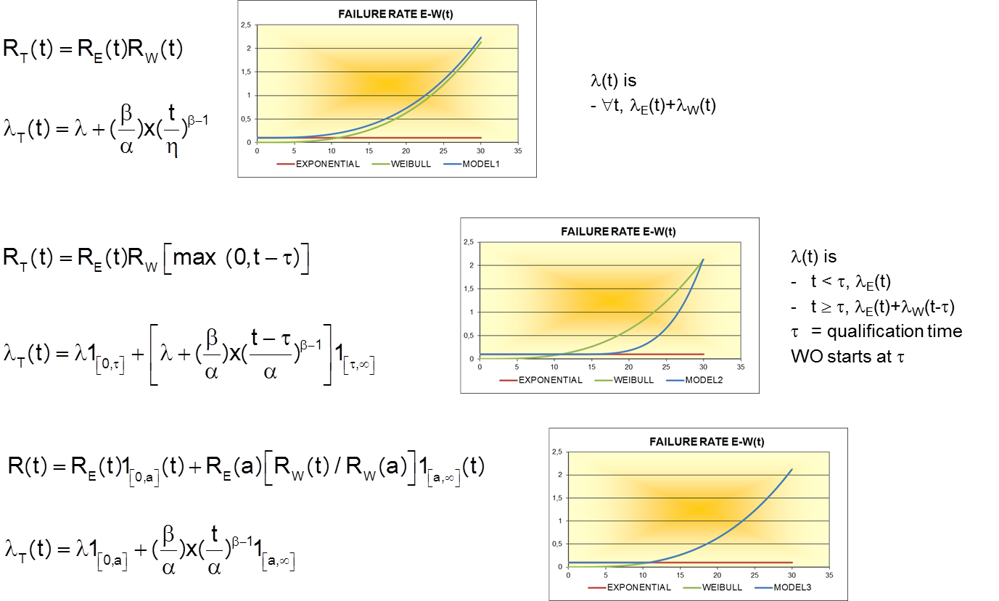
Figure 11-5: Failure rates for the three Wear-out models (Exponential, Weibull)
Guidance to derive the Wear Out distribution characteristics
In the case there is no data to support the selection of a wear-out failure time distribution and the associated parameters it is recommend to apply the following process.
The first assumption is to consider a normal distribution. The user should have to determine:
- the Qualification time (e.g. 10 years or equivalent) t_{Q} , by default it is the specified lifetime.
- a level a of quality (a=1, 2 or 3) represented by
  - 1σ: P(T> m-1σ) = 84,1%
  - 2σ: P(T> m-2σ) = 97,7%
  - 3σ: P(T> m-3σ) = 99,85%
depending on the level of quality of the qualification.
- a ratio v = σ/m (σ=vm) representing the variability of the manufacturing process, 10% is recommended by default (to be justified considering the quality of the manufacturing process),
Then the characteristics are calculated:
m – aσ=m-avm =t_{Q}
m = t_{Q}/(1-av)
σ= vm
Knowing m and σ, the distribution N(m,σ) is completely defined and the resulting functions R_{WO}(t), F_{T}(t), f_{T}(t) and λ_{WO}(t)=f_{T}(t)/R_{WO}(t) are defined likewise.
It is possible also to derive a Weibull distribution, similarly to the Normal distribution by adapting the two parameters β and α of the Weibull distribution in order to match the expected value m and the standard-deviation σ.
Then the probability P (T > t_{Q}) provides the level of Confidence (LoC), i.e. R_{WO}(t_{Q})
It is noteworthy that when the parameters are consistent the reliability function is similar between the normal distribution and the Weibull distribution. Figure 4-6 (resp. Figure 4-7) presents an example of such calculation with normal law (resp. Weibull).
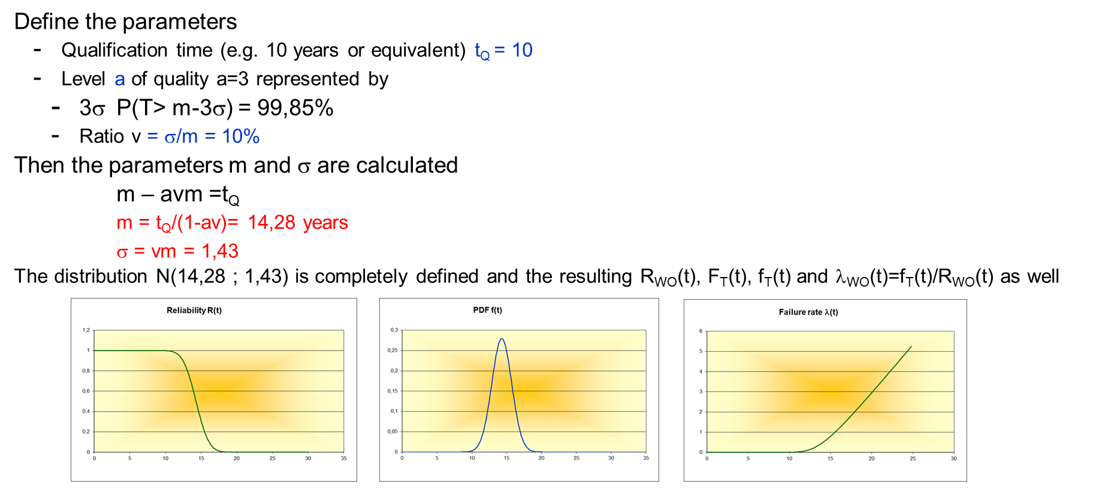
Figure 4-6: Example of WO distribution calculation (assumption: Normal distribution)
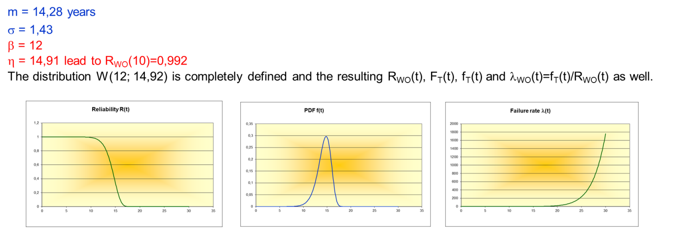
Figure 4-7: Example of WO distribution calculation (assumption: Weibull distribution)

Step 6: Systematic failures modelling
The step 6 consists in adding a probability of failure related to Systematic Failures.
$$P\left(FAILURE\right)=1-\left(1-SF\right)*(1-e^{-\int_{0}^{t}{λ_{4}\left(u\right)du}})$$ | Equation 4-7
The model is common to all miscellaneous items.
Refer to the Chapter 12 for defining the SF value.

Step 7: Extrinsic failures modelling
The step 7 consists in adding a probability of failure related to the external particles.
$$P\left(FAILURE\right)=1-\left(1-EX\right)*\left(1-SF\right)*(1-e^{-\int_{0}^{t}{λ_{4}\left(u\right)du}})$$ | Equation 4-8
The probability of extrinsic failures EX is dependent on (1) the item location (outside the satellite), (2) the probability to be hit by a particle (refer to µmeteorits flux and characteristics depending on the orbit, on the position on the orbit and on the velocity vector) and (3) the shielding for the item protection.
The definition of a model representing the probability to be hit by a debris is out of the scope of the Current document. Refer to Chapter 10 for more information.

Result after completing Step 1 to Step 7
The method allows deriving a reliability function in time as presented here above.
It is up to the discretion of the user to use the result appropriately:
- Probability of failure
- Probability of success
- Equivalent failure rate derived at a certain time (only valid at this time)
- Approximation of the probability of failure by λt, when λ is small regarding 10⁻².
An example of calculation is presented in Table 4-5.
Table 4-5 Example of a reliability calculation for a Miscellaneous item: TWTA.

4.6 Use of IOR data and/or tests results
As presented, a reliability model can be built based on IOR data and/or on test data (manufacturers, user) or combined with IOR data and/or on test data (manufacturers, user).
The basic failure rate or the basic probability of failure in Table 11-8 is based on such IOR data. The data was compiled from the IOR background in ADS & TAS fleets.
Per miscellaneous items, the anomalies are collected regarding representative products (quality, range of operational conditions, orbit as relevant) and the failures are classified in random failures (RF) and systematic failures (SF). To avoid duplication of systematic anomalies, they are only counted once. That means that the derived failure rates include as relevant systematic failure contribution.
The IOR data recorded are:
- Reference: miscellaneous item number
- Satellite subsystem
- Miscellaneous item description (e.g. Li-Ion Battery)
- Cumulated time in-orbit and/or tests for the relevant sample of items
- Number of failures
- type of failure: random, systematic
- Point estimate: to provide a point of comparison with one-sided interval estimator
- File: the file addresses the events (failures) listed to derive a failure rate
  - Description of the event
  - Classification of the failure, either random or systematic
  - Time to failure
  - Statistical weight: representing the percentage of the items fleet at the time of the failure (number of items operational at failure time divided by the number of the items in the fleet).
  - Example: the percentage is nearly 100% for low values of TTF and the percentage decreases as the TTF increases in time.

Failure rate estimator
The basic failure rate estimation is a one-sided upper bound interval estimation, see Chapter 6 (Part II) for details.

Proportion of failure estimator
To determine a proportion of failures based on the observation of failures within a sample of n elements (e.g. IOR data for “one-shot” device), it is possible to use:
- Point estimate
- Bayesian estimator
- Estimation by interval.
It is recommended to use the interval estimate, see Chapter 6 (Part II) for details.

Gamma Bayesian estimator
The failure rate is no longer considered as a real but as a random variable Λ.
In the case of the exponential distribution, a natural prior distribution is the Gamma distribution (conjugate of the exponential distribution), see Chapter 7 (Part II) for details.
The Bayesian estimator is defined as the expected value of the random variable Λ knowing that a failure has been observed at t1, t2…tn). Then, with a sample encompassing n items and n associated times to failure:
$$E\left(Λ/{T_{1}}=t_{1},T_{2}=t_{2}, …, T_{n}=t_{n} \right)=\frac{α+n}{β+ \sum_{i}{t_{i}}}= \frac{\frac{α}{n}+1}{\frac{β}{n}+ \frac{\sum_{i}{t_{i}}}{n}}$$ | Equation 4-9
The parameters of the gamma prior distribution are selected as per the knowledge of the item.
Let us assume for a certain miscellaneous item that a basic failure rate is calculated.
Let us assume that there are some items already in flight with a certain cumulated time, not sufficient enough to provide a result in the order of magnitude of the specification (without prior knowledge).
Let us consider λ₀ as a first estimation of the failure rate (e.g. provided by Current document or existing model).
Let us consider a Gamma (α, β) distribution assumed as “prior” distribution of the failure rate Λ.
It is necessary to provide rules for determining the two parameters α and β with two equations.
We determine α so that the expected value of the gamma distribution is λ₀.
$$\text{E}\left(Λ\right)=α/β=λ_{0}$$ | Equation 4-10
This provides a first equation with α and β.
A second equation is provided by the level of confidence “a” attributed to the value λ₀:
$$F_{Λ}\left(λ_{0}\right)=P\left(Λ≤λ_{0}\right)= \int_{0}^{λ_{0}}{\frac{β^{α}e^{-λβ}λ^{α-1}}{Γ(α)}}=\frac{1}{Γ(α)} γ\left(α,α\right)=a$$ | Equation 4-11
Ideally, the prior should be defined based on two different estimates for the failure rate λ₀, one representing an “average” value (point estimate, entering Equation 4-10) and one representing an estimate at a given level of confidence (e.g. conservative estimate, entering Equation 4-11).
Once α and β are determined it allows to derive the Bayesian estimator with n being the number of failures and ∑ti the cumulated time.

Basic failure rate derivation for “non-standard model” items
When the miscellaneous item under consideration does not match the criteria of the miscellaneous equivalent class (e.g. SSPA – Solid State Power Amplifier- cannot be compared to a TWTA in terms of technology), it is necessary to build a reliability model based on engineering/PoF approach as defined hereafter.
Once the reliability model is established it can be tailored as necessary based on the approach presented in Section 4.5.
First, it is necessary, to collect/define all technical information about the miscellaneous item in order to characterize it (refer to Section 4.5). Then the basic failure rate λ₁ =λ _{B} is defined (step 1) as discussed below. Finally, the tailoring of this basic failure rate follows the “standard model” procedure as presented in the subsections of Section 4.5 corresponding to step 2 to 7.

DFMEA / PFMEA
After the first item characterization, a DFMEA and a PFMEA are performed in order to assess the failure modes due to (1) design errors and (2) manufacturing errors.
It is recommended to use the SAE standard [BR95] which provides the method to apply for a DFMEA / PFMEA. PFMEA is also specified in [RD2] .
FMEA: Required for every unit
- Is a tool/method supporting the design of the unit, identifying all the elementary “failure modes” due to “RANDOM FAILURE” (part intrinsic reliability) as defined in the failure mode list (refer to [RD2] annex G).
- @unit level: under supplier responsibility
- @system level: integrated at system level by System RAMS engineer (including HSIA supporting the failure tolerance: observability in-orbit…)
DFMEA: Required on critical functions only (Risk analysis)
- Is a tool/method supporting the product quality identifying all the elementary failure modes due to DESIGN errors. It includes, as a minimum, the failure modes identified by FMEA.
- @unit level: under unit designer / Quality Assurance responsibility
- @system level: reviewed by procurement within the unit acceptance process
PFMEA: Required on critical functions only (Risk analysis)
- Is a tool/Method supporting the product quality identifying all the elementary failure modes due to MANUFACTURING errors.
- @unit level: under unit Quality Assurance responsibility
- @system level: reviewed by procurement within the unit acceptance process

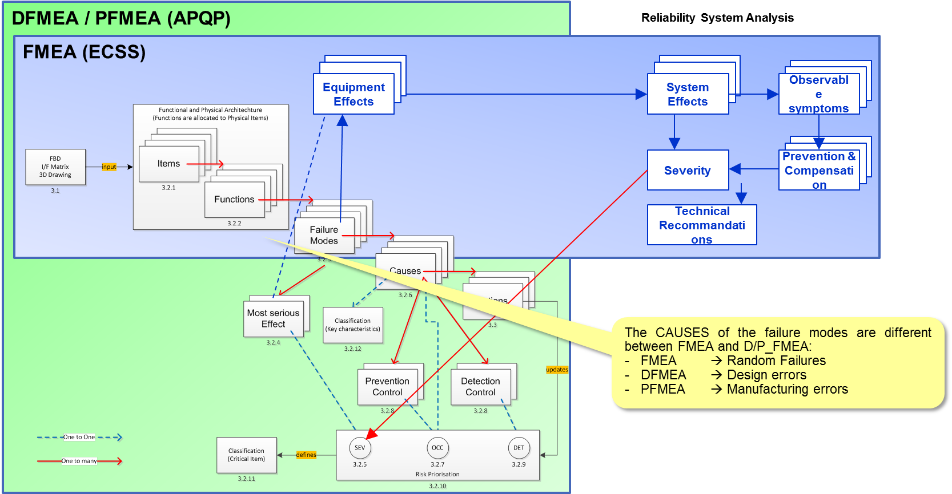
Figure 4-8: Differences between FMEA, DFMEA and PFMEA.
Figure 4-8 highlights the differences and the commonalities between FMEA, DFMEA and PFMEA.
Figure 4-9 provides an example of DFMEA and PFMEA at elementary part level (interconnect between Solar cells). The left-hand side of the table refers to FMEA (blue perimeter in Figure 4-8), whereas the right-hand side refers to DFMEA data (green perimeter in Figure 4-8).
The main outcome is the ranking of every root cause (Design error, Manufacturing error) in
- SEVerity
- OCCurrence
- DETectability
The Risk Priority Number (RPN), which is derived, is an index reflecting the residual technical risk.
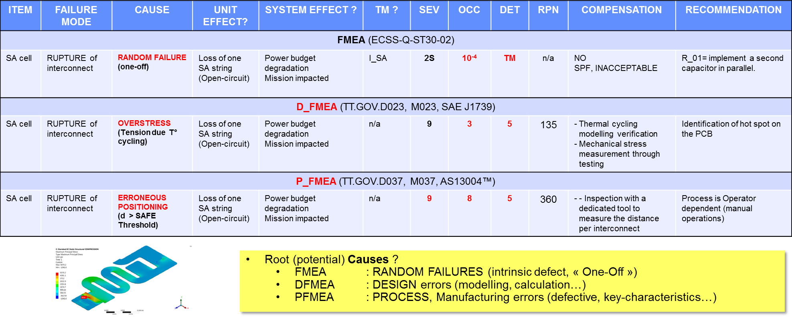
Figure 4-9: DFMEA and PFMEA at element part level (example of Solar cells interconnect)
SA: Solar Array ; I_SA: SA current ; TM: Telemetry; SPF: Single Point Failure
Table 4-6 Occurrence scale with 10 levels.
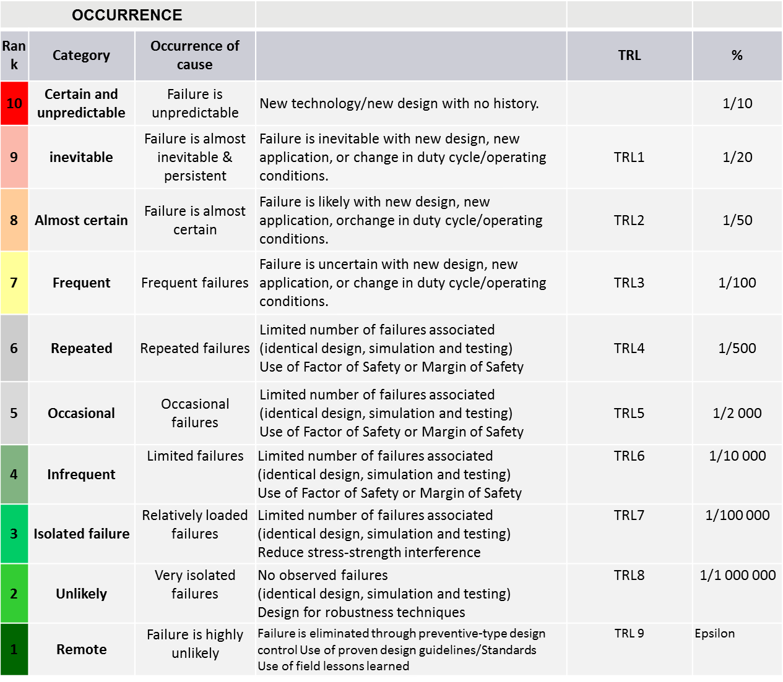
TRL: Technology Readiness Level

Probability assessment
The occurrence scale of Table 11-6 is used to derive, based on engineering judgement, either a failure rate or a probability of failure, per failure mode:
- In the case Detectability (i.e. the capacity to detect on ground the defect) is certain, the probability of failure is set to 0 under the condition that no degradation in time is expected (e.g. if a particle inside a RF passive part which originates from manufacturing is necessarily detected on ground with no possibility to get a particle during the mission, then the associated probability of failure is set to 0).
- A probability of occurrence is assigned to every failure mode and the sum provides the probability of occurrence of the item.
- A failure rate could be derived assuming the probability of occurrence on the specified lifetime is equal to the probability assigned to the failure mode, e.g. probability assessed to 10⁻⁴ as level 4 (Table 4-6) leads to a failure rate of 1,14 10⁻⁹ for 10 years.
This represents the basic failure rate or the basic probability of failure.
Then the general process to adapt this failure rate is described in Section 4.5.
It is noteworthy that this probability ranking needs to be clearly justified and documented.

Reliability Data for Miscellaneous “Standard model”.
Table 4-8 provides the basic failures rates or basic probability of failure (%) to be considered for miscellaneous “standard models”.
The meaning of the columns is explained in Table 4-7.
Note 1: MIS_01 TWTA, Single HPA
The failure rate is provided per TWT Channel (mono channel or dual channel). In order to be used for LEO, if adaptation is necessary, it is recommended to use (1) by default the following proportion (based on average MIL-HDBK-217 [RD12] reliability prediction) of the whole failure rate.
- EPC_common = 36%
- EPC_channel = 9%
- CAMP = 25%
- TWT = 30%
Or (2) to use the supplier repartition as per its own reliability prediction.
Table 4-7 Structure of the reliability data table (
Table 4-8).
Column | Description | Remark
REF | Identifies the miscellaneous item
EQUIPMENT | Name of the item
FR | Depending on the model either a constant Failure rate (fit) or % standing for estimate of the proportion of failures  A figure (integer) means a Failure rate in fit. A proportion (figure followed by %) means a proportion of failure | Constant failure rate @60% LoC (Chi Square) or Probability of failure @60% upper bound one-sided interval
POINT ESTIMATE | When relevant - observed failure(s) – point estimate of the failure rate or of the proportion of failures %
QUALITY | Level of quality used to define the “standard model” | HIGH, MEDIUM, LOW
MATURITY | Indicates the level of maturity, generally based on the first use of the equipment in-orbit
TECHNOLOGY | Indicates when relevant which technology is concerned
COMPLEXITY | Indicates when relevant the level of complexity
ORBIT | Indicates which orbit is relevant to the “standard model” | LEO, GEO
T° | Indicates the range of T° when T° has to be considered
POWER | Indicates the range of Power when Power has to be considered
CYCLING | Indicates the fact that cycling is a contributor to reliability
DUTY CYCLE | The percentage of time during which the item is operated
OTHER | Any other parameters or data to be considered
WO | Wear-Out is to be considered when “YES”

Table 4-8 Miscellaneous items Reliability data for “standard model”.
REF | EQUIPEMENT | FR  (fit) / % | POINT ESTIM. | QUALITY | MATURITY | TECHNOLOGY | COMPLEXITY | ORBIT | T° | POWER | CYCLING | DUTY CYCLE | OTHER | WO
RF – Radio Frequency
STD_001 | TWTA, Single HPA  (refer to note 1) | 200 | n/a | HIGH | since 1990 | HPA (TWTA) | TWTA complexity | GEO  LEO | 30° C < T° < 60°C | ALL | 30° C < T° < 60°C | ON  ON/OFF | All frequencies C, X, Ku, Ka, L | YES
STD_002 | TWTA, Dual HPA | 400 | n/a | HIGH | since 1990 | HPA (TWTA) | TWTA complexity | GEO  LEO | 30° C < T° < 60°C | ALL | 30° C < T° < 60°C | ON  ON/OFF | All frequencies C, X, Ku, Ka, L | YES
PWR - Power
STD_003 | BATTERY CELL (GEO) | 5 | 2 | HIGH | since 2000 | Li-Ion | X S - Y P  Z P- A S | GEO | 0°C < T°C < 20°C | n/a | n /a | 100% | DoD < 70%  V < 50v | YES
STD_004 | BATTERY CELL (LEO) | 1 | n/a | HIGH | since 2000 | Li-Ion | 18560 | LEO | 0°C < T°C < 20°C | n/a | 90mn | 100% | DoD < 70%  CID, PTC | YES
STD_005 | SOLAR ARRAY CELL Si | 0,15 | n/a | HIGH | since 1990 | Si | Triple-Junction | GEO  LEO | -100°C < T° <100°C | n/a | n/a | n/a | n/a | YES
STD_006 | SOLAR ARRAY CELL GaAs | 0,15 | n/a | HIGH | since 1991 | GaAs | Triple-Junction | GEO  LEO | -100°C < T° <100°C | n/a | n/a | n/a | n/a | YES
STD_007 | SADM GEO | 210 | 150 | HIGH | since 1992 | SlipRing | n/a | GEO | -100°C < T° <100°C | some kW | n/a | 100% | n/a | YES
STD_008 | SADM LEO | 213 | 105 | HIGH | since 1992 | SlipRing | n/a | LEO | -100°C < T° <100°C | some kW | n/a | 100% | n/a | YES
PROP - Propulsion
STD_009 | THRUSTER | 82 | 71 | HIGH | since 1990 | Cold gas  Hot gas | 1N – 10N | GEO  LEO | n/a | n/a | ALL | from low to high rate |  | YES
STD_010 | TANK TUBING (SPF) | 3,27% | 2,4% | HIGH | since 2000 | Ti  Al | PIPING | GEO  LEO | n/a | n/a | n/a | n/a | MEOP up to 200bars | NO
AOCS – Attitude and Orbit Control System
STD_011 | RW GEO | 250 | 205 | HIGH | since 1990 | bearing  magnetic | n/a | GEO | -30° C < T° < 80°C | n/a | n/a | 100% | REACTION  MOMENUM | YES
STD_012 | RW LEO | 140 | 112 | HIGH | Since 1990 | Bearing  magnetic | n/a | LEO | -30° C < T° < 80°C | n/a | n/a | 100% | REACTION  MOMENTUM | YES
DEP - Deployment
STD_013 | DEPLOYMENT DEVICE Antenna | 0,2% | n/a | HIGH | since 1990 | hinge | n/a | GEO  LEO | n/a | n/a | n/a | one-shot |  | no
STD_014 | DEPLOYMENT DEVICE Solar Array | 0,3% | n/a | HIGH | since 1990 | hinge | n/a | GEO  LEO | n/a | n/a | n/a | one-shot |  | no

CONCLUSION TO BE ADDED?

