CDI College
BDA400 – Data Science Tools and Techniques
Assignment 2
Technical Analysis using R – Preliminary Stage
Submitted by: Paul Renny
Student ID: 664430119
Instructor: Amir Hamza, Haashim Chouhdry, Varun Singh
Date: 01/11/2026
GitHub Repository
https://github.com/paulrenny81-prog/TechnicalAnalysis

Introduction
This report documents the preliminary stage of a three-part technical analysis project in R. In this stage I set up a GitHub repository for the course, installed R and RStudio, installed the packages needed for technical analysis, created a portfolio of stock symbols, and wrote R functions to import the price data, compute basic statistics and display the results. Each step is described below with screenshots.
Portfolio: Apple (AAPL), Microsoft (MSFT), Alphabet (GOOGL), Amazon (AMZN) and Tesla (TSLA).
Data period: the most recent 365 days of daily prices from Yahoo Finance.

1. GitHub Account and Repository Setup

1.1 Creating the GitHub account
- Went to https://github.com and selected Sign up.
- Entered an email address, password and the username paulrenny81-prog, then verified the email address.
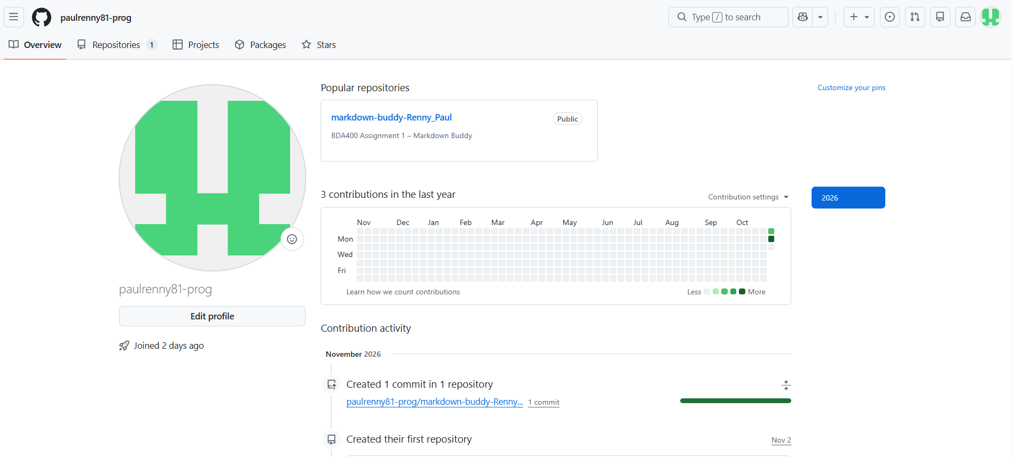
GitHub account created – profile page for paulrenny81-prog
Figure 1: GitHub account created – profile page for paulrenny81-prog

1.2 Installing and configuring Git
- Downloaded Git from https://git-scm.com/downloads following the guide at https://github.com/git-guides/install-git.
- Ran the installer with the default options.
- Opened a terminal (Git Bash) and confirmed the installation and set my identity:
git --version
git config --global user.name "Paul Renny"
git config --global user.email "your-email@example.com"

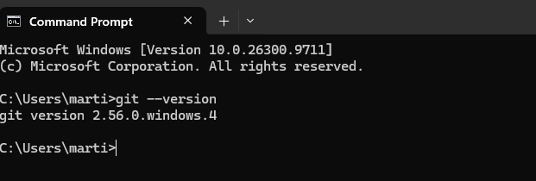 Git installed – output of git --version and git config
Figure 2: Git installed – output of git --version and git config

1.3 Creating the TechnicalAnalysis repository
- On GitHub, clicked New (the + icon, then New repository).
- Named the repository TechnicalAnalysis, set it to Public, ticked Add a README file and clicked Create repository.
- Cloned the repository to my PC and created one subfolder per assignment:
git clone https://github.com/paulrenny81-prog/TechnicalAnalysis.git
cd TechnicalAnalysis
mkdir A02

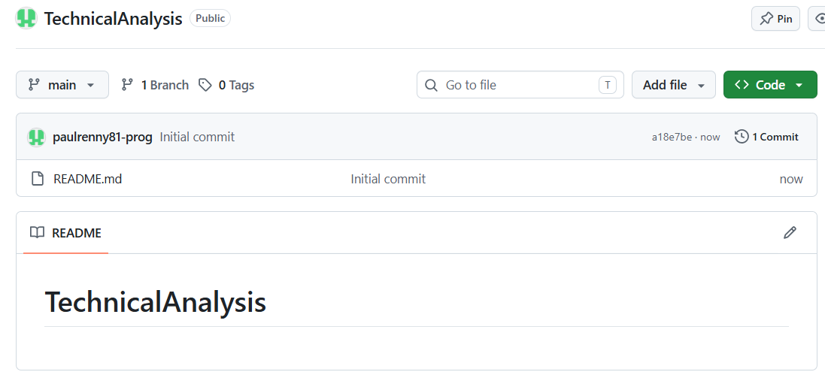
New repository form with the name TechnicalAnalysis
Figure 3: New repository form with the name TechnicalAnalysis
[ Insert screenshot here ]
TechnicalAnalysis repository page on GitHub
Figure 4: TechnicalAnalysis repository page on GitHub
Repository structure: each assignment has its own folder, as required.
TechnicalAnalysis/
├── README.md
└── A02/
├── portfolio.txt
├── technical_analysis.R
├── portfolio_statistics.csv
└── Renny_Paul_BDA400_A02.docx

2. Installing and Configuring R and RStudio

2.1 Installing R
- Went to https://cran.rstudio.com/ and chose the download for my operating system (Windows: Download R for Windows → base → Download R-4.x.x for Windows).
- Ran the installer, accepted the licence, kept the default install location and components, and clicked Finish.
[ Insert screenshot here ]
CRAN download page for R
Figure 5: CRAN download page for R
[ Insert screenshot here ]
R installer – setup wizard
Figure 6: R installer – setup wizard
[ Insert screenshot here ]
R installation completed
Figure 7: R installation completed

2.2 Installing RStudio
- Went to https://posit.co/download/rstudio-desktop/ and downloaded RStudio Desktop.
- Ran the installer with the default settings.
- Opened RStudio and confirmed it detected R by checking the version in the Console:
R.version.string

[ Insert screenshot here ]
RStudio download page
Figure 8: RStudio download page
[ Insert screenshot here ]
RStudio open with the R version shown in the Console
Figure 9: RStudio open with the R version shown in the Console

3. Installing R Packages for Technical Analysis
The following packages were installed from CRAN with install.packages():
Package | Purpose
quantmod | Downloads stock price data (getSymbols) and draws financial charts (chartSeries).
TTR | Technical Trading Rules – indicators such as the simple moving average (SMA).
xts | Extensible time series objects that quantmod returns price data in.
zoo | Ordered time series functions that xts is built on.

install.packages(c("quantmod", "TTR", "xts", "zoo"))
library(quantmod)
library(TTR)

In the script, a helper function install_if_missing() installs only the packages that are not already present and then loads all of them, so the script can be run on any computer.
[ Insert screenshot here ]
install.packages() running in the RStudio Console
Figure 10: install.packages() running in the RStudio Console
[ Insert screenshot here ]
Packages tab in RStudio showing quantmod and TTR installed
Figure 11: Packages tab in RStudio showing quantmod and TTR installed

4. Project Configuration and Initialization
I created a plain text file named portfolio.txt in the A02 folder (File → New File → Text File in RStudio) and listed one stock symbol per line:
AAPL
MSFT
GOOGL
AMZN
TSLA

The function read_portfolio() reads this file, removes blank lines and spaces, converts symbols to upper case and drops duplicates, so the portfolio can be changed just by editing the text file.
[ Insert screenshot here ]
portfolio.txt open in RStudio
Figure 12: portfolio.txt open in RStudio

5. Function to Import and Load Stock Data
load_stock_data() reads portfolio.txt and downloads one year of daily prices for each symbol from Yahoo Finance using quantmod::getSymbols(). Each result is converted into its own data frame with columns Date, Open, High, Low, Close, Volume and Adjusted. If a symbol cannot be downloaded the function shows a warning and continues with the others.
load_stock_data <- function(file = PORTFOLIO_FILE,
from = START_DATE, to = END_DATE) {
symbols <- read_portfolio(file)
stock_list <- list()
for (sym in symbols) {
result <- tryCatch(
getSymbols(sym, src = "yahoo", from = from, to = to,
auto.assign = FALSE),
error = function(e) { warning("Could not download ", sym); NULL })
if (is.null(result)) next
df <- data.frame(Date = index(result), coredata(result))
names(df) <- c("Date","Open","High","Low","Close","Volume","Adjusted")
stock_list[[sym]] <- df
}
stock_list
}

After loading, each stock is also stored as a separate data frame in the environment (AAPL_df, MSFT_df, GOOGL_df, AMZN_df, TSLA_df).
[ Insert screenshot here ]
Console output of load_stock_data() and the data frames in the Environment pane
Figure 13: Console output of load_stock_data() and the data frames in the Environment pane

6. Functions to Compute Basic Statistics
calculate_statistics() takes one stock's data frame and calculates the statistics on the closing price. calculate_all_statistics() runs it for every stock and combines the results into one summary data frame.
Statistic | R function | Meaning
Moving average | TTR::SMA(Close, n = 20) | Average of the last 20 closing prices; smooths daily noise to show the trend.
Mean | mean() | Average closing price over the year.
Median | median() | Middle closing price; less affected by extreme days.
Mode | calc_mode() (custom) | Most frequent closing price, rounded to the cent.
Standard deviation | sd() | How much prices spread around the mean – a simple measure of volatility.

Base R does not include a function for the statistical mode, so I wrote calc_mode(). Prices are rounded to two decimals so repeated values can be counted:
calc_mode <- function(x, digits = 2) {
x <- round(x[!is.na(x)], digits)
tab <- table(x)
as.numeric(names(tab)[which.max(tab)])
}

The results are stored in a structured list: stats$summary holds one row of statistics per stock, and stats$data holds each stock's data frame with the new SMA_20 column. The summary is also saved to portfolio_statistics.csv.
[ Insert screenshot here ]
Statistics summary table printed in the Console
Figure 14: Statistics summary table printed in the Console

7. Utilities to Display Output
To present the data in several of the ways used on Yahoo Finance, I wrote these display functions:
Function | Output
display_stock_data() | First and last 5 rows of each stock's data frame, with the number of trading days and date range.
display_quote_summary() | Yahoo-style quote card: last close, daily change and % change, open, high, low, volume and 52-week range.
display_statistics() | The combined statistics table for the whole portfolio.
plot_price_with_ma() | Line chart of the closing price with the 20-day moving average and the mean.
plot_statistics_comparison() | Bar charts comparing mean price and standard deviation across the stocks.
plot_candlestick() | quantmod candlestick chart with volume and moving average.

[ Insert screenshot here ]
display_stock_data() output for one stock
Figure 15: display_stock_data() output for one stock
[ Insert screenshot here ]
display_quote_summary() output for the portfolio
Figure 16: display_quote_summary() output for the portfolio
[ Insert screenshot here ]
Close price with 20-day SMA chart (e.g. AAPL)
Figure 17: Close price with 20-day SMA chart (e.g. AAPL)
[ Insert screenshot here ]
Mean price and standard deviation comparison bar charts
Figure 18: Mean price and standard deviation comparison bar charts
[ Insert screenshot here ]
Candlestick chart with volume (e.g. MSFT)
Figure 19: Candlestick chart with volume (e.g. MSFT)

8. Uploading to GitHub
All files for this assignment were placed in the A02 folder and pushed to the repository:
git add A02
git commit -m "Assignment 2: technical analysis preliminary stage"
git push origin main

[ Insert screenshot here ]
A02 folder on GitHub showing all assignment files
Figure 20: A02 folder on GitHub showing all assignment files

Conclusion
This stage set up the full working environment for the project: a GitHub repository with a folder per assignment, R and RStudio, and the quantmod and TTR packages. The R script reads the portfolio from a text file, imports a year of price data for every symbol, calculates the moving average, mean, median, mode and standard deviation, and displays the results as tables and charts. These functions will be reused and extended with further technical indicators in the next two stages.

References
- CRAN. (n.d.). R Installation and Administration – Installing packages. https://cran.rstudio.com/doc/manuals/r-release/R-admin.html
- GitHub Docs. (n.d.). Set up Git. https://docs.github.com/en/get-started/quickstart/set-up-git
- Ryan, J. A., & Ulrich, J. M. quantmod: Quantitative Financial Modelling Framework. R package. https://CRAN.R-project.org/package=quantmod
- Ulrich, J. TTR: Technical Trading Rules. R package. https://CRAN.R-project.org/package=TTR
- Yahoo Finance. https://finance.yahoo.com/

GitHub repository: https://github.com/paulrenny81-prog/TechnicalAnalysis

