**Android Application Documentation and Basic Details**

Name: Paul Richie Gomes

ID: 16101284

CSE491

Semester: Summer2019

Project: TravelBus

**A. Documentation:** The android application TravelBus is based on the concept of booking for a bus.

**B.** **Basic Work Flow:**

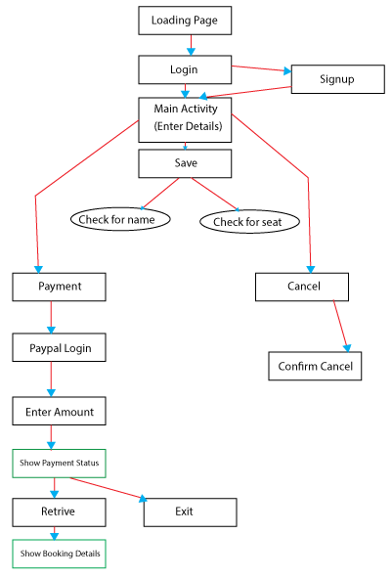

**C. ScreenShots of App:** ScreenShots are provided in the folder.

**D. Details:** In this app at first there is loading page which takes it to the Login page. In the login page there is field for email and password. Upon clicking Login user goes to MainActivity. If a user is not registered for the app then upon clicking signup page he can go to Sign up page and fill out the fields email, password and confirm password. Upon entering SIGNUP on sign up user gets registered through firebase email authentication and goes to MainActivity.

**MainActicity:** In MainActivity at first there is a name and phone number field which is for entering name against which booking will be done. Show Calendar takes to DatePicker which provides the user the need to see calendar for booking convenience.

Spinner is used in From,To,Date,Time & Seat. Spinner values are stored in Strings.xml. In from field if the user selects **Dhaka** then in “To” spinner **Dhak**a will not show up. If the user selects **Barisal** in from then it will not be shown in “To” spinner. In “Date” Spinner, when a user selects a date seat number changes in “Seat” spinner according to the selection of “Date” spinner. Upon clicking save, If a seat is already selected then it uses query in firebase to check if the seat is already taken. If it is taken it shows “Seat taken” others “successful” toast & if name is not provided it will show “You did not enter a username”.

1. Cancel: cancel button takes to a activity where user gives his username and upon selecting confirm cancellation the node in the firebase will be deleted against the provided name through query.
2. Payment: Upon Selecting Payment user will go to paypal login page, then after logging in by entering payment amount user can pay which will then show payment details and Retrive and Exit page.
3. Google Maps: Upon pressing the button the user can directly go to google maps from app

**Retrive:** Upon clicking retrieve user will get firebase details of booking in listview

**Exit:** Upon clicking exit the user will exit the application.

**E. Dependencies Used:**

implementation fileTree(dir: 'libs', include: ['*.jar'])  
 implementation 'com.paypal.sdk:paypal-android-sdk:2.15.3'  
 implementation 'androidx.appcompat:appcompat:1.0.2'  
 implementation 'com.squareup:android-times-square:1.6.5@aar'  
 implementation 'androidx.constraintlayout:constraintlayout:1.1.3'  
 implementation 'com.google.firebase:firebase-auth:16.0.5'  
 implementation 'com.google.firebase:firebase-database:16.0.4'  
 testImplementation 'junit:junit:4.12'  
 androidTestImplementation 'androidx.test:runner:1.2.0'  
 androidTestImplementation 'androidx.test.espresso:espresso-core:3.2.0'  
 implementation 'com.google.android.material:material:1.0.0'  
}

**F. Import Used:**

import android.app.Activity;  
import android.content.Context;  
import android.view.LayoutInflater;  
import android.view.View;  
import android.view.ViewGroup;  
import android.widget.ArrayAdapter;  
import android.widget.TextView;

import android.os.Bundle;  
import android.widget.Toast;  
import com.squareup.timessquare.CalendarPickerView;  
import java.util.Calendar;  
import java.util.Date;

import android.view.WindowManager;  
import android.widget.ProgressBar;

import androidx.annotation.NonNull;  
import androidx.appcompat.app.AppCompatActivity;  
import android.content.Intent;  
import android.text.TextUtils;  
import android.widget.Button;  
import android.widget.EditText;

import android.widget.AdapterView;  
import android.widget.ArrayAdapter;

import android.widget.Spinner;

import com.google.firebase.database.DataSnapshot;  
import com.google.firebase.database.DatabaseError;  
import com.google.firebase.database.DatabaseReference;  
import com.google.firebase.database.FirebaseDatabase;  
import com.google.firebase.database.Query;  
import com.google.firebase.database.ValueEventListener;

import org.json.JSONException;  
import org.json.JSONObject;

import com.paypal.android.sdk.payments.PayPalConfiguration;  
import com.paypal.android.sdk.payments.PayPalPayment;  
import com.paypal.android.sdk.payments.PayPalService;  
import com.paypal.android.sdk.payments.PaymentActivity;  
import com.paypal.android.sdk.payments.PaymentConfirmation;

import android.view.animation.Animation;  
import android.view.animation.Transformation;

import com.google.android.gms.tasks.OnCompleteListener;  
import com.google.android.gms.tasks.Task;  
import com.google.firebase.auth.AuthResult;  
import com.google.firebase.auth.FirebaseAuth;

import android.net.Uri;

**G. Java Classes:**

i. Sign.java=Sign Up

ii. Login.java=Login

iii. MainActivity.java=Booking information selection

iv. Load.java= loading page

Progress.java=loading page

v. Retrieving Information and get set

Adapter.java

Members.java

SecondActivity.java

vi. ThirdActivity.java= Cancel

vii. Paypal.java=paypal

PaymentDetails.java=paypa**l**

**H. Problems which were encountered:**

Solved Problems: Sending spinner values to database, Retrieving values from database, use query to check existing database, paypal authentication, sandbox system

Remaining Problems:

1. Cannot select specific seats based on specific dates and problem in giving a limit of dates the user can select
2. Cannot refund directly to account with paypal. Therefore, toast shown “We will contact you for refund”

**I. Scope for Future Improvements:**

a. sending email to confirm booking

b. make particular options for train booking

c. use google maps to show navigation of source and destination

d. use phone call option to call