Paul Romer

CSD340

Module 5 Assignment

bioSite

Subject: Ericka Romer, My Wife

**Interview Questions**:

1. Tell me a little bit about your background and how you ended up where you are today?

Born and raised in Northern California. Started photography and art as a teenager. Some college at BYU-I which led to us meeting a few years later. Loves animals.

1. What are some of your favorite hobbies or activities to do in your free time?

Watching tv shows and movies, photography, art (painting & furniture restauration), playing with the dogs, and fishing.

1. Are there any specific interests or passions that you're particularly proud of?

Photography, art, and cooking.

1. Can you describe your current job or role, and what you enjoy most about it?

Photographer and Business Owner. Bringing joy to people by showing their beauty in pictures.

1. What are your long-term career goals, and how do you see yourself growing in the next 5-10 years?

Buy a house. Continue photography, art, furniture restoration, and start gardening.

1. How do you like to relax and unwind?

Watch a favorite movie with a nice blanket with family.

1. What is your favorite tradition?

Birthday dinner at Joe’s Crab Shack with Family.

1. What's the most rewarding part of running your own photography business

Creatively bringing out the beauty in things. Being in nature and seeing the joy on clients faces when they love their pictures.

1. What's your favorite dish to cook, and why?

Cinnamon Pie, because it’s yummy and reminds her of the comfort of watching one of her favorite TV shows, Psych.

1. If you could travel anywhere in the world for a photography project or assignment, where would you go and what would you hope to capture?

The migration of the monarch butterflies in central Mexico.

**Bio (250 words)**:

Ericka is gifted with an eye for beauty. She is a talented photographer, cook, artist, and business owner. Born and raised in Northern California, Ericka spent her childhood surrounded by the natural beauty of the region, often capturing it through her camera. During this time, she developed a passion and talent for art, photography, and cooking.

Today, she shares those talents through her photography business, Honey West Co. As a photographer, she enjoys when she delivers pictures that bring out the best in people and loves to see the joy on their faces when they see their photos. Her favorite shoots are stylized shoots, where she can bring out the beauty in subject and nature while expressing her creative side. Her bucket list shoot is to photograph the Monarch butterfly migration in central Mexico.

Alongside her business as a photographer, Ericka enjoys art, furniture restauration, and cooking. In the next 5-10 years, she hopes to buy a house where she can continue to develop and share her artistic talents. She hopes to have a garden, some small animals, and areas she can make own. Beautiful and comfortable locations to gather with family and friends. In her free time, she loves a good movie or TV show. There are many favorite dishes in Ericka’s house. Inspired by one of her favorite TV shows, Psych, her favorite dish to cook is Cinnamon Pie. She says that it is her favorite because it’s a perfect combo of comforting and delicious. The perfect relaxing evening is one with family, a big blanket, her favorite movie, and a delicious piece of Cinnamon Pie.

**Wireframe**:

**Style Guide**:

Color Palette

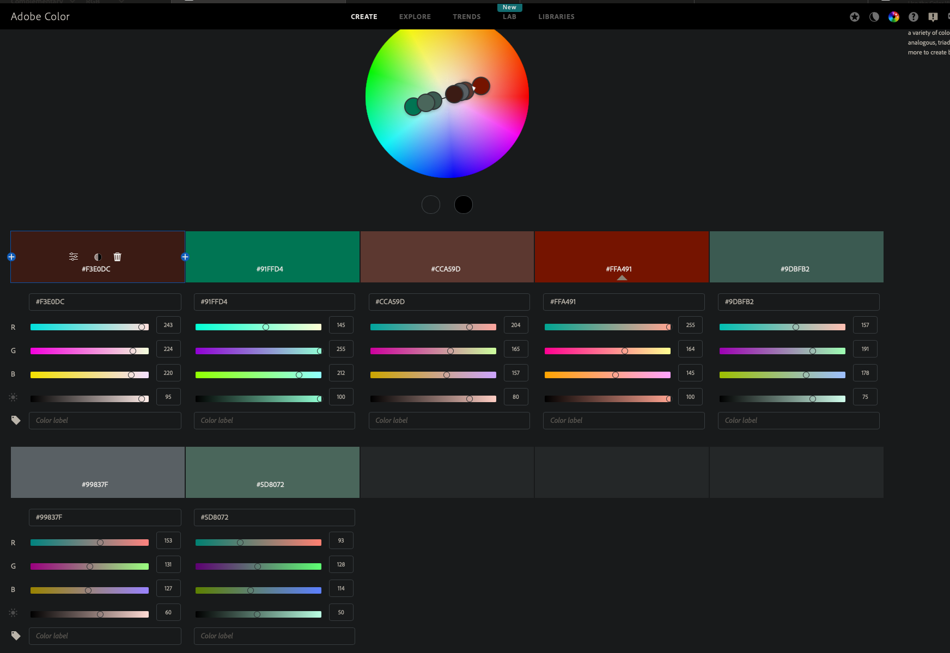

<https://color.adobe.com/create/color-wheel>

Atomic Level

**1. Colors**

* Background Color: #5D8072 (Green/Grey).
* Primary Font Color: #FBE9D0
* Link Color:
* Content Container Color: #CCA59D

**2. Typography**

* Font-Family: Verdana
* TypeScale:
* h1: 36px, bold
* h2: 24px, bold
* h3: 18px, bold
* p: 16px, regular
* LineHeight: 1.5
* LetterSpacing: Adjust slightly for headers, e.g., 0.02em.

**3. Spacing**

* Padding: 20px for headers and footers.
* Use a spacing scale, such as 4px, 8px, 16px, 32px for consistency.

**4. Images**

* BorderRadius: 5px.
* Border: 1px solid #ccc.
* BoxShadow: 0 2px 4px #0000001a.

**5. Lists**

* UnorderedLists: list-style-type: circle;

**6. Horizontal Rule**

* Height: 4px.
* Background Color: #CCA59D.

**7. Hover States**

* Links**:**

**Other Design Tokens**

Consider defining hover states (e.g., darken the primary color by 10% for links or buttons).

Primary Color: #5D8072 Green/Grey

Font: Verdana

Header Font Sizes

* h1: 36px, bold
* h2: 24px, bold
* h3: 18px, bold

Paragraph

* p: 16px, regular

Header and Footer Padding: 20px

Unordered List: list-style-type: circle;

Horizontal Rule:

* hr:  height: 4px;
* background-color: #CCA59D;

Images:

* border-radius: 5px;
* border: 1px solid #ccc;
* box-shadow: 0 2px 4px #0000001a

**7-10 images**: related to the subject's story, including 3 hobby-related images, 3 goal-related images, and 1 portrait image.