CSD 460

Group 4

William Renard

Julie Sakai

Tazmin Somerville

Tatiana Tan

Paul Romer

Module 5 Assignment

Moffat Bay: Database Dev Assignment

Moffat Bay and User Tables:

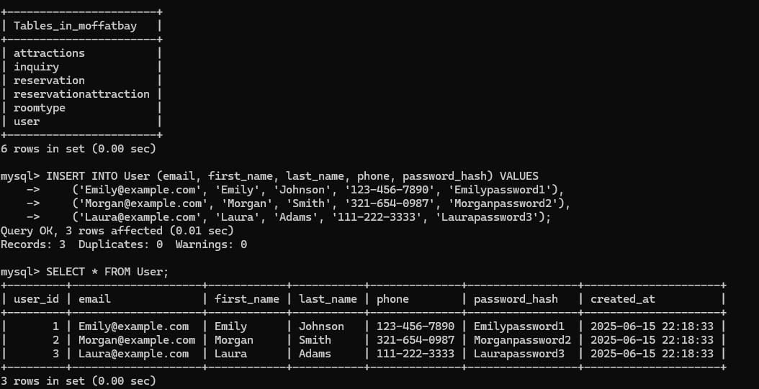

Inquiry Table:

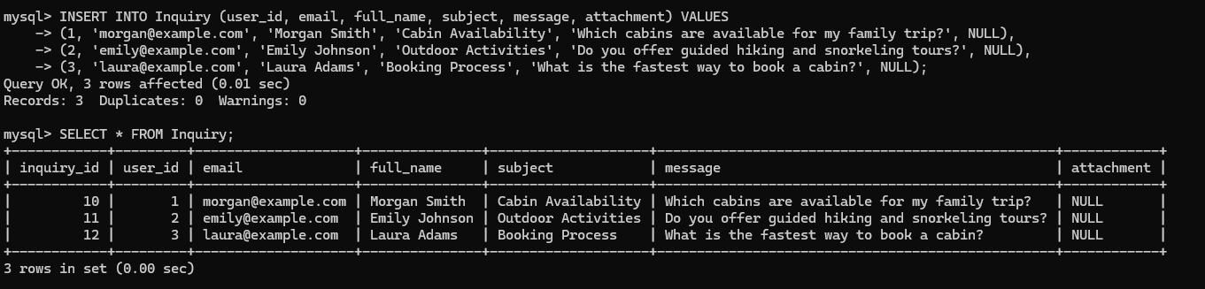

RoomType Table:

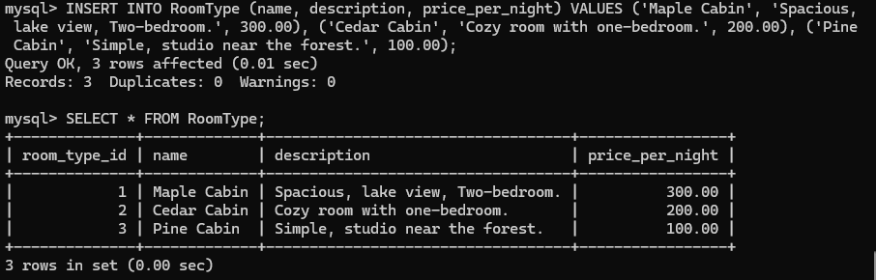

Reservation Table:

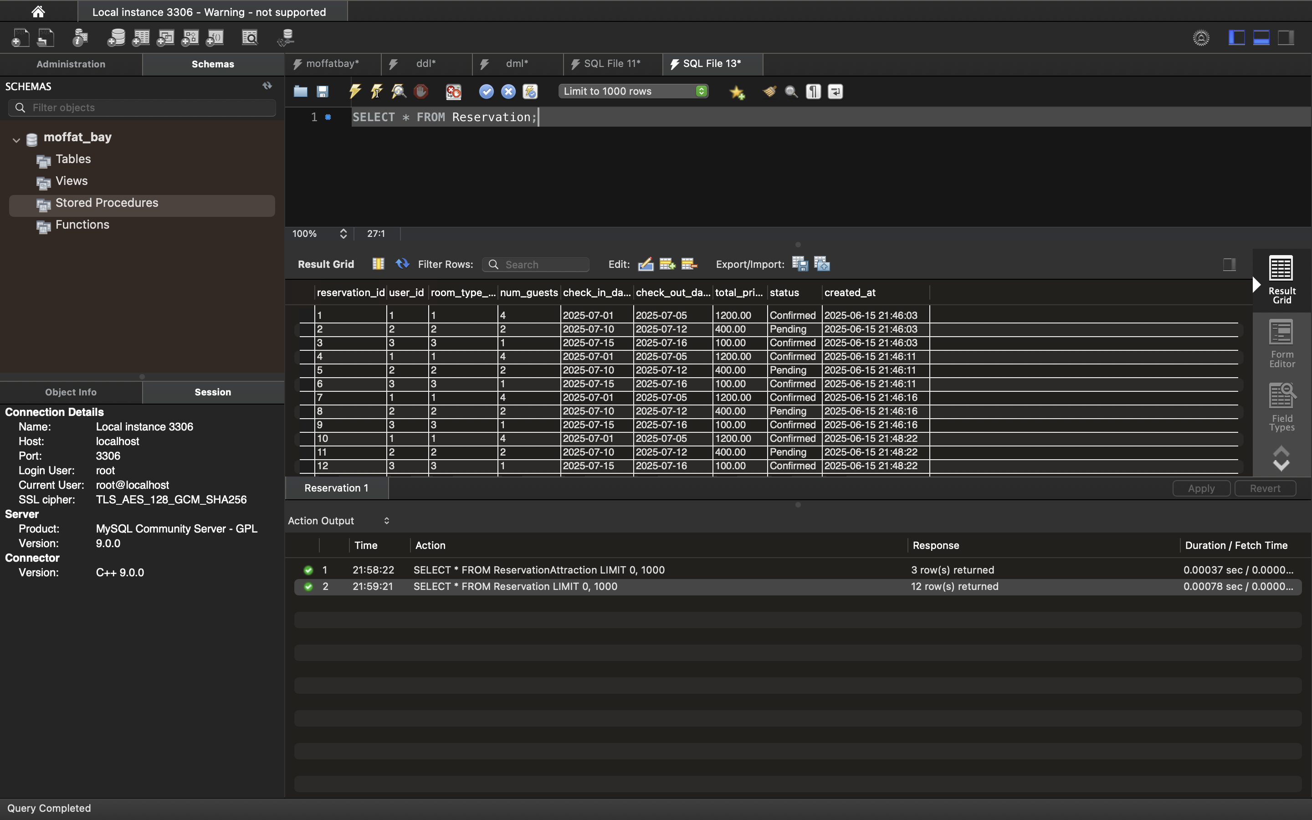

Attraction Table:

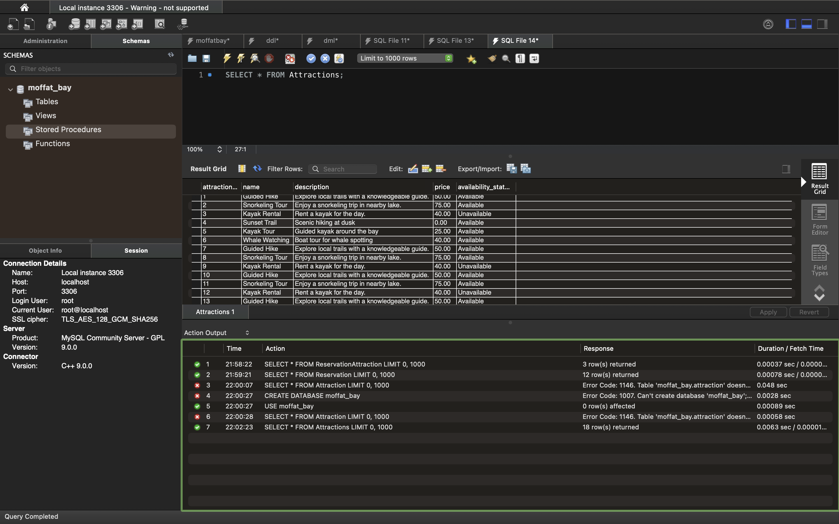

Reservation Attraction Table:

