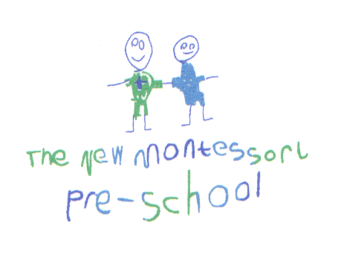CHARITY NUMBER 1086853 | Sponsored Wheels Event | 
 | CHILD’S NAME:

In order to raise money for the New Montessori Pre-School the Management Committee, Fundraising Team and staff are joining the parents and children for their annual Sponsored Wheels Event. All monies raised will be used to purchase and replace equipment and materials for our pre- school. Thank you for your donation.

SPONSORS: There is a way of increasing your donations at no extra cost to you. Under Gift Aid we can reclaim 28p of tax for every £1 that you give. To qualify you must pay enough UK Tax to cover the amount reclaimed. If you have not completed a Gift Aid form do please ask for one.
Please put your sponsor’s name, address, and postcode, tick the Gift Aid column and date the “Gift Aid” column. Thank you. |  |  |  | GIFT AID
NAME | ADDRESS  (include postcode please) | AMOUNT | PAID | TICK | DATE
TOTAL COLLECTED : £

