1) Probate_Letter_Generator.xls requires Macros. After opening select Enable Macros
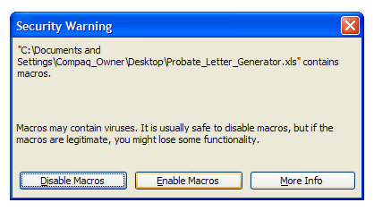

2) The spreadsheet has two tabs.

- Letter Generator – Orchestrates the contents of the letter
- Data Sheet – Stores address, names, property info, etc.

You can toggle between these two sheets by selecting the tabs:

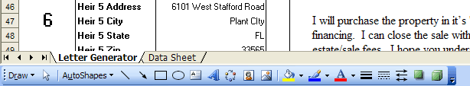

Or by pushing the buttons on the top of each sheet:

3) The Data Sheet

The Data Sheet stores the information that feeds the Letter Generator sheet. It is important that you do not modify the layout of this sheet.

The fields and examples (required fields are in blue):

Case #: 2007-02952
Case Type: Formal Administration
Property Type: Single Family
Personal Rep: Debbie Mae Paloma Ho
Rep Address: 5138 Sterling Manor Drive
Rep City: Tampa
Rep State: FL
Rep Zip: 33647
Attorney: Andrew P. Trakas
Attorney Address: PO Drawer 1121
Attorney City: Winter Haven
Attorney State: FL
Attorney Zip: 33882
Decedent: Guy H. Ball
Property Address: 700 Oleander Drive SE
Property City: Winter Haven
Property State: FL
Property Zip: 33880
Heir 1: Brian H. Ball
Heir 1 Address: 700 Oleander Drive SE
Heir 1 City: Winter Haven
Heir 1 State: FL
Heir 1 Zip: 33880
Heir 2: Lance G. Ball
Heir 2 Address: 700 Oleander Drive SE
Heir 2 City: Winter Haven
Heir 2 State: FL
Heir 2 Zip: 33880
Heir 3: Henrietta Miller
Heir 3 Address: 141 Briarcliff Drive
Heir 3 City: Orlando
Heir 3 State: FL
Heir 3 Zip: 32806
Heir 4: Sally I. Simon-Wright
Heir 4 Address: 6534 Donahoo Road
Heir 4 City: Kansas City
Heir 4 State: KS
Heir 4 Zip: 66104
Heir 5: Lynda Fuller
Heir 5 Address: 6101 West Stafford Road
Heir 5 City: Plant CIty
Heir 5 State: FL
Heir 5 Zip: 33565
Total Assessment: $60,499

4) The Letter Generator

Once your data is entered or imported into the Data Sheet, it is time to generate a letter. There are 6 steps:

- Step 1: Select a record number. Corresponds to column A on the Data Sheet
- Step 2: Enter the Date of the letter.
- Step 3: Select who this instance of the letter should be addressed to.
- Step 4: Select who should be CCed on this instance of the letter.
- Step 5: Prepare the Letter. Hit this button to apply your selections to the letter.
- Step 6: Print the Letter. If a letter is part of a campaign consisting of future mailings, change the date in Step 1 and hit the print button again.

All 6 steps are clearly noted in Probate_Letter_Generator.xls and in the below screenshot.
