### Paul Shaw

Dec 1st, 2020

IT FDN 110A

Assignment #8

Assignment #8 - Classes

Introduction

Week 8 modules and chapter 8 added more complexity to programs by working with classes.

Assignment Task

The assignment task was to revise previously written code that would perform the same end task inputting a product and it’s value into a txt file, by using classes.

Proof of Work

Script was developed with the knowledge learned in module 8. The script was started from the Assignment08_starter file and built within the Pycharm program and additionally ran with the Windows command prompt. I also utilized Assignment_06 code for a lot of the main script code/IO code as it was very similar. I was able to find solutions for most code to transfer them to a function setup with the aid of the course material. The code was ran in both the command prompt and PyCharm and worked well.

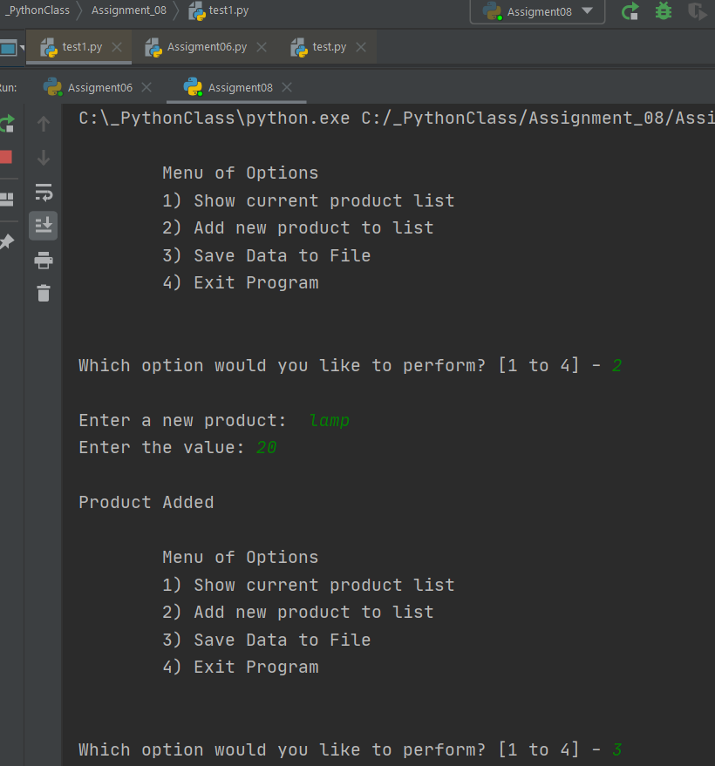

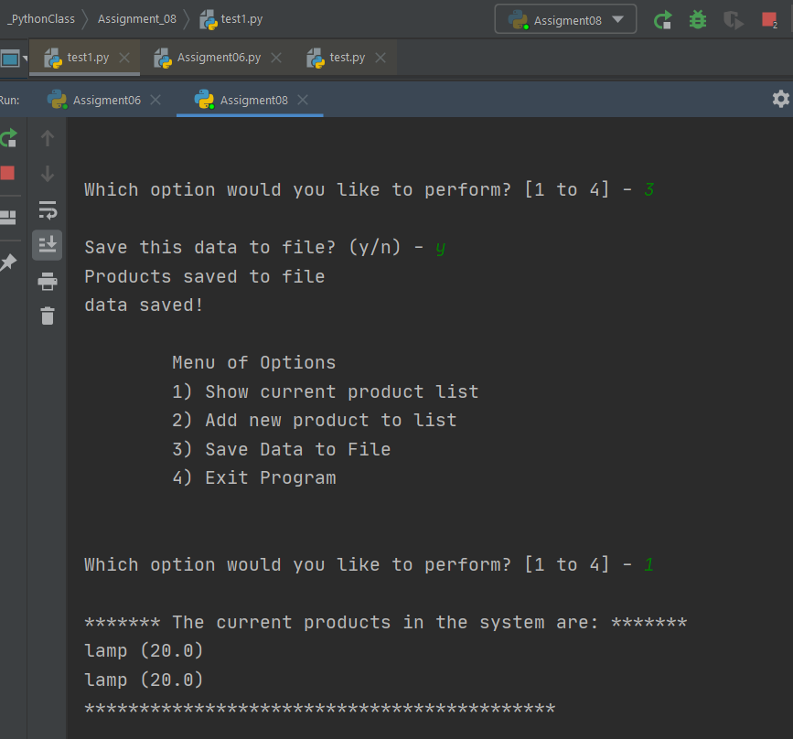

Figure 1: PyCharm Execution

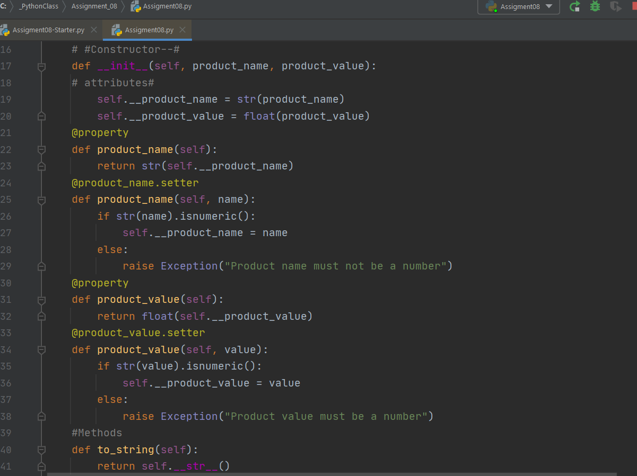

Figure 2: Clips from pycharm code

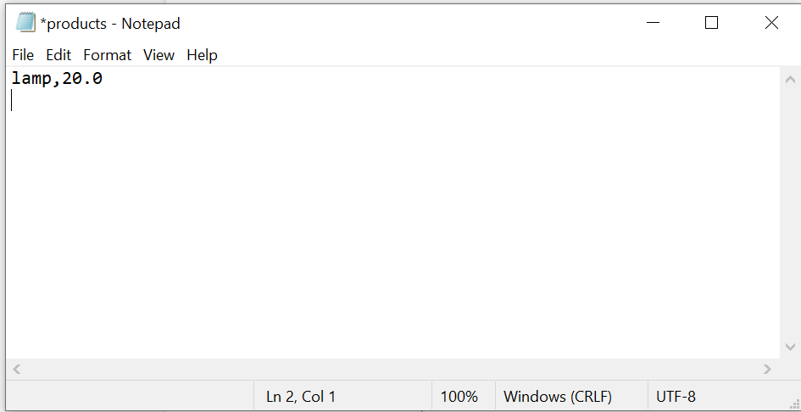

Figure 3: Updated txt file from input

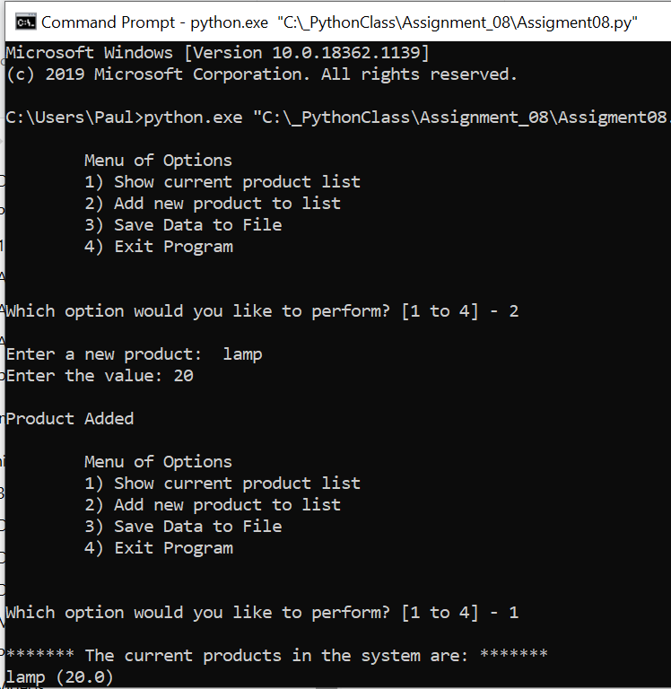

Figure 4: Executing properly within command prompt.

Summary

As shown the code completed the task.