### Paul Shaw

November 24th, 2020

IT FDN 110A

Assignment #6

Assignment #6 - Task List

Introduction

Week 6 modules and chapter 6 added more complexity by working with functions.

Assignment Task

The assignment task was to revise previously written code that would perform the same end task of inputting a task & priority, however the code would work by using functions.

Proof of Work

Script was developed with the knowledge learned in module 6. The script was started from the Assignment06_starter file and built within the Pycharm program and additionally ran with the Windows command prompt. I was able to find solutions for most code to transfer them to a function setup with the aid of the course material. Unfortunately I ran into some errors working the option 2 - remove an item code; I simply wasn’t able to code this to work. All other functionality however worked well, and all script was updated to act within a function where possible. I was also able to run the program in both pycharm and a command shell, however I had specifically identified the location of the ToDoFile.txt, otherwise an error would generate. Some help with this would be greatly appreciated, I think there’s an issue with the PATH.

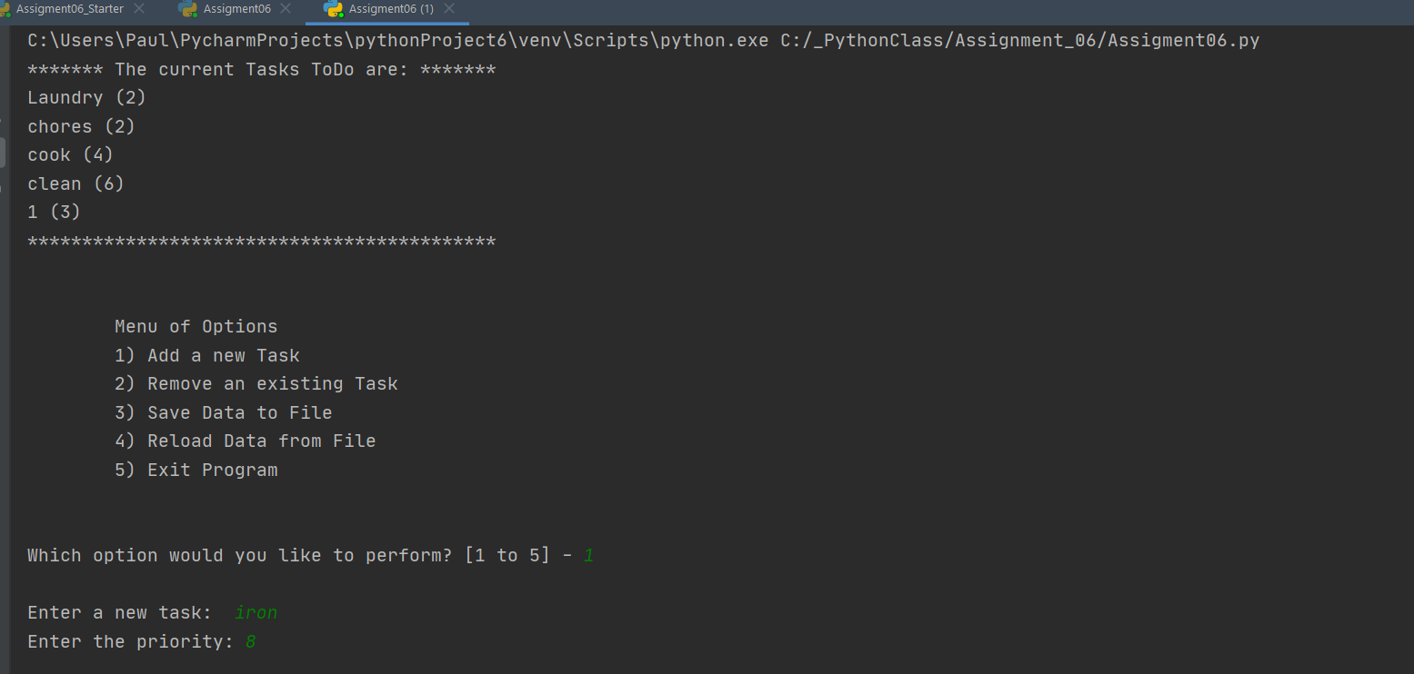

Figure 1: PyCharm Execution

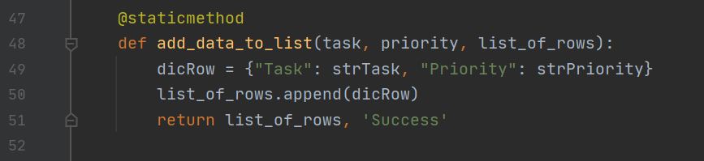

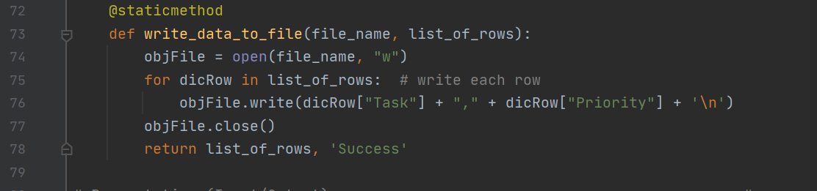

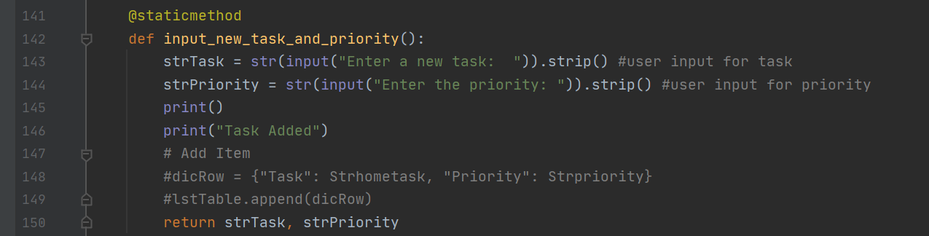

Figure 2: Clips from pycharm code

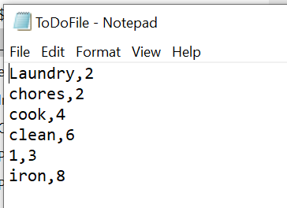

Figure 3: Updated txt file from input

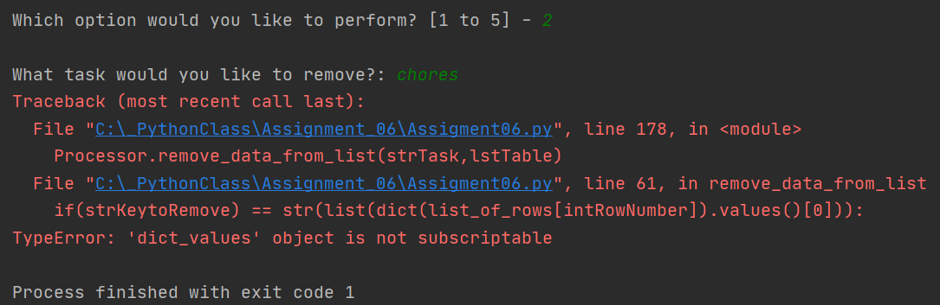

Figure 4: Option 2 generates error when removing item.

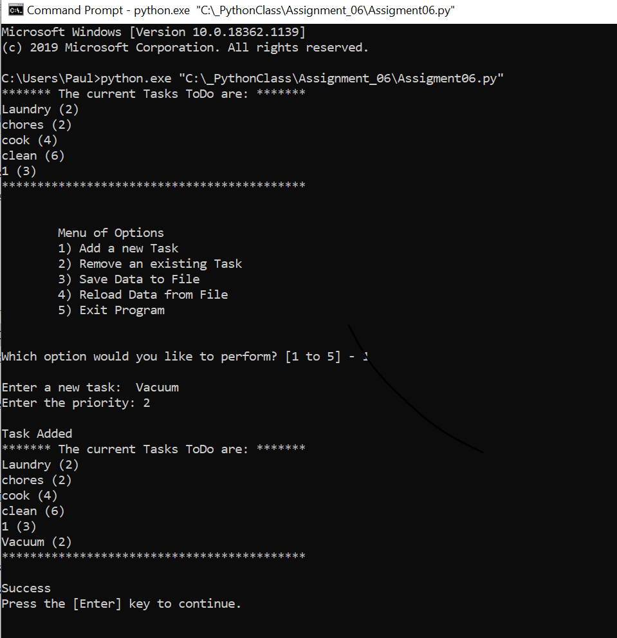

Figure 5: command shell executing properly

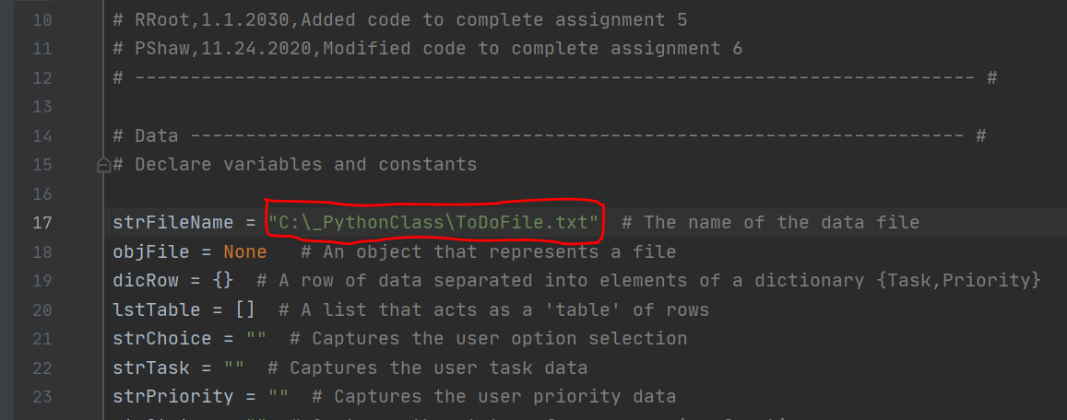

Figure 6: Had to convert file directory from generalized to specific path to get command shell to function.

Figure 6: Clips of pycharm code

Summary

As shown in the figures there were some errors generated with my code and I was unable to successfully complete the assignment. I am also confused with the command prompt error as I set up the relative file location exactly how Dr. Root had done in the module, which gave me some confusion.