### Paul Shaw

Dec 1st, 2020

IT FDN 110A

Assignment #7

Assignment #7 - Pickling, Try & Except

Introduction

Week 7 modules and chapter 7 added more complexity to programs by working with pickling and.

Assignment Task

The assignment task was to revise previously written code that would perform the same end task of saving data to a file as a pickled format, and reloading it from the pickled format. Additionally a short example was created on how to execute a try & except operation.

Proof of Work

Script was developed with the knowledge learned in module 7. The script was started from the Assignment07_starter file and built within the Pycharm program and additionally ran with the Windows command prompt. I was able to find solutions for most code to transfer them to a function setup with the aid of the course material. The code was ran in both the command prompt and PyCharm and worked well. The try and except function also displayed error codes appropriately, as the case when the user inputs a string when it is expecting an interger.

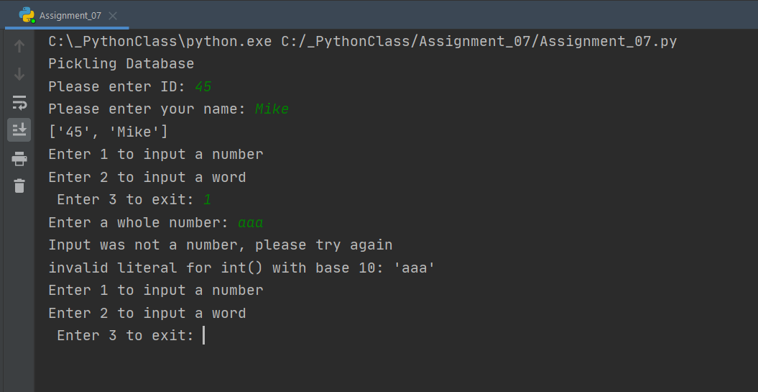

Figure 1: PyCharm Execution(pickling, try & except)

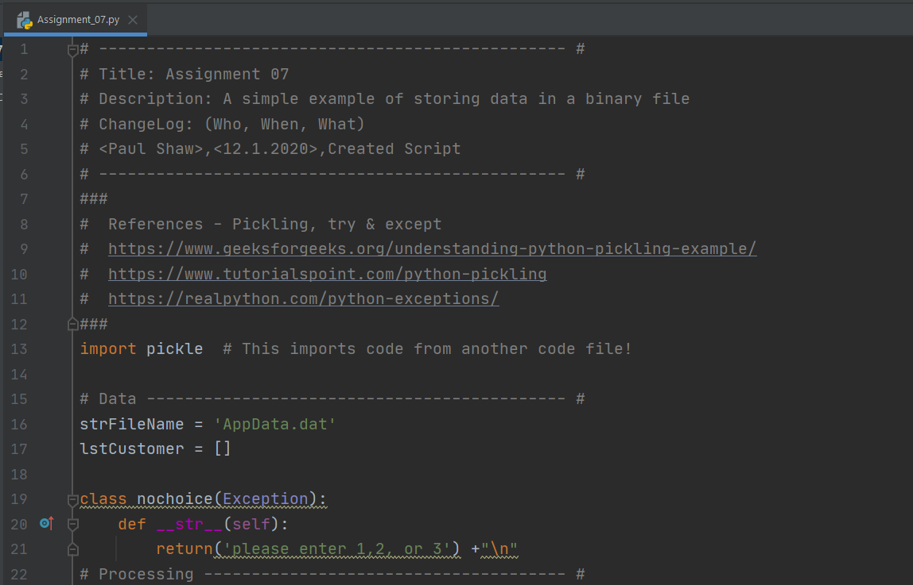

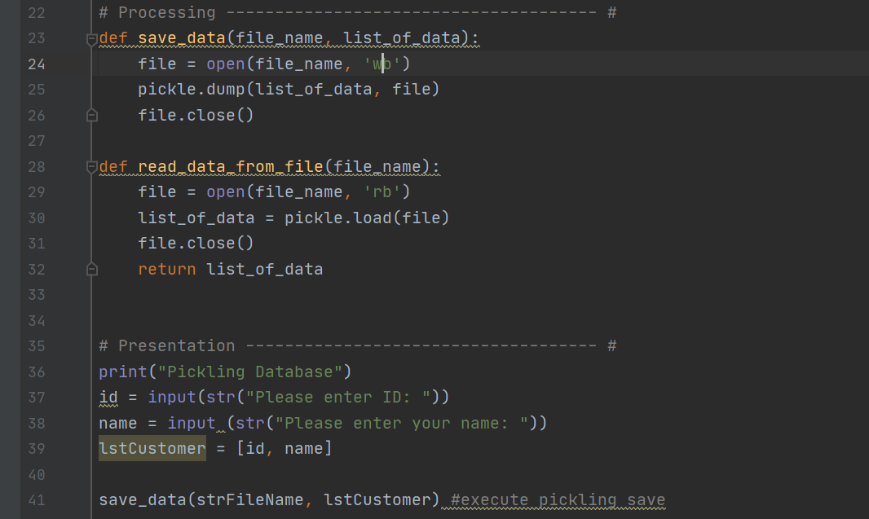

Figure 2: Clips from pycharm code

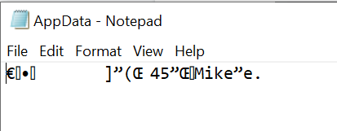

Figure 3: Updated pickled txt file from input

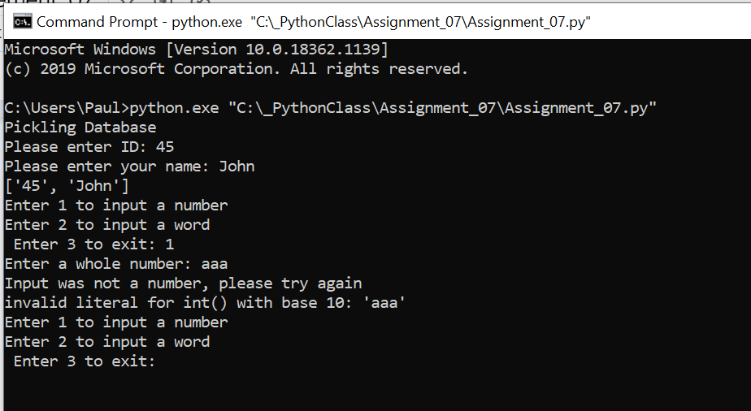

Figure 4: Executing properly within command prompt.

Summary

As shown the code completed the task, albeit in a simplified manner.