Exp. 5 Automatic Night Lamp

Circuit diagram:

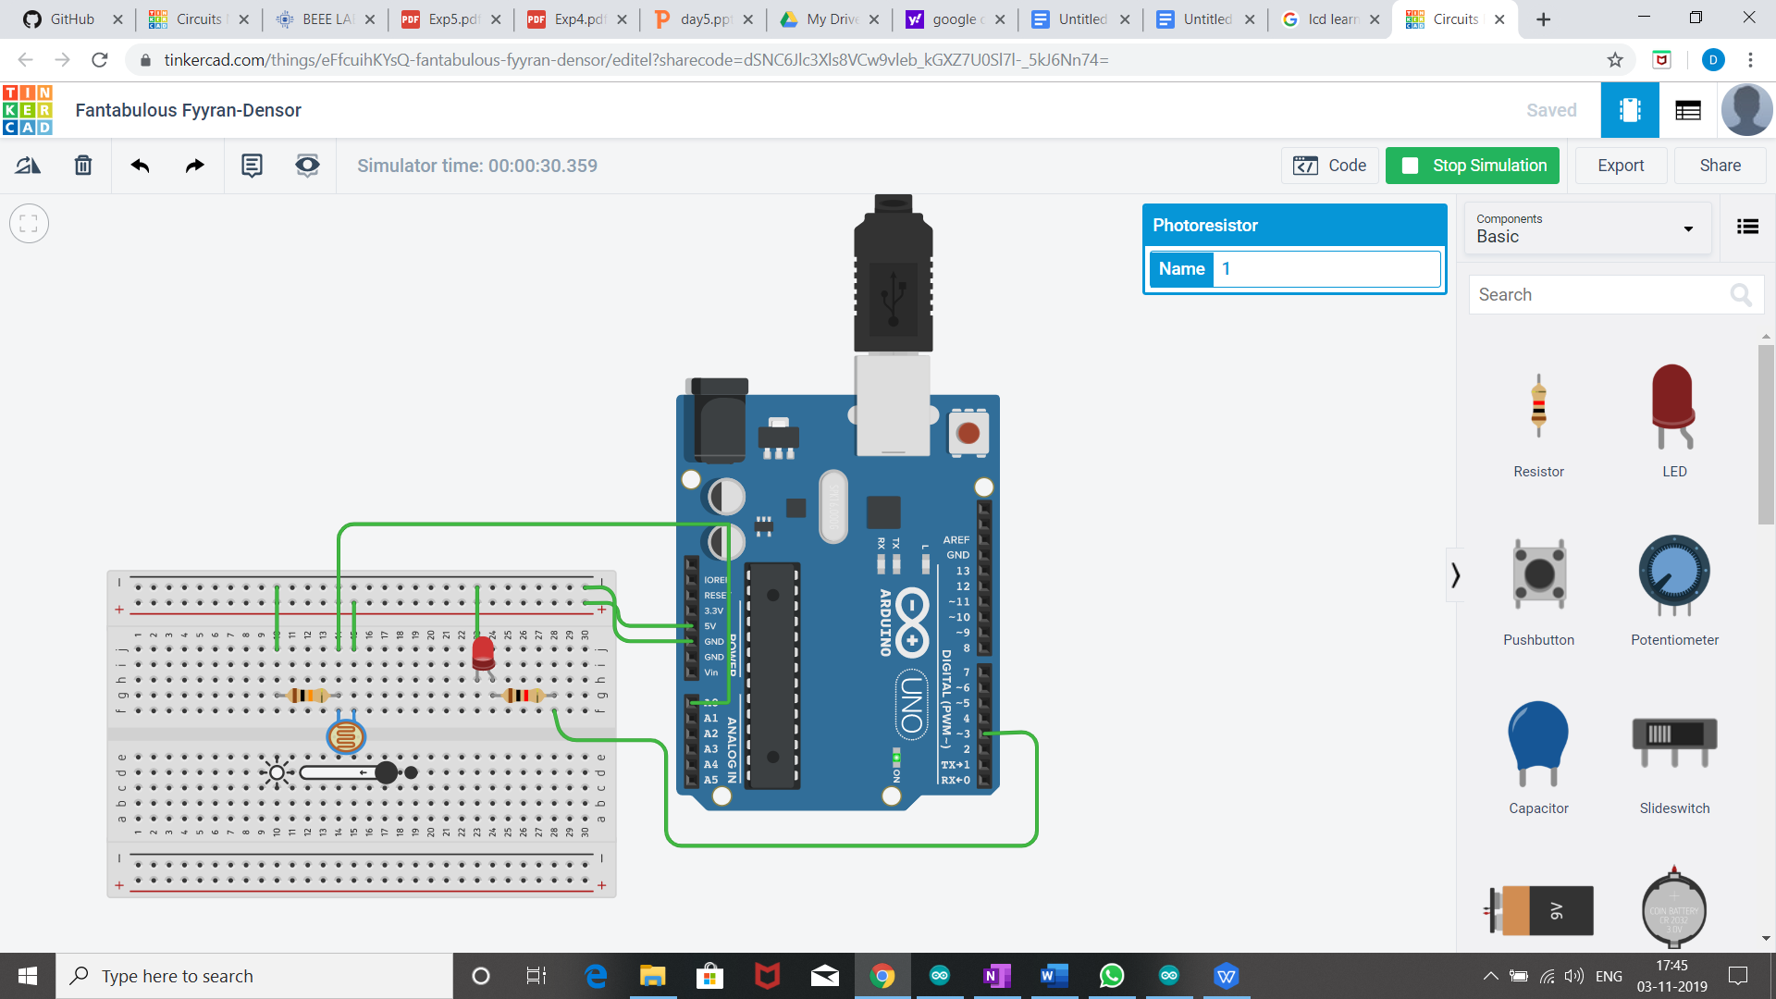

Theory:

Concept used:

* We have used the concept of LDR(light dependent resistor).
* The LDR is a special type of resistor which allows a lower voltage to pass through it (high resistance) whenever its dark and higher voltages to pass (low resistance) whenever there is a high intensity of light.
* A photoresistor can be applied in light-sensitive detector circuits , and light -activated and dark -activated switching circuits.

Learning and observations:

* Resistance is inversely proportional to incdent light intensity.
* In dark,resistance become less and LED glows brighter and in light , resistance is more and LED is dimmer.

Problem and troubleshooting:

* Check the range of sensor value for darkness correctly.
* A resistor of proper resistance should be used to avoid fuse.
* Connection should be tight.
* LED should be checked earlier to avoid any error.

Precautions:

* Correct PORT/ Board should be selected.
* LDR should be working properly.
* Resistor should be of suitable value.
* Setup should be kept at dry place.

Learning Outcomes:

* We have learnt the use and function of LDR which is light sensitive resistance.
* 0 to 5 volt is indicate by the sensor value from 0 to 1023.
* How to connect LDR and Arduino using breadboard.