**Notes on Knowledge Propagation**

* Consensus 🡪 Propagation 🡪 State of Knowledge
* Consensus guarantees two things
  + At least one­ learner will learn a value V
  + All other learners which learn a value will learn only V
* In 2 PC:

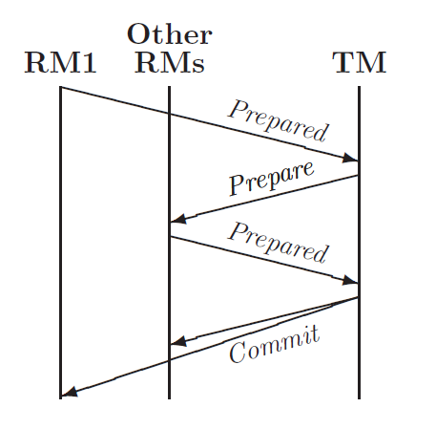

* In our use case, a learner which has learnt a value after consensus behaves as a TM and tries to commit the value to all other learners which behave as RMs
  + There is no RM1
* Just a single round of2PC should be enough because if the TM sends a “commit” message, then it means that all other RMs have agreed to learn the value proposed by the TM. Therefore, any RM should be confident that all other RMs are learning the same value
* However, after consensus, multiple learners may behave as TMs.
  + All TMs will propose the same value
* Therefore, we will propose a version of 2PC that allows progress with multiple TMs
  + Safety is not an issue since all TMs will propose the same value
* No previous work has been done to prove theorems about 2PC’s progress
  + Two papers have model checked