Proposal for Capstone Project 2

Manufacturing is undergoing a major change with Industry 4.0 which refers to the fourth industrial revolution. Industry 4.0 is a trend toward automation and data exchange in manufacturing technologies and processes which includes cyber-physical system (CPS), the internet of things (IoT), industrial internet of things (IIOT), cloud computing and artificial intelligence (Wikipedia) which enables the creation of smart factories. In Industry 4.0, interconnected sensor-enabled equipment is required in smart factories. Sensors continuously generate data for every aspect of the manufacturing process; data that can be collected and analyzed in real time (IVEDIX). Machine Learning is a key component for the predictability of failures of equipment using raw sensor data in a smart factory. The promise of Industry 4.0 is the enhancement of manufacturing productivity which go beyond today’s gains. As the following diagram shows, sensors will play a major role in the push towards manufacturing automation and the smart factory.

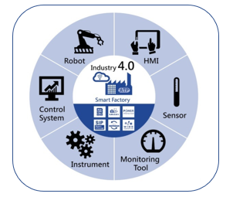

Source: [thingtrax](https://thingtrax.com/2017/10/05/industry-4-0-increases-machine-efficiency/)

In a smart factory, the following depicts the roles of sensors in the smart factory. Sensors that monitor vibration, temperature, acceleration, audio, images and other signals will be used.

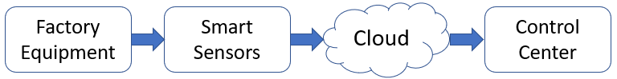

Sensor data is more available than ever. Industry 4.0 refers to the next step in industrial technology, with robotics, computers and equipment becoming connected to the Internet of Things (IoT) and enhanced by machine learning algorithms. With this accessibility, managers, executives and [data scientists](https://towardsdatascience.com/why-data-scientists-will-turn-to-industrial-and-manufacturing-industries-in-the-near-future-6f690e02dfd3) can use that insight to improve the efficiency and productivity of the whole operation. “People are now looking at how to leverage industrial IoT sensor data to project things that may happen - predictive maintenance, line management or quality control” (Tower-Clark)

For this project, I would like to use sensor accelerometer data to predict failures of industrial equipment. Data was created by the Case Western Reserve University containing normal and faulty bearings. Experiments were conducted using a 2 hp Reliance Electric motor, and acceleration data was measured at locations near to and remote from the motor bearings using sensors. Accelerometers were placed on the fan end and drive end of the motor as well as the base part of the motor. Accelerometers were placed at the 12 o’clock position at both the drive end and fan end of the motor housing. Outer raceway faults are stationary faults, therefore placement of the fault relative to the load zone of the bearing has a direct impact on the vibration response of the motor/bearing system. In order to quantify this effect, experiments were conducted for both fan and drive end bearings with outer raceway faults located at 3 o’clock (directly in the load zone), at 6 o’clock (orthogonal to the load zone), and at 12 o’clock. Vibration signals were collected using a 16 channel DAT recorder, and were post processed in a Matlab format (CSEGROUP).

I would like to use classification algorithms and Neural Networks to predict when faults will occur. I will use Neural Networks to create a feature set for the classification algorithms and possibly for predictive results. The following is a diagram of the equipment:

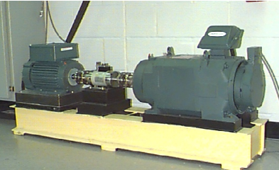

Source: [CSEGROUPS](https://csegroups.case.edu/bearingdatacenter/pages/apparatus-procedures)

Data was collected at 12,000 samples per second. Speed and horsepower data were collected using the torque transducer/encoder and are included in the data. Sensor data was collected for inner raceway outer raceway and ball damage of the bearing assembly. Below is a diagram of a bearing assembly:

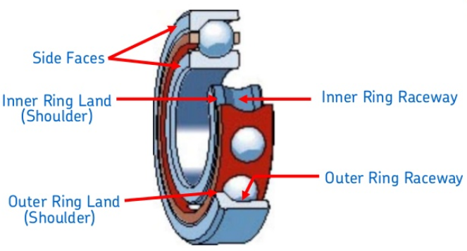

Source: [SKF Bearings](https://www.slideshare.net/NaushadAhamed/bearing-basics-skf)

Various defects were incorporated into the bearings of the motor. Single point faults were introduced to the test bearings using electro-discharge machining with fault diameters of 7 mils, 14 mils, 21 mils and 28 mils for SKF bearings, and data was collected using the accelerometer sensors. Baseline data was also captured at normal operation without defects. Data was also collected with four different loads applied to the motor at 0 HP, 1HP, 2HP and 3HP.

The process for this project will be:

Data Acquisition and Wrangling, Exploratory Data Analysis (EDA) with Exploration of Engineering Techniques (Fast Fourier Transform and Wavelets), Feature Engineering and Extraction and Machine Learning. At each step the results will be documented and eventually published into a document for review.