

**Project**

Course Code: **CSE405**

Course Title: Computer Networks

*Submitted To:*

**Dr. Anisur Rahman**

Assistant Professor

Department of Computer Science & Engineering

*Group Members:*

* Shovon Paul

2015-1-60-130

* Towsif Ahmed Omi

2014-1-60-020

* MD. Enamul Haque

2015-1-60-090

**Title: Creating a University Network**

**Introduction:** The purpose of this project is to create a university network. We have completed this project in a group consisting of three members. We have created a network for ACCORD University which owns a large number of computers with a complex network infrastructure. Our project is about configure DHCP and a web server (HTTP), IPv4 addressing and address translation. We used cisco packet tracker and implemented in windows computer. Our DHCP configuration automatically assign IPv4 address to the host.

**Background:** Our task is to create a complete model of the complex network by discovering the interconnectivity of the systems and subnetworks which will reflect the Accord university’s structure and facilities. On top of that the university runs a number of complex networks systems to support several of its business process like admissions, results, eTender, advising, key management and so on. This complex network infrastructure is subnetted and switching/ routing mechanisms are are in practice. We Configured DHCP and web server(HTTP) and IPv4 addressing.

**TOOLS:** For the design of network topology and conceptual modeling, we used Cisco Packet Tracer. For implementation of DHCP and HTTP, we used Packet tracer. Our DHCP configuration automatically assign address to any host from the assigned IPv4 address of our design. Our webserver generate webpage that reflects the company profile.

**Procedure:** First we will take hosts from where admissions, results, eTender, advising and different types of activities are done. To interface the hosts, we will take switch. At that point we will take a router for making a network. After that we will take DHCP server, DNS server and HTTP server. The DNS server is for HTTP server. So the web server can be workable. Everything ought to be associated with wire at that point. Then we will assign gateway IP in the router. The router will recognize server and switch with those gateway IP.

We will assign the IP’s of switch or server which will be recognizable to router. Our Those will be their default gateway Ip. We will also assign the server IP

Now we will make recognizable the switch side network to router.

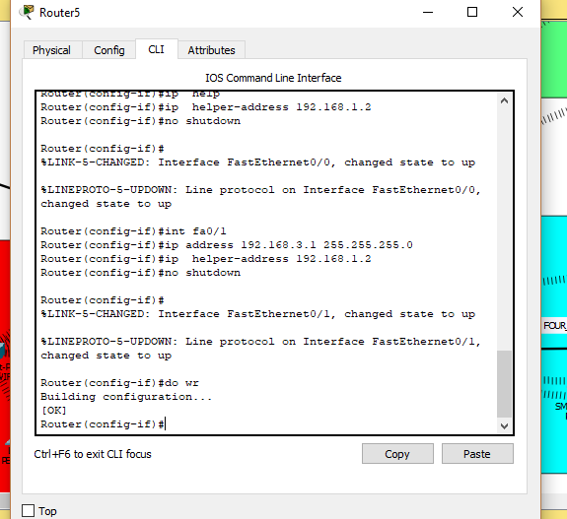

Similarly we can assign the default gateway to the server.

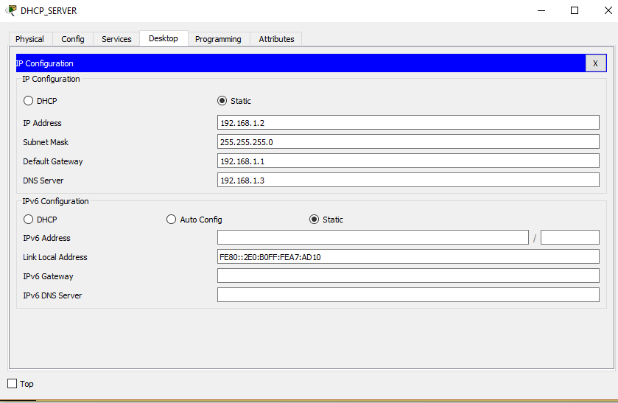

Then we will go to the HTTP server.

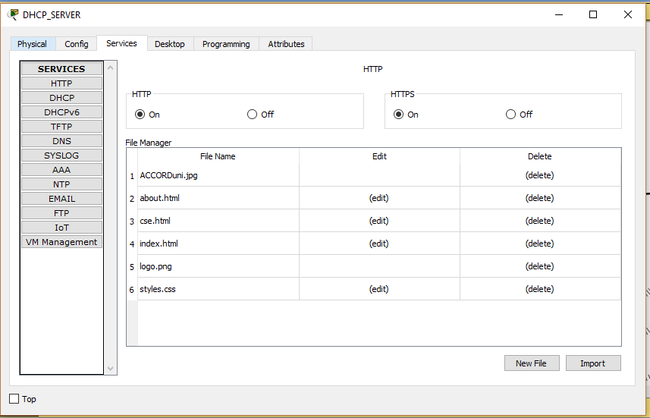

Figure: HTTP .

We will assign IP similarly to DNS and DHCP server.

Now we will go to the ‘Services’ to name the website. We named our website ‘www.accorduni.edu’.And also include the IP of the web server in the interface.

We can also edit the page of the website.



Figure: Edit HTTP page

Now we will work with Hosts . Host should configured as DHCP instead of Static .That will generate automatically an IP number to the host.

Then we will ping 192.168.1.2 from every host and check whether it is sending packets and replying or not . If We get reply then we will go to the web page and type ‘www.accorduni.edu’ and then a web page will appear .

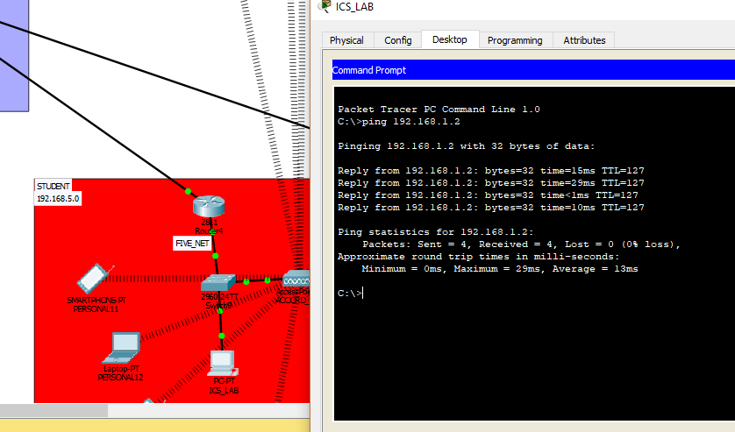

Figure: Pinging and web page

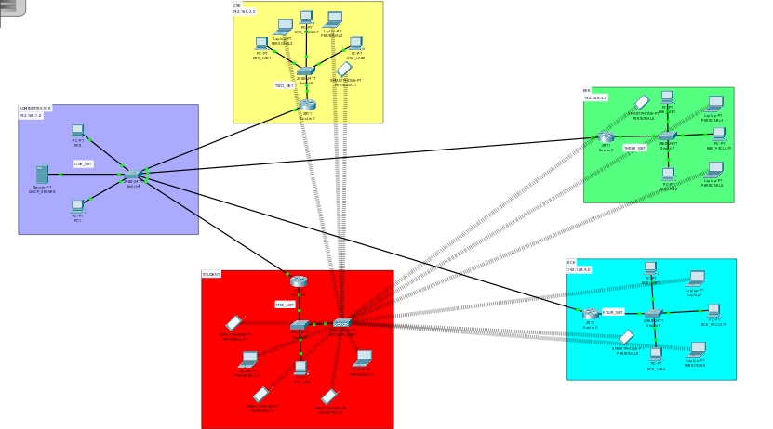

Figure: Final Design