**Part II: Study of the impacts of renewable connection to the distribution network.**

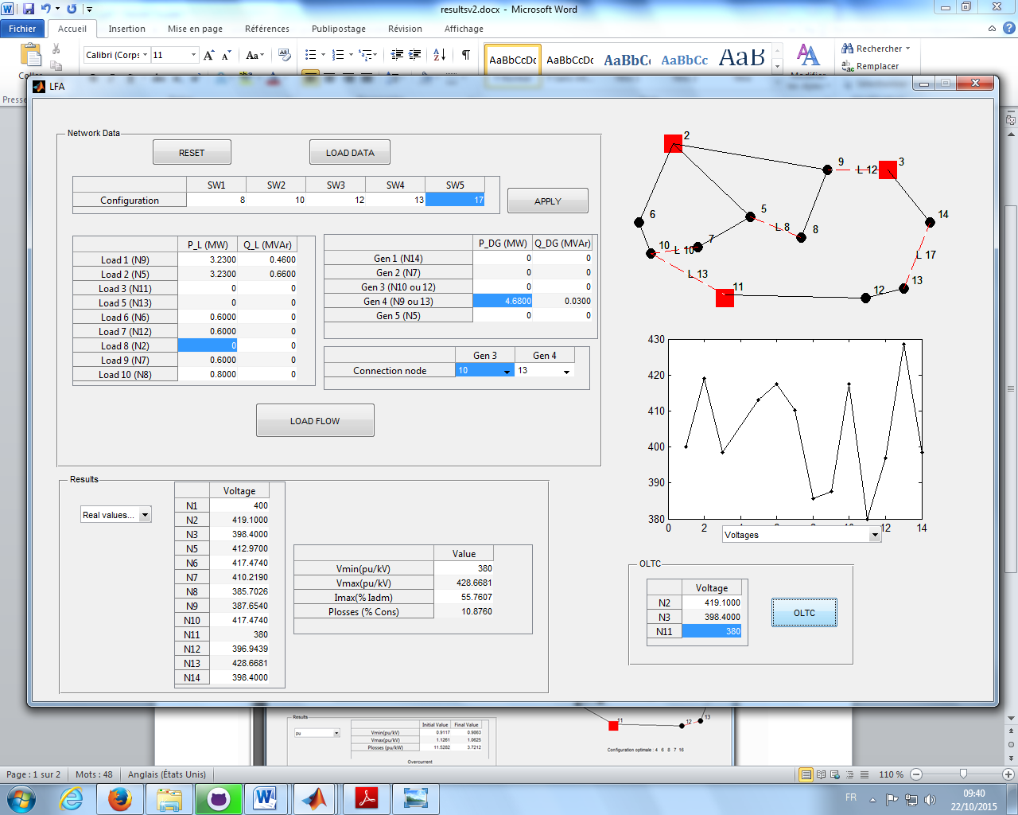

Error is less than 1 percent,

err =

Error can be a result of:

1. Error in sensors
2. Loads and productions vary during time
3. Uncertainities in R and X

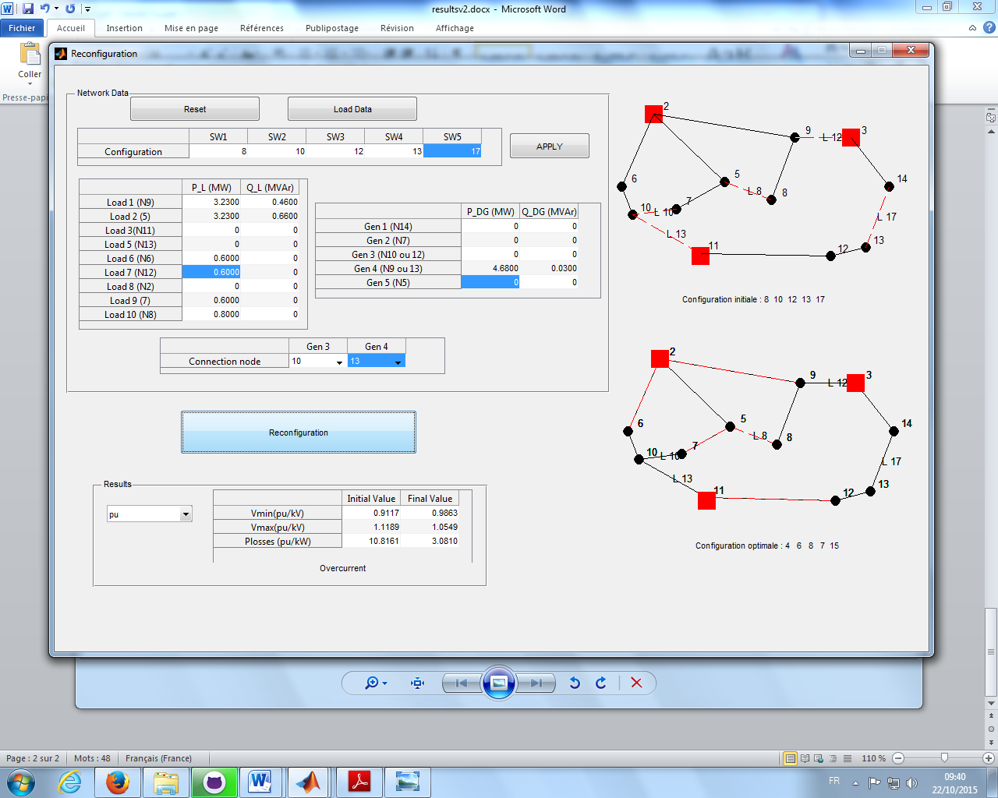

The reconfiguration is calculated using SOB algorithm and found to be 4 6 8 7 15

The load flow results after reconfiguration is found to be

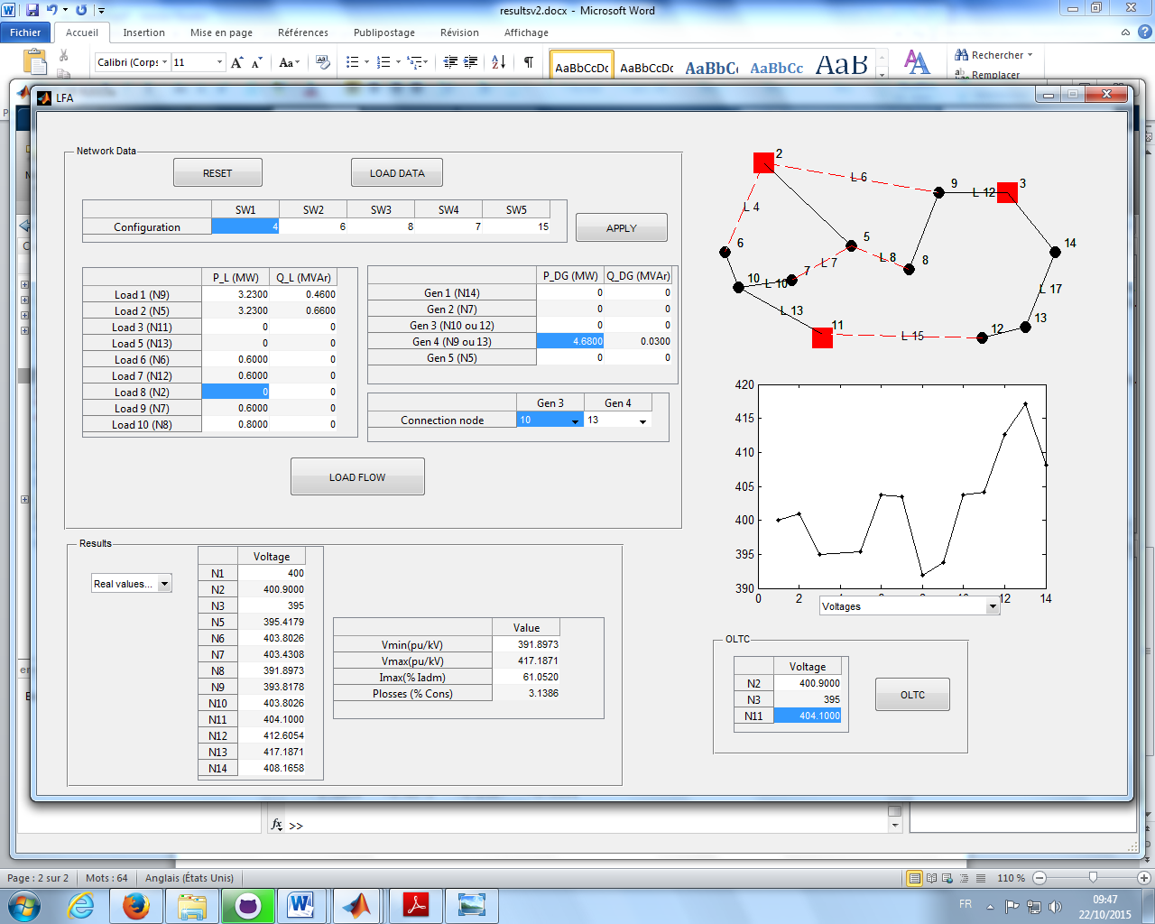

The results match with the PREDIS configuration.