Notes on Dust Collector System
This will add linear actuators (or maybe rotary servo motors) to new custom-made (or possibly commercial-off-the-shelf) blast gates, plus sensors to detect when a machine is turned on or off to control blast gates and the dust collector motor appropriately.
Disclaimer: I know that this whole thing could be done without a microprocessor by a clever hardware engineer who knew his trade. It would be cheaper by far, and cooler by an order of magnitude. I am not such a person, however, so I revert to my safe zone as a software engineer and crush this problem with a dedicated computer running a Python program on a Linux machine. So there.

Be sure to check the ‘new ideas’ section at the end.

Architecture
This picture is an overall view of the physical collection system:

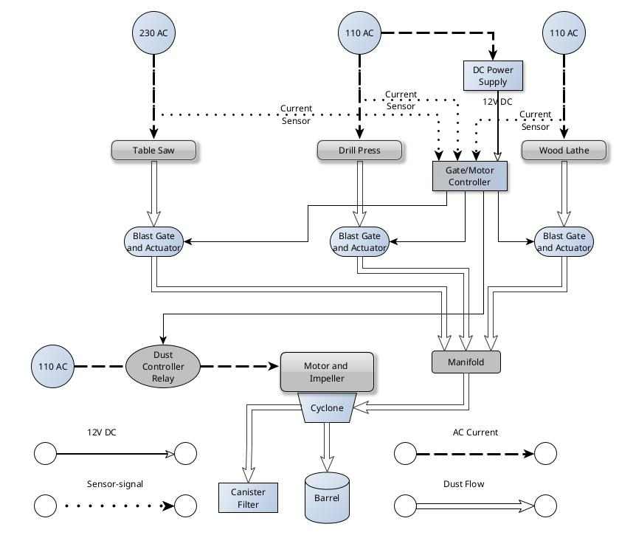

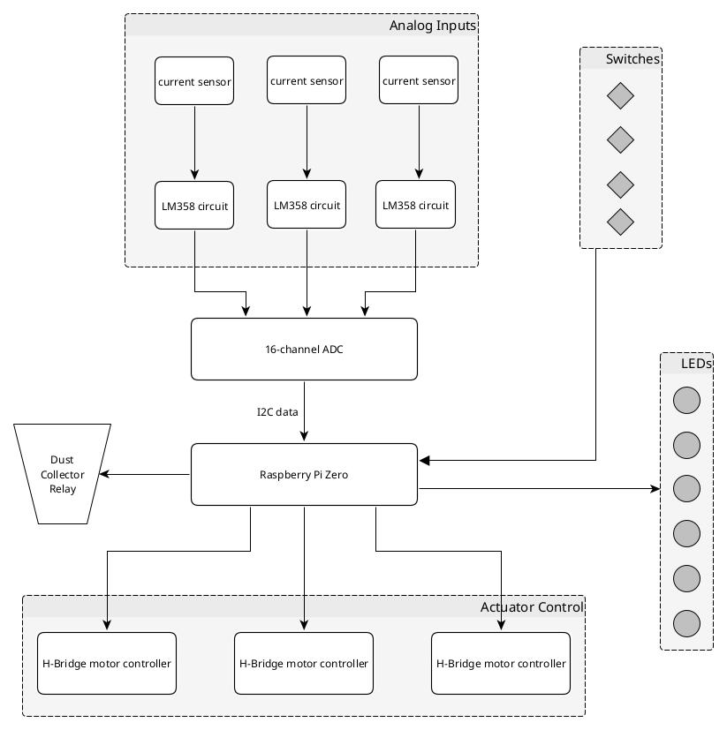
This is an overview of the hardware system (the controller itself):

Gate/Motor Controller
This controller is implemented on a Raspberry pi zero, much like this one by adafruit. I’ve got plenty of suitable wall-plug 5V supplies like this one available, so one of them will do for power. It’s got more than enough GPIO for my needs. I’ll need an external A/D multi-channel converter such as this ADS1115 for sensing current in the shop tools (saw, drill press and lathe power cords).

Components
I have on order from Amazon:
- A linear actuator that travels 4 inches in a couple of seconds, and has a 4.5 lb push, which should be more than enough. See this information.
- A 12V power supply for the actuator. This one can handle power needs for all 3 gates. See this information.
- A current sensor module. See this information.
- A 40 Amp AC solid state relay to control power to the dust collector motor. See this information.
- 1 pc. 47 Ohm resistor from Amazon (100)
- 2 pcs. 10K Ohm resistors from Amazon (100)
- LM358 op amp and block from Amazon (lots)
- 16 bit 4- channel ADC from Amazon (3 pcs) (spec sheet here) There is a good library built for this -- see here.
- H-Bridge motor controller from Amazon (4 pcs) (spec sheet here)
Some usage notes: here (there may be confusion between different specs – be sure to follow the actual labels on the board)
- I will soon order this canister filter that is MERV 15, Open Both Ends, 34" Tall, No Inner cage - Heavy duty outer cage. I have 84 inches of height to work with. If I stack two of them, that takes up 68 inches, leaving me with 16 inches to spare. That does not leave me room for both the inlet above and a bucket below. About $225
- If I have a bucket below the filter for catching stuff, I need a gamma lid. Here’s a link to a youtube video that shows how to mount it. About $12.
- I will also order a Dust Deputy Cyclone from Amazon. About $180.
Items 5, 6 and 7 form a circuit to read the current signal coming from the current sensor (item 3).
Item 8 connects all 3 analog inputs from each of the converters made by 5-7 and convert them to digital.
Item 9 controls the linear actuators (reverse/forward)

Basic Logic
The controller measures the current sensor on each machine. If there is current flowing (that is, the machine is on) then the blast gate for that machine is opened. [Since the actuator has limit switches at each end, it should OK to keep telling it to open. Otherwise some sort of state machine is in order.] In addition, the relay for the dust collector motor is activated, turning on the dust collector. [This too is an idempotent operation.] If a sensor indicates that the machine is not running (no current) then the corresponding blast gate is closed [again, idempotent]. If no machines are running, the dust collector relay is turned off, and the dust collector stops after a suitable delay (maybe 3 minutes or so? Maybe determined by dip switches? Or overridden by push-button?)
There may be a need to introduce a short delay between starting to open the blast gate and turning on the dust collector, since the actuator needs a couple of seconds to work. This is easy to do if it becomes necessary, but I don’t think it will – it takes the dust collector motor a couple of seconds to spin up anyways, and that’s about how long it takes the gate to open.
I should include some power-on logic in the program to move each output to a known safe state (gates closed, dust collector off) and wait for a second or two.
At this time I don’t see the need to provide micro-switches to detect open/closed gates, but that’s a possibility if I want to detect faults in the system such as a jammed gate or burned-out actuator or servo.

Input and Outputs

Inputs
The 16-bit 4-channel ADC is an I2C device. The circuit diagram is shown below.

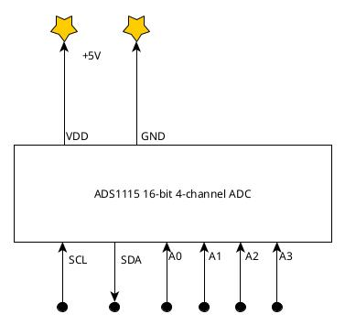

The input from the current sensors is an analog voltage I can read with the multi-channel A/D after running it through the LM358 circuit. The circuit below (from a youtube screenshot) will measure current in the PCTZ-02.
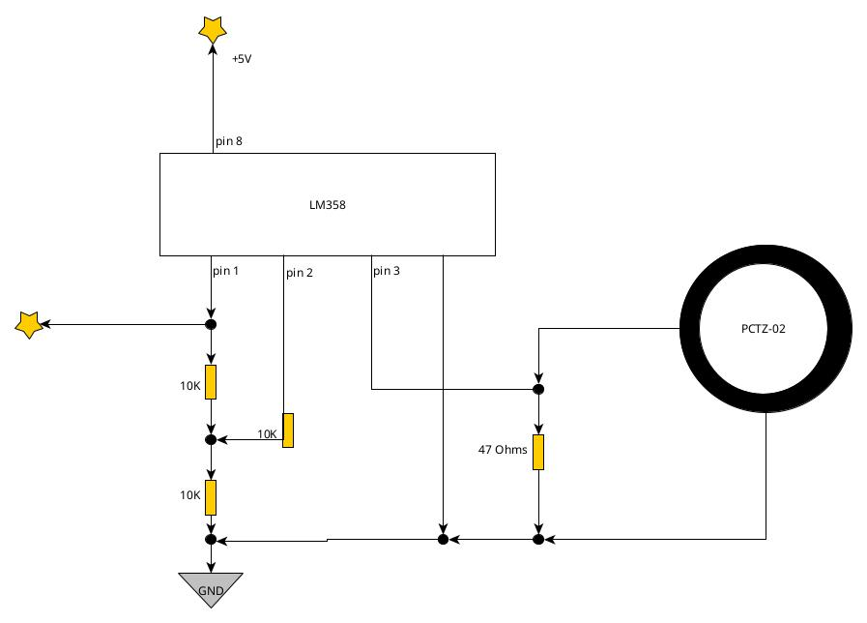

Outputs
- Output to the actuators is just a 12-volt signal with polarity reversed to reverse the direction. Here’s a link to a ChatGPT discussion about H-bridges to implement this.
- Output to the solid-state relay is simple.
- I might want to add some LED outputs to show status, just for coolness. For example, green for open, red for closed, similar for the motor.

Hardware
There are many designs for blast gates, such as this one for DIY, or this one (which is really silly, because it would leak like a sieve) , or this beauty (with free shipping – this is the best one I’ve seen.). Then there’s this plan for DIY – very cool. If the servo I just ordered doesn’t do the trick, this one surely will.

Testinghere
Just for coolness it would be neat to add a push-button that would initiate a sequence of events to verify correct operation. (There’s lots of great choices for momentary contact panel-mount push-buttons like these. De-bouncing: look here for a hardware solution, or here for software solutions)
For example, one such sequence would be:
- open gate 1, wait 5 seconds,
- close gate 1, wait 5 seconds
- same for gates 2 and 3
- open all gates, wait for 5 seconds
- close all gates, wait 5 seconds
- open all gates, wait 5 seconds
- turn on dust collector, wait 60 seconds
- turn off dust collector
- close all gates
… and so on.

Online Resources
- measuring ac current with arduino

Development methodology
Python is the language of choice here. ChatGPT can do a decent job of generating skeleton code given suitable prompts. I plan to develop separate Python apps for checking out each component.
- Current sensor input: a program to read the current sensor at 1 Hz or so and print out the value.
- Linear actuator: a program to move the actuator all the way out, wait 3 seconds, then all the way back, wait 3 seconds, and repeat.
- Solid-state relay: turn AC outlet on and off.
- Basic logic: a program that will exercise the logic of the controller by simulating inputs via a script. Doing this early on will make implementation of the logic easier.

New Ideas
This guy has a nice way of moving blast gates. So does this guy. The idea is to use a blast gate that pivots around a single point instead of sliding linearly. I’ve ordered 3 servo motors from Amazon that I’ll play with – this might be a more compact solution.
Also, I may need a small fan to keep air running over the processor board to keep it from overheating.
I may need a hardware switch to force each gate/collector control, if I want to just run the dust collector without having a machine on (to clear the air in the shop, for example). Also need to disable the controller from running its usual loop. Or, read both the current and the switch and ‘or’ them together?
This phenolic would be good for blast gate material, housed in an MDF enclosure.
This sensor may be a better choice for measuring the current. Code is here.
I had a good chat with ChatGPT about servos – the results are in the files “full_verbatim_servo_chat_final_corrected.pdf” and “servo_power_up_chat_cleaned.pdf”.

McMaster-Carr is a good source of thick sheets of polycarbonate, Delrin and such for making mounting blocks for the servos to glue on to the gate housing. Will 15-minute J-B Weld hold Delrin?

