# **How to Implement Git Version Control**

## **What is Git Version Control?**

According to the 2nd Edition Pro Git Book (2004), version control is a system that records changes to a file or set of files over time so that you can recall specific versions later. For the examples in this book, you will use software source code as the files being version controlled, though in reality you can do this with nearly any type of file on a computer.

## **Implementation and Sample Code**

1. Make sure to install Git, and add it to the Path incase you are using Windows OS.

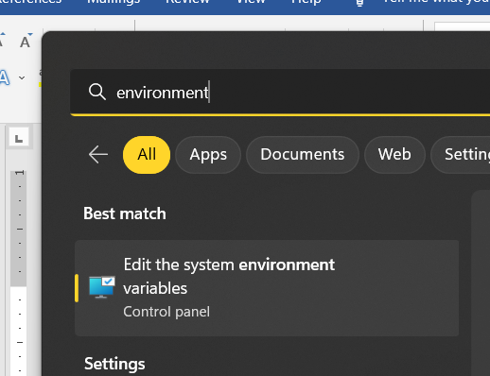

Search “Edit the system environment variables”

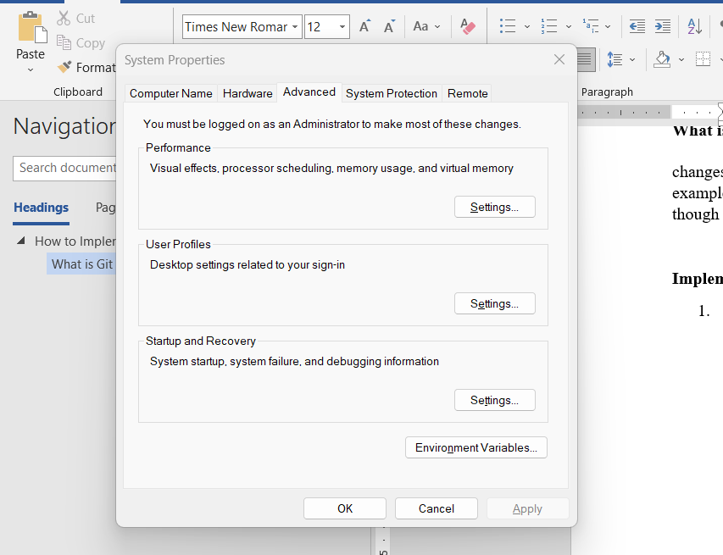

Click Environment Variables.

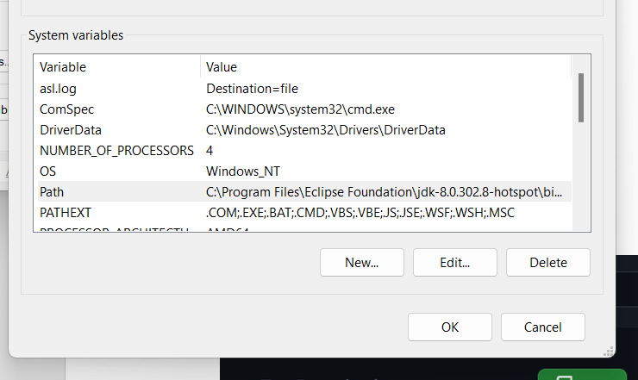

Double Click Path.

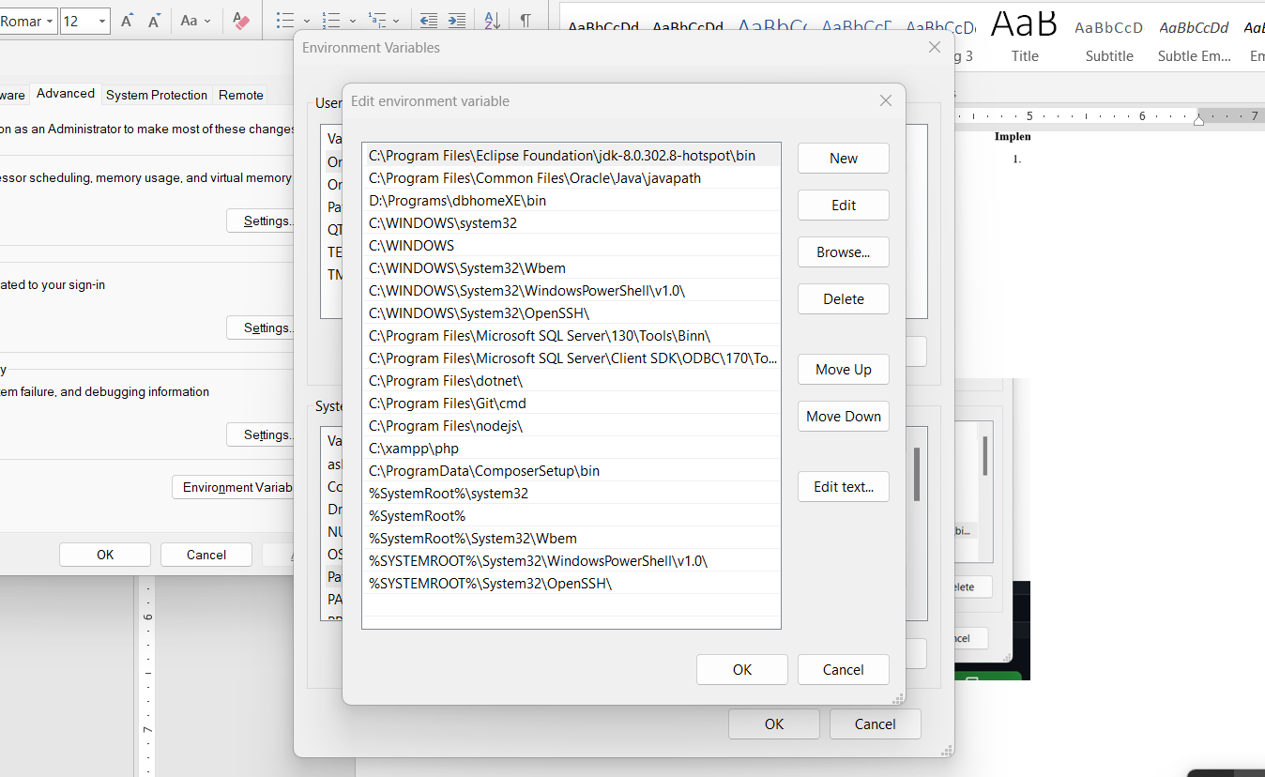

Make sure to add C:\Program Files\Git\cmd, then click OK.

1. Make a repository in your Github Account.

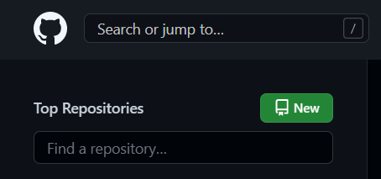

Click New Button.

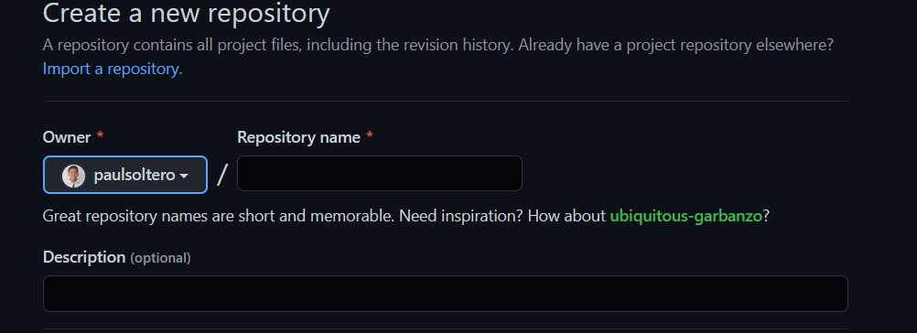

Input the Repository Name, and click Create Repository at the bottom pane of the website.

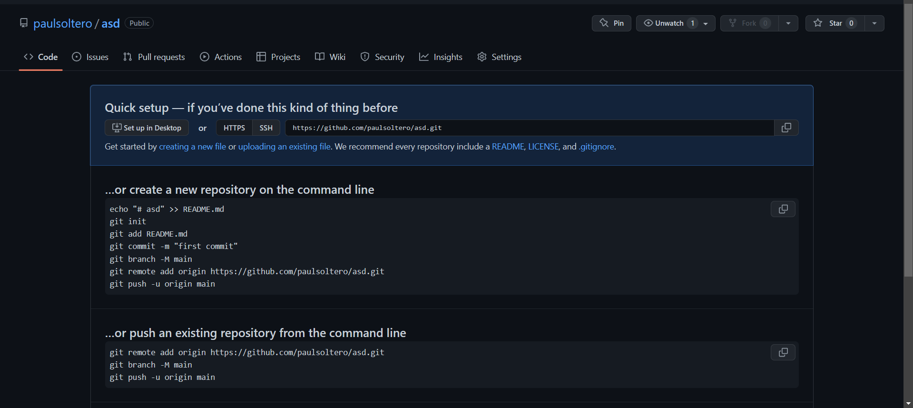

This should be the ouput after creating an empty repository.

1. Now, let’s try to commit our activity #1

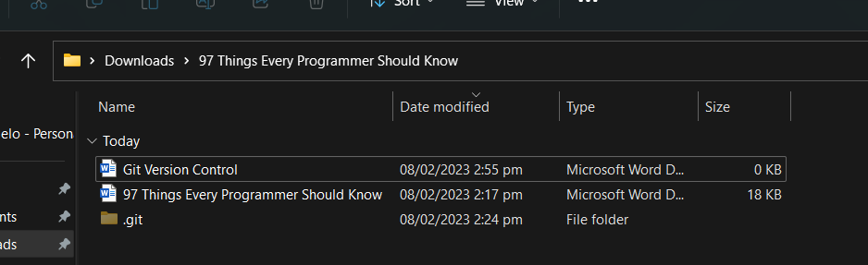

Double click the file path, then change it to “cmd”.

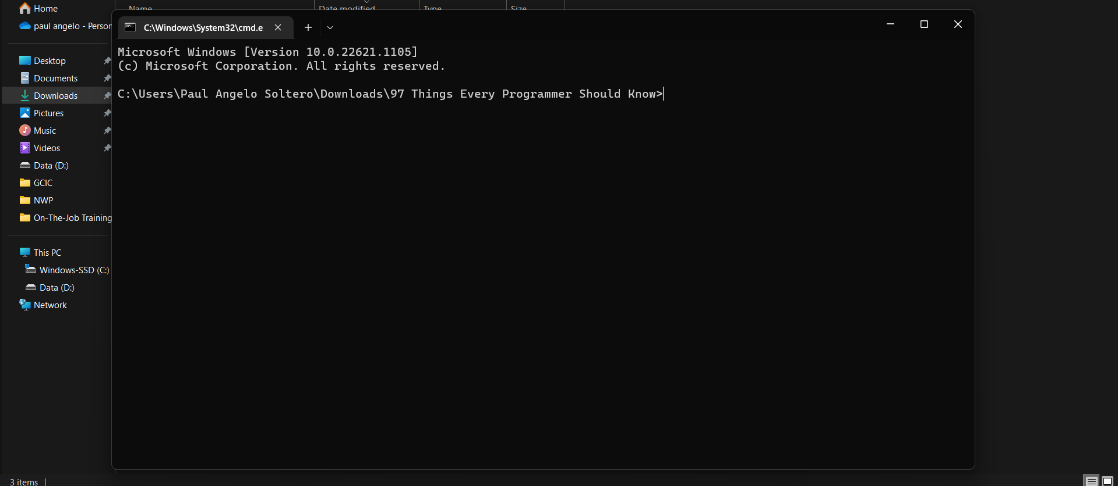

A cmd terminal should appear on your screen.



Now, follow the following code in creating a new repository

**Git init**

– initialize the repository

**Git add .**

– to add all files inside the folder, but you can also specific the file that you wanted to add only. Ex. Git add activity.txt

**Git commit -m “first commit”**

– to commit the files inside the repository. This will serve as a history of your repository. You can also change the message of your commit

**Git branch -M main**

– this will create the main branch of your repository, but you can also add another branch of your repository.

**Git remote add origin <repository link>**

- Copy the HTTPS of your repository. This will add remotely to your github repository.

**Git push -u origin main**

– This mean that added file will push to your repository main branch.

1. As you commit more in your repository, it will reflect on your github.

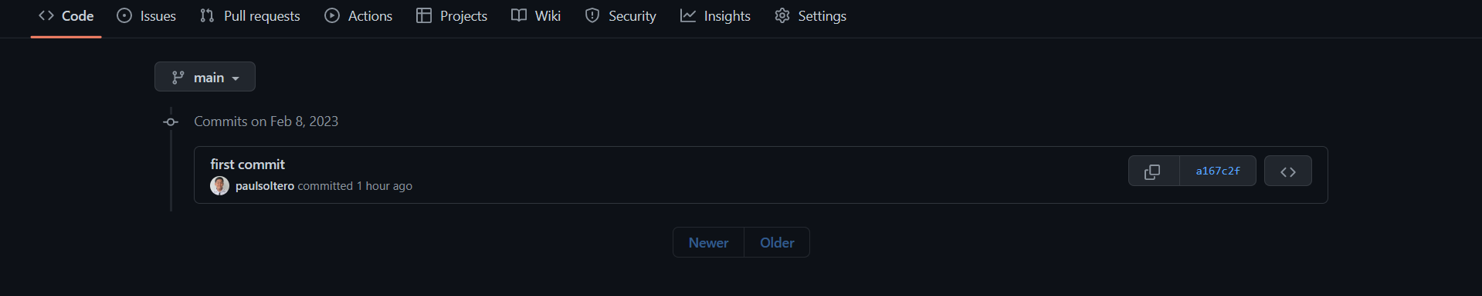

Here is another example from our capstone project

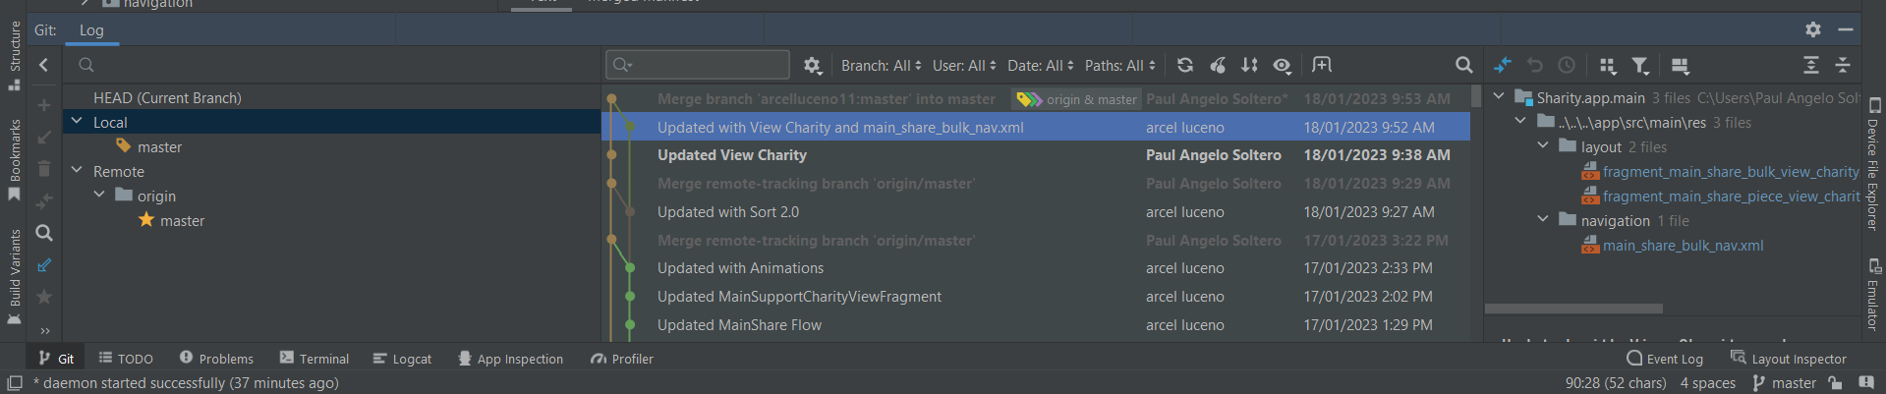

In this way, you can go back and check your older code, and can revert incase your pushed files are not working correctly.