Name:Paulson k babu

Splunk Practical Lab Documentation
Purpose:
This document is used to record hands-on work performed in Splunk, including screenshots, configurations, observations, and results.

1. Environment Details
Splunk Version:10.0.2
Splunk Type :Enterprise

2. Objective of the Task

The goal of this lab was to simulate a real-world FTP server environment. I generated 600 logs containing three types of behavior:

Normal Activity: Students downloading homework.

Brute Force Attack: A hacker trying to guess a password 150 times.

Insider Threat: A "Super User" accessing secret password databases.

3. Data Upload Details
File Name:best_lab_600.log
Index Used:ftp1_log
Sourcetype:ftplog

4. Configuration Steps
During the "Add Data" process in Splunk, I used these specific settings to prevent data merging:
- Event Breaks: Set to "Every Line" (This fixed the problem where only 252 logs appeared).
- Timestamp Extraction: Set to "Current" to ensure all 600 logs were indexed separately.
- Field Extraction: Used the "Extract Fields" visual tool to create custom fields for user, src_ip, action, and file_name.

Step-by-step actions performed in Splunk:
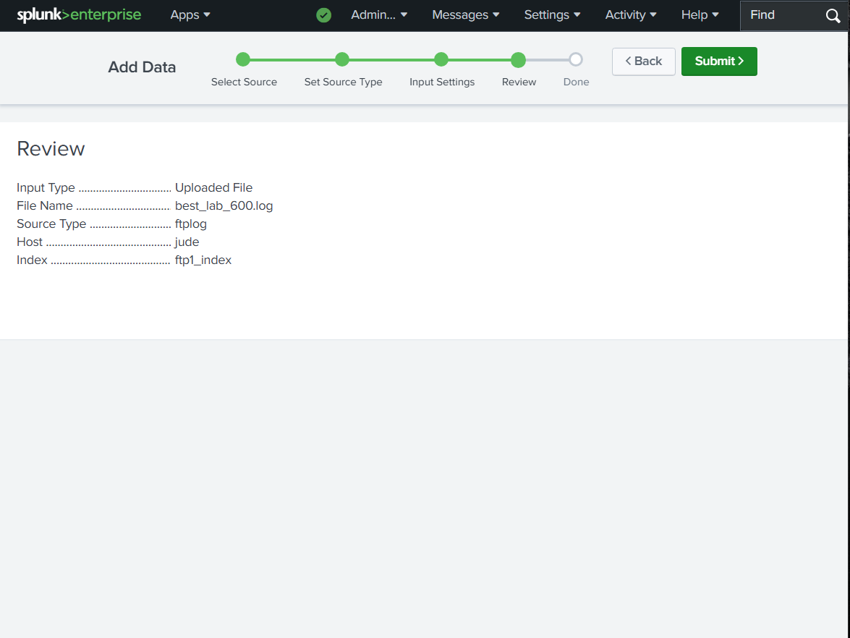

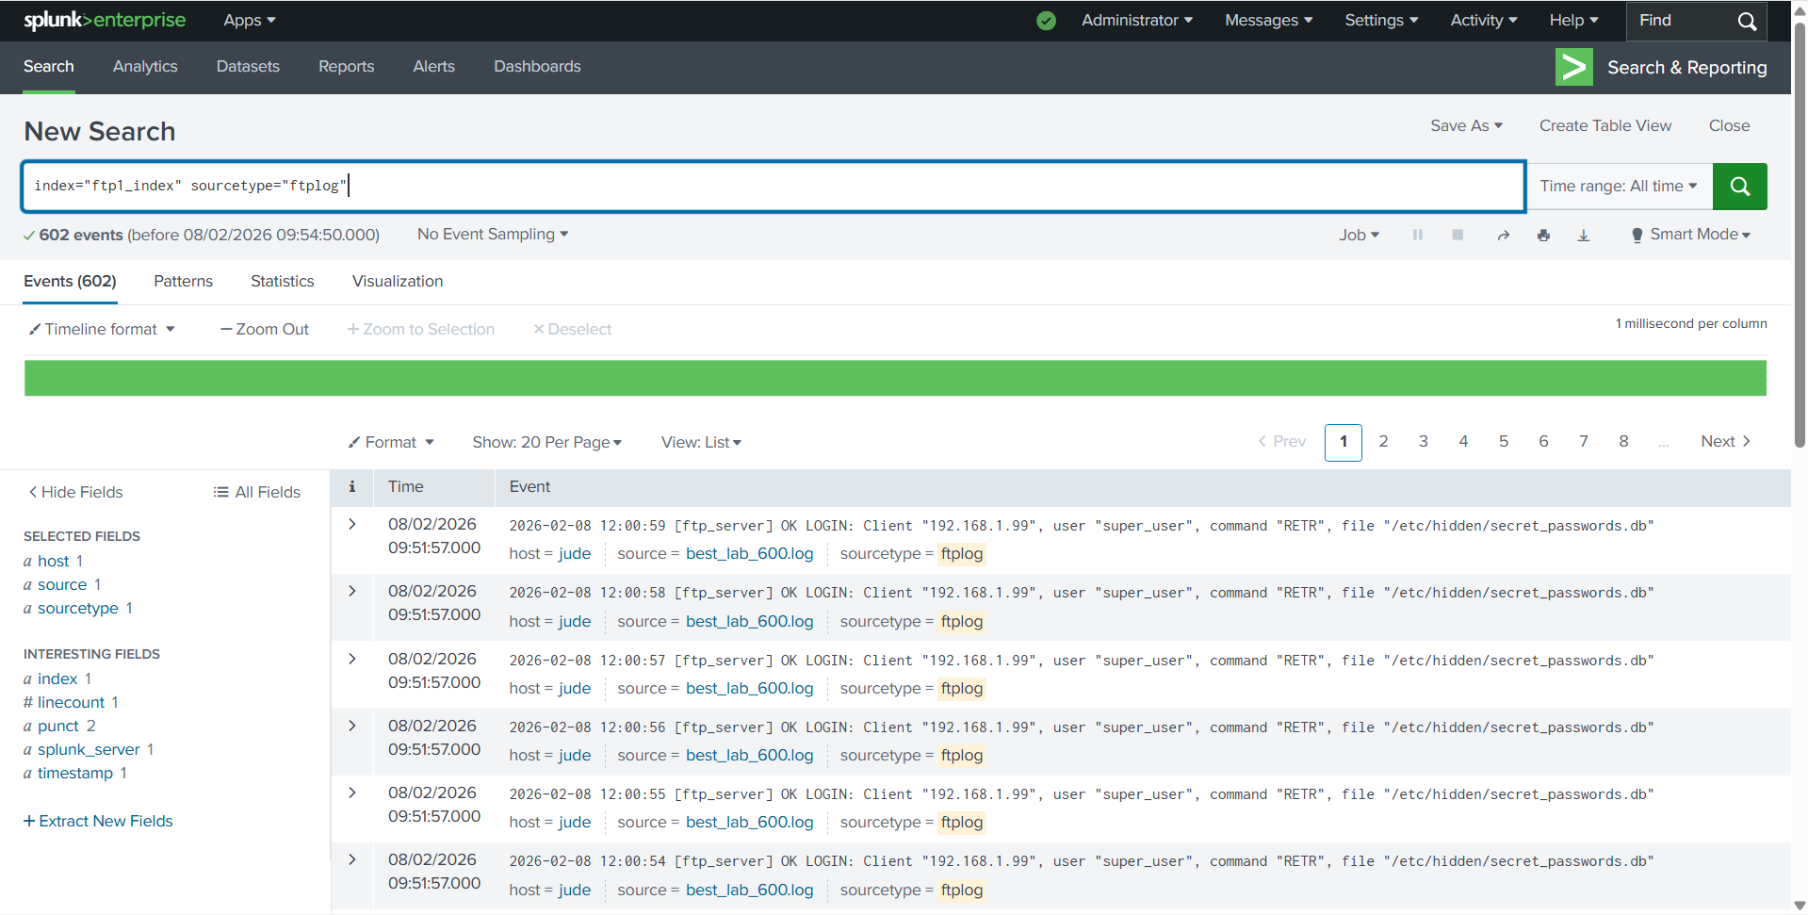

Field Extraction: Used the "Extract Fields" visual tool to create custom fields for user, src_ip, action, and file_name.
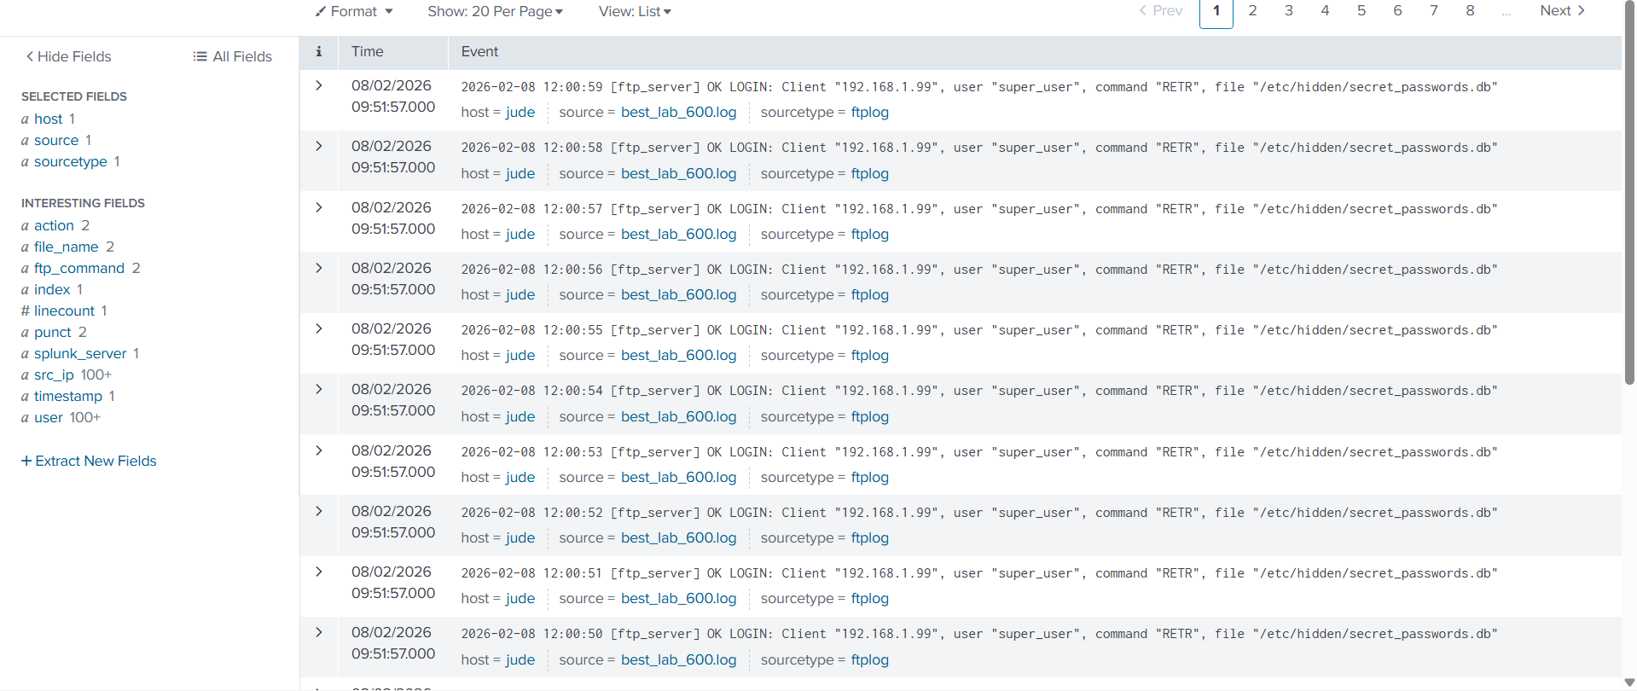

5. Search Queries and Results

i)Normal Activity: Students downloading homework.

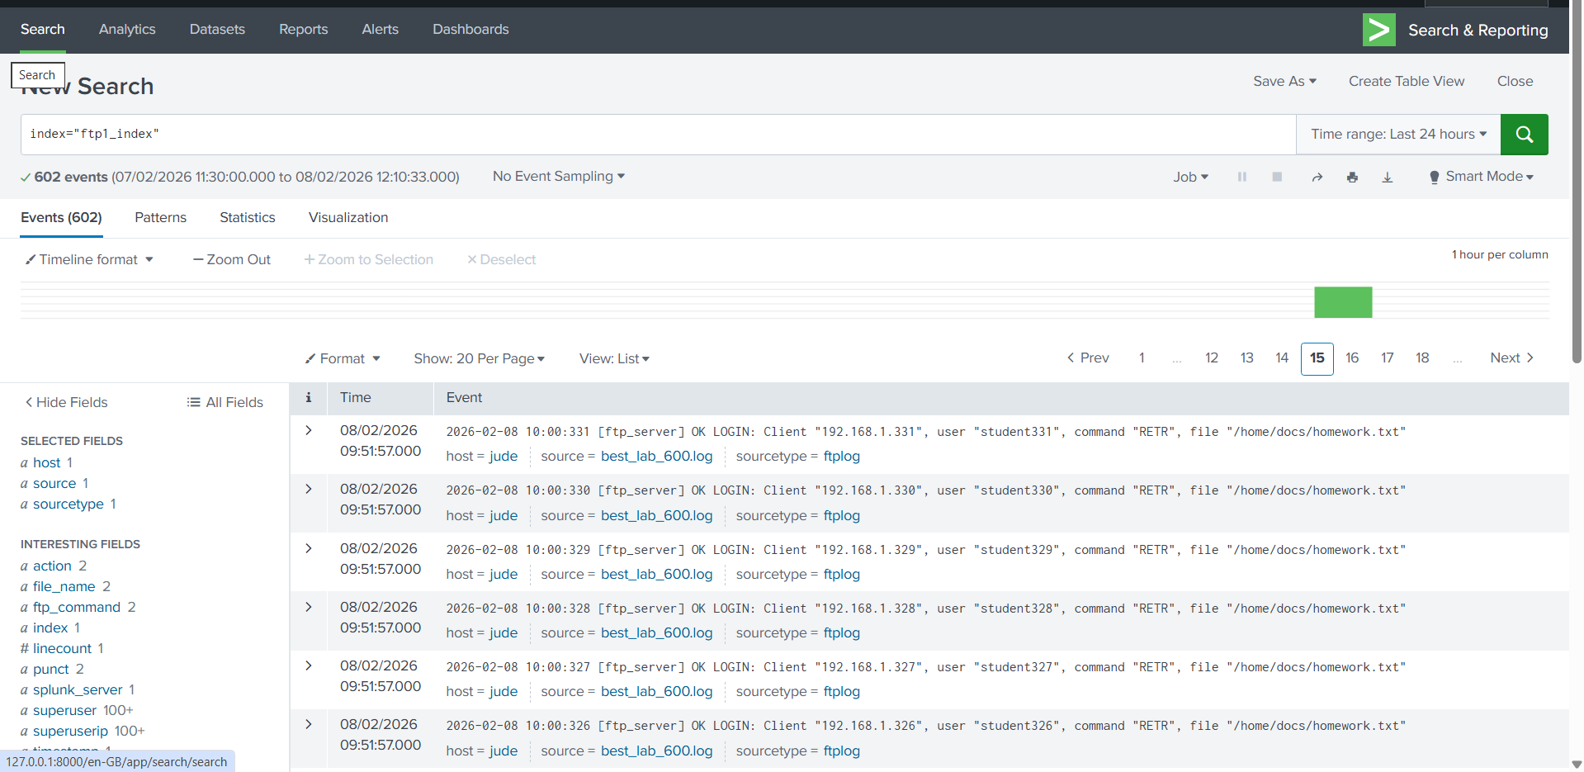

ii)Brute Force Attack: A hacker trying to guess a password 150 times

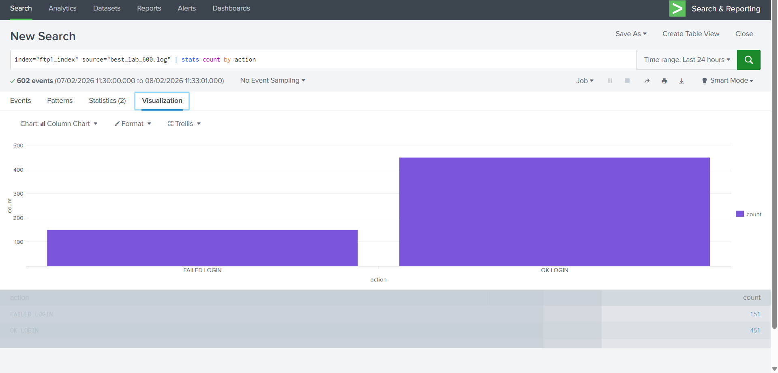
iii)Insider Threat: A "Super User" accessing secret password databases.

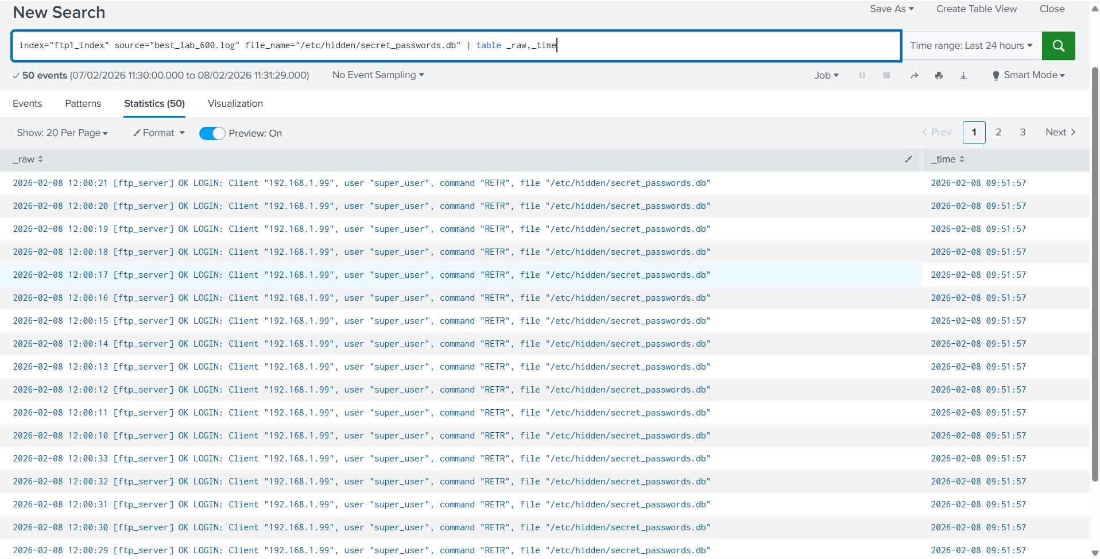
.

9. Key Learnings
- Line Breaking is Vital: If Splunk isn't told to break at "Every Line," it will merge events and give incorrect counts.
- Field Extraction is a Superpower: By turning messy text into "Buckets" (Fields), I can use the stats command to see patterns instead of reading 600 lines manually.
- Visualizing Anomalies: Using a Pie Chart makes it easy to see that the "admin" user was doing too much work, which signaled an attack.

