Name:Paulson k babu

Splunk Practical Lab Documentation
Purpose:
The objective of this task is to analyze web server access logs to gain visibility into user behavior and identify potential security threats.

1. Environment Details
Splunk Version:10.0.2
Splunk Type :Enterprise

2. Objective of the Task

Web Traffic Baseline: Categorizing HTTP request methods (GET, POST) and identifying top-accessed endpoints to understand normal site usage.

Error & Anomaly Detection: Analyzing HTTP response codes (200, 401, 404, 500) to find spikes in server errors or unauthorized access attempts.

Security Threat Hunting: Using SPL to detect specific malicious activities such as Directory Traversal attacks (/../../etc/passwd) and automated probing from suspicious IPs.

User Session Analysis: Calculating session durations to differentiate between human users and automated scanners.

3. Data Upload Details
File Name:http_access.log
Index Used:http_index
Sourcetype:access_combined

4. Configuration Steps
Step-by-step actions performed in Splunk:
Step 1:
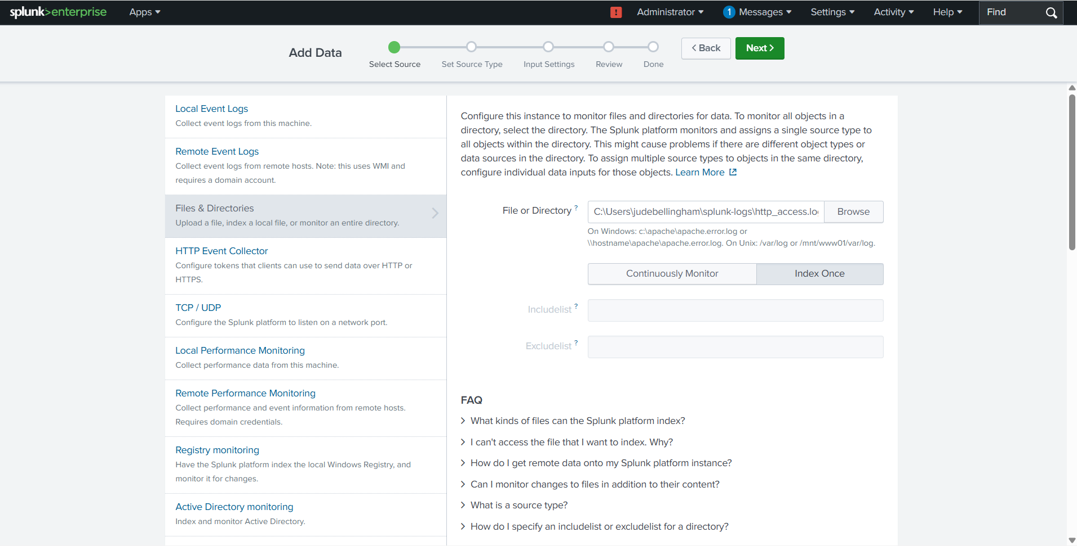
Step 2:
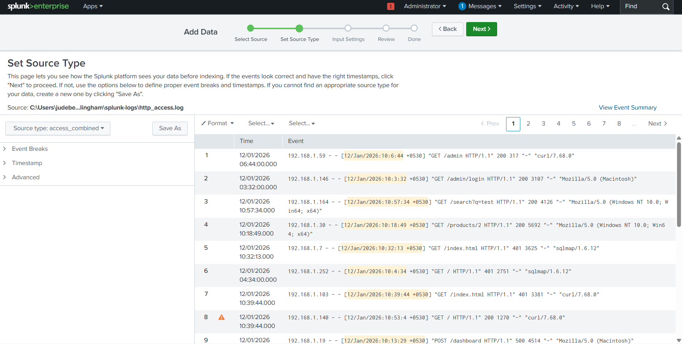
Step 3:
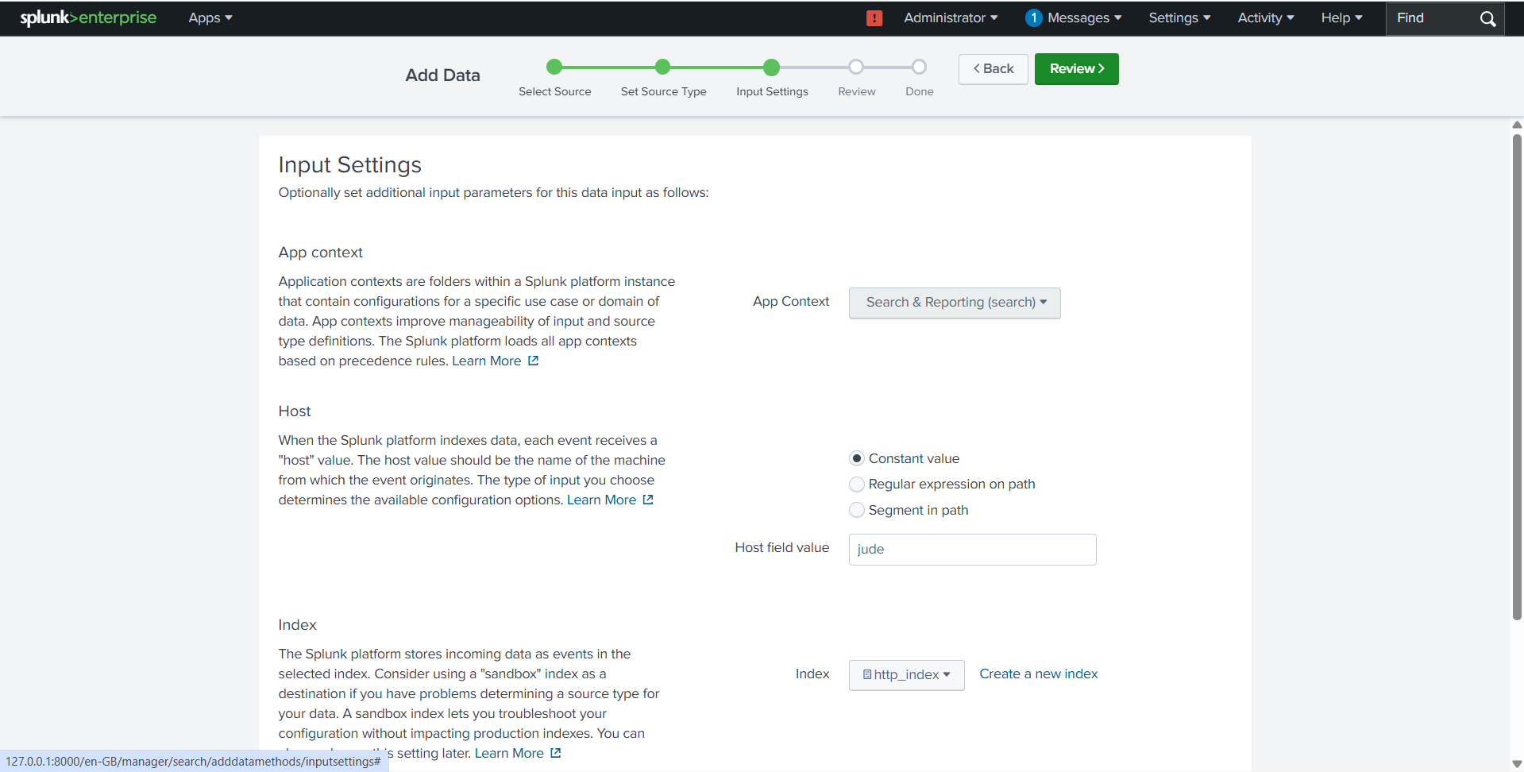

Step 4:

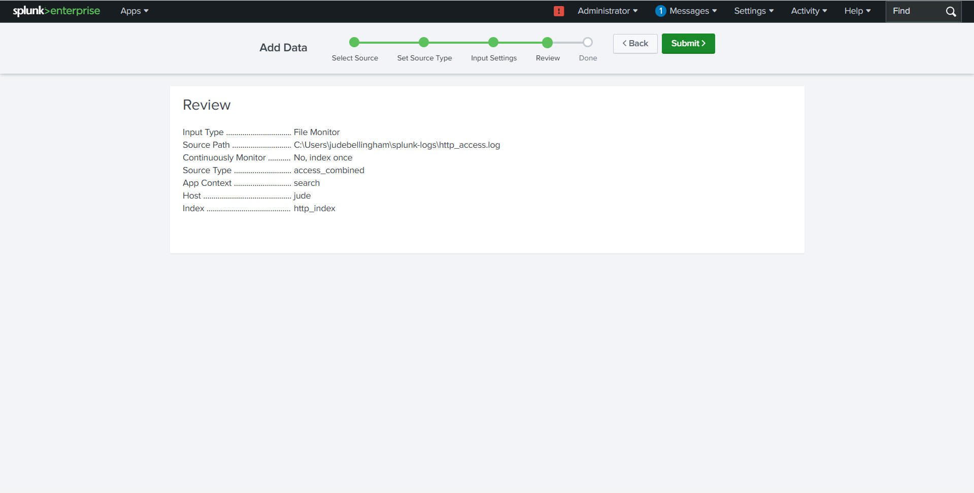

Step 5:

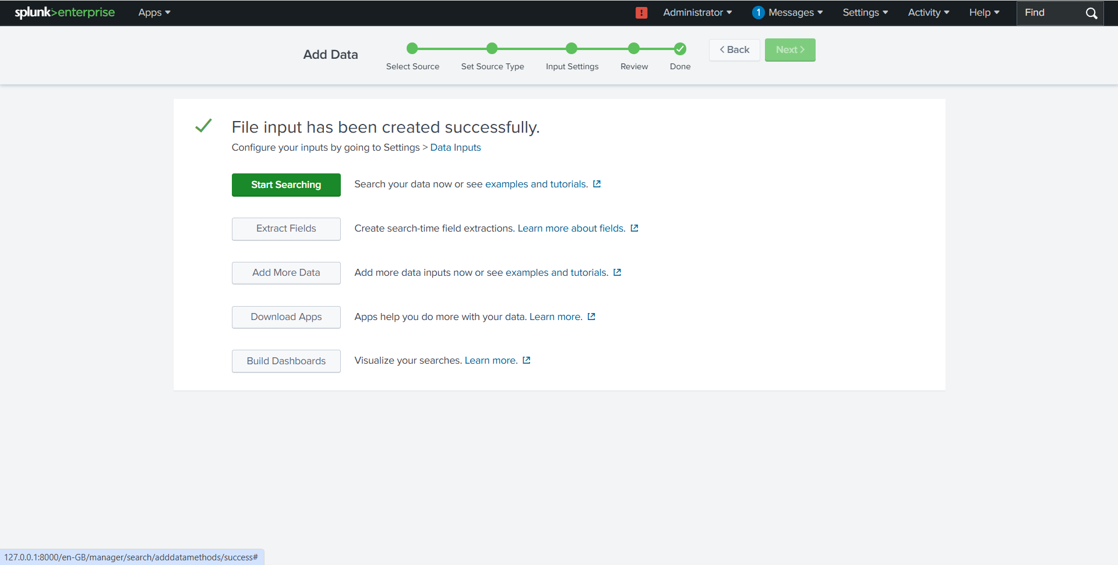

Step 6:

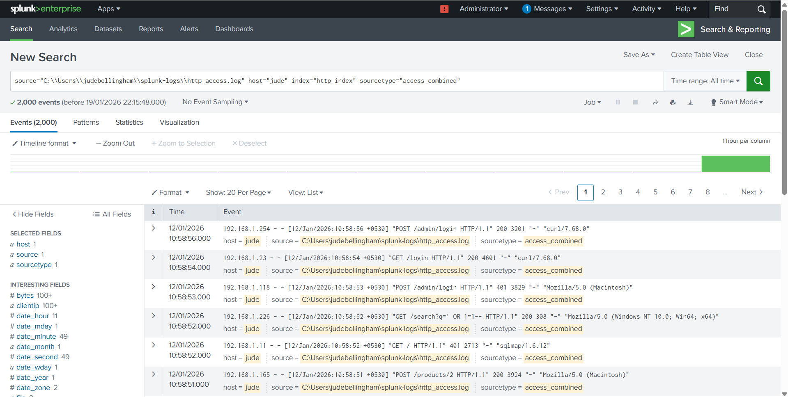
Step 7:
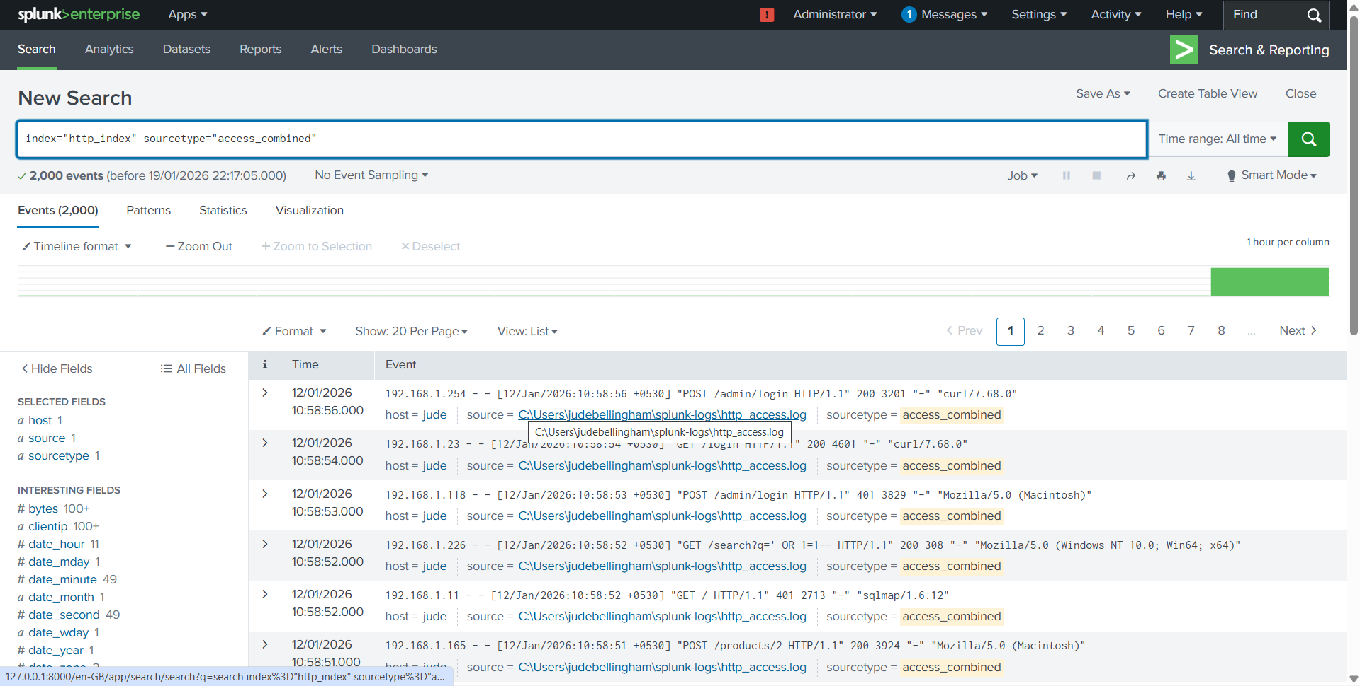

5. Search Queries and Results

i)Determine the distribution of request methods (GET, POST, etc.) to understand web traffic patterns.

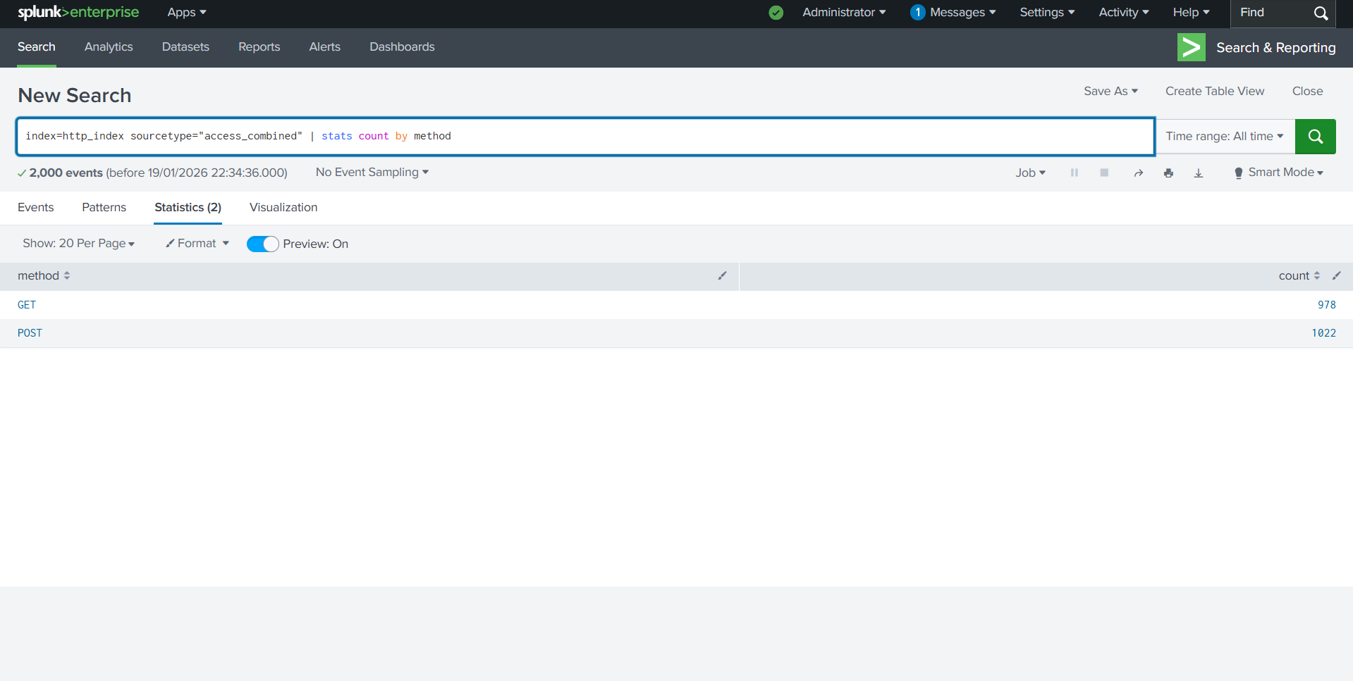

ii)Identify top URLs or endpoints accessed by users

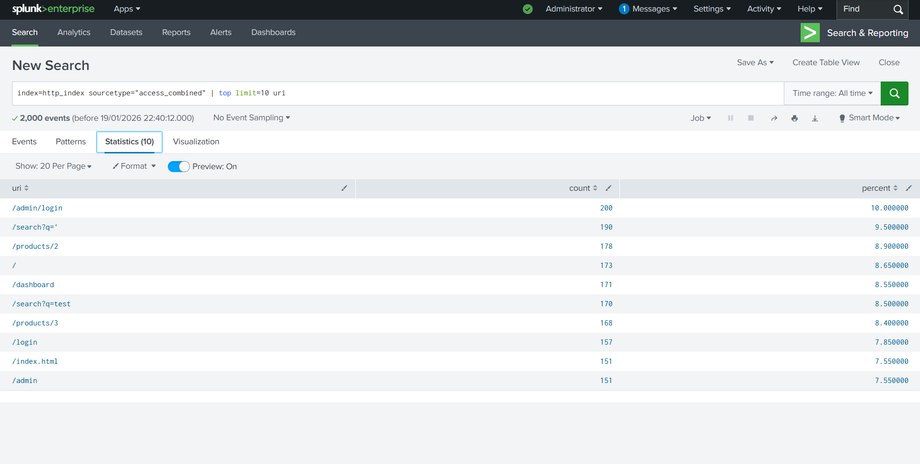

iii)Analyze response codes to identify errors or successful requests.
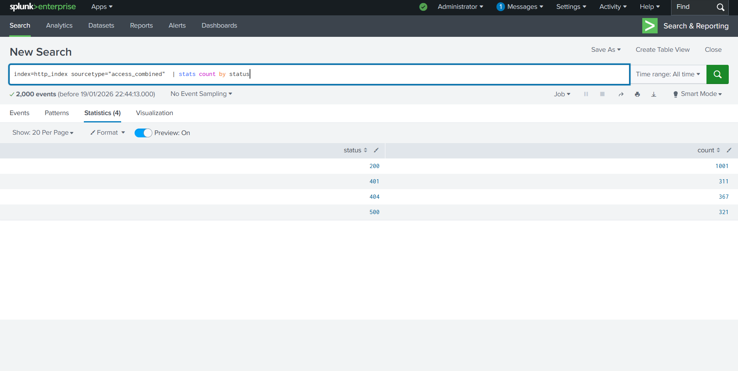

iv)Detect anomalies
- Look for unusual patterns in file transfer activity.

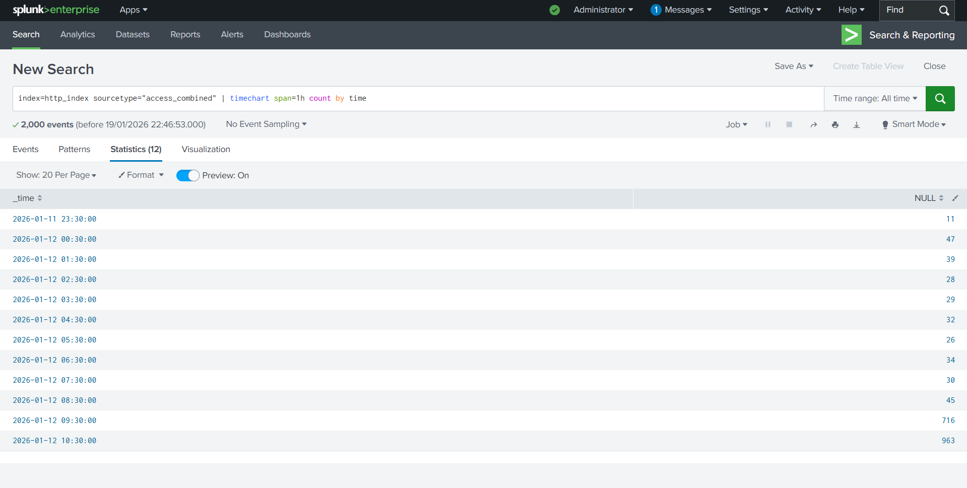

- Analyze high volumes of error responses
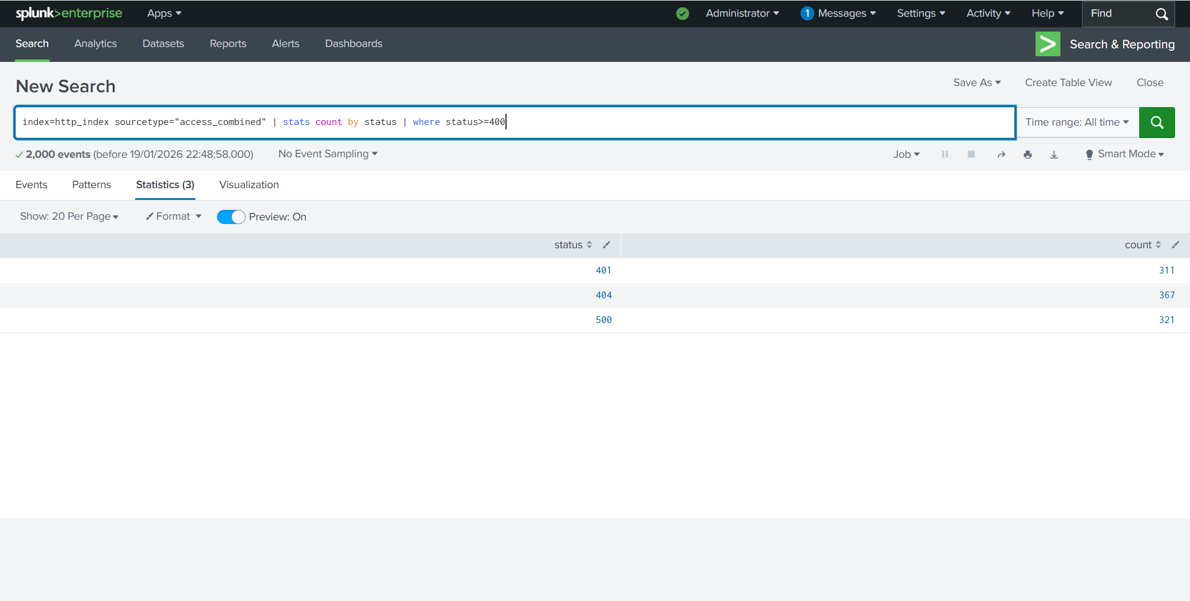

- clients that have hit "Unauthorized" (401) or "Forbidden" (403) errors more than 3 times in a short window.
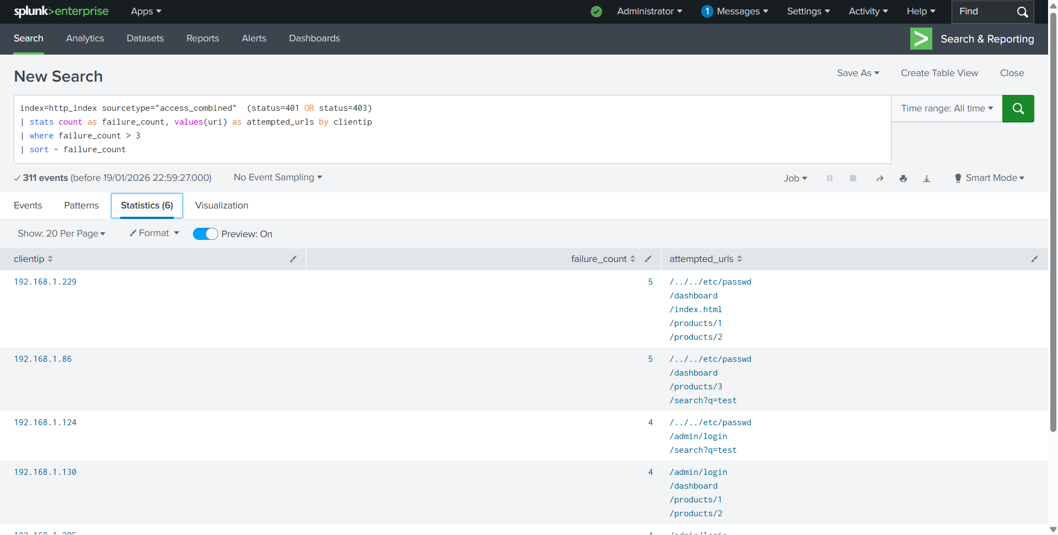

- Calculate Session Durations per User
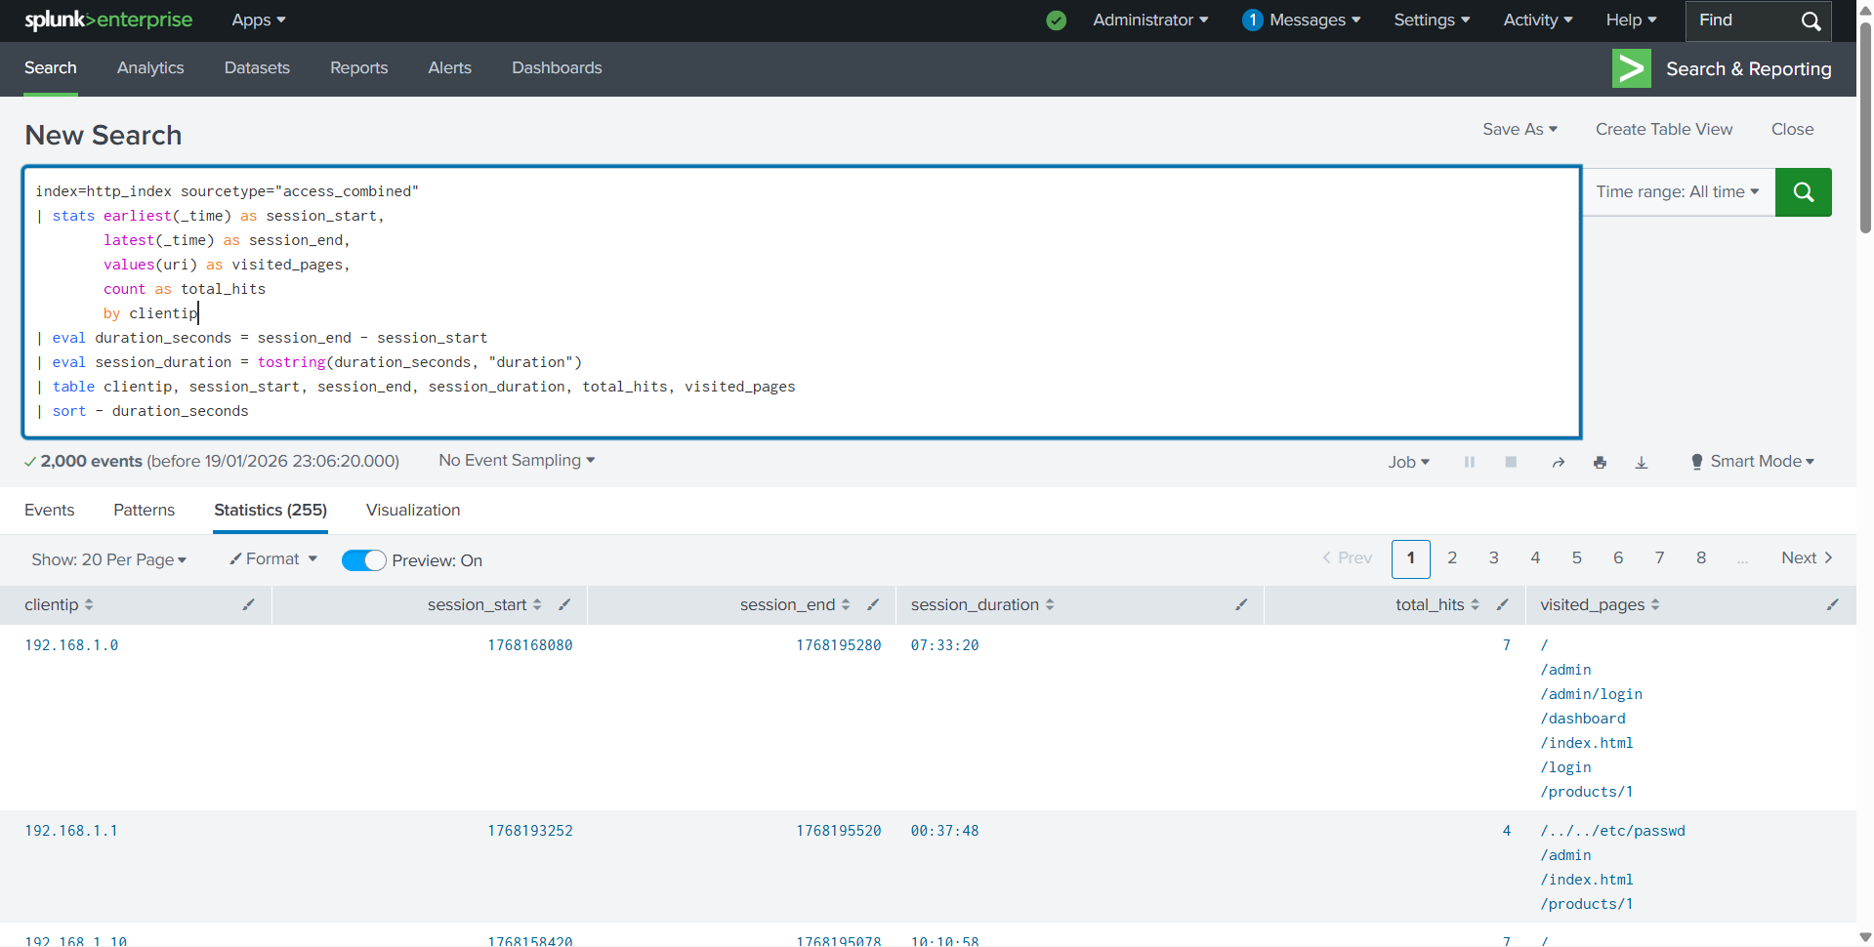

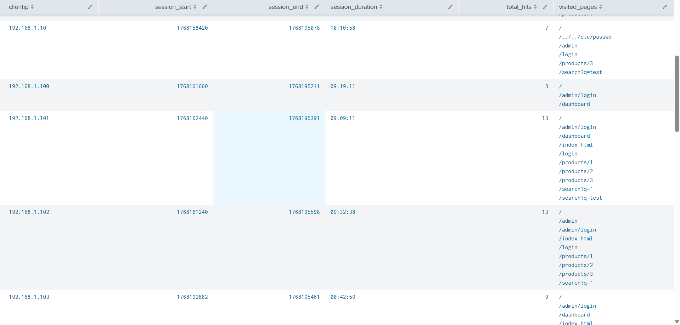

9. Key Learnings
HTTP Field Significance: I learned that status codes like 401 (Unauthorized) and 403 (Forbidden) are critical for identifying brute-force attempts or unauthorized probing.
Advanced Statistics: I learned how to use the stats command to group hundreds of raw events into a concise table that highlights specific attacker IPs and their targeted URLs.
Time Calculation: I discovered how to use eval and tostring to convert Unix timestamps into human-readable session durations (HH:MM:SS), which is essential for distinguishing bots from real users.

