

The APN Edge Software User Manual

Introduction

Computer System Requirements

Software
- Microsoft Internet Explorer (IE) version 6.0, or higher. Other internet browsers do not fully support the table formatting techniques. To find out which version of IE you are using, open the browser and click on Help, then About Internet Explorer. If you need to download and install or upgrade your browser, click on the link below or type it into the address bar of your current internet browser.
www.microsoft.com/downloads
- Adobe Acrobat Reader version 6.0, or higher is necessary to view the report properly. To find out which version of Adobe you are using, open the program and click on Help, then About Acrobat Reader. If you need to download a newer version of Adobe, click on the link below or type it into the address bar of your internet browser.
http://www.adobe.com/products/acrobat/readstep2.html

Hardware
- Operating System: Microsoft® Windows 98 Second Edition, Windows 2000 or Windows XP
- CPU Speed: Intel Pentium II Processor, or greater
- System Memory (RAM): 256MB
- 1GB of available hard-disk space

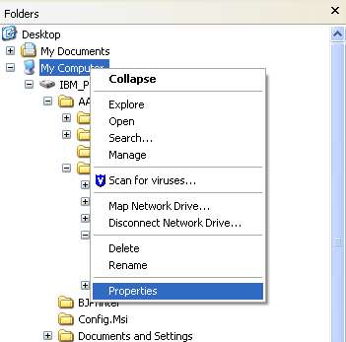
To find out the specs of your computer, open you are Windows Explorer (Start – Programs – Accessories – Windows Explorer, right click on My Computer, and select Properties.

Internet Access
- Due to the integrated calculations and large file output, you will need a high-speed internet connection (i.e. not a dial-up connection) in order to access the APN Edge System. This connection may be DSL, cable, high-speed wireless, office LAN, or other connection of at least 256kbps.

APN Edge Software Overview

Accessing the System

Open your internet browser (e.g. Microsoft Internet Explorer {IE}). Click on the address bar and type http://www.apnedge.com, then press Enter. (See below)

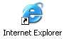
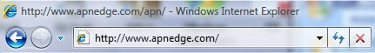

Once the page loads, click on the Login button at the bottom of the page. You will now be prompted to enter the username and password you have received. Once entered, you will be directed to the main home page of the system (below).

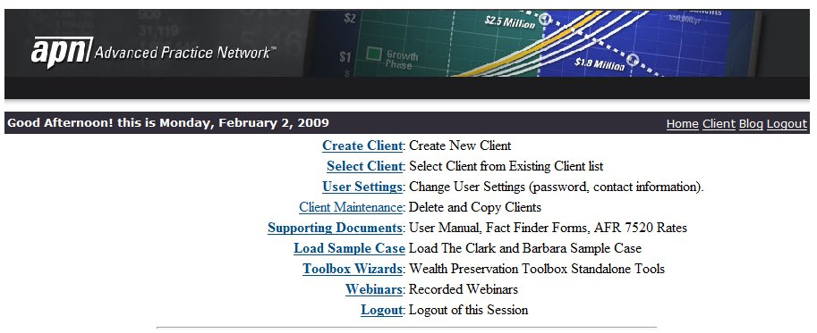

If at any time you get lost within the system, simply click on the Home button in the upper right corner of the screen to be taken back to this menu. We will refer many times to Links, which are items on the screen you may click one time to go to another menu or screen. They are identified by their blue color and underline. If you wish to stop your session in the APN Edge system, click on the Logout link in the lower right corner of the screen, and then confirm you wish to logout.

Using the System

The Edge System is a sophisticated database that is accessible through the internet. When you receive your user name and password, a directory within the database is allocated just for you. Thus, no other user can access the information or client cases you input to the system. Any data you enter as part of a client case is automatically saved to the database, and will be readily available during your current session, and any other time you log back in. All data is saved on the APN web servers – which means you do not have to use disk space on your own computer. When you are ready to print a case, you will create a report (in the universal Adobe format) that can be saved on your computer and viewed or printed as many times as you wish.

Since all aspects of each client case (calculations, case design, etc.) are saved to the APN web database, you will need to be online any time you create or edit a client case. Once a case is saved in the report format (Adobe), you may view and print that case at any time without being connected to the internet. If you wish to enter or edit data in the presence of a client, simply make sure you have internet access to your computer in the room of your meeting.

The APN Edge Blog

From the main toolbar, one can launch a new window to access a BLOG that is dedicated to the Edge Software System. Entries in this blog will be updated on a frequent basis and provide additional insight of the software. New features will be introduced as well as some tips and techniques that one may use. If you wish to make comments, you are welcome to do so.

IRS Section 7520 Rates

From the main window, you can select and display a table that lists the past and current IRS Section 7520 rates. This will be updated on a monthly basis.

Client Maintenance

From the main menu, you will find other links that point to documentation, changing your password, and deleting clients. At a future time, the ability to copy a client’s data will be provided.

Data Entry

Here are some key elements for entering data within the system:

- All dates should be entered in the following format M/dd/yyyy. Suppose you want to enter in the date September 15,1942, then you would type 09/15/1942. Typing the date in another format may generate an error, and or may default to today’s current date.
- Numbers can be entered with commas, and decimal points:
  - 4,567,555
  - 3000000.00
  - 4,500,000.00
- Numeric data fields that are entered in as a percentage may include a percent sign. The software stores this number in its decimal format; enter it in as a percentage:
  - 2
  - 2%
- Phone number can be entered in any format, but you want to be consistent.

Sample Case

The APN Edge System includes two sample cases that you can load and copy to your account:
- Clark and Barbara Jones - $65M Estate
- Bruce and Nadine Smith - $25M Estate

For each of these cases, the assets and liabilities, basic documentation, personal data are included. The Estate Planning Strategies are not part of the sample case. You can access these from the main menu: “Load Sample Case”. You can then select the sample by clicking on the appropriate link. Many of the examples in this user manual use the data from the Clark and Barbara sample case. After selecting the sample case to load, you will be redirected back to the main menu. Click on the “Select Client” link and you should see the sample case as part of your list of clients.

Creating a New Client Case

To create a new client case (and to follow the sample case we will enter in these instructions), click on the top link labeled “Create Client”. The first section completed is the Client Personal Data (name, date of birth, address, etc.).

It is important to have as much of the client’s data (personal and financial information – see data input sheets) as possible when creating a new case. This will reduce the total time spent on the case, ensure greater accuracy of the plan, and make your client meetings more productive. APN recommends you have a meeting with the client to obtain and/or review this data, rather than just relying on the client to complete paper work on his or her own.

Personal Data (Contact, Family & Advisor info)
Now let us get started … click on Create Client. You will now see the Personal Data screen (below). When you have entered in the information, click Add.

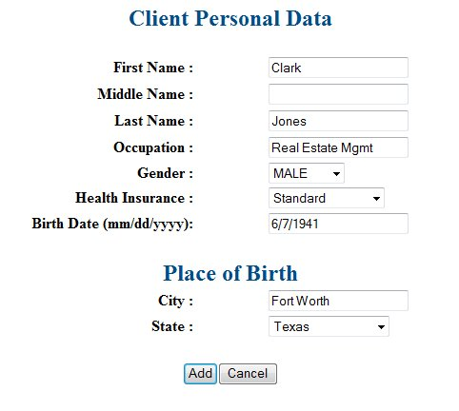
NOTE: Please enter in all of the information contained in this sample case so you can verify your output with the one generated by APN. This will ensure that your computer system and settings do not cause any difficulties with the software calculations and report generated.

The data you have just entered has been saved to the database. You can now access the client file named Clark Jones anytime you enter the system. If you have just entered the new client information, or selected an existing client, you should see the Client Screen and its associated links for Estate Planning for this client.

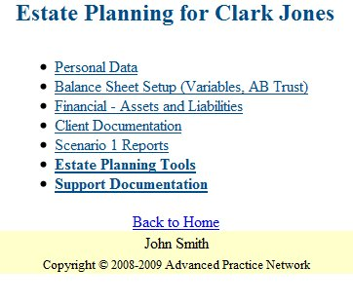

Personal Data

Click on the line “Personal Data”. Your screen should now show other Personal Data information you will need to enter.

Click on the Spouse and Marriage link to enter the information you see below, then click Add.
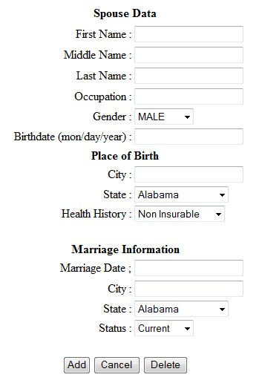
Spouse & Marriage entry form

You will now be brought back to the Spouse screen. If your client had a previous spouse, you would click on Add to enter that person’s information (if desired).

Click on the Personal Data link at the bottom of the screen to continue adding other details (contact info, children, advisors, etc).

First, we will enter information about the children. Click Children, then, in the new screen that appears, click on the Add Child button. Children are entered the same way they are born … one at a time. They are also listed in the order in which they are entered. Thus, if you want the oldest first, youngest last, and so on, then they must be entered in this manner.

The grandchildren’s first names and ages will appear exactly as they are typed – including spaces, hyphens and any other separators. Thus, when entering text, you may wish to type longer entries into a word processor beforehand for assistance. Word processor tips can be found further below.

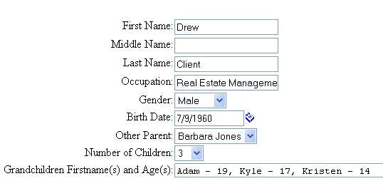

Now enter the information for the other children (below).

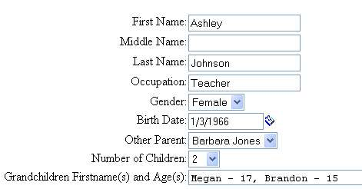

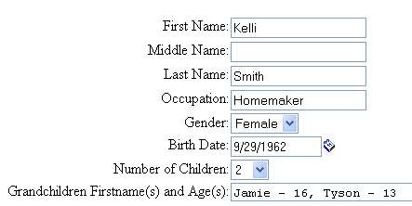
Child entry forms

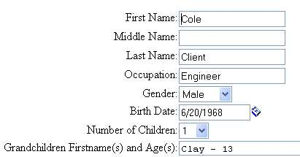

When finished, click on the Personal Data link at the bottom of the screen. Now we will enter the client’s contact information. Click on the Add Residence button to insert contact information for the client’s home, business, vacation and/or second home.

The first thing you must select is the type of location for this entry. The type will determine the order in which the information is displayed (work first, then home, then other), and the label header automatically given to the contact source (e.g. “Work Address”). The description is optional, but very helpful. All information will appear exactly as it is typed. Therefore, if you want the phone number to appear with parentheses around the area code, then you must type them in the entry box.
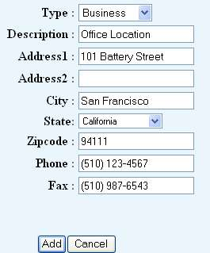
At left is the entry for the work address.

Residence / Contact info entry forms

Follow the same procedure for the primary residence and vacation home.

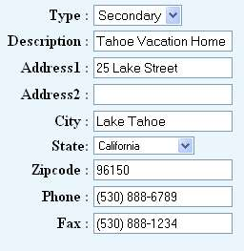
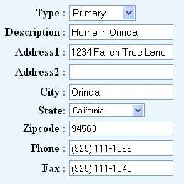

Next, we will enter the contact information for all of the advisors working as part of the planning team. Each name entered will appear on page three of the plan printout. Click on the Advisors link to begin.

We will add the accountant first, and then the attorney (see below). As in other parts of the system, all text (e.g. phone and fax numbers) will appear exactly as you type them into the input line. The advisors will appear, from left to right, in the order they are entered.

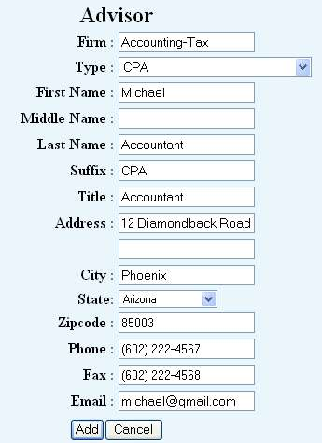
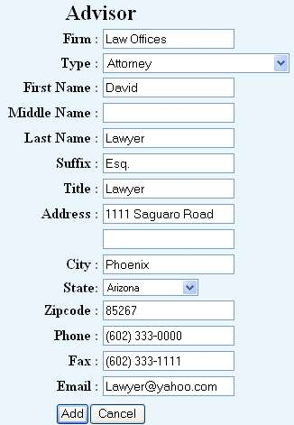

Advisor entry form

Now, add your own personal information as the planner for your client. Generally, you will want to be the “Wealth Preservation Strategist”.

When all the advisors have been added, click on the Personal Data link again, and then click on the Heirs link. Although children and grandchildren have already been added, this feature allows you to specify the total number of heirs to be used for gifting and planning purposes. This number should generally be equal to the number of children and grandchildren. Click on the Change button, then type the # 16 in the text input line.

Congratulations, you are now done entering the client’s personal data. Next, we will enter the financial information (assets and liabilities) to create the balance sheet and projections.

Financial Data (Assets & Liabilities)

Click on the Client link at the bottom of the screen to go back to this client’s main page. We will proceed in order of those listed on this screen, beginning with Cash & Equivalents.

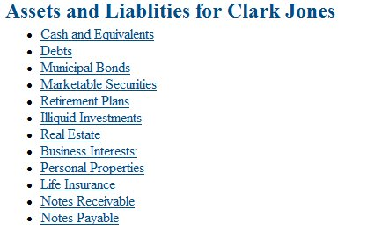
Asset & Liability Menu Screen

Cash and Equivalents

The first asset added in the Cash & Equivalents section is a standard checking account. Remember – these and all other assets & liabilities entered into the system will appear in the order they are entered, not alphabetically or numerically. Thus, if you have a preference regarding the order of assets listed for a client … set your order from the beginning.
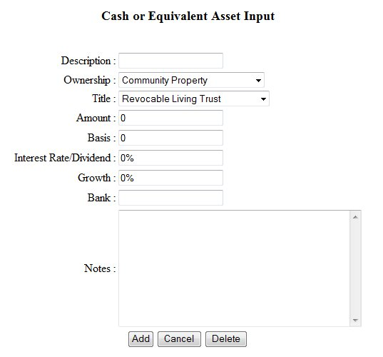
NOTE: Every input line must contain an entry, so a zero must be typed instead of simply leaving a blank line in order to proceed.

Be certain to know the ownership and titling of each asset entered all throughout the system. If you do not know the ownership, assume Joint Property, until you learn the correct answer, since it is the most common type. Community Property is not available in all states. If you are not certain of the title, select Not Sure until you can learn the correct answer.

This is how each Asset/Liability home screen looks in the system. This view allows you to see all of the assets that have been entered for a particular category. From here, you can view and edit the details of each asset. If you wish to delete an asset, then click on edit and one of the options will be to delete it.

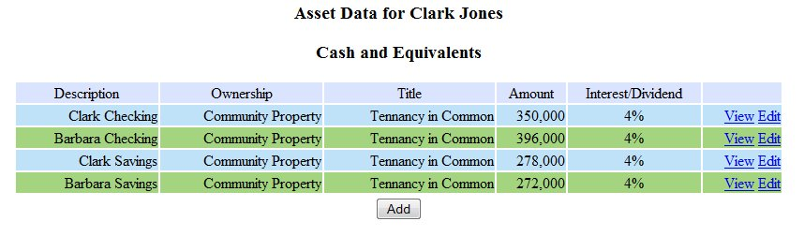

Debts

To begin entering Debts, click on the Next button in the upper right corner of the screen (fastest way), or click on Assets & Liabilities at the bottom of the screen, and then select Debts from the main page. If you are ever lost within the system, just click on the Client button at the bottom of the page to return to the main Estate Planning page for the client whose plan you are reviewing.

Municipal Bonds

Now click on the next button in the upper right hand corner of the screen to go to the Municipal Bonds section, and add the asset shown below.

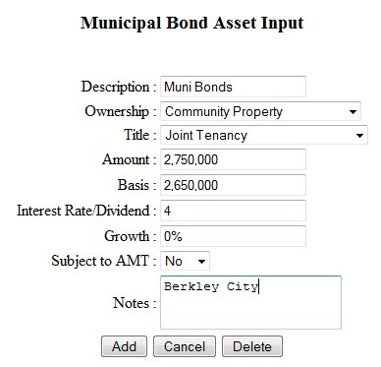

Marketable Securities

Now click on the next button in the upper right hand corner of the screen to go to the Marketable Securities (Securities Portfolio) section, and add the assets shown below.

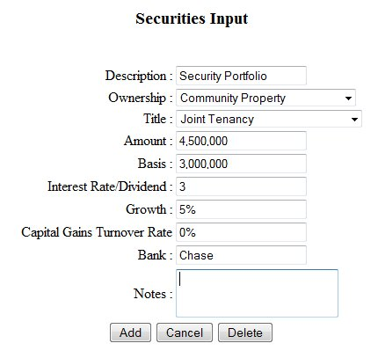
Marketable Securities asset entry forms

Retirement Plans

Make sure you know how each individual plan is calculated from a minimum distribution basis for your own clients – which will affect how the plan is calculated to life expectancy throughout the client case. For this sample case, we assume each Retirement Plan is calculated based on lives of both … the plan owner and the spouse.
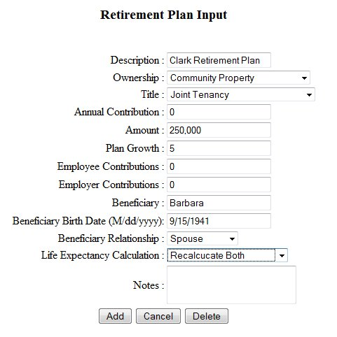

Illiquid Assets

Illiquid assets may include business interests and other holdings that are not easily sold. Below you will see how the entry form for Illiquid Investments appears.

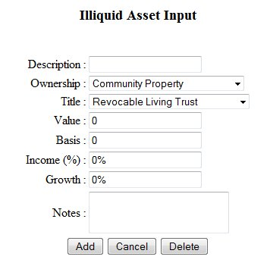
Illiquid Investment asset entry form

Real Estate

Many estates will have real estate assets that are separate from their personal property. This may include business buildings, malls, etc. Many properties may be owned by one of more individuals, only enter in the client’s share of the property, rents, and expenses. You might want to make a note of joint ownership in the notes section.

The Gross Rents and Operating Expenses entries are a Yearly amount, not monthly. As you can see, many additional input and assumption options are available for the Real Estate assets.

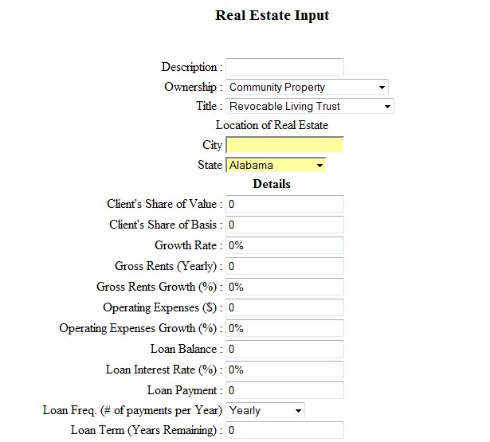
3

One can also add depreciation; this currently only supports the straight-line depreciation method. Enter the current value, salvage value, and the year of liquidation.
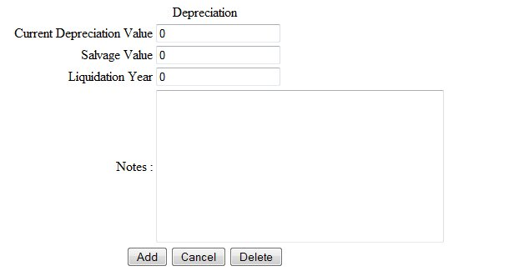

Business Assets

Only input the portion owned by the client. The field “Anticipated Liquidation Date” is the date that the client expects to sell this business if it is part of their plan. The software will then change the net worth of the asset to a cash flow entry in the year of sale.

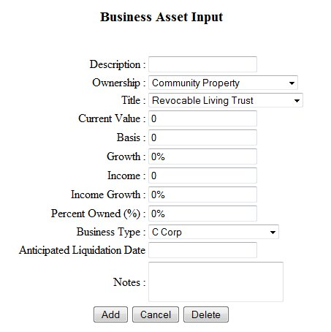
Business Asset data entry form

Personal Use Property

We will now enter assets in the Personal Use Property category. These assets may include homes, boats, cars, antique Chia Pets, furnishings, jewels, precious metals, and others that do not fit in any of the other categories already discussed. While one might want to put a residence and or vacation home in the real estate section, it is best to do so here.

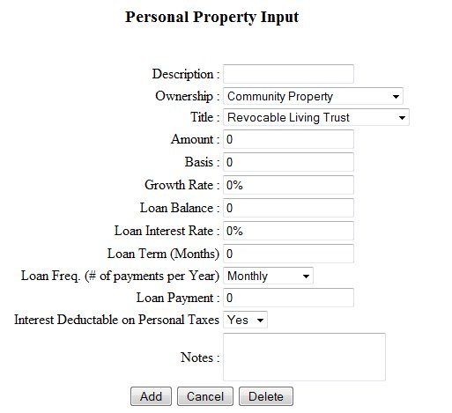
Personal Property entry forms

Life Insurance

We will now add the Life Insurance assets for this client. We assume the client has three whole life policies, all owned within the taxable estate.

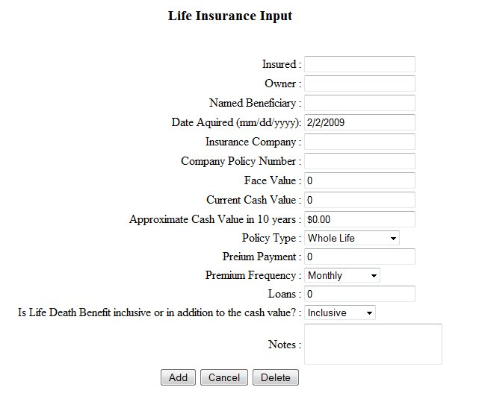
Life Insurance entry forms

If you add a cash value for the 10th year, the software will extrapolate the cash value over the life of the cash flow analysis. While not an exact figure, it does approximate the cash value for later years.

NOTE: You will notice that many asset entry forms, such as these for life insurance policies, contain a Notes section at the bottom. Any information typed in the Notes section will not appear in the report printout.

Notes Receivable and Notes Payable

The last two asset categories are Notes Receivable, and Notes Payable. These assets are simple notes that are owed to the client, or that the client owes to another individual or entity.

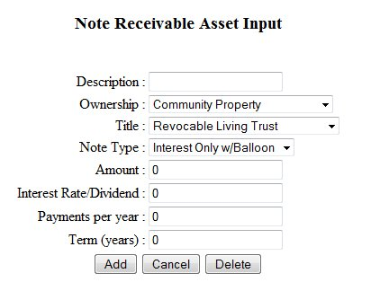

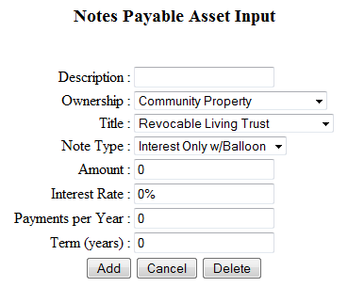

Scenario 1 Setup

At this point, you have entered several assets and are ready to setup the parameters for generating the Cash Flow and Net Worth tables. Click on the link “Balance Sheet Setup” found on the client menu. You will see three links. The first link takes you to the screen for specific variables used in the analysis:

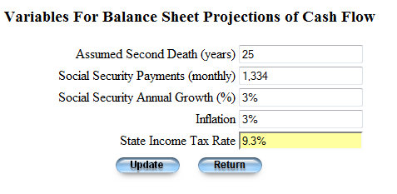

The first field “Assumed Second Death (years) is the value that you pick for the number of years to project the table. For best results, you should pick a number that is 4-5 years beyond the projected last death of either the client or spouse. For instance, in the Clark and Barbara sample case, the projected years of life expectancy are 14 and 18. We would then pick a number greater than 18, for the sample we used 25 years.

Enter the estimated Social Security Payments (monthly) and the annual growth of the social security.

Since each state has its own income tax rate, and income bracket for high net worth clients, input the tax rate for the state where they reside. This will be used to estimate the tax burden on income for each year.

The next link on the setup menu “Additional Balance Sheet Line Items” is used to add lines to the cash flow, net worth, estate distribution, to family, and to charity.
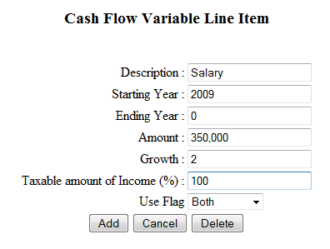

For instance, if you wish to add a salary for the client from a source other than one of the assets, you can add it here. In the example shown, we start the salary in year 2009, with an initial amount of $350,000 and a growth rate of 2% per year. The Ending year value can be a specific year such as 2015, or if you put “0” then it will continue without stopping.

Specify the portion of this as a taxable amount.

Similar entries can be added t o the plan for the major section of the Scenario reports.

Another section in the setup is specifying the AB Trust.

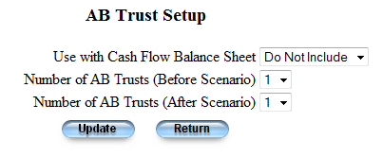
First of all if you do not want to list the Marital Deduction, select “Do Not Include”, the next two fields select the number of trusts or deductions to include in the before and after scenarios.

Click back to the “Client Menu”.

Client Documentation

Now we are ready to do some typing. On the main Estate Planning screen (discussed just prior to the income/expense assumptions), you will see the options for Objectives, Philosophy, Observations, & Recommendations. All four of these categories are sections in which you type text, which appears exactly as you type it. We highly recommend you use a Word Processor (such as Microsoft Word, Word Perfect, etc.) to type this information first, and then copy and paste it into the APN System.

NOTE: None of the calculations of the client plan will be affected by the text that is typed into the four above noted categories. Thus, you may wish to leave them blank for some of your own cases. However, since these areas can provide terrific insight into the plan analysis and recommendations, they are incredibly helpful tools to help the client agree to implement your recommendations.

The APN Edge System, like most web-based applications, does not utilize spelling or grammar correction technology. This why using a word processor will be vital. Spelling errors detract from the content and erode client and advisor confidence in the plan design. Remember, though, that even the best programs cannot find all spelling and grammar mistakes, so be careful to review the text thoroughly.

The next section we start creating the client documentation to include in the report. Currently there is no support for special formatting, although at some time we will add that functionality.

Objectives: When working with a client, you will find that they have specific wishes and desires. As a trusted advisor, you will work with the client(s) to generate a list of objectives for their estate planning. Each objective is automatically numbered.

Philosophy: These are values and ideas that the clients may wish to define. Help with generating these ideas, is found in the Estate Planning Documentation from the APN network. Both a title and body of text are required.

Observations: As you model the client’s estate, you will notice several things that you might want to document and print as part of the report.

Recommendations: As you work with your clients advisors, you will make several recommendations that will help with their estate planning. The data entry of these requires both a header, and associated text. Both are required.

Examples of each of these four sets of documentation are found in the sample cases. It is important that you create your own observations, objectives, philosophy, and recommendations for a particular client. The personalized nature of these is an important part of your presentation for the client. You may use the sample case wording if it is appropriate.

Scenario 1 Reports
The Scenario 1 is critically important to help show the client how much money/assets they will lose to various taxes, especially upon death. In other words, this will help the client recognize the fever so you can then prescribe the aspirin.

Click on the Scenario 1 Reports link from the client menu.

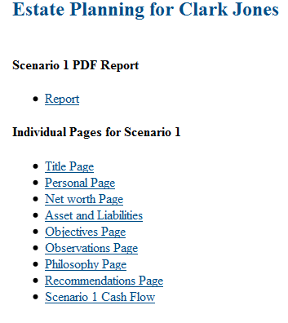

The first link will print out the report for the existing estate from the assets, and setup variable that you have entered. This report does not include any estate planning that you may have done. The other links on this page print out the individual pages from this section of the report.

The reports and pages are all generated as Adobe PDF documents, and are downloaded to your browser. You can then save these from the Adobe software plug-in within the browser, just click on the printer icon, or even save it first to your computer by clicking on the “floppy” icon.

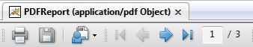

Whenever you create a new client in the APN Edge System, we recommend you generate a report of Scenario 1 and save the file as a record. Then, you can easily reference that as a baseline going forward. The client and/or advisors will almost always have various changes to the projections or assumptions used, so don’t spend time on Scenario 2 for your own client cases until after the client and team have agreed on the baseline.

Designing Estate Planning Tools/Recommendations – Scenario 2

Now the real fun begins. Although this instructions manual will show you how to enter planning strategies in the APN Edge System, its purpose is not to tell you when, why and how to design the strategies themselves. Each tool and or strategy

From the main client screen (below), click on the Estate Planning Tools link. If you are just starting the planning stage, or want to start over, click on the “new button”, otherwise click on the “continue” button.

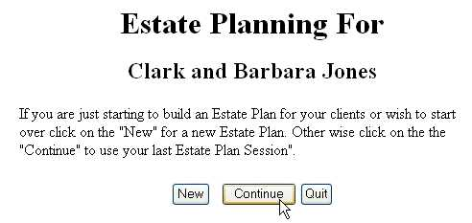
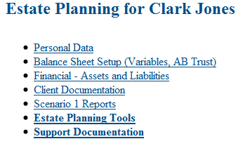

You will now be directed to the main Estate Planning Tools input screen (shown below). If you have already created some planning techniques for a client, they will appear on this screen. As you can see, this list is currently blank since we are just starting to enter techniques.

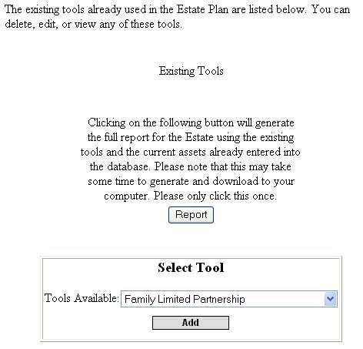
Estate Planning Tool input form

When we are done adding all of the recommended strategies, your Estate Planning Tools screen will look like the following.

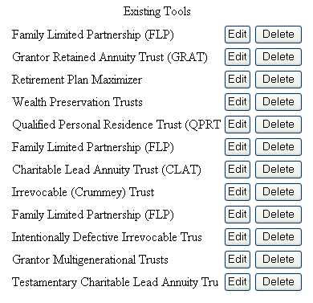
List of Existing Estate Planning Tools (shown as it will look once all tools have been added)
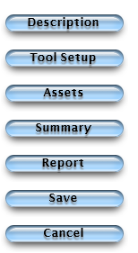
All of the tools will show a similar button menu on the right hand side of the web browser menu. Normally, you will work from top to bottom, but if you need to go back, you can select the section from the menu:
- Description – This will direct you to the screen where the tool matrix is displayed, this provides some guidance on how this tool should be used.
- Tool Setup – Properties and variables for each of the tools are entered from this menu screen. For instance, in many of the tools, the IRS Section 7520 rate will be entered.
- Assets – You can add one or more assets to most tools. The strategies that do not require assets will not have this menu button.
- Summary, a brief summary of the tool will be presented, after looking at the numbers; you can go back and make adjustments.
- Report – This generates those pages from the Scenario 2 report for that tool.
- Save – After entering the tool setup fields and assets, you can save this to include it as a strategy for Estate Planning.
- Cancel – This cancels the most current session using this tool.

Family Limited Partnership (FLP)
The first technique we will add is a Family Limited Partnership (FLP). FLPs are used throughout this client case, and most all other client planning cases, in combination with other techniques (CLAT, GRAT, etc.) to further leverage the reduction in taxes obtained. This is because the assets may receive a reduction in value (by a certified valuation or appraisal), due to the lack of marketability and lack of control through the Limited Partner ownership interest in the asset(s). Thus, for tax purposes, the value of an asset may be valued at 30% less than its original value simply by transferring ownership into an FLP. There are several rules and issues that one needs to figure in when establishing an FLP. Check with an attorney, and use the services of an appraiser will provide you with the guidance in establishing this partnership and its associated discounts. This is prior to any further discounts or leveraging obtained with the actual planning strategy (GRAT, etc.).

Choose Family Limited Partnership (FLP) from the drop down list and select Add.

You will now see the main FLP menu (below).

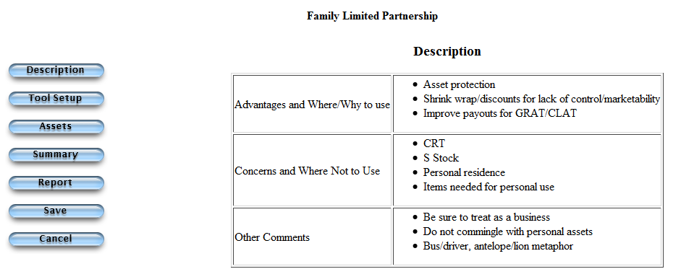

The Description screen is the main page you are viewing. You cannot change this overview description text and diagram. The only aspects that you may change are the Tool Setup and the Assets. We will walk through each of these.

Click on the Tool Setup button. This is how you enter a name and specify the general variables for this particular tool. However, entering this information still does not yet add any benefit or value to the client’s plan until we add assets to the technique. Enter in the information you see below for the FLP parameters, and then select Update.

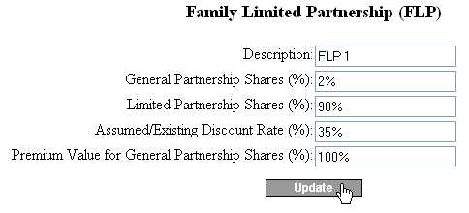
FLP entry form

After you click Update, you will then select “Save” button on the right hand menu.

Now, click on the Assets button to choose what item(s) will be added to the FLP as property.

Click the drop down list next to Assets Available, and select the asset that you want to add to the FLP. Leave the Amount of Asset to Distribute as 100%, (If you only want to add a part of this asset, and then enter the percent that you want to add). Click the Add button.

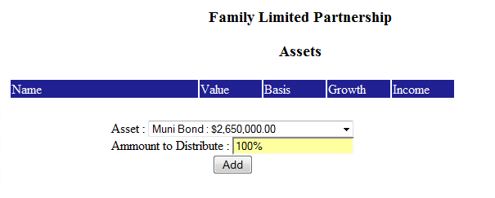

Once the asset has been added, you will see it listed as an asset of this technique.

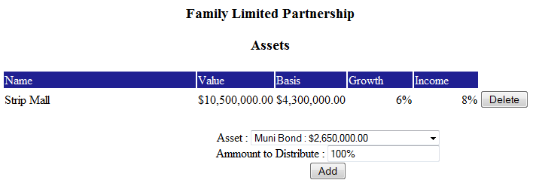

At any time, you can view the summary of the assets added to the FLP, and the $ amounts attributed to General and Limited Partner interests, and the appropriate discounted value, by clicking on the Summary button. The Summary of FLP 1 appears here.

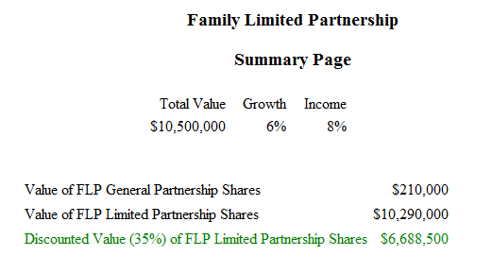
FLP summary screen (once the tool has been added)

When you are done, click on the “SAVE” button to save the FLP with the assets that you have added.

You will follow this same process for your own client cases. You will select the FLP, as a tool to use, then you will add one of the client’s assets to this technique.

NOTE: The APN Edge System is designed to help avoid as many errors as possible, without hindering your creative planning. Thus, if you add an asset to a technique (e.g. FLP), then that asset will no longer appear in the drop down list of available assets for that tool the next time you view that screen. You may add as many assets as the client owns to any tool in the APN Edge System.

Qualified Personal Residence Trust (QPRT)
The next tool we will use is a Qualified Personal Residence Trust (QPRT). Although the tool is entered as one strategy, two trusts will actually be used to yield a greater discount on the tax value of the strategy. To do this, the client’s attorney would separate the ownership of the home into two partial ownership interests, one owned by the husband and the other by the wife, individually. This split or fractional interest ownership can provide another layer of discount for lack of marketability (most buyers would not want to share the home with some other owner they do not know).
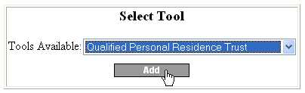
Choose Qualified Personal Residence Trust (QPRT) from the drop down list and select Add.

Now click on the Assets button and add the Asset (in the example we show a Vacation Home).

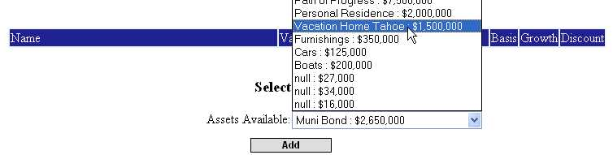

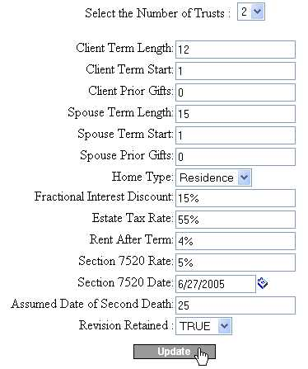
QPRT variable screen (shown when you click Tool Setup)

Although the APN Edge System automatically applies the applicable estate tax rate in any given year, based on current law, you still need to specify the applicable estate tax rate to show how any particular asset would be distributed to heirs and taxes if both deaths occurred today. When a report is generated, you will see a pie chart that reflects this tax/heir distribution.

The rent after term demonstrates that upon completion of the trust term(s), the home will be owned by the trustee(s) of the QPRT – which will not be the client. In any arms length transaction, a homeowner would require a non-owner resident to pay rent for the use of the property, based on general market rental rates.

NOTE: Do not forget to update the IRC § 7520 rate (Applicable Federal Rate – AFR) if the implementation date goes beyond the three month window during which an established rate may be used.

You may now view the overview of the layout and benefits for the QPRT technique by clicking the Summary button (below).

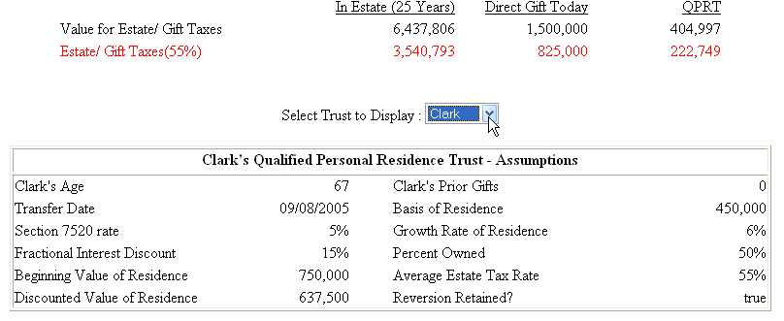

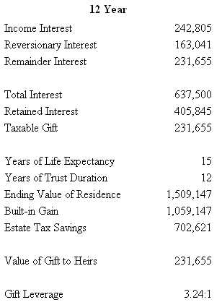

NOTE: You will see the term Gift Leverage in some tools used in the system. This term refers to the amount of success a tool yields in tax savings. For example, if a client made a direct cash gift to a child, the entire amount would subject to a gift tax calculation (using the annual exclusion, lifetime applicable credit amount, or a current gift tax). Thus, the leverage on a straight cash gift is 1:1. It cost $1 to gift $1 worth of assets. The QPRT shown above enables the client to transfer $3.24 worth of assets that are valued, for tax purposes, as only $1. The higher the ratio (e.g. 10:1), the better the results from the strategy. This will be a helpful reference point as you help the client to decide which strategies are most important to implement.

Grantor Retained Annuity Trust (GRAT)
The next tool we will use is a Grantor Retained Annuity Trust (GRAT) for the client’s Strip Mall asset – the LP portion that we recently added to an FLP. Although the tool is entered as one strategy, two trusts will actually be used (like the QPRT) to yield a greater discount on the tax value of the strategy.

Once you click to add the GRAT, you will be taken to the Tool Setup screen. Enter the information below and click Update. NOTE: Using insurance is not the default. You must select Y from the drop down menu at the top to open the insurance input blanks at the bottom of the form.

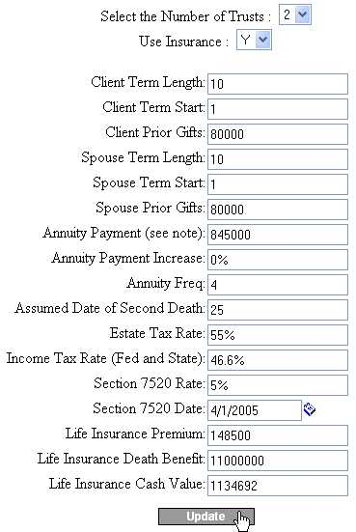
GRAT variable screen (shown when you click Tool Setup)

The Tool Setup screen will be refreshed with this information. Now click on the Assets tab. From the drop down, select the FLP-LP asset valued at $10,290,000, and click Add.

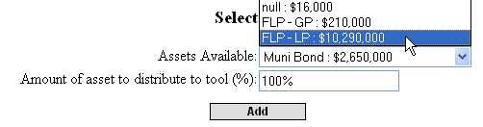
Adding an asset to the GRAT

You will now see the FLP-LP shares we created earlier (from the Strip Mall asset) added as an asset of the GRAT. The GP shares will still be owned by the client inside of their taxable estate. You may now view the overview of the results/benefits of adding the GRAT technique by selecting the Summary button. The top of your summary should be the same as shown below.

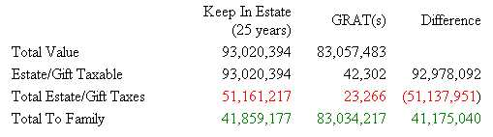

You will also notice the Gift leverage shown towards the bottom of the screen. With an leverage of 243 to 1, the GRAT, combined with life insurance, is one of the most significant tools a client can use to reduce taxes and increase wealth transfer.

Click the Save button at the bottom of the screen to solidify this strategy to the client’s plan. You will be redirected to the Existing Estate Planning Tools screen, where we will begin adding the next tool.

Charitable Remainder Uni-Trust

The next tool we will use is a Charitable Remainder Trust (CRT), or more specifically a Charitable Remainder Unitrust (CRUT). The CRT will be used to sell three real estate properties and avoid an up-front capital gains tax assessment.
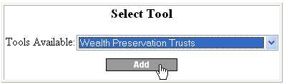
Select Wealth Preservation Trusts from the Select Tool menu and click Add.

Click on the Tool Setup button and enter the information you see below and click Update.

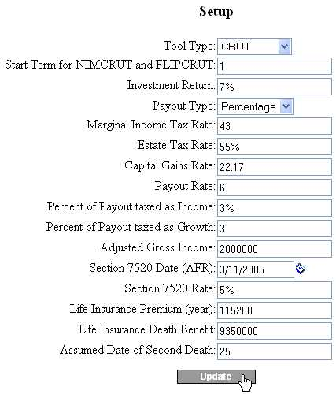
CRT variable screen (shown when you click Tool Setup)

Now click on the Assets button at the top of the screen to add three real estate properties to this technique: Crescent, Adams Ave, and Ramada. Once added, your Assets screen will refresh and look like the one below.

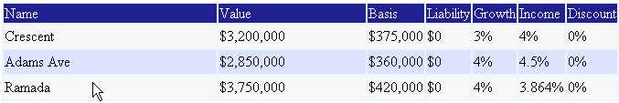

You may click on the Summary link to view the details of this technique. Please remember to click Save, either on the menu of the screen to implement this tool for the client plan. You will then be directed back to the Existing Estate Planning Tools screen again, where we will begin adding the next tool.

Retirement Plan Maximizer (RPM)
The Retirement Plan Maximizer (RPM) is just as its name implies – a tool to derive more wealth transfer out of an existing retirement plan account. These qualified accounts are subject to the greatest amount of taxation of any asset in the estate due to the double taxes – income and estate. The income tax comes in the form of Income in Respect of a Decedent (or IRD) – which means that the owner/recipient would have to pay income on the pre-tax contributed assets upon receipt of the money. This is on top of the estate taxes due upon death.
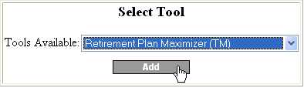
Select Retirement Plan Maximizer (TM) from the drop down list of tools at the bottom of the screen, and click on Add.

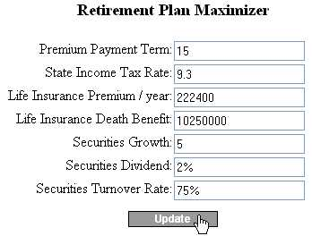
Click on the Tool Setup button from the top menu. Change the setting to match those shown here.

Now click on the Assets button to add these three retirement plan assets: Company Plan, Personal Plan IRA, and Barbara. Once added, your assets summary page should look like this.

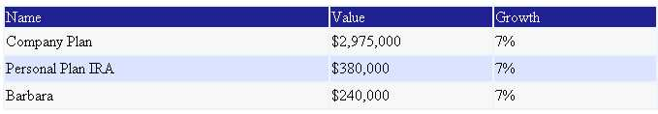

You may select any other buttons from the top menu to view the effectiveness of this strategy, and its comparison to the current scenario for transferring the retirement plans. You will notice that with the current scenario, at its highest taxation point (due to current law), the total percentage to taxes is over 84%!

As always, remember to click Save, either at the top or the bottom of the screen to implement this tool for the client plan. You will then be redirected to the main Existing Estate Planning Tools screen, where we will add another Family Limited Partnership.

Charitable Lead Annuity Trust (CLAT)
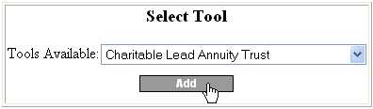
Scroll down to the bottom of the page to the Select Tool menu.

Select Charitable Lead Annuity Trust and click Add.

You are now viewing the main Description page for the CLAT. As you can see, a CLAT differs in many ways from a CRT. The main difference is that the income portion paid to charity is made immediately, with the remainder trust balance transferring to the client’s intended recipient (generally their children, grandchildren, etc.). Thus, an immediate source of cash (generally resulting from the assets contributed), and the client’s ability to go without these payments, are necessary for this technique to work.

As you will note from the assets contributed to the FLP we will use (above), income producing real estate is the primary source of assets we will use. We have also assumed contributing a portion of securities (liquid investments) to the FLP that will be used. This provides some readily accessible cash – just in case the real estate rental income during any payment period is less than required from the trust.
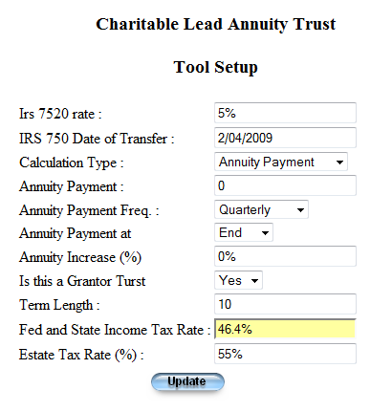
Click on the Tool Setup button and enter the information seen here.

There are three calculation types:
- Annuity Payment – an specific amount that you specify
- Remainder Interest – What the desired remainder interest would e.
- Zero remainder interest

If you want to increase the annuity payment on each year, input the percentage increase.

If this is a grantor trust, then select yes.

Click on the assets button and add one or more assets. Generally, you will want to create an LLC, or FLP to maximize the effectiveness of this tool.

Your summary of the CLAT tool should look the similar as the one below.

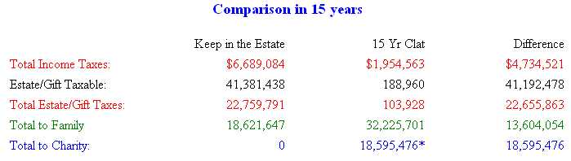

Be sure to click the Save button to add the CLAT as a technique used for this client. You will now be returned to the Estate Planning Tools page – ready to add the next technique. Seven tools down, five more to go.

Irrevocable (Crummey) Trust (ILIT)
Although several planning tools utilize life insurance tied to their specific design and objectives, an Irrevocable Life Insurance Trust (ILIT) is still necessary in most client cases. Many planning techniques can reduce or eliminate the respective taxes on various types of assets. It is far more effective to not pay taxes at all, than it is to buy life insurance to pay the taxes. However, not every asset in an estate can benefit from sophisticated tax-leveraging tools. In addition, life insurance remains a very effective transfer and payment tool based on its favorable tax treatment that has existed for decades.

The new life insurance policy we will use for this case assumes an annual premium payment of $620,600, and a death benefit of $40,600,000. In order to add the ILIT technique, scroll down to the bottom of the Estate Planning Tools page and select Irrevocable (Crummey) Trust from the list and click Add.
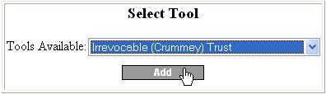

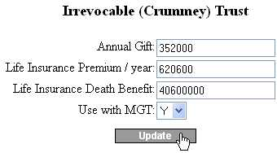
Click on the Tool Setup button and add the variables seen here.

The screen will refresh once you click Update. Make sure you click Save at the bottom of the screen to add this tool to the current client or it will not be part of the recommendations (even though you clicked Update).

The ILIT tool is now added to the recommendations and planning tools used by this client. You will be redirected to the Estate Planning Tools screen, ready to add our next strategy.

Intentionally Defective Irrevocable Trust (IDIT)

There are two different versions of the Intentionally Defective Irrevocable Trust (IDIT). The first uses an advance technique where the note that is returned to the estate, is placed inside one or more Grantor Retained Annuity Trusts to effectively remove the note from the estate. The second does not implement this second step.

From the Estate Planning Tools screen, choose Intentionally Defective Irrevocable Trust (IDIT) from the drop down list of planning tools, and click on Add.

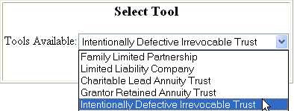

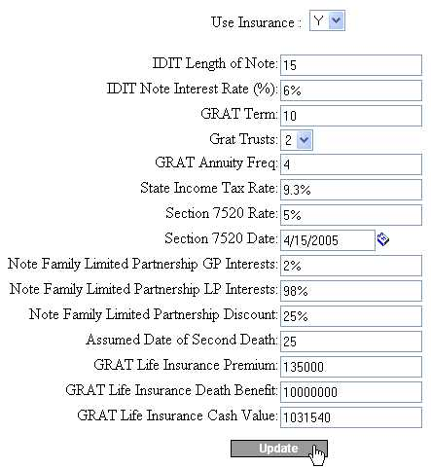
Click on the IDIT Setup button and edit the variables to match those shown here.

NOTE: Make sure to select Yes (Y) to use insurance in connection with this tool. The default selection is No. You will not see the insurance input boxes until you select Y for insurance.

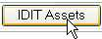
Once you have entered these variables, click on the Update button at the bottom of the screen. The page will now be refreshed. Click on the IDIT Asset button.

The first asset we will add is the FLP IDIT that we just entered above (using the $7,500,000 Path of Progress asset). Select it by name, FLP IDIT-LP, from the drop down list on the screen. Once added, your IDIT Asset screen should look the same as the one below.

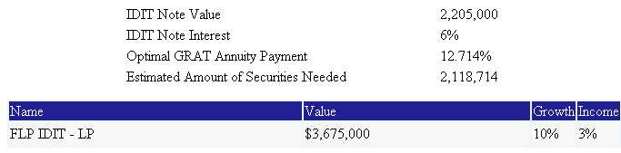

NOTE: Notice that above the FLP asset you will see several variables. One of which is the Estimated Amount of Securities Needed. This is automatically calculated to provide liquid assets to help make income payments necessary with this strategy, to get good gift leverage. However, you do not need to enter this exact dollar amount in as an asset. Rather, you will select a security (or several securities if one does not equal the amount shown) as an asset to add to the IDIT tool, and the correct amount will be placed within the tool as an asset. In other words, the system helps you to optimize this tool, and helps you to only select the appropriate amount of securities from the available list.

Let’s see this helpful feature in action. Scroll down to the Select Securities Portfolio drop down list, shown here.
Asset Add screen showing Security #2 being added to the IDIT
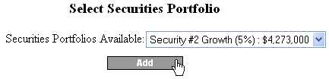

We will select Security #2. Although this asset has a value of $4,273,000, the APN Edge System calculated that only $2,118,714 is needed to optimize the IDIT. Therefore, the system will only allocate about half of Security #2 to the IDIT. When you select Security #2 and click Add, the page will be refreshed. You will see that the system only allocated the $2,118,714 of Security #2 (shown below). Thus, $2,154,286 worth of Security #2 is still available for other planning.

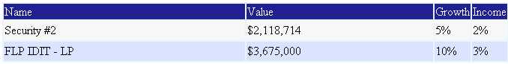

This may seem confusing at first, but this feature is designed to optimize the transfer value of the IDIT planning tool, and help by tracking the dollar amount of the assets that have already been committed to other planning tools.

NOTE: We will use Security #2 for another planning strategy. When you see this asset listed in the drop down list of assets, only the amount remaining will be shown. In other words, the system tracks how much of each asset has already been used for other planning tools. Only the amount remaining, if any, will show as available from the drop down list of assets available for any planning strategy. For example, now that 100% of the FLP IDIT-LP shares have been committed to the IDIT, that asset no longer appears as available in the drop down list of assets to add to another planning tool.

NOTE: As discussed above, always add the FLP asset first to the IDIT, the system will then tell you the amount of securities to add. When you select the securities, only the amount needed will be added from those securities chosen (if the value exceeds the amount needed).

Click on the Comparison button. Your screen should look like this.

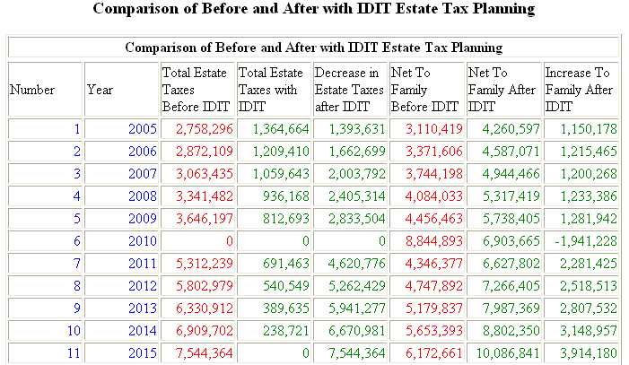

Do not forget to click on the Save button at the bottom of the screen before proceeding.

Intentionally Defective Irrevocable Trust (IDIT)

The second form of the IDIT is the more traditional.

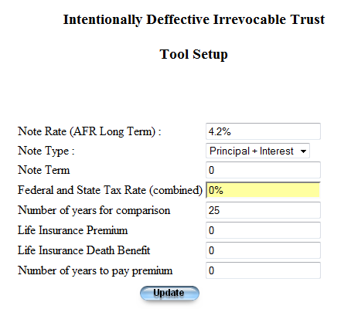
There are a few steps that one should follow when using this tool. First of all the note rate used should be the current IRS AFR Long Term rate as published by the IRS. Second, when adding assets to the estate, you should probably include a liquid cash gift that is some percentage of the assets to be sold. You can also use an FLP or LLC to obtain discounts if applicable due to lack of control, and or marketability.

If you were to sell $1,000,000 of assets to the IDIT by first placing it in an LLC, and then getting a discount of 35%, than the note value is $650,000. The gift should be calculated by dividing the value of the note by .9 or 90% and then subtract the note value, or in this case $72,222.

Multigenerational Trust (Family or Dynasty Trust)
Our next planning tool will be the Multigenerational Trust (often referred to as a Dynasty Trust or Family Legacy Trust).

NOTE: This tool is designed within the system as a Grantor trust – meaning that the trust is designed for the client (the grantor) to retain or derive some sort of control or benefit within the trust provisions. This may take many forms, and will be different from one trust to another. However, in this sample case, we assume that the client is grantor, not the owner, of the trust, and is liable, by law, for the income taxes owed on income attributed to the assets within the trust. Since the client must pay these income taxes, the trust is further leveraged by not having to make those respective tax payments. This may be a substantial amount of money each year. However, since it is by law (part of the grantor provisions and guidelines), the “extra” benefit to the trust of the income taxes not paid is not deemed a gift. Thus, the trust receives additional leverage of transfer and growth by making it a grantor style trust.

The system also allows you to specify whether the trust created is subject to the Rule Against Perpetuities. This rule essentially limits the life of a trust, depending on the term set by the respective state. Not being subject to this rule means that the trust can exist almost indefinitely. However, the trust must be established in a state that allows the existence to extend beyond the Rule Against Perpetuities.
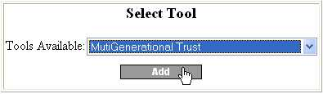
Scroll down to the bottom of the Estate Planning Tools screen and select Multigenerational Trust from the drop down list and click Add.

From this main description page, click on the Tool Setup button.
Enter the information shown below and select Update.

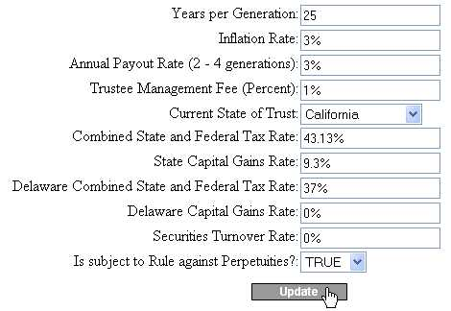
Multi-
Generational variable screen (shown when you click Tool Setup)

Remember, selecting True for “subject to Rule against Perpetuities” means that the trust will not last indefinitely. Click on the Assets button and select Security #1 from the drop down list.

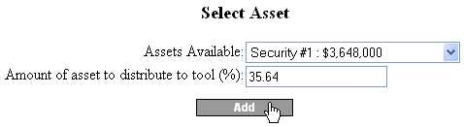

Once the security has been added, the asset screen should refresh and appear like the one below.

Now click on the Comparison button to see the benefits of using this tool. The top part of the screen should display these variables of the trust.

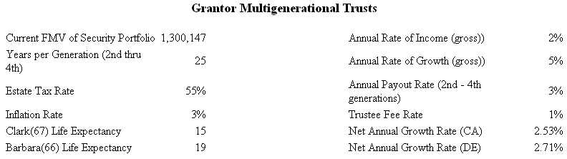

The very bottom of the screen will compare the trust under three scenarios:
- Normal distribution through the estate.
- Distribution through this Multi-Generational trust (assumed created in CA).
- How the assets would be distributed over time by avoiding the Rule Against Perpetuities (if the trust was created in Delaware, or another state that allows the violation of this rule). You should also see values growing through several generations in between these two parts.

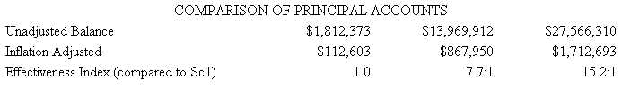

You can see that having the trust designed to avoid the Rule Against Perpetuities can enhance the life and total value of the trust assets. These three options are shown in the report. Do not forget to click on the Save button at the bottom of the screen to add this tool for the client.

Testamentary Charitable Lead Annuity Trust (TCLAT)
The last technique we will add to this sample case is a Testamentary Charitable Lead Annuity Trust (TCLAT). This is often referred to as a last effort to reduce or eliminate the estate taxes as much as possible, since the tool is not created until the death of the client. As opposed to most other tools, the use of a TCLAT generally does not influence any regular management or activities for the client because no assets are transferred to the trust until it is created upon death.

We will add every asset remaining in the estate, except for the GP interests, and the life insurance cash values (listed as null to help you avoid using these assets). If you continue to click Add, the system will quickly add each new asset shown in the drop down menu.

Select Testamentary Charitable Lead Annuity Trust from the drop down list of tools, and click Add.

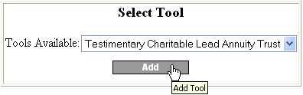
Now click on the Tool Setup button and change the variable to match those below.

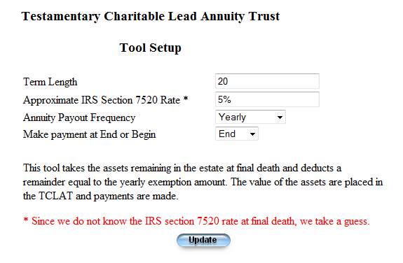
Test. CLAT variable screen (shown when you click Tool Setup)

However, we will not need to click on the drop down arrow each time we wish to add an asset. Rather, you can simply click the Add button each time an appropriate asset is listed. The first is the Muni Bond. Once this is added, the page will refresh and show Clark Checking as the next asset. Again, simply click Add. Do this 10 more times until the first “null” asset is listed. Remember, the “null” assets are the cash values of existing life insurance policies (which we will not use for any tools in the plan).

Now click on the Summary button at the top of the page to view the benefits of utilizing this planning tool. The top of the screen will show the following assumptions.

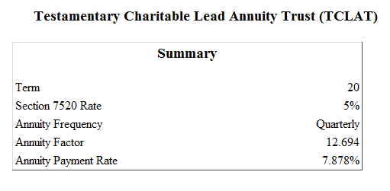

Be sure to click on the Save button at the bottom of the screen to add this tool for the client.

Generating the Client Report

Now that all of the variables and planning tools have been added, we are finished with the creation of both scenarios (1 – Baseline, and 2 – Recommendations) for our sample case. We will now show you how to generate the plan output – which may be saved for viewing and/or printing at any time.

NOTE: You may generate a client report at any time during the process of creating a case for your clients. You can generate a report for the client and advisors to review the data for accuracy of information. Each of these reports helps document the progress of the client progression within your planning and sales cycle. We recommend that you always generate and print a report after you have completed the Baseline (Scenario 1) data entry work for a client for their review. This will save time and ensure accuracy of the assumptions used for planning recommendations.

From the Estate Planning Tools screen, click on the Report button (shown under the list of tools implemented for the client).

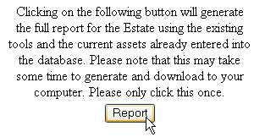

You will immediately be prompted with a pop-up window that asks you to Open or Save the desired report (shown below). We recommend that you choose the Save option because it helps you to see the status and ensure success of the download.

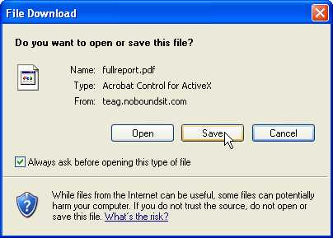

You will then be prompted to choose the destination to save the report.

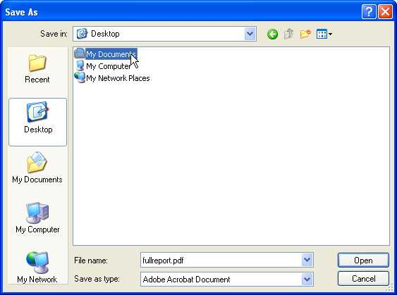

It does not matter where on your computer you choose to save the file, as long as: a) you have enough disk space, b) you give the file an appropriate name, and c) you remember where on your computer it is saved. We recommend saving client files in their own folders, and with unique names. For example, you could create a folder in the My Documents folder named clients. Then, you could create a new folder named Jones for this client. This case could be named “Jones Complete Plan”, or “Jones Scenario 2 (9-15-05)”, with the date being referenced in the name. The default name for each report created from the system is “fullreport.pdf”.

Once you have specified a file name and location, the download will begin. Your screen may look something like the one here, or depending on the browser settings, it will just load the file. A detailed case may be quite large and take a long time to download, please be patient, if everything was setup correctly, it should load.

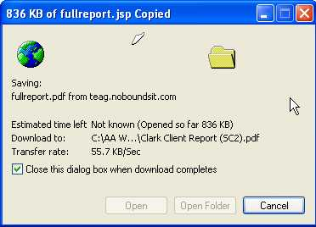

You will see the status of the report in the upper left corner of this new window. The report will be approx. 15MB in size (which is 15,000,000 bytes). For comparison, an average letter in Microsoft Word is approx. 40KB (which is 40,000 bytes). In other words, the file is very large. This is a big reason why a high-speed internet connection is required for use with the system. The download may take 5 to 15 minutes, depending on your exact connection speed.

NOTE: You must use Adobe Acrobat Reader version 6.0 or higher. If not, you may see black boxes around or near some of the pictures generated in the report.

