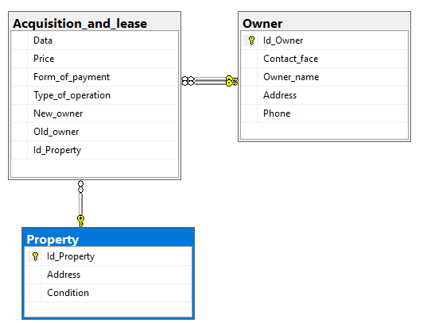

CREATE TABLE Owner
(Id_Owner INT PRIMARY KEY,
Contact_face VARCHAR(30),
Owner_name VARCHAR(30),
Address VARCHAR(30),
Phone VARCHAR(30));

CREATE TABLE Property
(Id_Property INT PRIMARY KEY,
Address VARCHAR(30),
Condition VARCHAR(30) CHECK(Condition = 'відмінний' or Condition='добрий' or Condition='задовільний'));

CREATE TABLE Acquisition_and_lease
(Data_ Date CHECK( Data_<= '2018-10-31'),
Price int,
Form_of_payment VARCHAR(30) CHECK(Form_of_payment = 'готівковий' or Form_of_payment='безготівковий'),
Type_of_operation VARCHAR(30) CHECK(Type_of_operation = 'придбання' or Type_of_operation = 'оренда'),
New_owner INT FOREIGN KEY REFERENCES Owner(Id_Owner),
Old_owner INT FOREIGN KEY REFERENCES Owner(Id_Owner),
Id_Property INT FOREIGN KEY REFERENCES Property(Id_Property));
INSERT INTO Owner
VALUES(1,'Alla Limenes','Zarina','Varazishevi street 5','716(56)601-69-52'),
(2,'Tatyana Krichevskaya','Jamila','Gomi street 3','5(44)058-80-32'),
(3,'Marina Stavitskaya','Guzel','Kojorskaya street 10','6(236)515-98-50'),
(4,'Svetlana Slivinskaya','Saida','Sioni Street 21','56(8182)131-91-22'),
(5,'Welta Deglava','Hafiz','Samgebro 9','48(6265)807-66-71'),
(6,'Tatyana Tkach','Zuhra','Wine rise 54','3(0463)762-78-40'),
(7,'Lydia Smirnova','Leila','Betlemi street 2','9(2619)972-63-93'),
(8,'Zinaida Rakhmatova','Zulfiya','Cotton rows 48','17(120)381-66-01'),
(9,'Tatyana Fedotova','Gulchatay','Abano street 58','30(576)852-12-60'),
(10,'Anatoly Kuznetsov','Fedor Ivanovich Sukhov','Gurdjaan street 14','11(536)895-06-11');
INSERT INTO Property
VALUES(145,'Varazishevi street 5','відмінний'),
(123,'Gomi street 3','добрий'),
(100,'Kojorskaya street 10','задовільний'),
(121,'Sioni Street 21','задовільний'),
(126,'Wine rise 54','добрий'),
(197,'Samgebro 9','відмінний'),
(200,'Betlemi street 2','добрий'),
(24,'Cotton rows 48','відмінний'),
(245,'Abano street 58','добрий'),
(214,'Gurdjaan street 14','відмінний');

INSERT INTO Acquisition_and_lease
VALUES('1999-04-15',20000,'безготівковий','придбання',1,8,145),
('2000-08-17',500,'готівковий','оренда',2,7,123),
('1987-07-13',4800,'готівковий','оренда',3,10,100),
('1997-07-14',45000,'безготівковий','придбання',5,9,121),
('2009-05-17',58000,'безготівковий','придбання',6,8,126),
('2011-04-14',2000000,'готівковий','придбання',7,1,197),
('2018-03-17',690360,'безготівковий','придбання',2,6,200),
('2017-01-12',1000,'безготівковий','оренда',3,4,24),
('2003-05-29',1500,'безготівковий','оренда',5,3,245),
('2006-04-30',2500,'готівковий','оренда',6,1,214);

--SELECT * FROM Owner;
--SELECT * FROM Acquisition_and_lease;
--SELECT * FROM Property;
/*SELECT * FROM Acquisition_and_lease WHERE Price=(SELECT MAX(Price) FROM Acquisition_and_lease);
SELECT * FROM Property WHERE Condition = 'добрий';
SELECT COUNT(*) FROM Property WHERE Condition = 'добрий';*/
SELECT SUM(Price),New_owner FROM Acquisition_and_lease GROUP BY (New_owner);

SELECT SUM(Price) as tc ,New_owner as owner from Acquisition_and_lease group by (New_owner)
having SUM(Price)=(
select max(tc) from (
SELECT SUM(Price) as tc ,New_owner from Acquisition_and_lease group by (New_owner)
) as temp1
)

CREATE VIEW ALL_DATA
AS
SELECT Property.Address,Data_,Price,Type_of_operation,Property.Id_Property FROM Property INNER JOIN
(SELECT * FROM Acquisition_and_lease INNER JOIN Owner ON
Acquisition_and_lease.New_owner = Owner.Id_Owner) AS TEMP ON
Property.Id_Property = TEMP.Id_Property

USE master
GO
CREATE PROC Information_
@Id_Property VARCHAR (20)output
AS
SELECT *
FROM Acquisition_and_lease
WHERE Id_Property = @Id_Property;

EXEC Information_ '145';

CREATE TRIGGER Killer
ON Property
instead of DELETE as
declare @Count int
select @Count = count(*) from deleted del inner join Acquisition_and_lease A
on del.Id_Property = A.Id_Property
if @Count > 0
BEGIN
RAISERROR ('zapret',16,1)
END
if @Count = 0
delete from Property from deleted inner join Property ON deleted.Id_Property = Property.Id_Property

CREATE TRIGGER ADD_UPDATE
on Acquisition_and_lease
for insert, UPDATE
AS
insert into dataAC ([New_owner],[Id_Property])
select New_Owner,Id_Property from inserted

--CREATE LOGIN Bill WITH PASSWORD='Tyu87IOR0';
--CREATE USER Bill FOR LOGIN Bill;
/*CREATE ROLE Auditors
GO*/
--EXECUTE sp_addrolemember "Auditors", "Bill"
--GRANT SELECT ON Accounting.Invoices TO public;
--grant execute on Information_ to Bill;
--deny all to Bill;

