:

Specificatii pe scurt:

- aplicatia trebuie sa faca poza/poze prin camera integrata sau de preferat alta camera (ca sa se poata misca/pozitiona usor) la apasarea unui buton

- la apasarea tastelor stanga/dreapta, se afiseaza pe ecran(ecran sau proiector tot acelasi lucru) pozele facute

- posibilitate manipulare imagine: rotit, deplasat st-dr

<https://www.youtube.com/watch?v=6KJWG6weGO4> , <https://www.youtube.com/watch?v=OjeCFUzUkVQ> – web cam video

<https://www.youtube.com/watch?v=ybA7PaswZcc> – capture images

AForge colour tracking:

<https://www.youtube.com/watch?v=skE4U2pcAtw>

<https://www.youtube.com/watch?v=vFuxNqjAqyg>

C# camera tutorials

<https://www.youtube.com/watch?v=dOvA-Mlx-Vg>

snapshot: <https://www.youtube.com/watch?v=xjMAfMAix9c&t=2s>

C# standalone application:

<https://www.youtube.com/watch?v=USfQzZX-ytQ>

Get all images from folder.

-take picture : - get one frame

-pornire aplicatie inainte de incepere curs : introducere date despre curs …pentru fiecare curs creez un folder(prin program) in care voi saslva pozele.

- pozitionare camera ca sa incadreze tabla,metoda manuala initial(extindere cu pozitionare cu servo, electric, + de pe mobil- reglaj fin )

-adaug posibilitatea de a grupa pozele intr-un folder cu numele cursului respectiv , arhivarea lor si trimiterea lor elevilor (pe mail ). -> nu automat ,ci manual din aplicatie

Incepe cursul :

-proful scrie ceva/umple tabla ->(aplicatia ruleaza).. fac poza(un buton tastatura -> mai tarziu , de pe telefon .

-se sterge tabla -> in orice moment se poate afisa pozele facute anterior pe ecran / proiector (tot din program prin sageti)

-manipulare imagine -> dupa ce afisez poza am optiunile :

- rotire

- zoom

-further functionalities to be implemented

-sfarsit curs :

-Masurare distante de pe poza -> reals

Used links:

<https://www.youtube.com/watch?v=wZ4BkPyZllY> – splashScreen

<https://spark.adobe.com/sp/design/post/d4edc0b9-313b-455c-8ab4-6207ced8bbed> - logo

Bibliografie

<http://www.aut.upt.ro/~dberian/Labs/Laborator3_MTP_IS.pdf>

* Next : curs nou , ora noua de curs ( grupez in foldere cursurile /laboratoarele)
* Parameter is not valid error !!!Application.Run( );

Portare aplicatie pe un server /

18.02 : - buton save image in flowLayout

- afisare poze in pictBox – fullScreen (stanga – dreapta )

-buton pentru fullScreen (

19.02:

-fullScreen :

-https://social.msdn.microsoft.com/Forums/windows/en-US/0ae1b84f-f114-43c1-a560-a1a4588c1eca/picturebox-fullscreen-display?forum=winforms

**STANDARDE UTILIZATE !!! -> BIBLIOGRAFIE -> STANDARDE IT**

Aplicarea conceptului de ClickOnce -> Autoliv ManualUpdates

20.02:

-picture Box free of errors

-screen projector OK

21.02

-Save image

-before starting to capture … set destination folder.

22.02

SAVING Bussines:

Start app : save – disabled ( empty pictBox si flowLay)

Take picture : -pictBox si flowLay

->press Capature -> add pict to pictBox and flowLay

->Save : -> save all pictures from flowLay to folder : select where TO + name of the picture.Lecture name present in ComboBox -> populated at startup with the name of the folders (lecture names)

->Delete .. delete picture from flowLayout : before saving them in folder

26.02

-flowLayout Copy Control :

**Să fac poza si cu telefonul**

27.02

**Write about Bitmaps and Vectorial Images**

* **Extension methods**
* **Clone controls :**

<https://docs.microsoft.com/en-us/dotnet/csharp/programming-guide/classes-and-structs/extension-methods>

28.02

**SERVO ARDUINO CAMERA :** [**http://www.pyroelectro.com/tutorials/arduino_multi_servo/**](http://www.pyroelectro.com/tutorials/arduino_multi_servo/)

[**http://www.instructables.com/id/Arduino-2-Servos-Thumbstick-joystick/**](http://www.instructables.com/id/Arduino-2-Servos-Thumbstick-joystick/)

01.03 – discutie prof :

03.03

- app working with 4-6 ( derulare poze)

-link cod Screen

-http://predicatet.blogspot.ro/2007/01/show-c-windows-forms-on-dual-monitor.html

- https://www.youtube.com/watch?v=kpPvkeKgsaQ

04.03

CRop

-- <https://www.youtube.com/watch?v=kpPvkeKgsaQ>

- https://www.youtube.com/watch?v=n4mjLiMiSmw&t=758s

**TEHNOLOGII MULTIMEDIA AN 4 : BIBLIOGRAFIE -> BITMAP,VECTORIALE….**

**06.03**

**-Sa corectez faza cu 4-6** (apas 4 dupa 6 => trebe de 2 ori )

/* bool IsMouseDown = false;

private void pictureBox_MouseDown(object sender, MouseEventArgs e)

{

IsMouseDown = true;

c.MouseDown(e);

//c.GetRectangle();

}

private void pictureBox_MouseMove(object sender, MouseEventArgs e)

{

if(pictureBox.Image !=null)

{

if (IsMouseDown == true)

{

c.MouseMove(e, ref pictureBox);

}

}

}

private void pictureBox_Paint(object sender, PaintEventArgs e)

{

if(pictureBox.Image != null)

{

c = new Crop(ref pictureBox);

c.Paint(e);

}

}

private void pictureBox_MouseUp(object sender, MouseEventArgs e)

{

if (IsMouseDown == true)

{

c.MouseUp(e,ref IsMouseDown,ref pictureBox);

}

}

*/

**07.03 –**

-pictureSizeMode -> Strech nu zoom …

* Rotate image
* Zoom image - cu efect in ce afisez.
* <https://www.youtube.com/watch?v=m6LiB0ohLy0>
* <https://www.youtube.com/watch?v=S9uSKO-BIgs>

**08.03**

- rotate/crop <https://www.youtube.com/watch?v=S9uSKO-BIgs&t=36s>-F – fullscreen-

G -> forma actuala cu posibilitate de modificare in timp real cand poza e pe proiector

* 1. **–** rotate

<https://www.youtube.com/watch?v=xMOoEuEY-WY>

am incercat <https://www.youtube.com/watch?v=S9uSKO-BIgs> pentru rotatii ..nu merge

am gasit link cu AForge ….Problema .. nu pot deschide imagini facute cu camera => zice ca wrong pixel format.

**Read AForge documentation.**

**10.03**

**-**rotate –OK

Back color – Done.

-la rotire imi taie imaginea … crop … trebuie scos

11.03

-sa fac trackBar-urile sa se modifice in functie de poza mea

-> sa pot sa fac zoom si cu poza rotita .

-> pozele incarcate din fisier au dimensiuni foarte mari (4000);

**->** [**https://forums.asp.net/t/1946743.aspx?CAPTURE+IMAGE+USING+DIGITAL+CAMERA+IN+C+AND+GET+THERMAL+IMAGES**](https://forums.asp.net/t/1946743.aspx?CAPTURE+IMAGE+USING+DIGITAL+CAMERA+IN+C+AND+GET+THERMAL+IMAGES)**+**

13.03

Rotate , zoom , move in Wpf

<https://www.youtube.com/watch?v=XYj9byw49K4>

* Add winformsIntegration – as reference

the type window is defined in an assembly that is not reference!!! ->

<https://weblogs.asp.net/jdanforth/open-a-wpf-window-from-winforms>

Bitmaps

-https://stackoverflow.com/questions/22499407/how-to-display-a-bitmap-in-a-wpf-image?rq=1

15.03

<http://rohitagarwal24.blogspot.ro/2011/04/convert-from-systemdrawingimage-to.html>

<https://stackoverflow.com/questions/1546091/wpf-createbitmapsourcefromhbitmap-memory-leak>

<https://stackoverflow.com/questions/29767636/convert-system-drawing-bitmap-to-system-windows-media-bitmapimage-for-wpf>

<https://stackoverflow.com/questions/1134671/how-can-i-safely-convert-a-byte-array-into-a-string-and-back>

<http://www.nikola-breznjak.com/blog/quick-tips/maximizing-a-wpf-window-to-second-monitor/>

--remove from xaml : xmlns:d="http://schemas.microsoft.com/expression/blend/2008"

xmlns:mc="http://schemas.openxmlformats.org/markup-compatibility/2006"

xmlns:local="clr-namespace:FullScreenWPF"

mc:Ignorable="d"

**21.03**

- Incadrare in wpf

- evenimente butoate in loc de mouse

- buton de ecran negru

-> <https://stackoverflow.com/questions/3526752/how-to-make-a-form-close-when-pressing-the-escape-key/3526775>

-

this.BringToFront();

**07.04**

**- picture box 1 .. sa intre intreg video in el**

* Adaugare
* Crop
* User friendly
* - sa fac tot din butoane
* - buton de HOME (reseteaza aplicatia)
* - buton de Save
* - sageata Stanga -> poza anterioara , Dreapta : poza urmatoare.Daca nu exista poza urmatoare -> ECRAN NEGRU
* - N de la New -> ecran gol
* API pentru a controla functionalitatea de captura a unui aparat

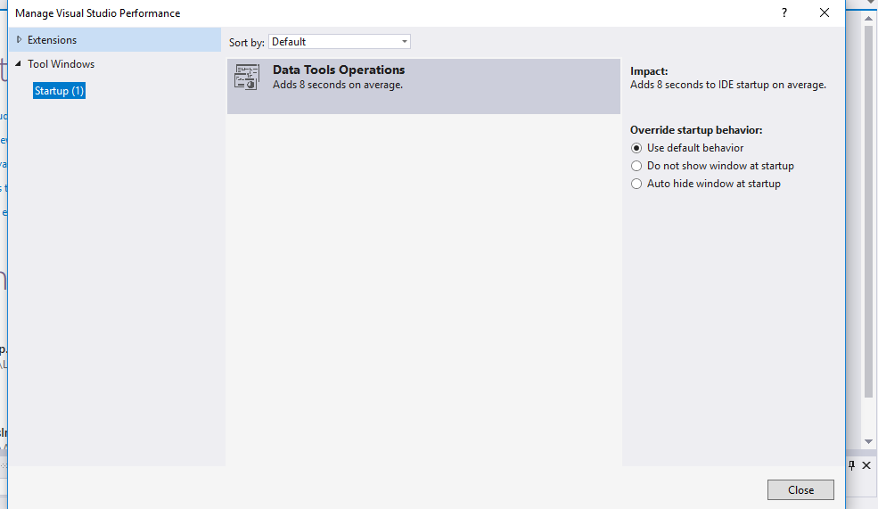

**08.04**

Deschid wpf negru la start-ul aplicatiei

- butoane manipulare poza : DONE

**11.04**

**- blank background button**

**DACA DUPA CE DAU F .. pozitia imaginii se reinitializeaza ???**

**-preiau indexul pozie(*pictureNr* prin getChildIndex)=> Algoritmica**

TO DO : Delete , Crop , Stanga-Dreapta de la sageti

0742375504 –gura humorului

0341 630 020 – constanta

0754 821 962 – braila

0748551155 – Cisnadie

Bugs :

-cand trec -> poza nu se schimba si in pbEditMode cand dau 4 sau 6

-crop nu merge pe poze mari

-am o linie alba la picture box-ul de FullScreenForm

-An array is stored in memory as a contiguous(one after another) block of memory while a linked list is stored in multiple blocks of memory at different addresses.

-The elements of linked lists are called nodes and each node has 2 elements : the data and the address of the next element while the array element has just one element.

-The time cost of accessing an element in an array is O(1) while in a linked list is O(n)( because we have to go from one element to another).

-When creating an array we need to know its size before creating it(fixed size) so it is possible to have unused memory while for a linked list we do not need to know its size before creating it and there is no unused memory.

-An array is stored in memory as a contiguous(one after another) block of memory while a linked list is stored in multiple blocks of memory at different addresses.

-The elements of linked lists are called nodes and each node has 2 elements : the data and the address of the next element while the array element has just one element.

-The time cost of accessing an element in an array is O(1) while in a linked list is O(n)( because we have to go from one element to another).

-When creating an array we need to know its size before creating it(fixed size) so it is possible to have unused memory while for a linked list we do not need to know its size before creating it and there is no unused memory.

-It's easier to store data of diffrent sizes in linked list.An array assumes every element is exactly the same size.

-linked lists can grow dinamicly.

* Logarithmic

The bug is that the output of the program will show me only if the last elemen from string1 is equal to the last element in string2 which does not mean that the strings are equal

Example : for string1="Dan" and string2="xyn" the program will say that they are equal(isEqual = true).

I take 6 of them and wheigh them ( 3 and 3).

- if they are equal it I take the 3 balls left and wheigh 2 of them to find the heavier.If the 2 are equal it means the one left is the heaivier

- if 3 balls at the begining are heavier I take them and wheigh 2 of them to find the heavier.If they are equal it means the one ball left is the heavier.

15

public static int[] function(int[] a)

{

int[] ret = new int[a.Length];

int sum = 0;

int avg = 0;

int k = 0;

for (int i = 0; i < a.Length; i++)

sum = sum + a[i];

avg = sum / a.Length;

for (int i = 0; i < a.Length; i++)

if (a[i] < avg)

{

ret[k++] = a[i];

}

int[] ret2 = new int[k];

for(int j=0;j<k;j++)

{

ret2[j] = ret[j];

}

return ret2;

}