Common UML Symbols and Relationships

4002-218

Paul Walter

Table of Contents
Common UML Symbols 3
Relationships 4
Gotchas 8

Common UML Symbols
Term | Criteria |  | UML Example | Implementation
Class  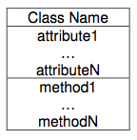 | A concept you identified in during the Discovery phase as an object you wish to have in your software system. |  | 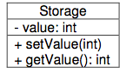  Notes:  “-“ Means Private  “+” Means Public  “#” Means Protected | public class Storage  {  private int value;  public void setValue(int i)  {  value = i;  }  public int getValue()  {  return value;  }  }
Abstract Class  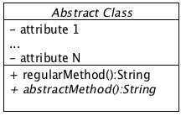  Notice the Italics in the title and method name that indicate an abstract class/method. | 1) When you have a generalized form of a concept that doesn’t make sense to instantiate (like Animal).  2) When you have a candidate class that you wish to define some default behavior for, but not all of it: the class that extends it should implement some. |  | Animal: notice that it's name is italic, as well as the method “getNoise()”. This means they are both abstract.  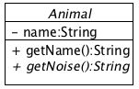 | public abstract class Animal  {  private String name;  public String getname()  {  return name;  }  public abstract String getNoise();  }
Interface  Same format as Class, but has <<iinterface>> at the top of the box. | Use this to ensure particular behavior exists in any object that implements it. |  | 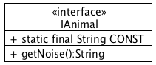 | /* Interface */  public interface IAnimal  {  public static final String CONST = "const";  public String getNoise();  }

Relationships
Term | Criteria |  | UML Example | Implementation
Generalization  (Inheritance)  “Is a” | Used to describe one class as being a more specialized form of another; when one class extends another:  “A Cat is aN Animal” |  | 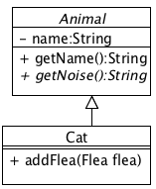 | /* Superclass */  public abstract class Animal  {  private String name;  public String getName()  {  return name;  }  //abstract class  public abstract String  getNoise();  }  /* Subclass */  public class Cat extends Animal  {  public String getNoise()  {  return "meow!";  }  }
Realization  (Implementing an Interface)  “Is a”  “Realization” is the UML specific term when an object implements an Interface.  Notice it is an arrow with the dashed line. | When you want to ensure functionality in an object without implementing it. |  | 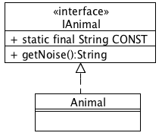 | /* Interface */  public interface IAnimal  {  public static final String CONST = "const";  public String getNoise();  }  /* Class */  public class Cat implements IAnimal  {  public String getNoise()  {  return "meow!";  }  }
Dependency  “Uses”  Notice the arrow points to the object that DOSEN’T have the reference (see Uni and Bi-Directional relationships, below, for reasons why). | Use this when you don’t need a permanent reference to an object  Example: when you pass it into a method only to use it as a local variable.  Another example is when you use objects (like System.out) in the main method; they aren’t referenced, they are just being called.  “RunCat uses System.out.println to print out messages .” |  | 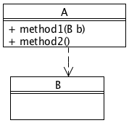 | import B;  public class A {  public void method1(B b) {  // B will be used locally  ...  }  public void method2() {  // local var  B tempB = new B();  ...  }  }
Association  “Has a” / “References”  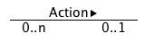 | Use this when you need a permanent object reference;  When the objects being grouped don’t conceptually create a whole;  And that the objects can exist independently. |  | 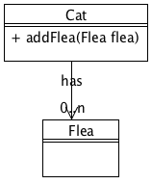  Note: the arrow at the end of the association line indicates that this relationship is one way: Cat knows about Flea but not vice versa. | import java.util.*;  public class Cat  {  private List<Flea> fleas;  public Cat(String name)  {  super(name);  fleas = new  ArrayList<Flea>();  }  public void addFlea(Flea flea)  {  fleas.add(flea);  }  }
Aggregation  “Has a”  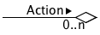 | Use this when you need a permanent object reference;  When the objects being grouped conceptually create a whole;  And that those objects can exist independently. |  | 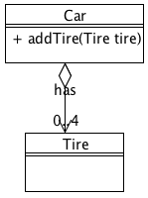  Note: the little arrow opposite the clear diamond on the Aggregation symbol which means this is a uni-directional relationship. | import java.util.*;  public class Car  {  private List<Tire> tires= new  ArrayList<Tire>();  public void addTire(Tire tire)  {  tires.add(tire);  }  }  public class Tire  {  }
Composition  “Has a”   | Use this when you need a permanent object reference;  When the objects being grouped conceptually create a whole;  And that those objects cannot exist independently. When the host dies, so do the objects that are grouped with it. |  | 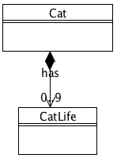 | import java.util.*;  public class Cat  {  private List<CatLife>  lives;  public Cat()  {  lives= new  ArrayList<CatLife>();  lives.add(new CatLife(1));  ...  lives.add(new CatLife(9));  }  }  public class CatLife  {  ...  }

Gotchas
Unidirectional vs. Bidirectional relationships  Uni-directional  Bi-directional   | Notice that the right hand side of the relationship line has an arrow (opposite the black diamond): This indicates that the relationship is only one way: there is only one reference.  If the relationship doesn’t have this distinction, then it is assumed that both objects participating in the relationship have a reference to each other.  In next column over we are going to explore what a bi-directional relationship looks like. |  | 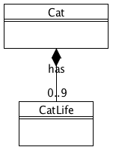  Note: This is a bi-directional relationship: notice the lack of an arrow opposite the black diamond. | import java.util.*;  public class Cat  {  private List<CatLife> lives;  public Cat()  {  lives= new ArrayList<CatLife>();  lives.add(new CatLife(this));  ...  lives.add(new CatLife(this));  }  }  public class CatLife  {  private Cat cat;  public CatLife(Cat cat)  {  this.cat = cat;  }  }

