Software Requirements Specification
for
Project Management Tool (PMT)
Version 1.0 approved
Prepared by Paul Walter
3/26/2007
Table of Contents
Table of Contents ii
Revision History ii
1. Introduction 1
1.1 Purpose 1
1.2 Document Conventions 1
1.3 Intended Audience and Reading Suggestions 1
1.4 Project Scope 1
1.5 References 2
2. Overall Description 2
2.1 Product Perspective 2
2.2 Product Features 3
2.3 User Classes and Characteristics 3
2.4 Operating Environment 4
2.5 Design and Implementation Constraints 4
2.6 User Documentation 4
2.7 Assumptions and Dependencies 4
3. System Features 4
3.1 System Feature 1 Error! Bookmark not defined.
3.2 System Feature 2 (and so on) Error! Bookmark not defined.
4. External Interface Requirements 15
4.1 User Interfaces 15
4.2 Hardware Interfaces 15
4.3 Software Interfaces 15
4.4 Communications Interfaces 16
5. Other Nonfunctional Requirements 16
5.1 Performance Requirements 16
5.2 Safety Requirements 16
5.3 Security Requirements 16
5.4 Software Quality Attributes 17
6. Other Requirements 17
Appendix A: Glossary 17
Appendix B: Entity-Relationship Diagram 18
Appendix C: Data Dictionary 18
Appendix D: Data Flow Diagram 25
Appendix E: Web Page State 27
Appendix F: Web Interface Mockups 31
Appendix G: Use Cases 31
Appendix H: Issues List 31

Revision History
Name | Date | Reason For Changes | Version

Introduction

Purpose
To create a system that will allow groups of people to flesh out their project timelines with a Gantt chart and assign tasks to individuals of that group online. This system will also track task progress. (Projected tasks as well as actual tasks; ie. When the task was actually completed)

<Identify the product whose software requirements are specified in this document, including the revision or release number. Describe the scope of the product that is covered by this SRS, particularly if this SRS describes only part of the system or a single subsystem.>

Document Conventions
Any special words will be signified with bold lettering, and any special classes will be signified with capital letters for their first letter and they will be italicized.

<Describe any standards or typographical conventions that were followed when writing this SRS, such as fonts or highlighting that have special significance. For example, state whether priorities for higher-level requirements are assumed to be inherited by detailed requirements, or whether every requirement statement is to have its own priority.>

Intended Audience and Reading Suggestions
The intended audience is development groups working on projects outside of their work or school, where geography might be a constraint.

<Describe the different types of reader that the document is intended for, such as developers, project managers, marketing staff, users, testers, and documentation writers. Describe what the rest of this SRS contains and how it is organized. Suggest a sequence for reading the document, beginning with the overview sections and proceeding through the sections that are most pertinent to each reader type.>

Project Scope
This project will be the main part of a website (whose functionality I won’t be building during this 10 weeks) that will supply collaborative tools for a development group to interact via the internet. This component will be a project portfolio with user management that will also have a Gantt chart associated with each individual project that can be defined by the group. Along with this it will be possible for a Project Admin to assign those tasks to individuals in the project group.

<Provide a short description of the software being specified and its purpose, including relevant benefits, objectives, and goals. Relate the software to corporate goals or business strategies. If a separate vision and scope document is available, refer to it rather than duplicating its contents here. An SRS that specifies the next release of an evolving product should contain its own scope statement as a subset of the long-term strategic product vision.>

References
None so far.

<List any other documents or Web addresses to which this SRS refers. These may include user interface style guides, contracts, standards, system requirements specifications, use case documents, or a vision and scope document. Provide enough information so that the reader could access a copy of each reference, including title, author, version number, date, and source or location.>

Overall Description

Product Perspective
This is a component of a larger system. The larger system will provide a project portfolio (which will include all the other components later mentioned), project participant management tool (adding or removing users to/from a particular project), a group scheduler (which would coalesce multiple schedules into one in order to find common meeting times ), a message board, a file repository, and a Gantt chart builder to a group of people working collaboratively.

The components that I will be focusing on are the project portfolio, user management tool, the project management tool and the Gantt chart builder.

The Project Portfolio will list all projects that are now, or have been worked on. This feature will also have the ability to hide selected projects to the Users of the site.

The User management tool will allow users of this site to be added, deleted, or have their account frozen.

The Project Management tool will allow a couple of things. The first is that it will allow a Project Administrator to add or remove active users to/from a particular project. The second thing that it will allow is tasks can be added, deleted, or assigned to those uses that have been assigned to this project.

The Gantt Chart builder will be the interface by which the Project Administrator and the Project Participants view, define, leave notes about, and generally interact with the tasks of the project. It will define on a timeline when up-coming deliverables, events, or milestones are / were.

Individual tasks on the Gantt chart will be able to be assigned to one or more participants assigned to that group. In addition every participant (a user that has been assigned to a particular project) that has been assigned a task can leave notes on their progress.

Every project will have Project Participants and a Gantt chart associated with it.

From a User perspective, the user will be able to look at all the tasks they have assigned to them on one to many the projects that they are working on or tasks for the whole project.

From a Project Administrator Perspective, the Project Admin can look at all the tasks of their project or those of one or a few individuals.

<Describe the context and origin of the product being specified in this SRS. For example, state whether this product is a follow-on member of a product family, a replacement for certain existing systems, or a new, self-contained product. If the SRS defines a component of a larger system, relate the requirements of the larger system to the functionality of this software and identify interfaces between the two. A simple diagram that shows the major components of the overall system, subsystem interconnections, and external interfaces can be helpful.>

Product Features
- Create / edit / delete a project
- Including project passwords (will allow users to sign on as the project-admin)

- Create / edit / delete users
- Including user passwords that will let them into the site

- Add / edit / remove participants for each project (users that have been associated with a particular project)

- Create / edit / delete a Gantt chart that can track user participation
- Will show projected and actual tasks
- Create / edit / delete tasks
- Assign project participants to tasks
- Create / edit / delete notes for tasks

<Summarize the major features the product contains or the significant functions that it performs or lets the user perform. Details will be provided in Section 3, so only a high level summary is needed here. Organize the functions to make them understandable to any reader of the SRS. A picture of the major groups of related requirements and how they relate, such as a top level data flow diagram or a class diagram, is often effective.>

User Classes and Characteristics
- Site admin
  - Is in charge of creating projects and users along with their respective passwords

- Project admin
  - Is in charge of managing tasks for the project and defining participants (drawn from the user pool)

- User
  - Can be part of mutliple projects

- Project Participant
  - Is a user when they are working on a specific project.
  - Is in charge of updating the status (ie. Completed) their respective tasks that they have been assigned
  - Can leave notes outlining their progress.

- System
  - Will display the gantt chart based on what the

<Identify the various user classes that you anticipate will use this product. User classes may be differentiated based on frequency of use, subset of product functions used, technical expertise, security or privilege levels, educational level, or experience. Describe the pertinent characteristics of each user class. Certain requirements may pertain only to certain user classes. Distinguish the favored user classes from those who are less important to satisfy.>

Operating Environment
The operating environment will require Windows XP with a Linux Virtual machine, Oracle Database, and PHP middle layer.

<Describe the environment in which the software will operate, including the hardware platform, operating system and versions, and any other software components or applications with which it must peacefully coexist.>

Design and Implementation Constraints
None so far.

<Describe any items or issues that will limit the options available to the developers. These might include: corporate or regulatory policies; hardware limitations (timing requirements, memory requirements); interfaces to other applications; specific technologies, tools, and databases to be used; parallel operations; language requirements; communications protocols; security considerations; design conventions or programming standards (for example, if the customer’s organization will be responsible for maintaining the delivered software).>

User Documentation
<List the user documentation components (such as user manuals, on-line help, and tutorials) that will be delivered along with the software. Identify any known user documentation delivery formats or standards.>

Assumptions and Dependencies
<List any assumed factors (as opposed to known facts) that could affect the requirements stated in the SRS. These could include third-party or commercial components that you plan to use, issues around the development or operating environment, or constraints. The project could be affected if these assumptions are incorrect, are not shared, or change. Also identify any dependencies the project has on external factors, such as software components that you intend to reuse from another project, unless they are already documented elsewhere (for example, in the vision and scope document or the project plan).>

System Features
<This template illustrates organizing the functional requirements for the product by system features, the major services provided by the product. You may prefer to organize this section by use case, mode of operation, user class, object class, functional hierarchy, or combinations of these, whatever makes the most logical sense for your product.>

Create Projects (Site Admin)
3.1.1 Description and Priority
This will allow a Site Administrator to create projects which will entail setting a project name, project password, and a short description of the project.

NOTE: Most Project editing will be left to the Project Administrator

High priority.

3.1.2 Stimulus/Response Sequences
- Authenticated Site Admin selects ‘Manage Projects’
- Site Admin is presented with a list of existing Projects.
- Authenticated Site Admin selects ‘Create Project’ from menu
- Site Admin is presented with a new screen devoted to Project Creation, then supplies a name, and a password for the project
- Site will present feedback in the form of a list of projects that have already been created.
    - Functional Requirements

REQ-1: The Site Admin will have to be authenticated in order to use this functionality
REQ-2: Each Project Name will have to be unique

Delete Projects (Site Admin)
3.2.1 Description and Priority
This will allow a Site Administrator to delete projects project from existence.

NOTE: Most Project editing will be left to the Project Administrator

High priority.

    - Stimulus/Response Sequences
- Authenticated Site Admin selects ‘Manage Projects’
- Site Admin is presented with a list of existing Projects.
- Next to the name of each project will be a ‘delete’ button.
- Site Admin will click this button, and be presented with a “Are you sure” dialog box that will make the user type in the words “DELETE IT”
- Upon Project deletion user will be taken to the list of existing projects minus the one they just deleted
3.2.3 Functional Requirements

REQ-1: The Site Admin will have to be authenticated in order to use this functionality
REQ-2: Each Project Name will have to be unique

Edit Projects (Site Admin)
3.3.1 Description and Priority
This will allow a Site Administrator to edit an existing project’s name, password and its short description.

High priority.

3.3.2 Stimulus/Response Sequences
- Authenticated Site Admin selects ‘Manage Projects’
- Site Admin is presented with a list of existing Projects.
- Next to the name of each project will be a ‘edit button.
- Upon clicking the edit button the Site Admin will be presented with a screen that looks identical to the Project Creation page (noted in ‘Project Creation’ feature listed above)
- Project Name and Password can be altered here.
- When done they will select the ‘submit’ button at the bottom of the page
- They will then be returned to the list of current project plus the changes that they just committed.

3.3.3 Functional Requirements

REQ-1: The Site Admin will have to be authenticated in order to use this functionality
REQ-2: Each Project Name will have to be unique

Create Users (Site Admin)
3.4.1 Description and Priority
This will allow a Site Administrator to create Users: set their user name and user password.

High priority.
3.4.2 Stimulus/Response Sequences
- Authenticated Site Admin selects ‘Manage Users’.
- Site Admin is presented with a list of existing Users.
- Site Admin will click the ‘Create New User’ button.
- They will be presented with a page that will allow User name, password, and user role to be inputted.
- When done they will select the ‘submit’ button at the bottom of the page.
- They will then be returned to a list of users (user id, user name, user password and their roles ) their changes included.

3.4.3 Functional Requirements

REQ-1: The Site Admin will have to be authenticated in order to use this functionality
REQ-3: Each User Name will have to be unique

Edit Users (Site Admin)
3.5.1 Description and Priority
This will allow a Site Administrator to edit existing system Users: data elements affected: set or edit user name, user password, and user role (admin, active, inactive).

Users do not really get deleted as this would also delete all the information that they have contributed to a particular project, they basically get suspended meaning that that user account is frozen and no one can use it to sign on to the site so their input will not be lost

High priority.
3.5.2 Stimulus/Response Sequences
- Authenticated Site Admin selects ‘Manage Users’.
- Site Admin is presented with a list of existing Users.
- Next to each existing user there will be an ‘edit’ button.
- They will be presented with a page that will allow User name, password, and user role to be inputted.
- When done they will select the ‘submit’ button at the bottom of the page.
- They will then be returned to a list of users (user id, user name, user password and their roles ) their changes included.

3.5.3 Functional Requirements

REQ-1: The Site Admin will have to be authenticated in order to use this functionality
REQ-3: Each User Name will have to be unique

Delete Users (Site Admin)
3.6.1 Description and Priority
This will allow a Site Administrator to delete Users.

This will delete the user perminately from the system and freeze all their project contributions.

High priority.
3.6.2 Stimulus/Response Sequences
- Authenticated Site Admin selects ‘Manage Users’.
- Site Admin is presented with a list of existing Users.
- Next to each existing user there will be an ‘edit’ button.
- They will be presented with a page that will allow user role to be changed.
- When done they will select the ‘submit’ button at the bottom of the page.
- They will then be returned to a list of users (user id, user name, user password and their roles ) their changes included.

3.6.3 Functional Requirements

REQ-1: The Site Admin will have to be authenticated in order to use this functionality
REQ-3: Each User Name will have to be unique

Edit Project (Project Admin)
3.7.1 Description and Priority
This will allow a Project Administrator to edit a projects description and its status to ‘open’ or ‘closed’.

High priority.

3.7.2 Stimulus/Response Sequences
- Authenticated Project Admin selects ‘Manage Projects’
- Project Admin is presented with a list of Project details: project name, project status, project description, and a list of Users participating in this project.
- Next to the name of each project will be a ‘edit button.
- Upon clicking the edit button the Site Admin will be presented with a screen that looks identical to the Project Creation page (noted in ‘Project Creation’ feature listed above)
- Project Name and Password can be altered here.
- When done they will select the ‘submit’ button at the bottom of the page
- They will then be returned to the list of current project plus the changes that they just committed.

3.7.3 Functional Requirements

REQ-1: The Site Admin will have to be authenticated in order to use this functionality
REQ-2: Each Project Name will have to be unique

Add Project Participants (Project Admin)
3.8.1 Description and Priority
Project Participants are users that have been assigned to a particular project. Multiple users can be assigned mutliple projects. This tool will allow the Project Manager to add users from the list of availible users on the site.

High priority.
3.8.2 Stimulus/Response Sequences
- Authenticated Project Admin will be presented with their main page that lists project details + current project participants and their statuses.
- At the top of this page the Project admin will select ‘add participant’
- They will be presented with a list of currently added (both authorized and not authorzied) users and a drop-down that lists all currently active users not already in the project.
- Once they have the person selected, they select ‘add this participant’
- The list of currently added users will be updated.

3.8.3 Functional Requirements

REQ-1: The Project Admin will have to be authenticated in order to use this functionality

Edit Project Participants (Project Admin)
3.9.1 Description and Priority
Edit means to change the Project Participants status in this project. They can be ‘authorized or ‘not authorized’ . Authorized means that they can contribute with task updates and task notes and ‘not authorized’ means that they can no longer look at the project details.

High priority.
3.9.2 Stimulus/Response Sequences
- Authenticated Project Admin will be presented with their main page that lists project details + current project participants and their statuses.
- At the side of each participant listed (and their status) there will be an ‘edit’ button.
- Upon editing the Project Admin will be presented with a page that lists that participant name plus a drop down with the selection ‘authorized’ or ‘not authorized’
- When the Project admin is done they will select the ‘submit’ button and be delivered to the Project details page.
3.9.3 Functional Requirements

REQ-1: The Project Admin will have to be authenticated in order to use this functionality

Create Task (Project Admin)
3.10.1 Description and Priority
Allow the Project Administrator to add specific tasks for a project.

Adding will allow Task name, task start date, task end date, and task description to be defined.

High priority.
3.10.2 Stimulus/Response Sequences
- Project Admin on the main page will click on the ‘Manage Tasks’ page and be taken to the page that defines tasks framed in a Gantt Chart.
- At the Top of this page they can click a button called ‘Create a task’
- They will be presented with a page that has a spot above the Gantt Chart that will allow the user to input task name, task description, task type, task start date (via a calendar) and task end date (via a calendar), and who the task is assigned too. (Out of a list of authorized project participants)
- When they are done they select ‘submit’ and they are taken back to the Gantt Chart with the new task added.
3.10.3 Functional Requirements

REQ-1: The Project Admin will have to be authenticated in order to use this functionality

Edit Tasks (Project Admin)
3.11.1 Description and Priority
Allow the Project Administrator to edit a specific tasks for a project.

Editing will allow all attributes to edit task name, task start date, task end date, and task description, and task completion date.

High priority.

3.11.2 Stimulus/Response Sequences
- Project Admin on the main page will click on the ‘Manage Tasks’ page and be taken to the page that defines tasks framed in a Gantt Chart.
- On this page, next to the list of milestones’s names on the left there will be an ‘edit’ button.
- When they click this button they will be returned to a page that looks a lot like the ‘add task’ page
- After editing this task and pressing the submit button they will be taken back to the Gantt chart.
3.11.3 Functional Requirements

REQ-1: The Project Admin will have to be authenticated in order to use this functionality

Assign Task to a Participant(Project Admin)
3.12.1 Description and Priority
Assigning a Task will allow the Project Admin to assign this task to a Project Participant. (A user who has been selected to participate in a Project)

High priority.

3.12.2 Stimulus/Response Sequences
- Project Admin on the main page will click on the ‘Manage Tasks’ page and be taken to the page that defines tasks framed in a Gantt Chart.
- At the Top of this page they can click a button called ‘Create a task’
- They will be presented with a page that has a spot above the Gantt Chart that will allow the user to input task name, task description, task type, task start date (via a calendar) and task end date (via a calendar), and who the task is assigned too. (Out of a list of authorized project participants)
- When they are done they select ‘submit’ and they are taken back to the Gantt Chart with the new task added.

3.12.3 Functional Requirements

REQ-1: The Project Admin will have to be authenticated in order to use this functionality

Delete Tasks (Project Admin)
3.12.1 Description and Priority
Deleting a task will clear it from the project and the system.

High priority.

3.13.2 Stimulus/Response Sequences
- Project Admin on the main page will click on the ‘Manage Tasks’ page and be taken to the page that defines tasks framed in a Gantt Chart.
- Next to the name of the tasks at the Gantt chart there will be a button that says ‘delete’. Which will pop-up a dialog box asking “Are you sure you want to delete project: thisProject” They will then have to type in ‘delete it’ and press submit.
- When they are done they select ‘submit’ and they are taken back to the Gantt Chart with the old task deleted.

3.13.3 Functional Requirements

REQ-1: The Project Admin will have to be authenticated in order to use this functionality

Create Task Notes (Project Participant)
3.14.1 Description and Priority
Each project participant will be able to add notes to the tasks they have been assigned to.

Low priority.
3.14.2 Stimulus/Response Sequences
Not sure yet.
<List the sequences of user actions and system responses that stimulate the behavior defined for this feature. These will correspond to the dialog elements associated with use cases.>
3.14.3 Functional Requirements

REQ-1: The Project Participant will have to be authenticated in order to use this functionality

Edit Task Notes (Project Participant)
3.15.1 Description and Priority
Each project participant will be able to edit notes for tasks they have been assigned to.

Low priority.
3.15.2 Stimulus/Response Sequences
Not sure yet.
<List the sequences of user actions and system responses that stimulate the behavior defined for this feature. These will correspond to the dialog elements associated with use cases.>
3.15.3 Functional Requirements

REQ-1: The Project Participant will have to be authenticated in order to use this functionality

Delete Task Notes (Project Participant)
3.16.1 Description and Priority
Each project participant will be able to delete a given note from the tasks they have been assigned to.

Low priority.
3.16.2 Stimulus/Response Sequences
Not sure yet.
<List the sequences of user actions and system responses that stimulate the behavior defined for this feature. These will correspond to the dialog elements associated with use cases.>
3.16.3 Functional Requirements

REQ-1: The Project Participant will have to be authenticated in order to use this functionality

Display Tasks (User)
3.17.1 Description and Priority
The User can pick what projects they would like to see tasks due on in order to view what they have due in a Gantt Chart. If they person signed on as the Project administrator they will also be able to manage the tasks

High priority.

<Provide a short description of the feature and indicate whether it is of High, Medium, or Low priority. You could also include specific priority component ratings, such as benefit, penalty, cost, and risk (each rated on a relative scale from a low of 1 to a high of 9).>
3.17.2 Stimulus/Response Sequences
Not sure yet.
<List the sequences of user actions and system responses that stimulate the behavior defined for this feature. These will correspond to the dialog elements associated with use cases.>
3.17.3 Functional Requirements

REQ-1: The User will have to be authenticated and added to a particluar project

Display Tasks (Project Admin)
3.18.1 Description and Priority
The Project Admin can pick what tasks in order to view what items are defining this project in a Gantt Chart. This will also provide the user interface for managing tasks.

High priority.

<Provide a short description of the feature and indicate whether it is of High, Medium, or Low priority. You could also include specific priority component ratings, such as benefit, penalty, cost, and risk (each rated on a relative scale from a low of 1 to a high of 9).>
3.18.2 Stimulus/Response Sequences
Not sure yet.
<List the sequences of user actions and system responses that stimulate the behavior defined for this feature. These will correspond to the dialog elements associated with use cases.>
3.18.3 Functional Requirements

REQ-1: The Project Administrator for that particular site will have to be authenticated

<Itemize the detailed functional requirements associated with this feature. These are the software capabilities that must be present in order for the user to carry out the services provided by the feature, or to execute the use case. Include how the product should respond to anticipated error conditions or invalid inputs. Requirements should be concise, complete, unambiguous, verifiable, and necessary. Use “TBD” as a placeholder to indicate when necessary information is not yet available.>

<Each requirement should be uniquely identified with a sequence number or a meaningful tag of some kind.>

Update Task (User)
3.19.1 Description and Priority
Allow the User to edit a specific tasks for a project.

Editing will allow all attributes to edit ‘actual start date’, task ‘completed end date’

High priority.

3.19.2 Stimulus/Response Sequences
- User on the main page will click on the ‘Manage Tasks’ page and be taken to a Gantt Chart that lists what tasks in what projects they are currently working on. Each project name will be a link to that project’s Gantt chart.
- Upon clicking on the project’s Gantt chart they will be able to see all tasks due and be able to filter tasks shown by whom they are assigned too.
- By clicking on the tasks that they have due in either views, they can edit that task
- On this page, next to the list of milestones’s names on the left there will be an ‘edit’ button.
- When they click this button they will be returned to a page that looks a lot like the ‘add task’ page
- After editing this task and pressing the submit button they will be taken back to the Gantt chart.
3.19.3 Functional Requirements

REQ-1: The Project Admin will have to be authenticated in order to use this functionality

External Interface Requirements

User Interfaces
See template below

<Describe the logical characteristics of each interface between the software product and the users. This may include sample screen images, any GUI standards or product family style guides that are to be followed, screen layout constraints, standard buttons and functions (e.g., help) that will appear on every screen, keyboard shortcuts, error message display standards, and so on. Define the software components for which a user interface is needed. Details of the user interface design should be documented in a separate user interface specification.>

Hardware Interfaces
C# with an Oracle database (using the ODBC api) will be used to implement this app

<Describe the logical and physical characteristics of each interface between the software product and the hardware components of the system. This may include the supported device types, the nature of the data and control interactions between the software and the hardware, and communication protocols to be used.>

Software Interfaces
C# with an Oracle database (using the ODBC api) will be used to implement this app.
The information coming into the system will be coming from ASP.net. This information is defined in the data dictionary below. The data elements names are: Current_date, Num_days_in_month, and First_day_in_month.

<Describe the connections between this product and other specific software components (name and version), including databases, operating systems, tools, libraries, and integrated commercial components. Identify the data items or messages coming into the system and going out and describe the purpose of each. Describe the services needed and the nature of communications. Refer to documents that describe detailed application programming interface protocols. Identify data that will be shared across software components. If the data sharing mechanism must be implemented in a specific way (for example, use of a global data area in a multitasking operating system), specify this as an implementation constraint.>

Communications Interfaces
A web browser will be used for the client.

<Describe the requirements associated with any communications functions required by this product, including e-mail, web browser, network server communications protocols, electronic forms, and so on. Define any pertinent message formatting. Identify any communication standards that will be used, such as FTP or HTTP. Specify any communication security or encryption issues, data transfer rates, and synchronization mechanisms.>

Other Nonfunctional Requirements

Performance Requirements
No performance requirements yet.

<If there are performance requirements for the product under various circumstances, state them here and explain their rationale, to help the developers understand the intent and make suitable design choices. Specify the timing relationships for real time systems. Make such requirements as specific as possible. You may need to state performance requirements for individual functional requirements or features.>

Safety Requirements
It should be understood that the passwords in this system are NOT encrypted. This is to be implemented at a later date.

This application will not be ready to go live until that security hole is implemented.

<Specify those requirements that are concerned with possible loss, damage, or harm that could result from the use of the product. Define any safeguards or actions that must be taken, as well as actions that must be prevented. Refer to any external policies or regulations that state safety issues that affect the product’s design or use. Define any safety certifications that must be satisfied.>

Security Requirements
As mentioned above in section 5.2, it should be understood that the passwords in this system are NOT encrypted. This is to be implemented at a later date.

This application will not be ready to go live until that security hole is fixed.

<Specify any requirements regarding security or privacy issues surrounding use of the product or protection of the data used or created by the product. Define any user identity authentication requirements. Refer to any external policies or regulations containing security issues that affect the product. Define any security or privacy certifications that must be satisfied.>

Software Quality Attributes
No specific quality attributes to list yet.

<Specify any additional quality characteristics for the product that will be important to either the customers or the developers. Some to consider are: adaptability, availability, correctness, flexibility, interoperability, maintainability, portability, reliability, reusability, robustness, testability, and usability. Write these to be specific, quantitative, and verifiable when possible. At the least, clarify the relative preferences for various attributes, such as ease of use over ease of learning.>

Other Requirements
None yet.

<Define any other requirements not covered elsewhere in the SRS. This might include database requirements, internationalization requirements, legal requirements, reuse objectives for the project, and so on. Add any new sections that are pertinent to the project.>
Appendix A: Glossary
Site Admin: This is a user of the site that is permitted to edit project and user attributes.
Project Admin: The administrator of the project who can edit task and participant attributes.
Project Participant: Is a User that has been selected to participate in a particular project.
User: Is a regular user of the site who can potentially become a project participant.

<Define all the terms necessary to properly interpret the SRS, including acronyms and abbreviations. You may wish to build a separate glossary that spans multiple projects or the entire organization, and just include terms specific to a single project in each SRS.>

Appendix B: Entity-Relationship Diagram 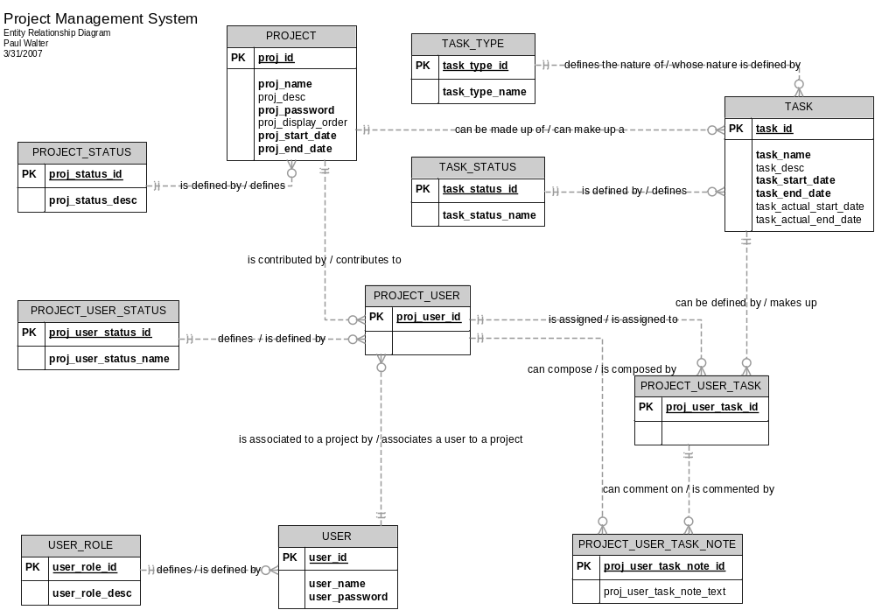
Appendix C: Data Dictionary
Table Name | Attribute Name | Primary Key? | Foreign Key? | Indexed? | Datatype | Description
USER | User_id | X |  |  | Integer
USER | User_name |  |  |  | Varchar
USER | User_password |  |  |  | Varchar
USER | User_role |  | X |  | Integer | Signifies whether or not this is a site admin or a user. Site admins can create new users, new projects, change passwords.
PROJECT | Proj_id | X |  |  | Integer
PROJECT | Proj_name |  |  |  | Varchar
PROJECT | Proj_desc |  |  |  | Varchar | Brief Project description
PROJECT | Proj_password |  |  |  | Varchar | This will be used to authenticate users who can add other users to a project and assign tasks
PROJECT | Proj_status_id |  | X |  | Integer | References PROJECT_STATUS. This will allow the Project Administrator to allow people to contribute, see but not contribute, or to not see or contribute anything to the project. The statuses are ‘open’, ‘closed’, ‘frozen’
PROJECT | Proj_display_order |  |  |  | Integer | /* to be implemented at a later date */
PROJECT_STATUS | Proj_status_id | X |  |  | Integer
PROJECT_STATUS | Proj_status_desc |  |  |  | Varchar | This describes in plain language what the status code is: ‘open’, ‘closed’ or ‘frozen’
PROJECT_USER | Project_user_id | X |  |  | Integer
PROJECT_USER | Project_id |  | X |  | Integer | Composite key, references PROJECT
PROJECT_USER | User_id |  | X |  | Varchar | Composite Key, references USER
PROJECT_USER | Project_user_status_id |  |  |  | Integer | /*will define if this project can be edited or even diplayed, will be either (‘open’, ‘closed’, or ‘frozen’)
PROJECT_USER_STATUS | Project_user_status_id |  |  |  | Integer
PROJECT_USER_STATUS | Project_user_status_desc |  |  |  | Varchar | This will describe whether a project is ‘authorized’ or ‘not authorized’. When a project user is ‘authorized’ they can contribute to a project, when not authorized it means they can  No longer contribute or even view project details
TASK | Task_id | X |  |  | Integer
TASK | Task_name |  |  |  | Varchar
TASK | Task_desc |  |  |  | Varchar | Description of the task
TASK | Task_start_date |  |  |  | DATE | Describes when the task starts
TASK | Task_end_date |  |  |  | Date
TASK | Task_status |  | X |  | Integer | References TASK_STATUS. Describes if the task is complete or incomplete
TASK | Task_type |  | X |  | Integer | References TASK_TYPE. Describes if this project is an “event”, a “deliverable”, or a “milestone”
TASK | Project_id |  |  |  | Integer
PROJECT_USER_TASK | Project_user_task_id | X |  |  | Integer
PROJECT_USER_TASK | Project_user_id |  | X |  | Integer | References USER
PROJECT_USER_TASK | Task_id |  | X |  | Integer | References TASK
PROJECT_USER_TASK_NOTE | Proj_User_task_note_id | X |  |  | integer | These are notes that can be left on each task that a user is assigned too.
PROJECT_USER_TASK_NOTE | Proj_user_task_id |  | X |  | Integer | References PROJECT_USER_TASK.
PROJECT_USER_TASK_NOTE | Proj_user_id |  | X |  | Integer | References PROJEC_USER.
PROJECT_USER_TASK_NOTE | Proj_user_task_text |  |  |  | Varchar | This is the actual text that the user has left about her / his assigned task
 | Unathenticated_name |  |  |  | Varchar | /* Username to be supplied */
 | Unathenticated_pword |  |  |  | Varchar | /* User supplied password, to be verified */
 | Authenticated_site_admin |  |  |  |  | /* Session variable, signifies that this is an authenticated Site Admin */  Authenticated_site_admin =  User_id +  User_name +  User_role_id
 | Authenticated_project_admin |  |  |  |  | /* Session variable, signifies that this is an authenticated Project Admin */  Authenticated_project_admin =  Proj_id +  Proj_name +  User_role_id
 | Authenticated_user |  |  |  |  | /* this info will mostly likely be kept in a session variable */  Authenticated_user =  User_id +  User_name +  User_role_id
 | Gantt_Chart_Object |  |  |  |  | /*This will be the display object for Tasks */
 | User_task_pref |  |  |  |  | /*user indicates which task the user prefers to update */
 | User_task_note_pref |  |  |  |  | /*user indicates which task note the user prefers to update */
 | calendar_info |  |  |  |  | Current_date +  Num_days_in_month +  First_day_in_month
 | Current_date |  |  |  |  | /*this will be drawn from ASP.net specifying what date it currently is so the Gantt Chart can display correctly*/
 | Num_days_in_month |  |  |  |  | /*this will be drawn from ASP.net specifying how many days are in that month so the Gantt Chart can display correctly*/
 | First_day_in_month |  |  |  |  | /*this will be drawn from ASP.net specifying what first day (Monday, Tuesday, etc..) of the month is so the Gantt Chart can display correctly*/
 | Site_mng_info |  |  |  |  | Site_mng_info =  Proj_name +  Proj_desc +  Proj_password +  Proj_status_id +  Unathenticated_name +  unauthenticated_pword +  User_role +  User_id +
 | Project_mng_info |  |  |  |  | Project_mng_info =  Unathenticated_name +  unauthenticated_password +  User_id +  Proj_user_id +  Proj_user_status_id +  Proj_id +  Task_id +  Task_name +  Task_desc +  Task_start_date +  Task_end_date
 | User_mng_info |  |  |  |  | User_mgng_info =  Unauthenticated_name +  Unauthenticated_pword +  Task_edit_pref +  User_task_note_pref

Appendix D: Data Flow Diagram
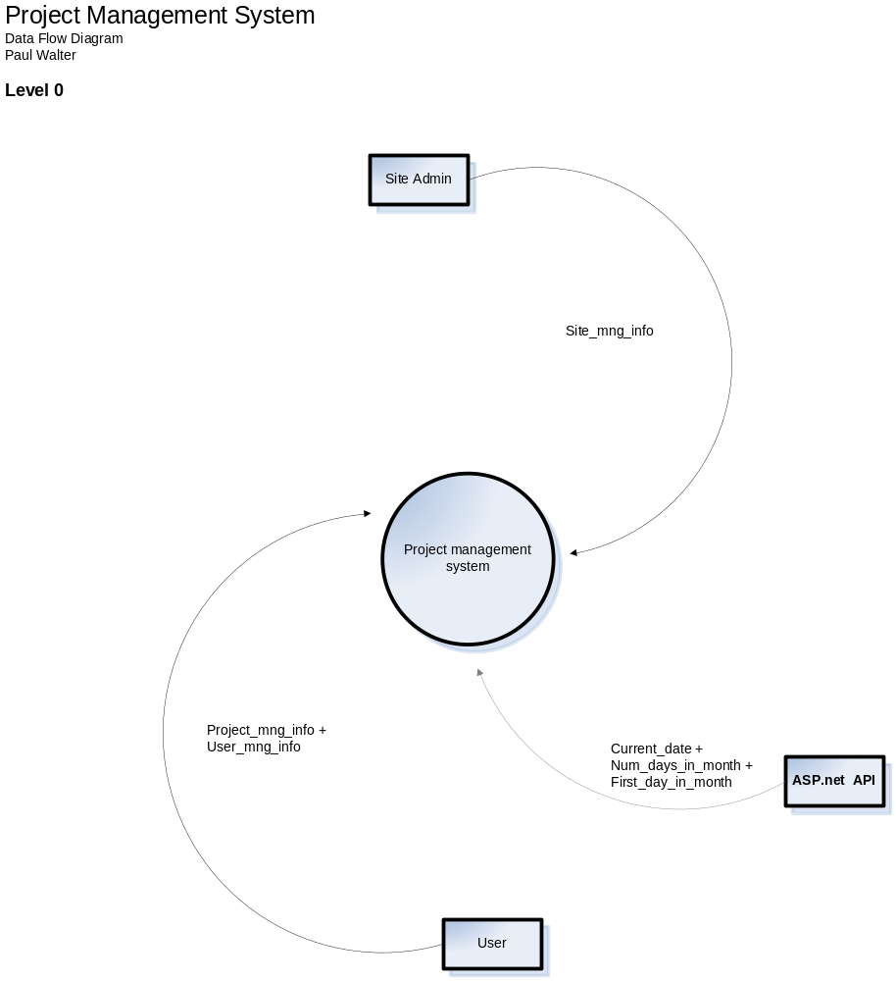

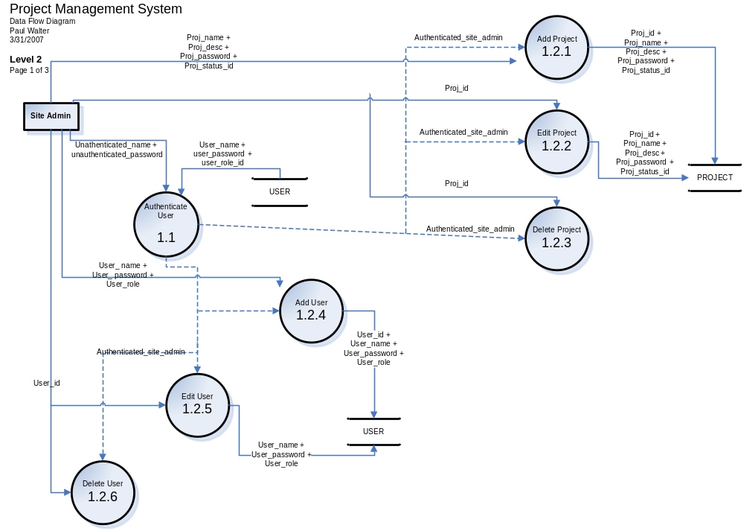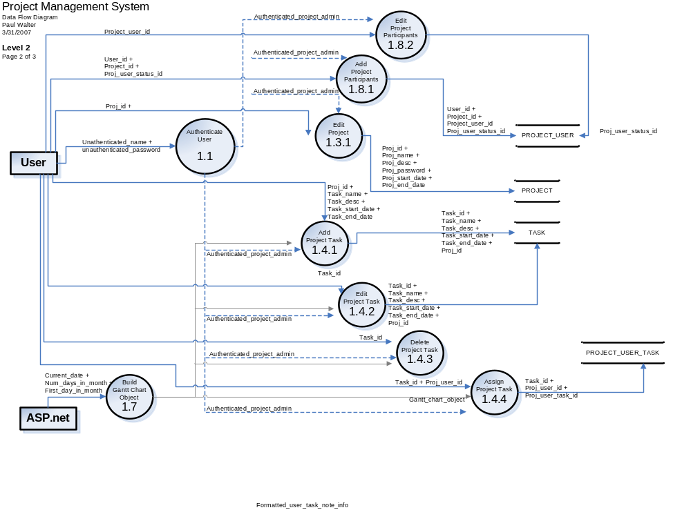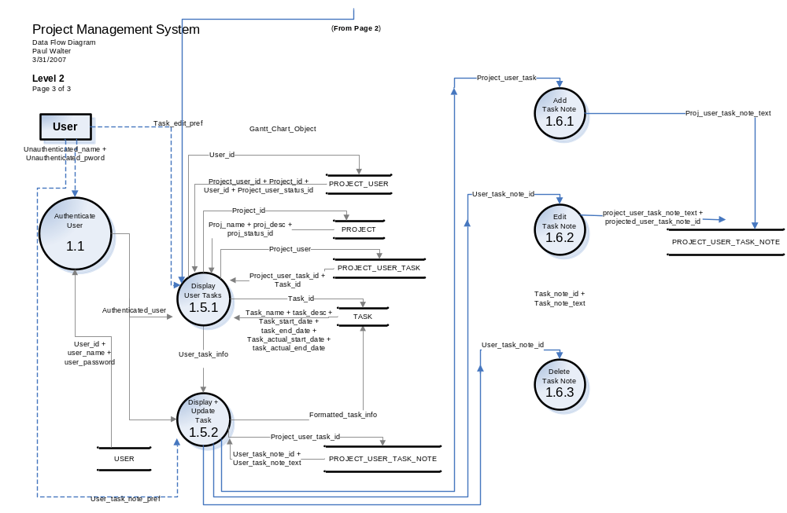

Appendix E: Web Page State Transition Diagram 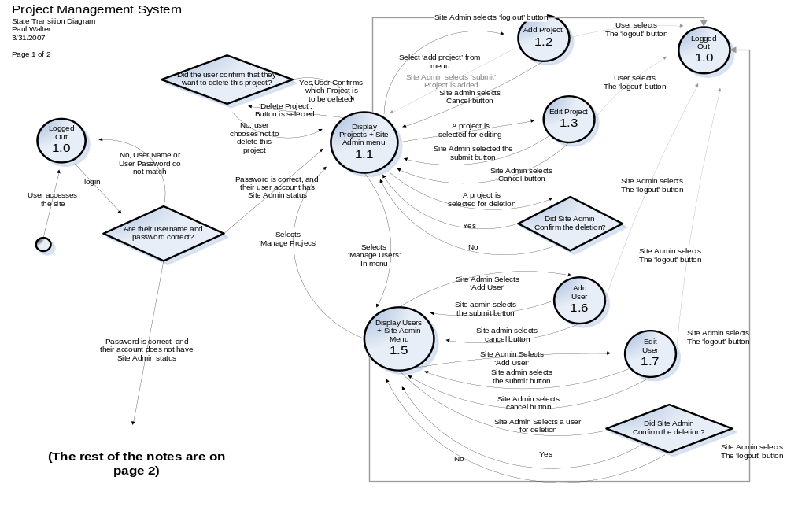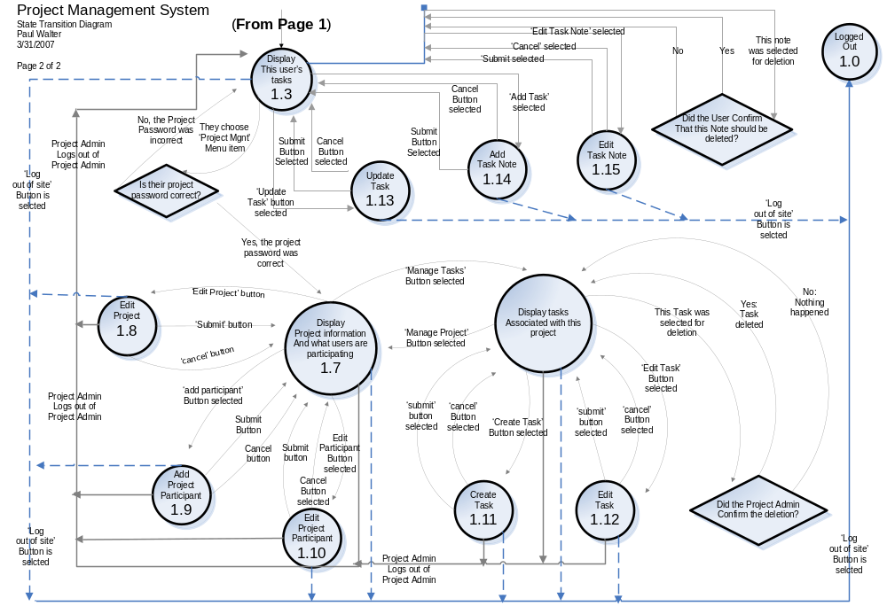
Appendix F: Web Interface Mockups
Basic Template Idea to use:
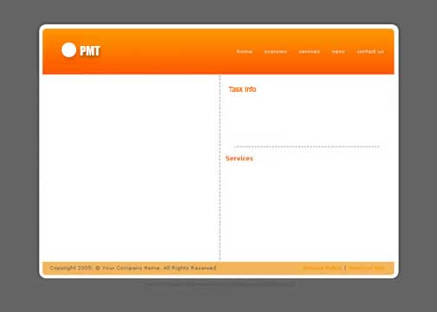
Appendix G: Use Cases
Appendix H: Issues List
< This is a dynamic list of the open requirements issues that remain to be resolved, including TBDs, pending decisions, information that is needed, conflicts awaiting resolution, and the like.>

