| **Statement of Work**  Dated: 14/04/2023  between  Ademco Inc. (Resideo Technologies)  and  Tecnológico de Monterrey (Chihuahua, México)  under the  Design and Manufacturing Agreement  Dated: 14/04/2023  Project Name: Vision Box | | |
| --- | --- | --- |
|  |  |  |
|  |  |  |
|  |  |  |
|  |  |  |
| **Revision History**   |  |  |  | | --- | --- | --- | |  |  |  |  | **Revision** | **Date** | **Change** | | --- | --- | --- | | 1.0 | 30/03/2023 | First Release | | | |

# STATEMENT OF WORK

This Statement of Work ("SOW" or "Statement of Work") is entered into by and between Ademco Inc., the operating entity in the United States for Resideo Technologies, with offices at Melville, NY 11747 United States (the “Company” or "Resideo") and Tecnológico de Monterrey (the “Supplier” or "Tec de Monterrey" ) and hereby fully incorporates the terms of the Design and Manufacturing Agreement ("Agreement") entered into between the Parties, dated <<DATE>>, by reference. Supplier will provide Resideo with the Services detailed in this SOW in accordance with the terms of the Agreement and the following requirements and schedules.

This SOW describes Supplier’s services (the "Services" as they are defined hereinafter) in respect of the Project.

The exhibits and attachments to this SOW provide additional terms and conditions applicable to the Project and are incorporated herein by reference. In the event of a conflict between the Agreement and this SOW, the terms of this SOW shall take precedence. The parties agree that for purposes of the Agreement, this SOW shall be considered an exhibit to the Agreement.

This SOW scope consists of: the full description of the vision box project, including the general scope of the project for the next ten weeks starting on march 27th 2023. This document also corresponds to the overview of the different designs for the hardware and software aspects of the project, and the testing process. The activity breakdown and the person responsible for each task. The definition of the user requirements as well as the expenses.

## Scope

The scope of Services performed under this SOW includes those described in this SOW and any additional or new services to which the Parties mutually agree in a written Change Order.

**Administrative Information:**

|  | **Project Manager Full name** | **Email address** | **Telephone number** | **Office Location address** |
| --- | --- | --- | --- | --- |
| **Resideo** | Luis Rojas | [Luis_Rojas@tec.mx](mailto:Luis_Rojas@tec.mx) |  |  |
| **Supplier** |  |  |  |  |

## Term

The term of this SOW commences on <<STARTING DATE>> ("Effective Date") unless earlier terminated or extended as set forth in the Agreement. Provisions for extension of this SOW, if any, are also as set forth in the Agreement.

**Invoices:**

Invoices will be sent to:

**Email Address- PDF Attachments only:**

**Postal Address:**

The Parties’ authorized representatives have executed this Statement of Work by their signatures below:

| Resideo Inc. | |  | Cornfleis | |
| --- | --- | --- | --- | --- |
| By: | Firmware Engineer |  | By: | Mechatronics Students |
| Name: | Luis Emmanuel Rojas Arredondo |  | Name: | Paul Timke Contreras, Sebastián Terrazas Contreras, Lec Adrian Jaschack Campos, Christian Loya Peña. |
| Title: | Diseño e implementación de sistemas mecatrónicos |  | Title: | Vision Box |
| Date: | 30/03/2023 |  | Date: | 30/03/2023 |

# Abbreviations

| Abbreviation | Description |
| --- | --- |
| DFX, DFM | Design for Excellence, Design for Manufacturing |
| EVT | Engineering Validation Test |
| DVT | Design Validation Test |
| PVT | Production Validation Test |
| FV&V | Firmware Verification and Validation |
| SV&V | Software Verification and Validation |
| SCM | Software Configuration Management |
| BLE | Bluetooth Low Energy |
| PPAP | Production Part Approval Process |
| OCR | Optical Character Recognition |

# Articles

| **ARTICLES** | |
| --- | --- |
| 1. | Scope |
| 2. | Services |
| 3. | Design Reviews |
| 4. | Testing |
| 5. | Manufacturing |
| 6. | EVT, DVT and PVT |
| 7. | Schedule |
| 8. | Responsibilities |
| 9. | Required Meetings |
| 10. | Required Software, Hardware, Equipment, and Facilities |
| 11. | Fees and Expenses |
| 12. | Product Cost |
| 13. | Termination/Expiration Assistance |

# 1. Scope

## Products

All products hereby listed are described in detail by their Product Specification Document. The specification is the reference for the product development.

Where applicable, reference designs are provided to facilitate or guide the product development.

Products to be considered for quotations are:

| **item** | **Resideo Vision Box** | **Resideo Product Description** |
| --- | --- | --- |
| 1 | Vision System | Camera and image processing software with Command Line Interface for Windows Operating Systems. |
| 2 | Illumination System | LED lights with diffuser and a microcontroller to adjust brightness levels and display for monitoring |
| 3 | Power Supply System | 120V AC and 24V AC power supply available inside the box.. |
| 4 | Structural System | Box to enclose the whole system to remove light variation |

**Specification**

Supplier must meet or exceed the requirements defined in the SOW Exhibits with version as defined below:

| **Exhibit** | **Resideo Specification Description** |
| --- | --- |
| A | Vision Box Product Requirement Document ("PRD") |
| B | Vision Box Software Deliverable List (“SDL”) |
| C | Vision Box Code Line Interface Manual |
| D | Product Acceptance Criteria for Approval |
| E | Supplier Certification |
| F | Resideo AME Recommendations & Requirements |

Approved deviations will be implemented in amendments to this SOW. Deviations to specifications will be reviewed for approval by the Supplier and Resideo in the form of **Change Request Form** located as an exhibit.

## Resideo Deliverables

* Project plan
  + Key milestones for DVT, EVT, RTP
  + Software Services
  + Software integration
  + Design reviews – SW, HW, MECH
* Product Technical Specifications
* Producto Testing Model
* Mechanical Design Drawing Reference
* Functional Requirements
* Mechanical requirements
* Quality Assurance Plan (QAP). Defined Acceptance Criteria for Approval of:
  + Development Validation Test (DVT)

## Supplier Deliverables

* Design Documentation:
  + Engineering specification
  + System architecture description
* Electronic Design Documents
  + Schematics (Illumination and Power Supply systems)
  + BOM
  + PCB Design files in agreed format
* Firmware Design Documents
  + Commented Source code
  + Firmware design description
* Mechanical Design Documents
  + BOM
  + Assembly drawings
  + 3D models
  + 2D drawings
* Instructions Manual
  + Standard Operating Procedure (SOP) Documentation

# 2. Services

## Supplier design services

Supplier will provide design services for the following:

* Mechanical engineering services and complete released project documentation packages to include, 2D and 3D files and mechanical bills of materials for any mechanical items for the project per the guidelines in the project requirements document.
* Electrical engineering services and necessary documentation for the project to include, bills of materials, electronic bare board design files, board fabrication drawings, assembly drawings, per the guidelines in the project requirements document
* Supplier is responsible in material selection & compliance with stated standards
* Supplier shall by analytical and empirical evidence show that the product is operating within the ratings (voltage) expected from agency testing for this product.
* Supplier shall by analytical and empirical evidence show that the project design conforms to all environment performance testing per the project Product Specification.
* Design Firmware to meet Firmware specifications

# 3. Design Reviews

First Design review to be arranged according to project plan. Subject of the review shall be:

* Product concept – 3D model
* Device architecture
  + Electronics
  + Firmware
* Identification of risks and plan to mitigate them

Supplier will be responsible for the following design reviews

* Schematic Reviews
* Layout Reviews
* Design FMEA
* Firmware code reviews

Reviews will be organized for any of the deliverables in the scope (EVT, DVT, PVT) and will be applicable for any of the products included into the scope.

Reviews will be based (but not limited to) requirements included into Product Specifications.

Resideo staff will take part in the review (attendees to be determined on a case by case as applicable).

# 4. Testing

It is the responsibility of the supplier to ensure the product is performing according to the expectations described into the product documentation package. Quality Assurance Plan (QAP)

The following deliverables are expected by Resideo:

* A product test plan including unit tests (Electrical, Mechanical, Firmware) and product integration tests. The test cases shall include the test requirements included into the product documentation package.
* A test report for any of the deliverables in the scope (DVT) applicable for any of the products included into the scope, (Text recognition, shape recognition, image comparison, empirical stress tests for box structure)
* A periodic (per 2 weeks) test report showing the overall test status shall be distributed to Resideo

# 5. Manufacturing

For this project's scope, the supplier will not manufacture the system nor will it include the manufacturing processes, tooling and materials specifications.

The supplier will only include the BOM for the prototype fabricated.

# 6. EVT, DVT and PVT

EVT: Solidworks 3D render for the vision box

* Bill of materials
* Technical drawing
* Weight

DVT: Functional Vision box prototype

Text, shape, color recognition

Image comparison

Illumination system for correct image processing

Ergonomic structure for comfortable handling of the vision box

PVT: It is out of the scope of the project

# 7. Schedule

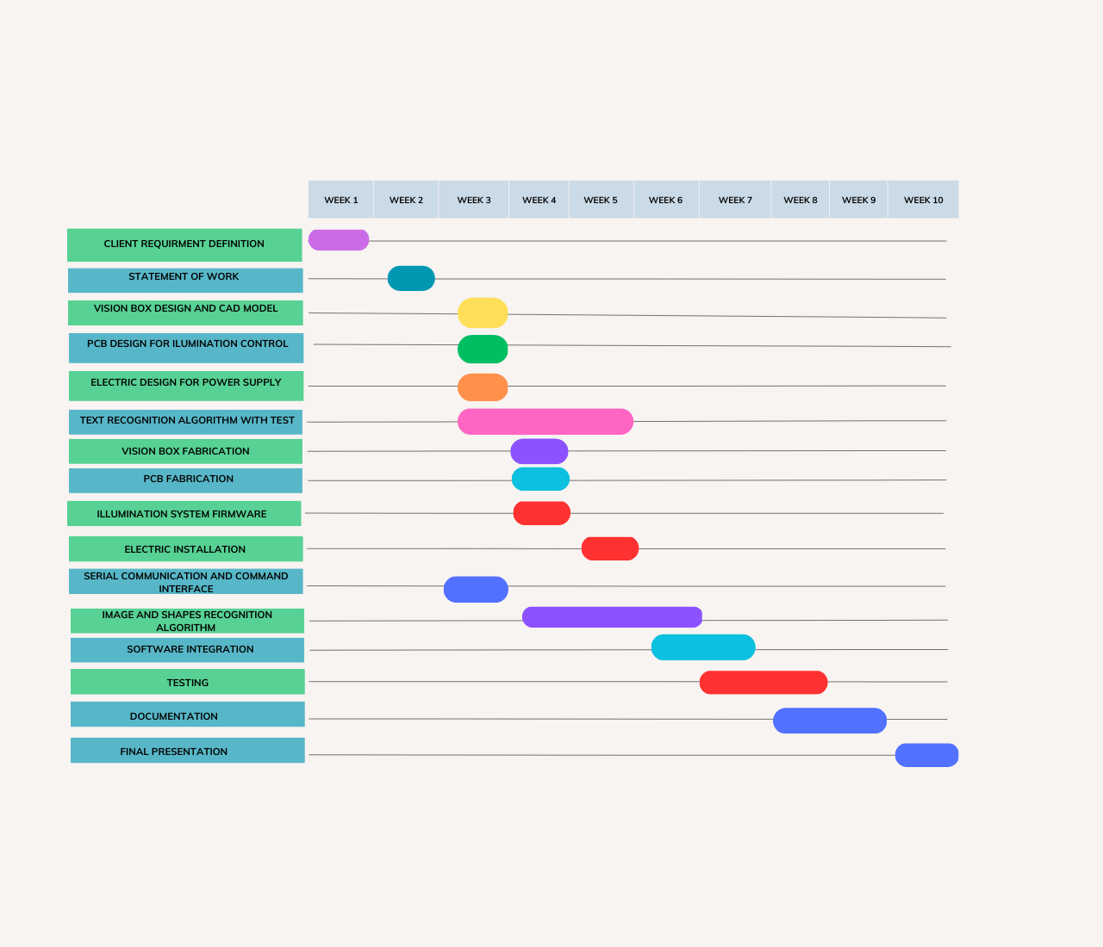

# 8. Responsibilities

Supplier shall provide all the deliverables specified during the Scope section of this document under Supplier deliverables.

Resideo shall provide timely feedback to the deliverables made from the supplier during Design Reviews in accordance with the deadlines set during said Design Reviews. Failure to comply will result in delays in the schedule.

# 9. Required meetings

The Supplier team shall hold the following meetings, where the Product Owner is the representative of Resideo and the Development team and the Scrum Master are members of the Supplier team.

* **Sprint Planning:** This session will be held by the development team and the Scrum master to discuss the worklist to be assigned to the current sprint. The product owner may be invited to the meeting, but attendance is not required.
* **Daily Stand-up:** This session is to be held by the Scrum Master and the development team to give updates on the work done currently by each team member and discuss blockers that may be affecting development.
* **Sprint Review:** This session will be held by the development team and the Scrum master to discuss the work and progress achieved during the last sprint and give relevant feedback. The product owner may be invited to the meeting, but attendance is not required.
* **Sprint Retrospective:** This session will be held by the development team and the Scrum master to reflect about things that worked and things that did not in regards to productivity and the development process.

# 10. Required Software, Hardware, Equipment and Facilities

**Required Software**

* Python Interpreter (Version 3.6 or above)
* Tesseract OCR Engine (Version 5.3.0 or above)
* com0com Null-modem emulator (Required Version pending)

**Required Hardware**

* Personal Computer
* USB Type A connection
* NEMA 5-15 Type B Outlet with 120V AC output

**Equipment and Facilities**

No specific equipment or facilities are required for the usage of this product.

# 11. Fees and Expenses

| **Fees** | **(MXN)** | **Expenses** | **(MXN)** |
| --- | --- | --- | --- |
| None |  | Lighting controlled box |  |
|  |  | Vision system |  |
|  |  | Electrical components |  |
|  |  |  |  |

# 12. Product Cost

| Feature | Cost (MXN) |
| --- | --- |
| Lighting controlled box |  |
| Vision system |  |
| Electrical components |  |
| Firmware |  |

# 13. Termination/Expiration Assistance