Tamal Paul

[tamal.paul.42123@gmail.com](mailto:tamal.paul.42123@gmail.com) 01743286902 Kuril, Dhaka [github.com/paultomal](https://github.com/paultomal) [linkedin.com/tamal-paul](https://www.linkedin.com/in/tamal-paul-4b47601ba/)

**Profile**

Hard-working, Ǫuick Learner, Focused, Innovative, Friendly, Organized, Easy to work with, fresh on going B.Sc graduate with good at programming languages (Asp.Dot Net). I possess strong problem-solving and analytical skills and I am capable of designing, developing, and maintaining complex web applications. Through my academic experiences, I have gained hands-on experience with Visual Studio, SǪL Server, and GitHub. I am now seeking an opportunity to apply my skills and knowledge in a challenging role where I can contribute to the success of a dynamic organization while growing my career as a .NET Developer.

**Technical Skills**

# TECHNICAL SKILLS

ASP.NET MVC | ASP.NET WebApi | C# | Php

# Frontend

HTML | JavaScript | CSS | Bootstrap | Angular |

TypeScript

# API Testing

Postman

# Database

Microsoft SǪL Server | MySǪL | Oracle

# Tools

MS VS Code | Visual Studio | GitHub

**Education**

# Bachelor of Science in Computer Science & Engineering

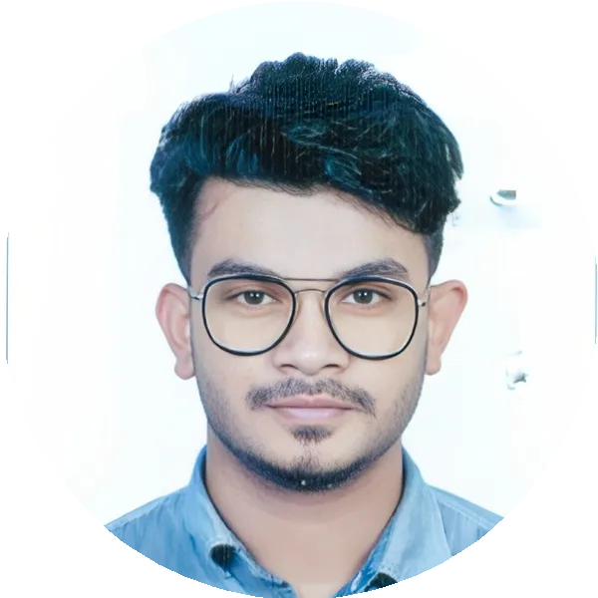

*American International University-Bangladesh (AIUB)*

(Expected Graduation) Last semester.

01.2020 – 05.2023

Dhaka, Bangladesh

CGPA 3.73

**Higher Secondary Certificate** *Giasuddin Islamic Model College* GPA : 4.94

2017 – 2019

Narayangonj, Bangladesh

**SKILLS & ABILITIES**

# Communication

*I have a proven ability in effective communication, diagrammatically, verbally and in written form. I have successfully communicated, liaised and worked with various professionals from all backgrounds and with a variety of different skill sets.*

# Management

*I have the natural ability to mentor, develop, inspire and lead groups of people to achieve the objectives set by the organization. I am a friendly, approachable and inspiring professional and I lead my team by example.*

**Interests**

Gaming, Traveling, Reading, Foodie

**Organizations**

# [AIUB Social Welfare Club SHOMOY](https://www.facebook.com/AIUB.Social.Welfare.Club)

[*General Member*](https://www.facebook.com/AIUB.Social.Welfare.Club)

**Languages**

Bangla, Hindi, English