Findings

Temporal bias in answer acceptance

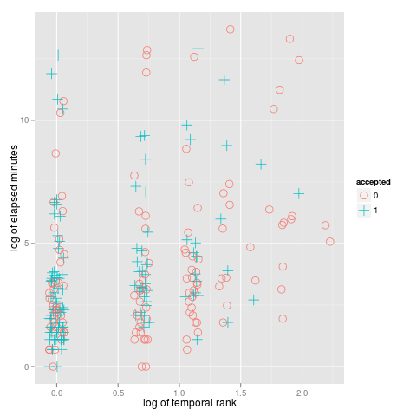 Figure 1 : Scatter of answers by temporal rank and minutes after the question was posted (log transformations)

Table 1: Predicting acceptance from temporal and textual features
 | Model | Prediction Accuracy on Acceptance (%), Area Under ROC Curve | NA
1 | temporal rank | 0.6150 | 0.6579
2 | quadratic temporal rank | 0.6150 | 0.6579
3 | log of temporal rank | 0.6250 | 0.6579
4 | time after question posted | 0.5194 | 0.5033
5 | answer length (chars) | 0.5647 | 0.5858
6 | Contains code | 0.5647 | 0.5858
7 | temporal rank + time after question | 0.6178 | 0.6442
8 | temporal rank + answer length | 0.6464 | 0.6948
9 | temporal rank + answer length + contains code | 0.6448 | 0.7033
10 | log of temporal rank + answer length + contains code | 0.6436 | 0.7020

Question longevity and "breaking" answers
As noted in previous studies, the activity window around new questions tends to be very brief, with most answers contributed on the same day, usually within hours of the question being added. As with many online activities, however, there is a long tail of activity and some questions are revisited months later.
Table xx shows a summary of questions and the time at which answers were contributed. The majority of question activity ceased after 30 days. In some cases, activity continued after 30 days but those questions contributed fewer user votes. Only in around 2% of cases did new questions garner the majority of votes.

Table 2: Longevity of Questions
 | Description | count(*)
1 | Answers above 30 days old scoring more highly | 24286
2 | Answers less than 30 days old scoring more highly | 160620
3 | No answers after 30 days | 1620674

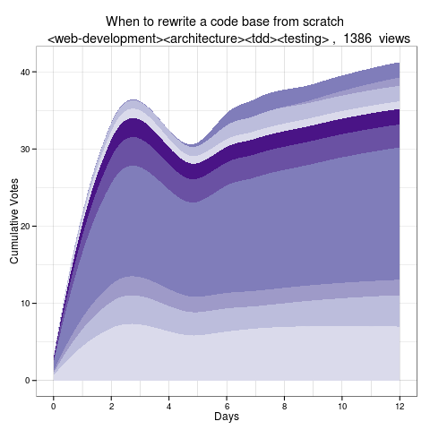 Figure 2 : Typical Question Timeline

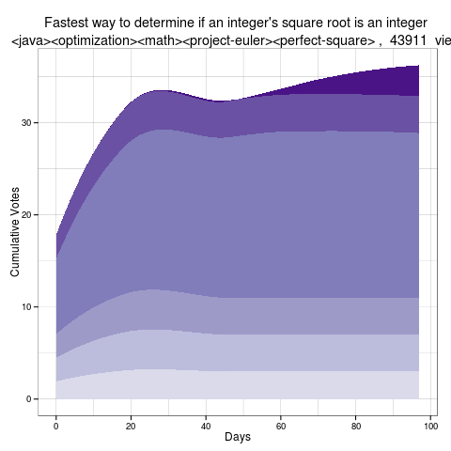 Figure 3 : "Breaking" Question Timeline (Answers receiving at least 6 votes)

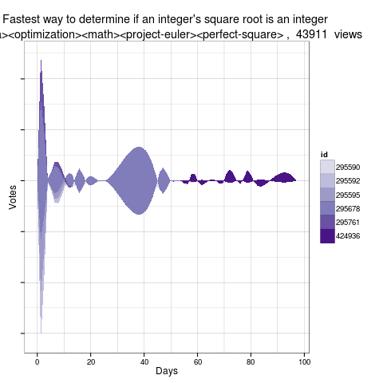 Figure 4 : "Breaking" Question Voting (Answers receiving at least 6 votes)

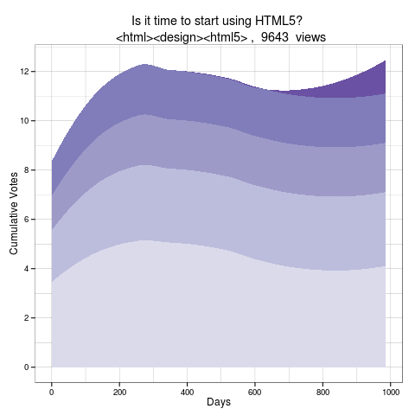 Figure 5 : "Breaking" Question Timeline

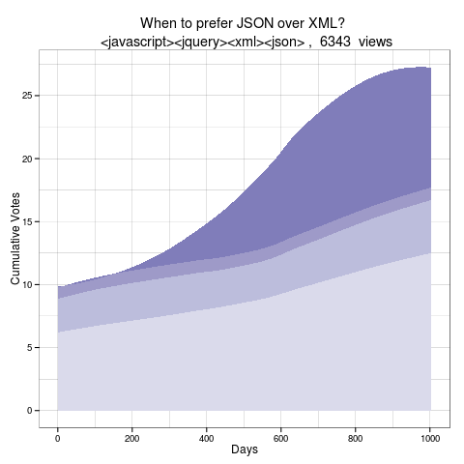 Figure 6 : "Evolving" Question Timeline

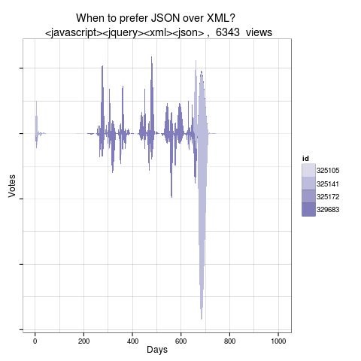 Figure 7 : "Evolving" Question Voting

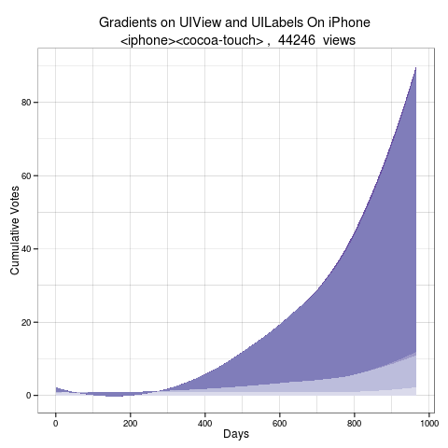 Figure 8 : "Breaking" Question Timeline

Question and answer edits over time
Evolution of moderation
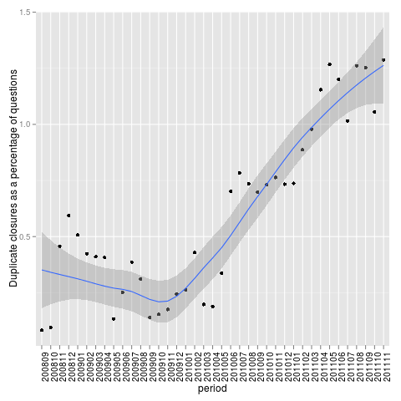 Figure 9 : Questions closed as duplicates as a percentage of total questions

