Knowledge fixation and accretion: Longitudinal analysis of a social question-answering site
Paul Matthews,
Department of Computer Science and Creative Technologies,
University of the West of England.

Abstract

Introduction
Social question-answering (Q & A) sites provide a platform for users to post questions on general or more specialist topics and receive answers from the community of users. Curated question-answer thread pages then become a resource of value more widely to web users looking for the same, or similar solutions to problems. Aspects of gamification and collaborative filtering - introducing points and rankings for asking and answering queries, and allowing users to vote on others' contributions - are common in these sites, and act as an incentive for members to provide answers. At the same time, they shape the way the information resource evolves and appears to the web user on subsequent visits. While the time to "populate" a question-answer resource may be quite short (fixation) a question will remain open for subsequent interaction, to be further enhanced, rated or edited by the community (accretion).

Information resources and architectures may be understood from a "pace layering" perspective {{116 Morville,P. 2005;}}. A concept originally applied to physical buildings, pace layering describes the differential rate of change between layers - such as structure/services/space plan in a building context - with a more permanent outer shell giving way to more rapidly changing inner layers. Over time, inner changes from new or fast-moving activities may be absorbed into the more permanent core. In the information context, this may be the process by which changes in content can be recognised and supported by the interface, navigation and social organisation of the system {{79 Campbell,D.G. 2006;}}. If an information resource is to remain pertinent and timely, then it needs to have this ability to absorb and adapt to new information.

This article will examine knowledge fixation and accretion in the technology - oriented social Q & A community "Stack Overflow", a resource widely used by computer programmers to provide programming language- or technology-specific answers to their questions. Before looking at the mechanics, successes and controversies within the Stack Overflow community and analysing longitudinal effects and patterns, I will discuss philosophical ideals for knowledge exchange and psychological aspects of knowledge seeking and contribution. Longitudinal aspects of other collaborative information environments will be discussed. I will then focus on social Q & A and their emergent dynamics.

Desirable norms and architecture for a knowledge commons
[Refs needed in this section]
Online, social Q&A lowers the barriers of entry to a community of knowledge to a simple interest and willingness to contribute. Social Q & A provides an online analogue of a social epistemological system, with community members providing "testimony" as to the best answer to a question. The foremost theorists in social epistemology regard their field as normative, in providing a framework for an epistemological system to converge on the true knowledge (defined in a number of ways) {{414 Goldman, A.I. 1999;}}. Conditions of such systems include inclusivity, diversity and authority. A system should be inclusive, in allowing anyone to contribute testimony. It should be diverse, in encouraging a range of opinion on which the information seeker can draw. It should be authoritative, in that users should be able to gauge the authority of the testifier and their warrant for knowledge {{829 Matthews,Paul 2012;}}.

Epistemic systems also need to accommodate different types of question, not only the simplified philosophical proposition of "whether p", but how-tos, whichs, whys and more general advice and recommendation seeking. Many of these wider question types do not have anything like a "correct" answer but are open to a diversity of views among which the receiver of testimony needs to choose. In doing so, we may formulate a tentative hypothesis until evidence seems sufficient to reject it {{414 Goldman, A.I. 1999;}}.

To these above conditions I would add that the system should be dynamic, flexible enough to accommodate new conditions that require knowledge to be updated, or new opinions or evidence to be included for consideration.

Social Q & A and user motivations
Sites such as Stack Overflow attract two overlapping yet partially distinct user groups - those seeking answers and those providing them {{714 Mamykina,Lena 2011;}}. Some mutual attraction is apparent, with the availability of answerers make the site attractive to questioners {{720 Kumar, R. 2010;}}. To understand the relative motivations for the two activities, we can look to well-established social psychology, information behaviour and communication theories.

Askers may often have a "high need for cognitive closure" {{382 Kruglanski,Arie W. 1990;}}. That is, they are highly motivated to receive knowledge which may be specific (e.g. confirming a hypothesis) or non-specific (a "best answer" to an open question) in a short time. When in receipt of candidate answers, questioners may be prone to "satisfice" or accept good-enough answers that enable them to progress in their current task {{685 Prabha,Chandra 2007;}}.

For answerers, many motivators for knowledge contribution in online communities have been identified, among them self-efficacy, sense of community and the principles of social exchange, reciprocity and individual recognition {{829 Matthews,Paul 2012; 389 Kosonen,Miia 2009;}}. In Stack Overflow, answer contributors similarly show both extrinsic and intrinsic motivation, to share knowledge and help the community while gaining externally recognisable kudos through the reputation gained. {{ 714 Mamykina,Lena 2011;}}

Some interesting and important research has been reported by Dearman and Truong into reasons that potential answerers do not contribute {{836 Dearman,David 2010/a;}}. This questionnaire-based research revealed that the third most common reason - after ignoring dubious questions and questions for which they did not know an answer - was that a question had already received answers. Within this group, some mentioned that a satisfactory answer was given which they felt they could not improve on. Importantly though, some answerers reported not answering for fear that their contribution would be lost or ignored in amongst the existing posts. Here we see that users may feel discouraged from adding knowledge based on an assessment of its (low) potential impact.

Quality in social Q & A
Quality assessment of a Q&A resource might consider question and answer quality individually or look instead at the quality of the emergent question and answer resource.
Stack Overflow has a range of guidelines and suggestions to users on how to formulate a question as well as detailed information on the type of questions that should be asked. The site FAQ encourages answerable, practical questions specific to the domain – open-ended, chatty questions are explicitly discouraged. Question guidelines request that answers first be properly researched, that users are specific as possible, that the question is on-topic and relevant to others

Quality of question and answers may be modelled using recoverable features and training against user-provided quality assessments, either those implicit in the system or those collected separately for the purposes of the research evaluation. Agichtein et al. {{831 Agichtein,Eugene 2008/a;}} , for instance, show that for Yahoo Answers, a combination of link analysis features, textual features, and user interaction features, can provide a model with up to 0.761 accuracy (area under the ROC curve) for predicting question quality and 0.878 for predicting answer quality against a cross validation set. The most important features for making the prediction for questions were usage statistics (such as click-throughs), user assigned scores (such as stars given to a question asker), and textual features (such as the amount of punctuation in the question text). For answers, answer length was significant, as were the frequency of words appearing in the overall corpus and the relative up vote proportion.

In terms of answers, one further route may be to assess answers based on which are "accepted" as a best answer by the questioner. Adamic et al {{341 Adamic,L. 2008/a;}} used a logistic regression on data from the social question answering site Yahoo Answers, to predict whether an answer would be accepted at the "best" answer. They selected data from a set containing 1,178,983 questions and 8,452,337 answers, balancing for accepted or not accepted answers. They claimed a 62% prediction accuracy - achieved using cross-validation - for accepted answers, based on reply length, the length of the thread (negative), the number of best answers given by the answerer and the number of replies (negative). There are, however, as discussed below, some temporal bias issues with treating accepted answers (or even those with the most upvotes) as proxies for the highest quality and we should be cautious here.

At a smaller scale and taking a mixed methods approach, Blooma et al {{754 Blooma,Mohan John 2008;/a}} analysed 300 question and answer pairs from Yahoo Answers, relating textual and non-textual features to answer quality. A multiple regression model was used, taking an overall quality rating of the answers by human volunteers as the dependant variable. Model variables were the reputation and authority of asker and answerer and the category (non-textual variables) and accuracy, completeness, language, reasonableness and answer length (textual features, again as ratings from the volunteers). The textual features of accuracy, completeness and length were the most significant regressors {{754 Blooma,Mohan John 2008;}}.

It is notable that the above studies have largely neglected temporal features of the interactions, or only including them implicitly (e.g. by counting the number of answers received or the overall click-through count). That said, some of the most significant quality features that have been identified: answer length, correctness of grammar etc, are probably better associated with questions and answers that more time to prepare and present.

Fewer studies have targeted the quality of the overall question-answer thread as a resource, which may consist of the question plus a number of different - though equally relevant - answers. In a way, well phrased questions with several high quality candidate answers may be the best overall quality resources and equivalent to Wikipedia's featured articles.

In a learning environment, multiple wiki texts - even when each text is itself collaboratively authored - may be more helpful to students than a single text, with individual preferences differing as to which may be most helpful {{825 Fountain, R. 2007;}}. Such intertextuality is often associated with the building of a more sophisticated understanding of the problem area and, perhaps counter intuitively, prior naivety towards a topic may actually help in building a nuanced understanding across multiple texts {{387 Bråten,Ivar 2008;}}.

In a game-theoretical analysis of social Q&A, Jain et al {{832 Jain,Shaili 2009/a;}} usefully distinguish between new answers that substitute for existing ones (providing an overall better answer alternative which renders existing answers redundant) and those that complement them (adding to and enriching the information already provided). Through a simulation exercise, they show that the existing voting system for Yahoo Answers is satisfactory in the case of substitution answers but less so for complementary answers. In the latter case, the ability for the question poser to award votes proportionally to a number of answers was found to be optimal. This analysis points to the possibility that current collaborative ranking systems may introduce bias to the detriment of overall resource quality.

Sources of bias through moderation, community size and the use of gamified interfaces
A number of forms of bias - both epistemically positive and negative - may be found within socio-technical systems. Firstly, there is bias introduced by the technology platform itself, through the way in which information is selected and presented to the user. Secondly, there is bias relating to the user community (norm-oriented bias) and how it may self-moderate or police. A third type of bias emerges as a result of user interaction with the technology, and may become manifest as the filtering effected on an information resource, or the order of presentation such that the user is more likely to read a particular section of the information.

In social Q & A and the Stack Overflow interface, the "fastest gun" issue has been identified and criticised both from within and outwith the community . Here, users compete to answer questions as quickly as possible, in order to gain the associated reputation points if their answer is accepted by the questioner {{714 Mamykina,Lena 2011;}}. As one community user puts it, after admitting to watching the very newest questions being posted to the site in order to select which to answer : "You can usually catch questions first if you watch this page. I think it is the easiest way to score rep.". While this has the desirable effect of the asker receiving an answer quickly, but may sacrifice quality given that the answerer is in a rush to provide information. The extent of the problem was highlighted, with the median answer time calculated at 11 minutes after the question was posted.

In epistemic online communities that reach a certain size, the sheer volume of information becomes very difficult to manage. The addition of new posts at a certain rate means that new questions may slip quickly from view and not be detected by potential responders. A number of corrective measures may be taken to refloat unanswered questions and to rank them by votes or activity, and Stack Overflow makes use of both of these approaches. These measures are only partially successful, however, and the activity window on new questions remains by and large fairly brief.
Collaborative filtering, in the form of aggregated user votes, provides an important mechanism to rank answers provided to users' questions. Again, "fastest gun" effects my lead to bias here as early answers start to gain votes before - possibly higher quality - answers accumulate. As we shall see below, this can be verified in Stack Overflow by looking at Answer scores in relation to the time they were contributed.

Knowledge accretion in collaborative authoring environments
Perhaps the most widely studied collaborative knowledge technology is the wiki, and the specific instance most widely studied is Wikipedia. Here, approaches have looked at the dynamics of article authoring and editing for different types of topic, and have reached a quite good understanding of how knowledge builds and changes over time.

Overall, although a large number of users may work on any particular article, additions and minor style edits are far more common than deletions or more thorough reorganisations {{821 Jones,John 2008;}}.

Quality Wikipedia articles are those which over time achieve a balanced objectivity and a relative stabilisation of information {{515 Sanger,Lawrence M. 2009;}}. In cases of contested or controversial topics, the overall direction of the article may be determined by the more persistent - as opposed to expert - editors.

The "Featured article" status of the very best pages are often taken as a proxy for quality, and these may have more policy edits than non - featured articles {{821 Jones,John 2008;}}.

The more prolific Wikipedia editors tend to have a better grasp of Wikipedia norms (e.g. a neutral point of view, and will cite these in edit page discussions about addition or change to content {{672 Panciera,Katherine 2009;}}. Notably, however, "generalist" regular contributors may not provide as high a quality of contributions as expert, irregular contributors {{814 Luyt,Brendan 2008;}}

A "first mover advantage" in Wikipedia articles has been identified. Content contributed early in a page's life tends to persist, and that may include any errors introduced early on {{814 Luyt,Brendan 2008; 826 Ehmann, K. 2008;}}. This was first identified and visualised in the "History Flow" project undertaken by IBM research {{788 Viégas, F.B. 2004;}}. It is not clear what the underlying explanation for the first mover advantage is, though it is possible that subsequent edits look at style and formatting issues and neglect the factual content of the articles.

Methods and Approach
This work used the Creative Commons data dump of the Stack Exchange web sites, a periodically published dataset containing partial information for a range of social Q&A sites, with Stack Overflow the largest. Most of the work was conducted using the May 2011 data, but where indicated the December 2011 data dump was used. The May 2011 dataset contains some 6,479,788 posts - incorporating both questions and answers - from amongst 756,695 users. By December 2011, the totals had grown to 7,397,507 posts and 887,372 users.

Preprocessed data and R code used in the analysis is available in the following repository: https://github.com/paulusm/InfoAccretion

Findings

Temporal bias in answer acceptance
An analysis of temporal factors in relation to answer acceptance confirmed the tendency for the first few answers received to be accepted in preference to later ones. Figure 1 shows a scatter graph of 250 randomly selected answers plotted by temporal rank and the time that the question was received. We can see that accepted answers appear more commonly toward the bottom left of the graph.

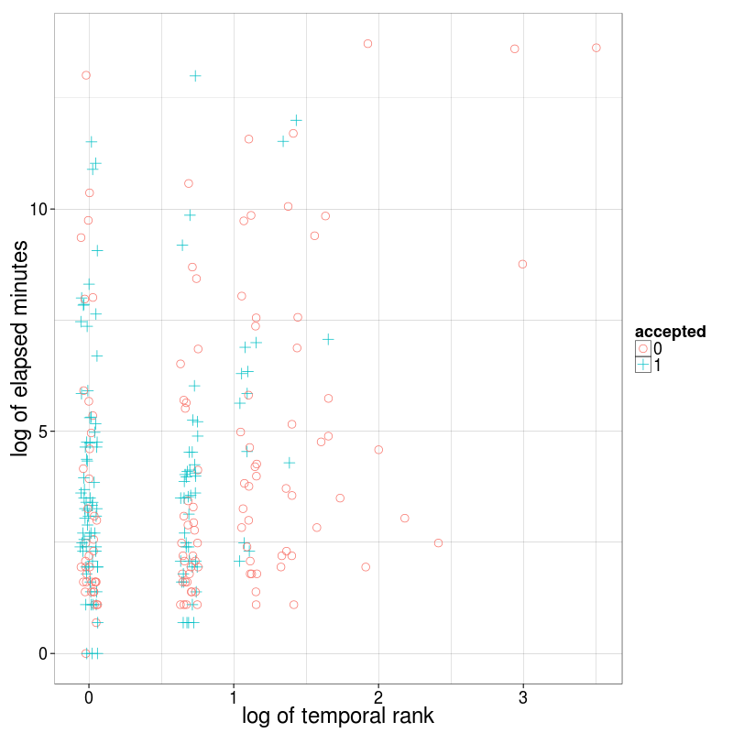 Figure 1 : Scatter of answers by temporal rank and minutes after the question was posted (log transformations)

In order to compare temporal factors with other structural features previously identified as important to acceptance or answer quality, multiple logistic models were constructed to provide predictions of answer acceptance. 5000 randomly selected answers were used to construct the models, with the features of temporal rank, the time from question to answer, the post length in characters and whether the post contained a code example. The non-temporal features had been identified in earlier studies as important features in acceptance decisions in Q&A generally or, for code examples, the Stack Overflow community {{341 Adamic,L. 2008; 713 Treude,C. 2011;}}.

Models were tested using a further separate sample of 5000 answers. The prediction accuracy in terms of a 0.5 prediction threshold and the area under the ROC curve are shown in Table 1, below.

Table 1: Predicting acceptance from temporal and textual features
 | Model | Prediction Accuracy(%) | Area Under ROC Curve
1 | temporal rank | 0.603 | 0.644
2 | quadratic temporal rank | 0.603 | 0.644
3 | log of temporal rank | 0.616 | 0.644
4 | time after question posted | 0.518 | 0.500
5 | answer length (chars) | 0.561 | 0.586
6 | Contains code | 0.561 | 0.586
7 | temporal rank + time after question | 0.605 | 0.632
8 | temporal rank + answer length | 0.635 | 0.686
9 | temporal rank + answer length + contains code | 0.640 | 0.695
10 | log of temporal rank + answer length + contains code | 0.636 | 0.693

We see that temporal rank provides the best single predictor of acceptance, with the timing of the response and the structural features relatively less reliable. Combining features only provides piecemeal improvements, with the best accuracy of 0.644 achieved with a combination of temporal rank, answer length and the contains code binary.

Question longevity and "breaking" answers
As noted in previous studies, the activity window around new questions tends to be very brief, with most answers contributed on the same day, usually within hours of the question being added. As with many online activities, however, there is a long tail of activity and some questions are revisited months later.

Table 2 shows a summary of questions and the time at which answers were contributed. The majority of question activity ceased after 30 days. In some cases, activity continued after 30 days but those questions contributed fewer user votes. Only in around 2% of cases did new questions garner the majority of votes.

Table 2: Longevity of Questions
 | Description | count(*)
1 | Answers above 30 days old scoring more highly | 24286
2 | Answers less than 30 days old scoring more highly | 160620
3 | No answers after 30 days | 1620674

Figure 2 shows a typical question timeline, with the majority of answers, and up-votes to these - signalling approval from other community members - received in the few days after the question was asked. The upper part of the graph presents the answers, each in different colour, with their cumulative up-votes over time. The lower part shows voting activity for the answers, with the size of the marker proportional to the number of upvotes received at that time.

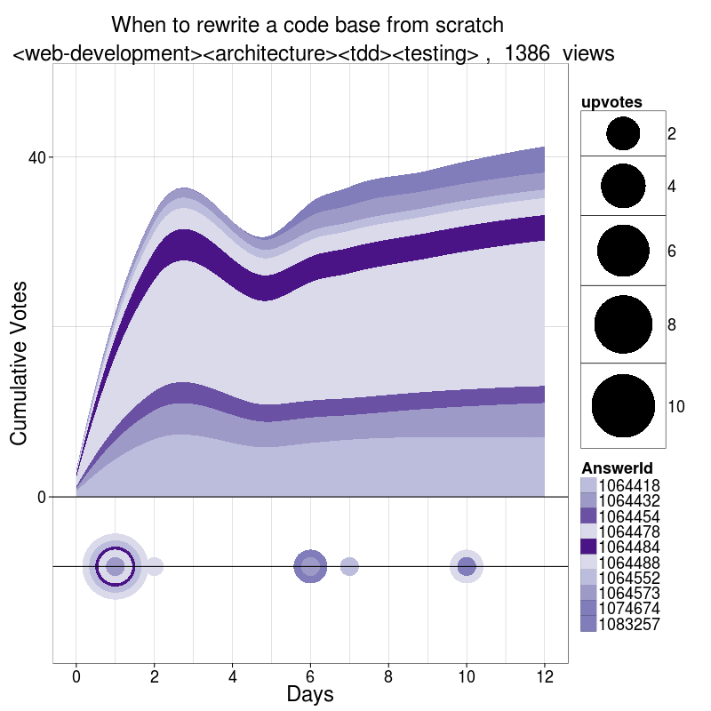 Figure 2 : Typical Question Timeline

The typical voting patterns are shown in figure 3, and tend to show the most activity on the day of question posting, with voting tailing off thereafter, but the majority of votes going to answers that were in place early in the timeline.

In a "poll" type question, voting is far more evenly spread out, with new answers appearing at intervals. This type of question, while attracting community participation and attention, is also a type disfavoured by moderators and liable to closure for being too subjective (see evolution of moderation, below).

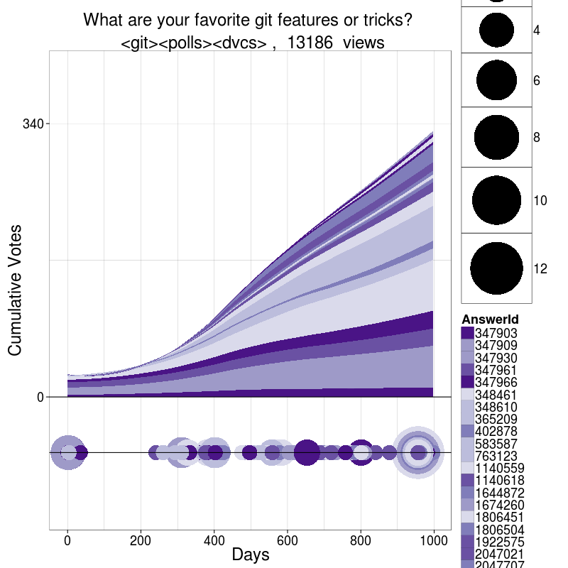 Figure 3 : "Poll" Question Timeline

In the minority of cases where a new, high quality candidate answer is received that manages to attract community attention, we see a timeline as portrayed in figure 4 below. Here, the question is quite specifically related to the "Project Euler" mathematical computing challenge and as such it might be argued that there would be a very focused, expert sub-community interested in the question.

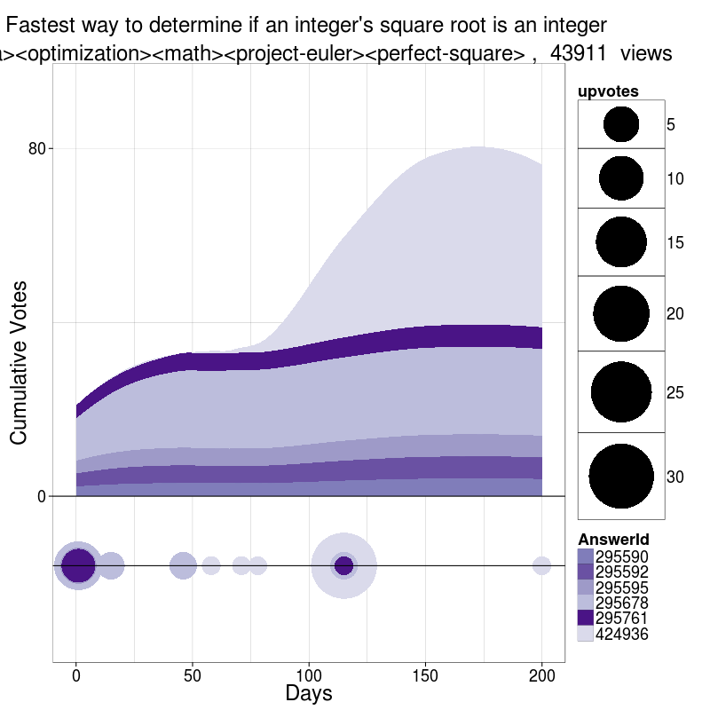 Figure 4 : New Preferred Answer Timeline (Answers receiving at least 6 votes)

We see from subsequent voting on this question that the new answer received gradual upvotes over time, promoting it up the ranking of answers according to vote tally.

In other cases we see questions where answers are mostly temporally close to the question, but the first mover advantage puts the earliest ahead initially. In time, however, a slightly later question (in this case just a few days) gains over subsequent months. Here, the newer question author has provided a more factual, broader summary of the pros and cons of web data formats than the originally upvoted answers (Figure 5)

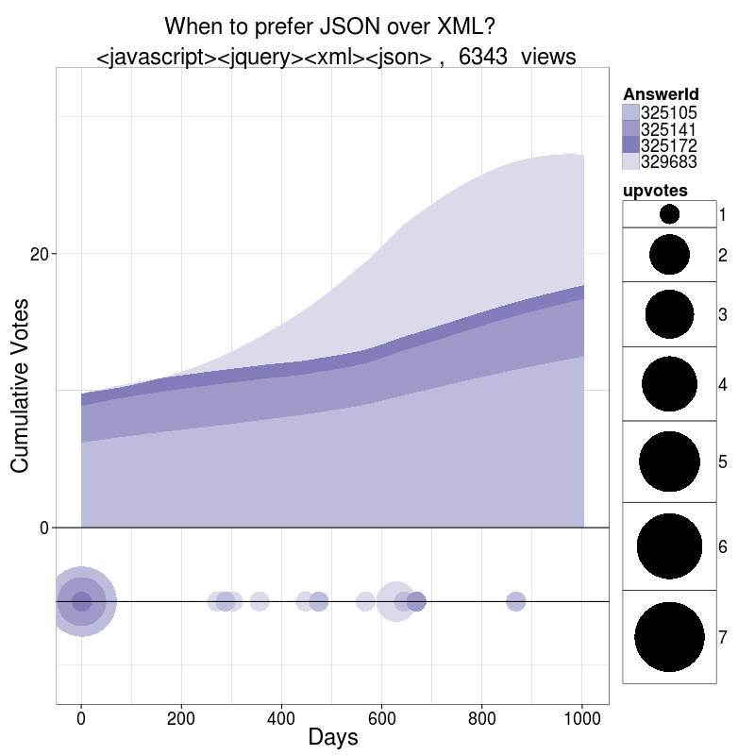 Figure 5 : "Breaking Answer"

In some cases a new technical approach emerges in time which supercedes previously provided answers. We also see here a rise in question popularity, probably coupled with increased general activity in the area - in that case of iOS development (iPhone apps).

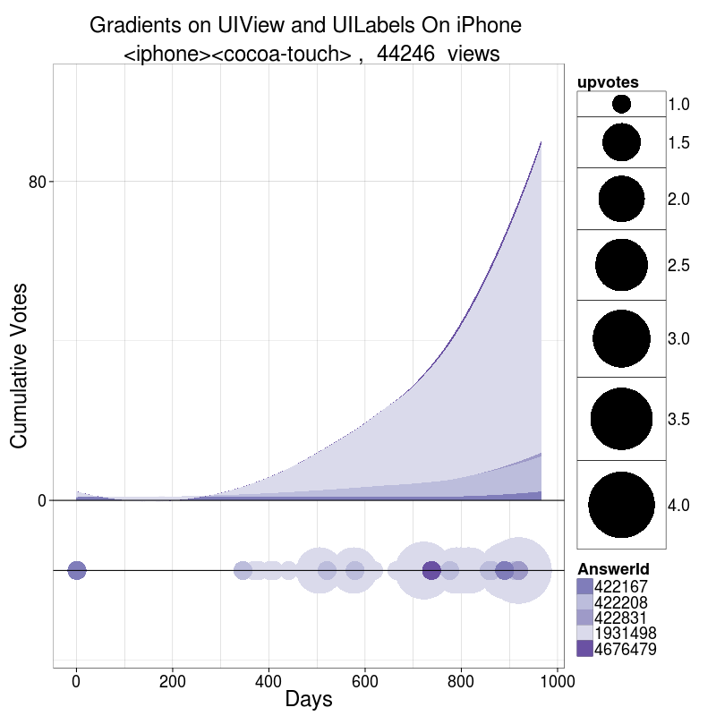 Figure 6 : New Technology Question

In this case, unlike the accepted answer, the preferred new answer provided almost a year after the question supplies a fuller answer, including a code example. The new answer is fourth if the questions are ranked temporally, but two of those ahead - including the accepted answer - are very brief and one only attracted a single upvote. This suggests that the new answer was visible with only minimum vertical scrolling on the part of the user and rose above two of the older answers quite quickly. The utility of the new answer is clear by the quantity of upvotes it attracted - but relied on the answer provider actively seeking out an older question and choosing to update the content with new information.

Question and answer edits over time
Above certain reputation thresholds, users are able to edit the question and answers of other users. In order to investigate the extent of editing, a "diff" was calculated using the Python difflib library. The library takes a "Gestalt" approach to text comparison, calculating the percentage match between two texts by working outward from the largest sequence matched. A diff ratio can then be calculated:
"If T is the total number of elements in both sequences, and M is the number of matches, this is 2.0*M / T. Note that this is 1.0 if the sequences are identical, and 0.0 if they have nothing in common." - difflib documentation
For the full corpus of questions in the September 2011 dataset, the mean diff overall was 0.92. Questions had received an average of 1.54 body edits with 35% of all questions receiving at least one edit. For answers, the mean diff was 0.94 and the average number 1.38 body edits - 20% of all answers received at least one edit. So more questions than answers receive an edit, and of those that are edited, questions are slightly more likely to be edited repeatedly.

To examine any relationship between the diffs of questions and answers to associated aspects of the posts, Spearman's correlation matrices were created and are shown in Tables 3 and 4, below. The "minsbetween" variable was the time in minutes between the first and last edits. Score is the sum of upvotes minus downvotes, and ViewCount the number of web views the post has received.

 | score | viewcount | diff | minsbetween | bodyedits | titleedits
score | 1.0000 | 0.3745 | 0.0132 | 0.1177 | 0.0425 | 0.0363
viewcount | 0.3745 | 1.0000 | -0.0472 | 0.1812 | 0.0622 | 0.0417
diff | 0.0132 | -0.0472 | 1.0000 | -0.2449 | -0.3599 | -0.0862
minsbetween | 0.1177 | 0.1812 | -0.2449 | 1.0000 | 0.2723 | 0.0748
bodyedits | 0.0425 | 0.0622 | -0.3599 | 0.2723 | 1.0000 | 0.1239
titleedits | 0.0363 | 0.0417 | -0.0862 | 0.0748 | 0.1239 | 1.0000

 | score | diff | minsbetween | bodyedits
score | 1.0000 | -0.0218 | 0.0532 | 0.1467
diff | -0.0218 | 1.0000 | -0.0230 | -0.3399
minsbetween | 0.0532 | -0.0230 | 1.0000 | 0.2782
bodyedits | 0.1467 | -0.3399 | 0.2782 | 1.0000

While we see no significant relationship between the extent of edits and quality ratings (score and viewcount), there are indications that the time between edits is related to score and viewcount for questions, and that the number of body edits may be important for answers. In the case of questions, this may be because edits over time keep the thread active and therefore more visible through the interface. In the case of answers, it is indicative of possible quality improvements introduced through iterative edits (even if more major changes are not associated with more views).

To further investigate this difference between questions and answers, the diff distribution was plotted for a random sample of 10,000 of each and is shown in Figure xx below. This reveals that questions tend to be edited more shallowly - and accords with user testimony that much of question editing is to do with more minor formatting

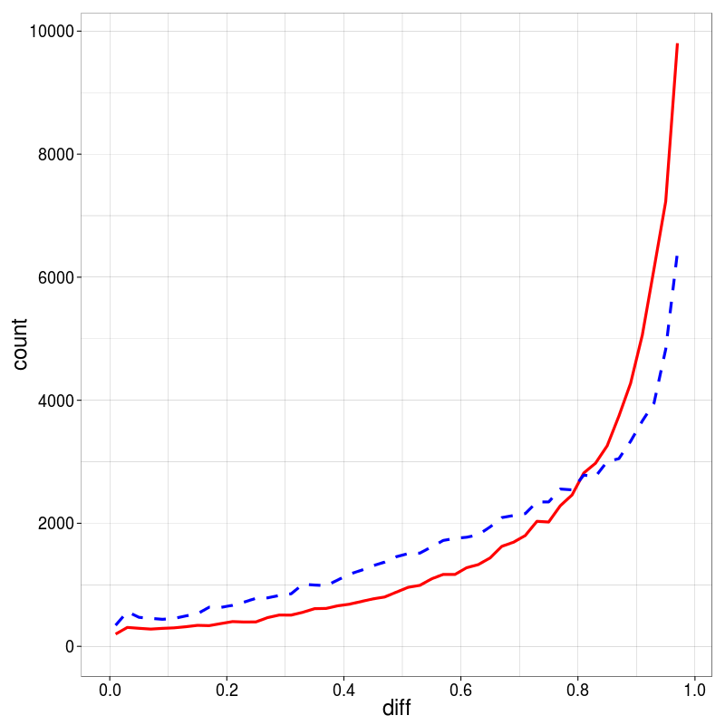 Figure 7 : Question(solid line) and answer (dashed line) diffs for posts with 2 or more edits

Figure xx illustrates the temporal distribution of edits. In the majority , edits are made quickly but there is long tail of edits over time. The peaks in the editing curves may partly due to behavioural aspects, such as users revisiting their posts at the same time the following day.

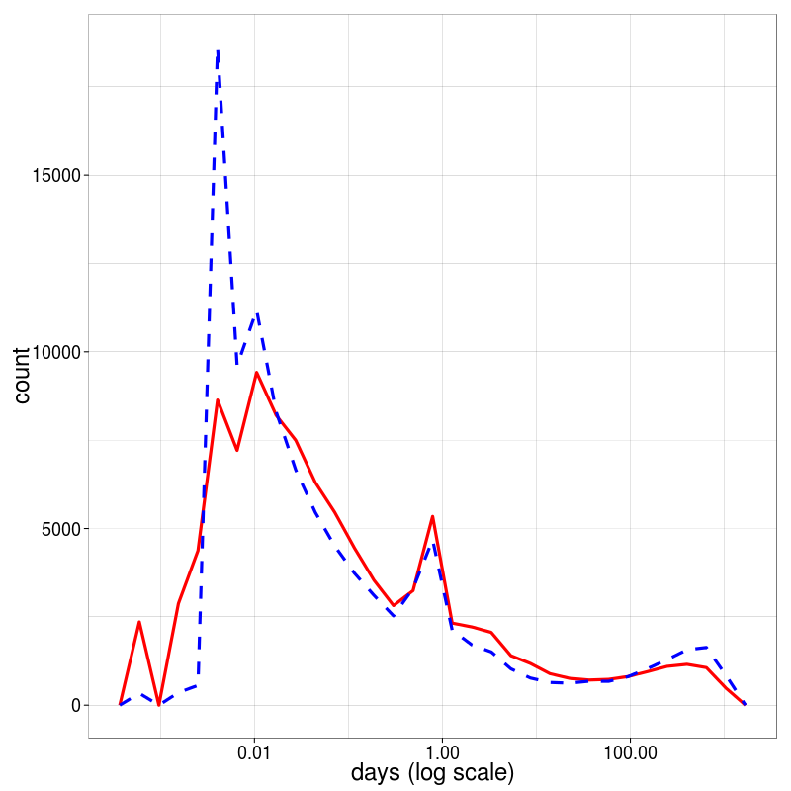 Figure 8 : Question(solid line) and answer (dashed line) editing period for posts with 2 or more edits

Evolution of moderation
In the Stack Overflow community, question duplicates are an acknowledged problem. The objective is a single, canonical answer to a specific question and the emergence of duplicates threatens this. With the success and expansion of the community this has been a growing problem. Users with a certain reputation level are able to flag questions as duplicates and vote for them to be closed, at which point the question is merged into the original.

We see from a comparison of duplicate closure votes over time, that this is in fact increasing with the accumulation of questions, indicating that policies to encourage the identification of duplicates are meeting some success (Figure xx).

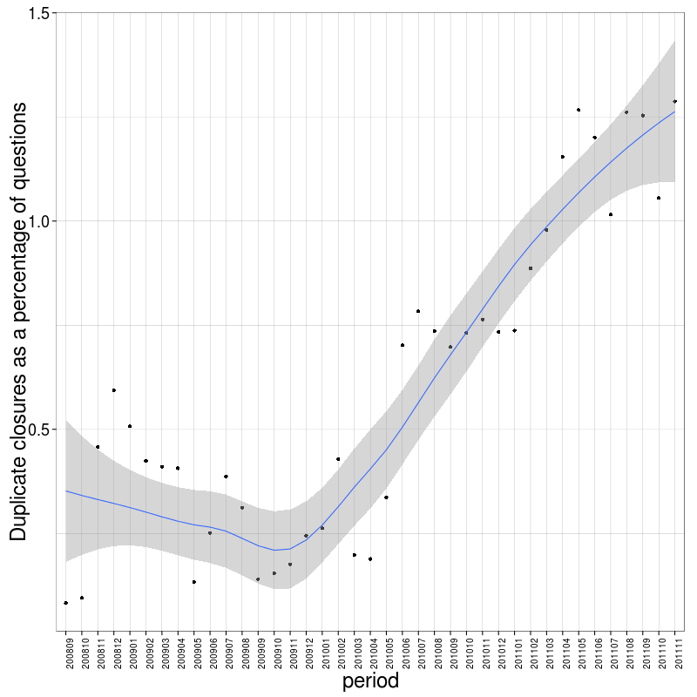 Figure 9 : Questions closed as duplicates as a percentage of total questions

A related issue is the closure of questions deemed to be off-topic and not suited to the remit of the community. Here again, there is a trend towards increasing numbers of questions being closed as off-topic (Figure xx). This is something that is itself a bone of contention within the StackOverflow community, as "off-topic" may be to some extent a matter of opinion.

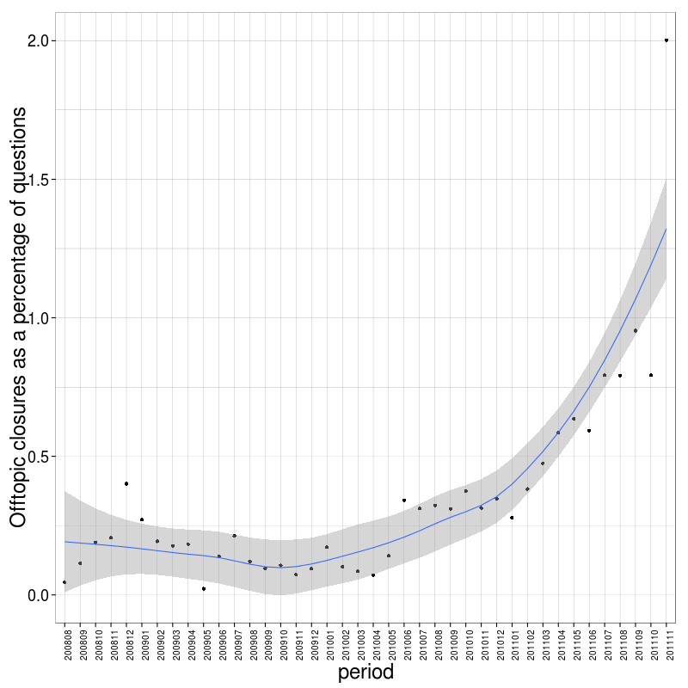 Figure 10 : Questions closed as off topic as a percentage of total questions

Discussion

Old questions, new knowledge
- how do they come to the fore?

The following exchange, from the "meta" discussion pages of diy.stackexchange.com, a sister site to Stack Overflow, illustrates this well:
"The fact that an old question can reappear and get new answers is by design. Things change, what was the best answer a year or two ago might not be any more. - ChrisF
I agree: it is a good thing when an old question is rekindled and receives new answers (typically from someone who was not here when the question first was posted). Remember that we're building a resource for posterity, not just helping the OP."– Vebjorn Ljosa
It is a very negative experience to spend time working on an answer, only to realize that the asker will never see it. – dbracey
@dbracey - don't focus on the asker. Focus on all the other people who'll find the question because they have the same problem. – ChrisF"

Conclusion

References

http://stackoverflow.com/faq
http://stackoverflow.com/questions/how-to-ask
http://meta.stackoverflow.com/questions/8137/do-you-watch-the-unanswered-page-home-page-or-another-page
http://stackoverflow.com/questions/1064403/when-to-rewrite-a-code-base-from-scratch
http://stackoverflow.com/questions/347901/what-are-your-favorite-git-features-or-tricks
http://stackoverflow.com/questions/295579/fastest-way-to-determine-if-an-integers-square-root-is-an-integer
http://stackoverflow.com/questions/325085/when-to-prefer-json-over-xml
http://stackoverflow.com/questions/422066/gradients-on-uiview-and-uilabels-on-iphone
http://docs.python.org/library/difflib.html
http://meta.stackoverflow.com/users/165455/aaron-bertrand
http://meta.diy.stackexchange.com/questions/668/how-can-we-keep-old-threads-from-coming-back

