Experiment 3
Experiment name: Statistical description
Date:1-1-25
Name: Paul Wilson
Roll No:49

program

data<-c(20,30,10,50,35,100,60,52)
mean_1<-mean(data)
print(mean_1)
median_1<-median(data)
print(median_1)
first_quartile_1<-quantile(data,0.25)
cat("First Quartile:",first_quartile_1)
third_quartile_1<-quantile(data,0.75)
cat("Third Quartile:",third_quartile_1)
min_val_1<-min(data)
cat("MINIMUM VALUE:",min_val_1)
max_val<-max(data)
cat("MAXIMUM VALUE:",max_val)
boxplot(data,main ="Boxplot of data",
xlab = "values",
ylab = "values",
col = "orange",
border = "brown")
data<-c(20,30,10,50,35,100,60,52)
var_1<-var(data1)
cat("Variance of data:",var_1)
data1<-c(15,20,35,45,50,42,30,25)
covar<-cov(data,data1)
cat("Covariance of data and data1 is:",covar)

OUTPUT
[1] “Mean: 44.625”
[1] “Median: 42.5”
[1] "First Quartile: 27.5"
[1] "Third Quartile: 54"
[1] "MINIMUM VALUE: 10"
[1] "MAXIMUM VALUE: 100"
[1] "Variance of data: 785.410714285714"
[1] "Covariance of data and data1 is: 122.607142857143"

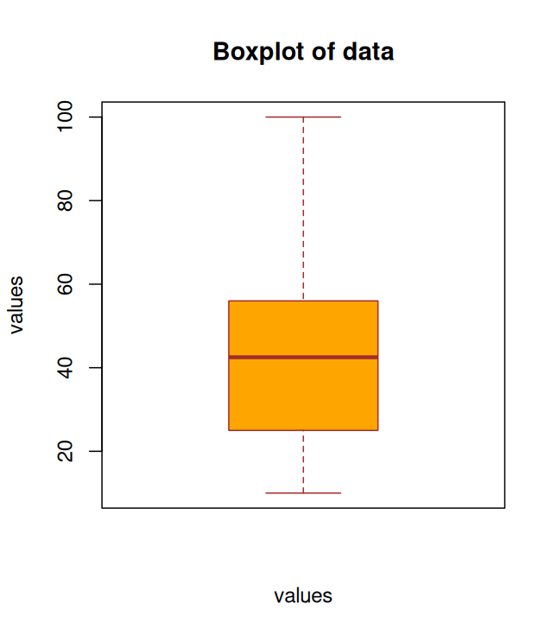
Experiment 4
Experiment name:variance,covariance,corelation coefficient
Date:8-1-25
Name: Paul Binu
Roll No:48

program
data1<-data.frame(Quantity=c(2,4,1),Price=c(160,200,80))
print(data1)
varian1<-var(data1$Quantity)
cat("Variance:",varian1)
covar<-cov(data1$Quantity, data1$Price)
cat("Covariance:",covar)
correl<-cor(data1$Quantity,data1$Price)
cat("Correlation:",correl)
plot(data1$Quantity,data1$Price,main='Scatter Plot',xlab='x-axis',ylab='y-axis',col='blue',pch=25)

contingency_table<-table(data1$Quantity,data1$Price)
print(contingency_table)
chi<-chisq.test(contingency_table)
print(chi)

data1<-data.frame(Quantity=c(2,4,1),Price=c(160,200,80))
cat("Row sum:",apply(data1,1,sum))
cat("Column sum:",apply(data1,2,sum))
print(outer(data1$Quantity,data1$Price))
OUTPUT

Quantity Price
1 2 160
2 4 200
3 1 80
Variance: 2.333333Covariance: 86.66667Correlation: 0.9285714
80 160 200
1 1 0 0
2 0 1 0
4 0 0 1

Pearson's Chi-squared test

data: contingency_table
X-squared = 6, df = 4, p-value = 0.1991

Row sum: 162 204 81Column sum: 7 440 [,1] [,2] [,3]
[1,] 320 400 160
[2,] 640 800 320
[3,] 160 200 80

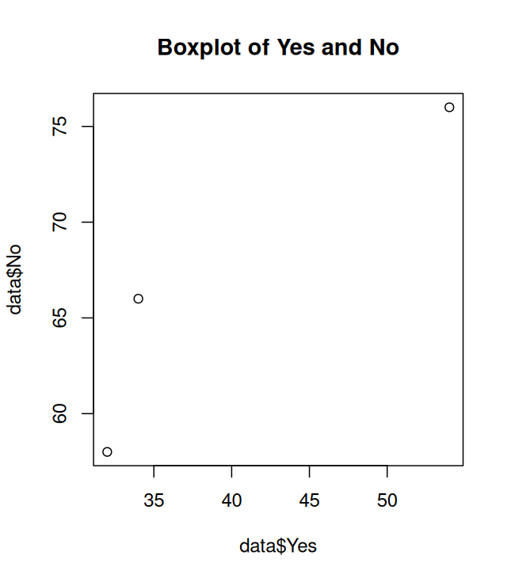

Experiment 5
Experiment name:menu driven
Date:15-1-25
Name: Paul Binu
Roll No:48

program
is_palindrome <- function(x) {
char_list <- strsplit(x, NULL)[[1]]
reversed_char_list <- rev(char_list)
reversed_string <- paste(reversed_char_list, collapse = "")
return(x == reversed_string)
}
is_fibonacci <- function(n) {
if (n == 0) return(TRUE)1
a <- 0
b <- 1
while (b < n) {
temp <- b
b <- a + b
a <- temp
}
return(b == n)
}

# Function to calculate factorial
factorial_calc <- function(n) {
if (n == 0) return(1)
return(prod(1:n))
}
menu <- function() {
repeat {
cat("\nChoose an option from the menu:\n")
cat("1. Merge Two Data Frames\n")
cat("2. Find Palindromes in Data Frame\n")
cat("3. Find Max/Min of Rows and Columns\n")
cat("4. Factorial of Fibonacci Numbers\n")
cat("5. Exit\n")

choice <- as.integer(readline("Enter your choice: "))

if (choice == 1) {
# Create two data frames with a common column 'ID'
df1 <- data.frame(ID = c(1, 2, 3, 4), Name = c("Alice", "Bob", "Charlie", "David"))
df2 <- data.frame(ID = c(1, 2, 3, 4), Age = c(25, 30, 22, 45))

merged_df <- merge(df1, df2, by = "ID")

cat("Merged Data Frame:\n")
print(merged_df)

} else if (choice == 2) {
df <- data.frame(
col_1 = c("m", "h", "r", "h", "m"),
col_2 = c("a", "h", "c", "w", "l"),
col_3 = c("m", "h", "b", "w", "l"),
stringsAsFactors = FALSE
)

df$Palindrome <- apply(df, 1, function(row) {
row_str <- paste(row, collapse = "")
return(is_palindrome(row_str))
})
write.csv(df, "palindrome_result.csv", row.names = FALSE)
cat("Results have been written to 'palindrome_result.csv'.\n")

} else if (choice == 3) {
df <- data.frame(
A = c(10, 20, 30, 40),
B = c(5, 15, 25, 35),
C = c(3, 13, 23, 33)
)

max_col <- apply(df, 2, max)
min_col <- apply(df, 2, min)

max_row <- apply(df, 1, max)
min_row <- apply(df, 1, min)

cat("Max of each column:\n")
print(max_col)
cat("Min of each column:\n")
print(min_col)
cat("Max of each row:\n")
print(max_row)
cat("Min of each row:\n")
print(min_row)

} else if (choice == 4) {
df <- data.frame(Number = c(5, 8, 12, 21, 34, 40, 55, 60))

# Check if each number is a Fibonacci number and calculate factorial if true
df$Is_Fibonacci <- sapply(df$Number, is_fibonacci)

# Calculate factorial for Fibonacci numbers
df$Factorial <- ifelse(df$Is_Fibonacci, sapply(df$Number, factorial_calc), NA)

# Display the data frame with results
print(df)

# cat("Fibonacci numbers and their Factorials:\n")
#print(fib_df)

} else if (choice == 5) {
cat("Exiting program.\n")
break
} else {
cat("Invalid choice. Please try again.\n")
}
}
}
menu()

OUTPUT

Choose an option from the menu:
1. Merge Two Data Frames
2. Find Palindromes in Data Frame
3. Find Max/Min of Rows and Columns
4. Factorial of Fibonacci Numbers
5. Exit
Enter your choice: 1
Merged Data Frame:
ID Name Age
1 1 Alice 25
2 2 Bob 30
3 3 Charlie 22
4 4 David 45

Choose an option from the menu:
1. Merge Two Data Frames
2. Find Palindromes in Data Frame
3. Find Max/Min of Rows and Columns
4. Factorial of Fibonacci Numbers
5. Exit
Enter your choice: 2
Results have been written to 'palindrome_result.csv'.

Choose an option from the menu:
1. Merge Two Data Frames
2. Find Palindromes in Data Frame
3. Find Max/Min of Rows and Columns
4. Factorial of Fibonacci Numbers
5. Exit
Enter your choice: 3
Max of each column:
A B C
40 35 33
Min of each column:
A B C
10 5 3
Max of each row:
[1] 10 20 30 40
Min of each row:
[1] 3 13 23 33

Choose an option from the menu:
1. Merge Two Data Frames
2. Find Palindromes in Data Frame
3. Find Max/Min of Rows and Columns
4. Factorial of Fibonacci Numbers
5. Exit
Enter your choice: 4
Number Is_Fibonacci Factorial
1 5 TRUE 1.200000e+02
2 8 TRUE 4.032000e+04
3 12 FALSE NA
4 21 TRUE 5.109094e+19
5 34 TRUE 2.952328e+38
6 40 FALSE NA
7 55 TRUE 1.269640e+73
8 60 FALSE NA

Choose an option from the menu:
1. Merge Two Data Frames
2. Find Palindromes in Data Frame
3. Find Max/Min of Rows and Columns
4. Factorial of Fibonacci Numbers
5. Exit
Enter your choice: 5
Exiting program.

Experiment 6
Experiment name: k-means Clustering
Date:12-2-25
Name: Paulu Wilson
Roll No:49

program

euclidean_distance <- function(x, y) {
return(sqrt(sum((x - y)^2)))
}

kmeans_custom <- function(data, k, max_iter = 100) {
centroids <- matrix(c(120,32,113,33),nrow=k,byrow=TRUE)

clusters <- rep(0, nrow(data))
prev_centroids <- centroids
iterations <- 0

while (iterations < max_iter) {
iterations <- iterations + 1
for (i in 1:nrow(data)) {
distances <- apply(centroids, 1, function(centroid) euclidean_distance(data[i, ], centroid))
clusters[i] <- which.min(distances)
}

c1 = list()
c2 = list()
cat("\n")
print(paste("Iteration:", iterations))
for (i in 1:nrow(data)) {
if (clusters[i] == 1) {
c1 <- append(c1, list(data[i, ]))
} else {
c2 <- append(c2, list(data[i, ]))
}
}
cat("\nCluster 1:\n")
print(do.call(rbind, c1))
cat("\nCluster 2:\n")
print(do.call(rbind, c2))
cat("\nCentroid 1:\n")
print(centroids[1, ])
cat("\nCentroid 2:\n")
print(centroids[2, ])
new_centroids <- matrix(NA, nrow = k, ncol = ncol(data))
for (j in 1:k) {
cluster_points <- data[clusters == j, ]
if (nrow(cluster_points) > 0) {
new_centroids[j, ] <- colMeans(cluster_points)
}
}

if (all(new_centroids == prev_centroids)) {
print("Convergence point reached")
break
}

prev_centroids <- new_centroids
centroids <- new_centroids
}

return(list(clusters = clusters, centroids = centroids))
}

data <- data.frame(
x = c(167,120,113,175,108),
y = c(55,32,33,76,25)

)

k <- 2
result <- kmeans_custom(data, k)

plot(data$x, data$y, col = result$clusters, pch = 20, main = "K-means Clustering",
xlab = "X-axis", ylab = "Y-axis", cex = 1.5)
points(result$centroids[,1],result$centroids[,2],col=1:k,pch=4,cex=1.0)

Experiment 6
Date:12-3-25
Name: K S Sreekumar
Roll No:37
Program: K-Means Clustering

euclidean_distance <- function(x, y) {
return(sqrt(sum((x - y)^2)))
}

kmeans_custom <- function(data, k, max_iter = 100) {
centroids <- matrix(c(120,32,113,33),nrow=k,byrow=TRUE)

clusters <- rep(0, nrow(data))
prev_centroids <- centroids
iterations <- 0

while (iterations < max_iter) {
iterations <- iterations + 1
for (i in 1:nrow(data)) {
distances <- apply(centroids, 1, function(centroid) euclidean_distance(data[i, ], centroid))
clusters[i] <- which.min(distances)
}

c1 = list()
c2 = list()
cat("\n")
print(paste("Iteration:", iterations))
for (i in 1:nrow(data)) {
if (clusters[i] == 1) {
c1 <- append(c1, list(data[i, ]))
} else {
c2 <- append(c2, list(data[i, ]))
}
}
cat("\nCluster 1:\n")
print(do.call(rbind, c1))
cat("\nCluster 2:\n")
print(do.call(rbind, c2))
cat("\nCentroid 1:\n")
print(centroids[1, ])
cat("\nCentroid 2:\n")
print(centroids[2, ])
new_centroids <- matrix(NA, nrow = k, ncol = ncol(data))
for (j in 1:k) {
cluster_points <- data[clusters == j, ]
if (nrow(cluster_points) > 0) {
new_centroids[j, ] <- colMeans(cluster_points)
}
}

if (all(new_centroids == prev_centroids)) {
print("Convergence point reached")
break
}

prev_centroids <- new_centroids
centroids <- new_centroids
}

return(list(clusters = clusters, centroids = centroids))
}

data <- data.frame(
x = c(167,120,113,175,108),
y = c(55,32,33,76,25)

)

k <- 2
result <- kmeans_custom(data, k)

plot(data$x, data$y, col = result$clusters, pch = 20, main = "K-means Clustering",
xlab = "X-axis", ylab = "Y-axis", cex = 1.5)
points(result$centroids[,1],result$centroids[,2],col=1:k,pch=4,cex=1.0)

