SAS Information Catalog

Pre-workshop tasks

Patric Hamilton

Cecily Hoffritz

Data Engineering Advisory

Nordics

Dear Student

Complete the following tasks the day before the workshop so that you are properly prepared.

Contents

1. Request a RACE image 3

2. Sync the Microsoft TEAMS site to Windows Explorer on your pc 4

3. Copy files to RACE 6

4. Create paths and load files 8

5. Verify that you can see files in global CAS library Public 14

# Request a RACE image

**The purpose of this task is to make a reservation of a RACE image the day before the workshop starts.**

1. Open your browser and click http://race.exnet.sas.com/.
2. Make a **2-day reservation** for the Cary image below. The image description will most likely show a later release, and this is fine. Make the reservation the day before your workshop.

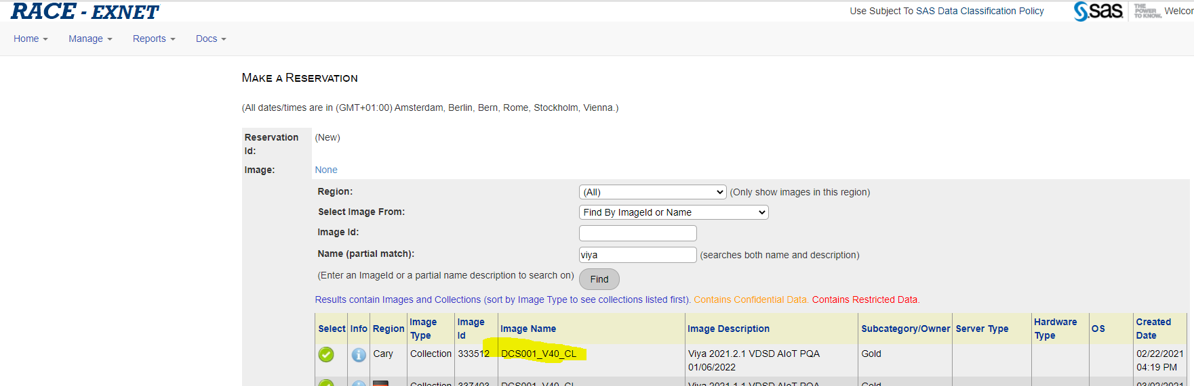

1. Click the green tickmark to the left of the image to select it.
2. Fill out with appropriate information. The end date is the start date for the workshop. Don’t change start and end times.

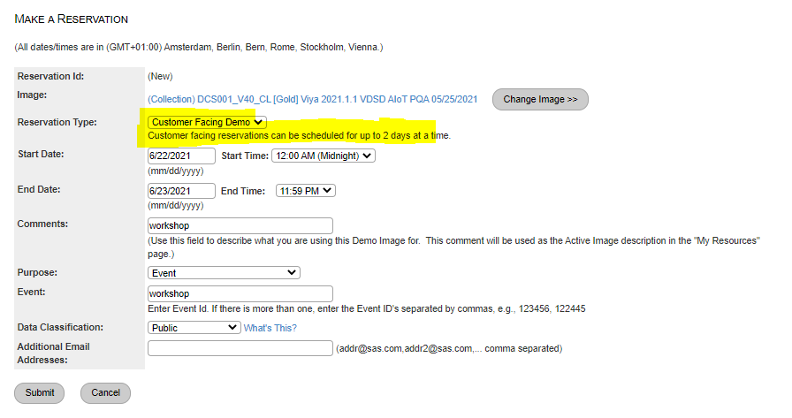

1. Wait an hour or more for all SAS Services to properly start.

# Sync the Microsoft TEAMS site to Windows Explorer on your pc

**The purpose of this task is to sync Microsoft Teams folders to Windows Explorer to make Microsoft Teams folders easier to access.**

1. Start MS Teams on your laptop and click Teams.

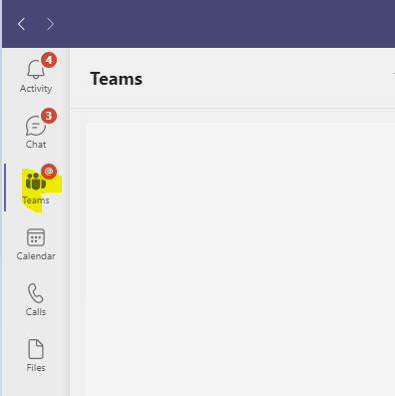

1. Click  to filter.
2. Add **information gov** to your filter. The team site for this workshop, **Introduction to SAS Information Governance on SAS Viya Workshop**, appears.

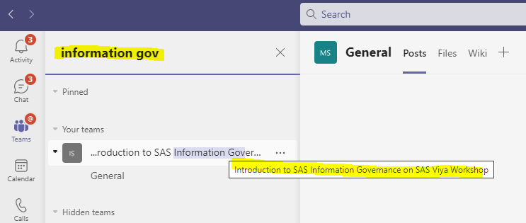

1. Pin the team site by clicking the **3 dots** to the right of **General** and clicking **Pin**.

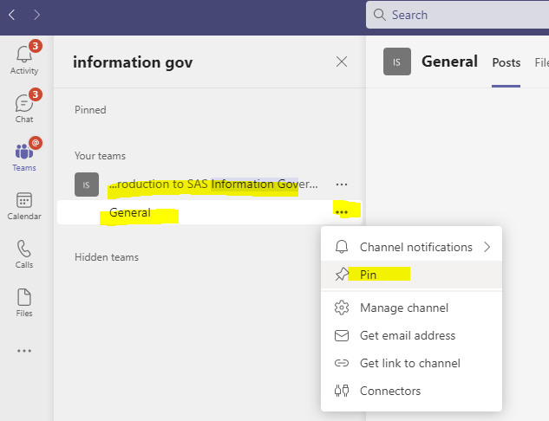

1. In **General**, select **Files** and click **Sync**.

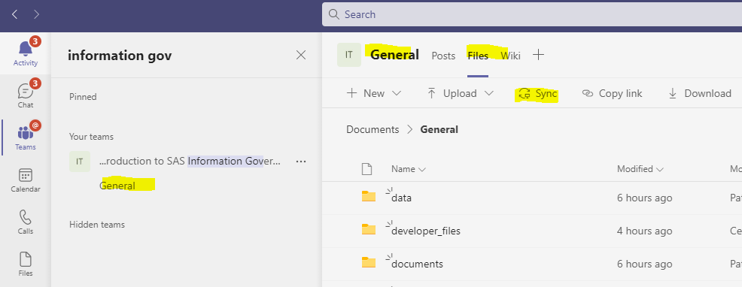

After syncing, you get a SAS icon in Windows Explorer containing your synced Team site folder.

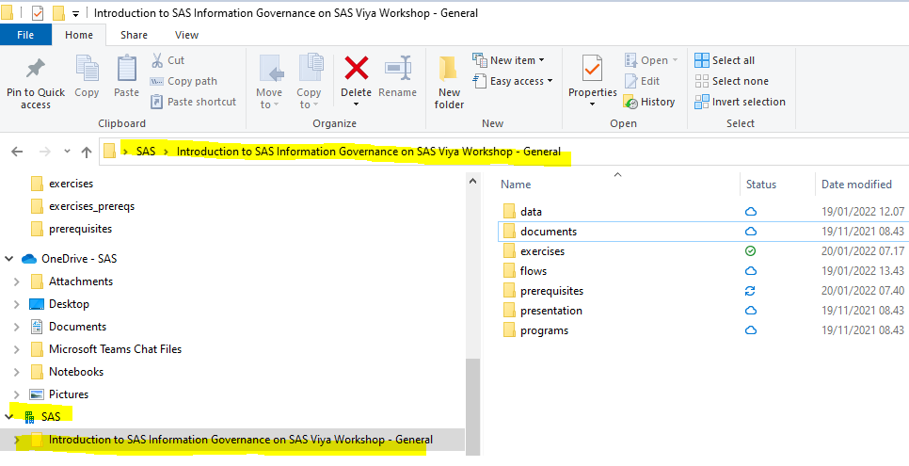

# Copy files to RACE

**The purpose of this task is to copy files from the synced folders in Windows Explorer on your desktop to Windows Explorer on the RACE image.**

1. Open a new Windows File Explorer on your own pc and type the following \*IP-ADDRESS*\c$ where IP-ADDRESS refers to the information to access the Remote Windows Desktop in the RACE email.

You get the network credentials logon window below (sometimes it takes seconds to appear, or it is hidden behind another application (ALT TAB).

1. Log on with the SAS user localhost\sas with the password Orion123, see below.

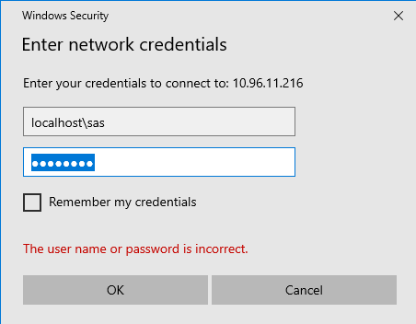

1. Switch to the RACE Windows folder below.

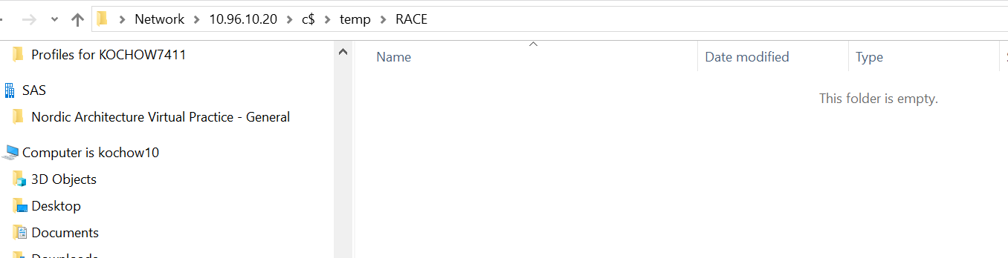

1. In Windows Explorer on your pc, copy the folders in your synced Teams **data** folder.

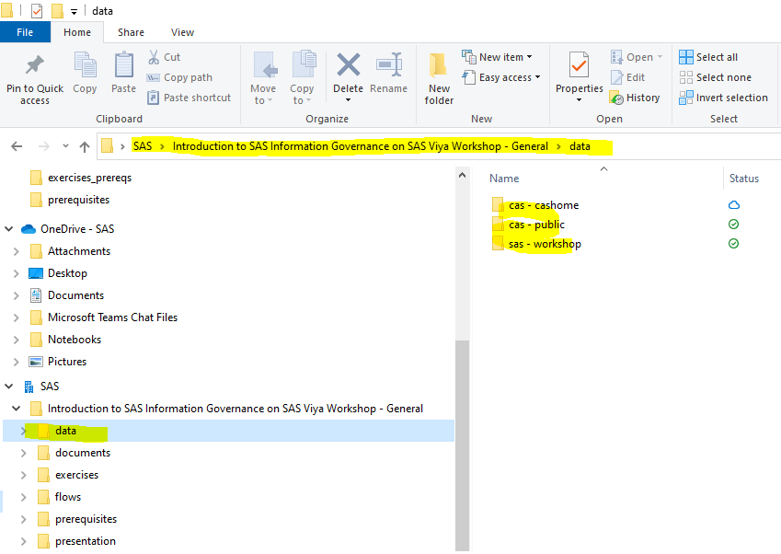

to C:\temp\RACE.

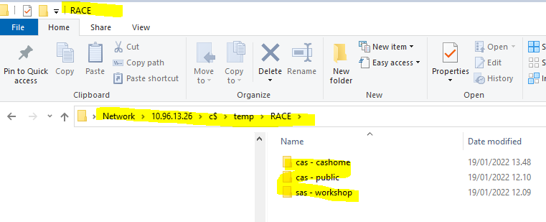

# Create paths and load files

**The purpose of this task is to load files from RACE Windows Explorer to Linux via MobaXterm.**

1. Select MobaXterm from your Remote Windows desktop.

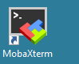

1. Double click the session server.demo.sas.com to start the session.

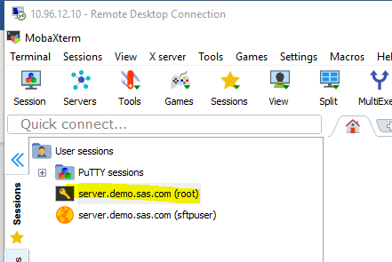

1. In the graphical interface in the left pane investigate if there is a folder named **data** below /. 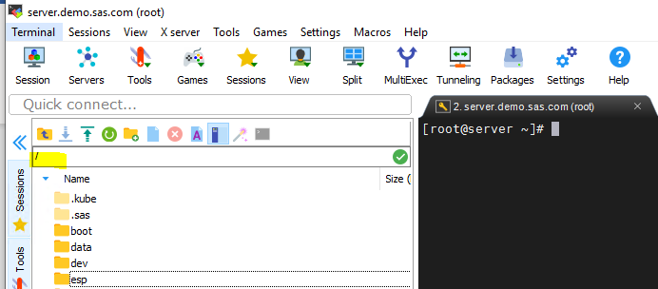
2. Copy the command below that creates a soft link, **/data/caslibs**, to the default location for caslibs.

**ln -s /srv/nfs/kubedata/sse-cas-default-data-pvc-c75fd892-29a8-44a8-8dd8-97f6e94d0c61/caslibs/ /data/caslibs**

1. Paste it to the command line with a right click. Click Enter to run the command. 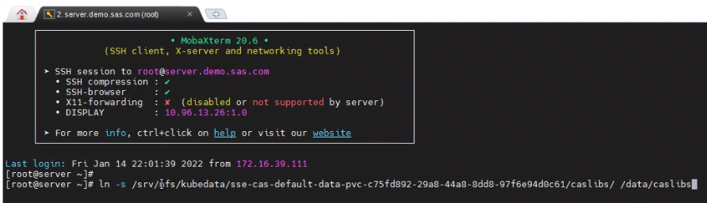
2. In the graphical interface in the left pane, switch to **/**. Notice the data folder that is the start of the soft link location.



1. In the graphical interface in the left pane, double click the **data** folder and then **caslibs** to get to this location where public is visible.

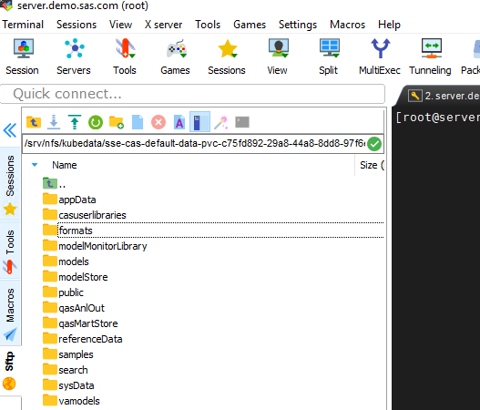

1. In the graphical interface in the left pane, double click the public folder.

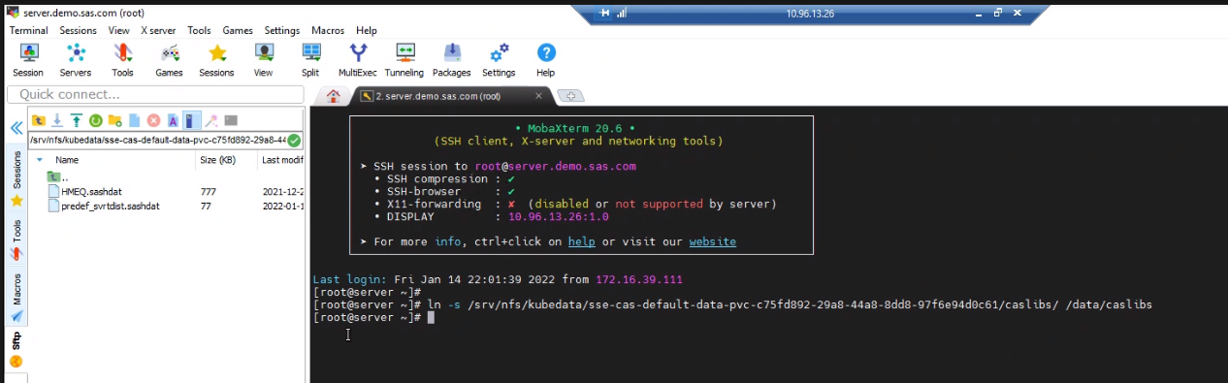

1. Right click in the left pane and select **Upload to current folder**.

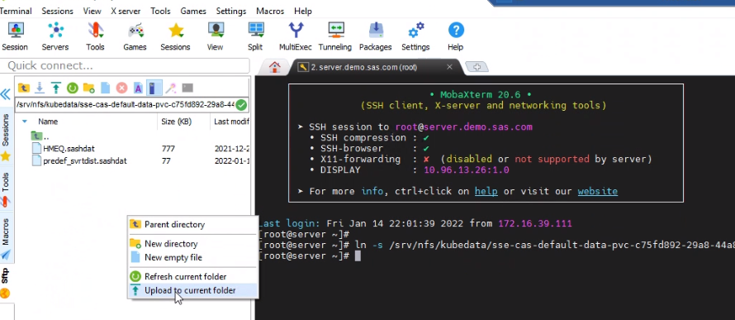

1. Copy all files in C:\Temp\RACE\cas - public and select Open. There might be more files in the list than what you see here.

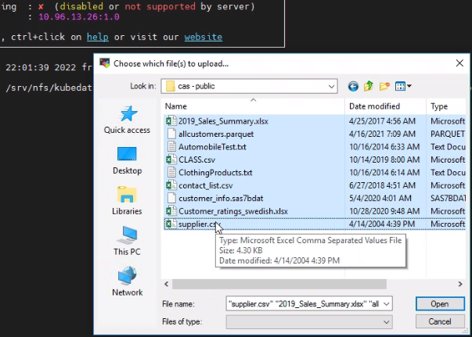

Your files are uploaded to the public folder.

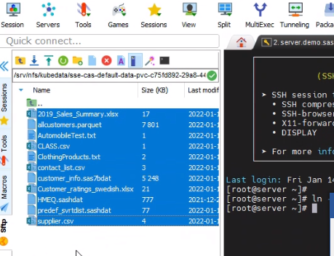

1. In the graphical interface in the left pane, switch to the location /home/sasdemo/data/cas.

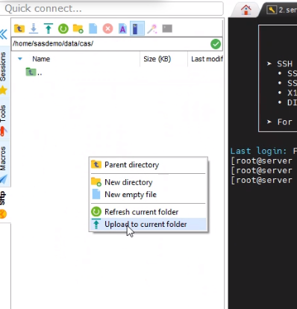

1. Upload to this location all files that reside in C:\Temp\RACE \cas - cashome. There might be more files in the list than what you see here.

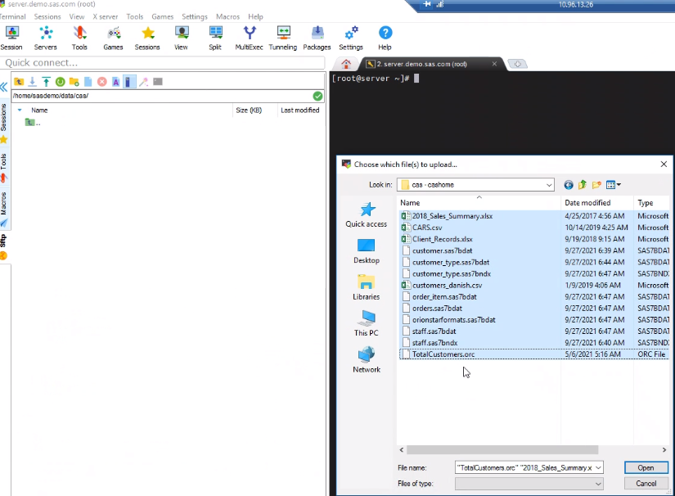

Your uploaded files now reside in /home/sasdemo/data/cas.

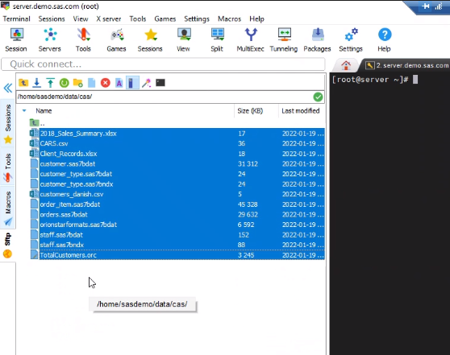

1. Switch to the /home/ folder and click the Create new directory icon.

Create workshop below /home/.

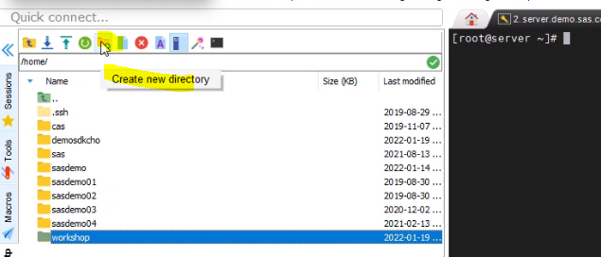

1. Copy all files from C:\Temp\RACE \sas - workshop to /home/workshop. There might be more files in the list than what you see here.

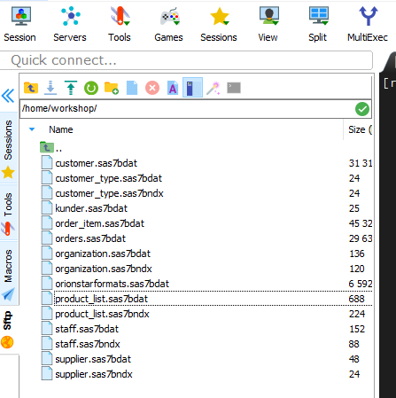

# Verify that you can see files in global CAS library Public

**The purpose of this task is to verify that you can see the physical uploaded files in Public.**

1. In Google Chrome on your remote Windows desktop select SAS Environment Manager from the SAS Viya shortcut menu and sign in as sasdemo with the password Orion123.

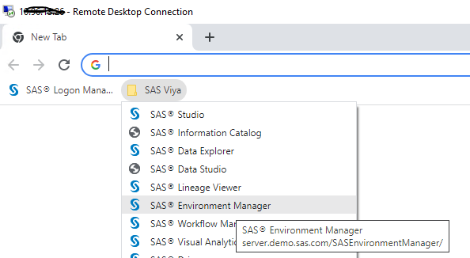

1. Select the Data icon in the right pane, then click Data Sources where you will find Public.

