**Validate that you can sign in to the SAS internal SSEMONTHLY Viya server**

1. Access SAS Studio on SSEMONTHLY

<https://ssemonthly.demo.sas.com/SASStudio>.

1. Sign in by clickling **Azure AD using OIDC**.

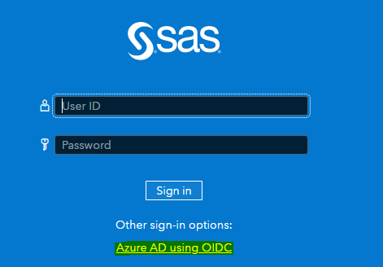

Do you have access? If not, contact the instructor, cecily.hoffritz@sas.com.

**Sync the TEAMS site to Windows Explorer**

If you have problems accessing the Teams site and syncing, contact cecily.hoffritz@sas.com.

1. Start MS Teams and click Teams.

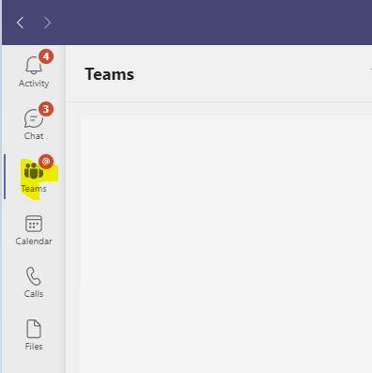

1. Click  to filter.
2. Add **moving** to your filter. The team site for this workshop, **Moving SAS Programs to Viya Workshop**, appears.

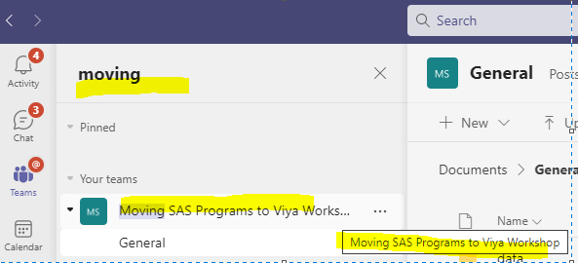

1. Pin the team site by clicking the **3 dots** to the right of **General** and clicking **Pin**.

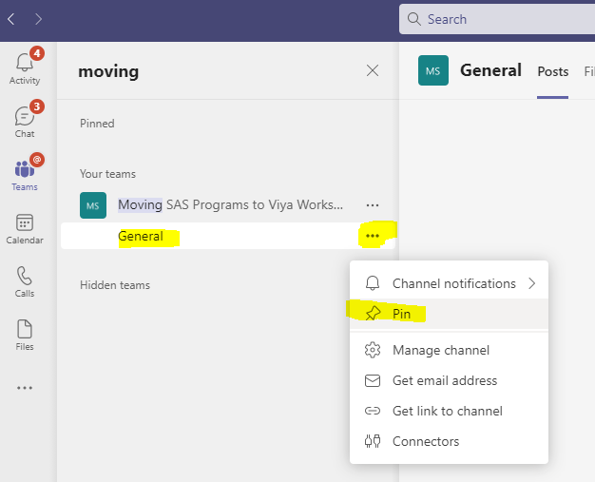

1. In **General**, select **Files** and click **Sync**.

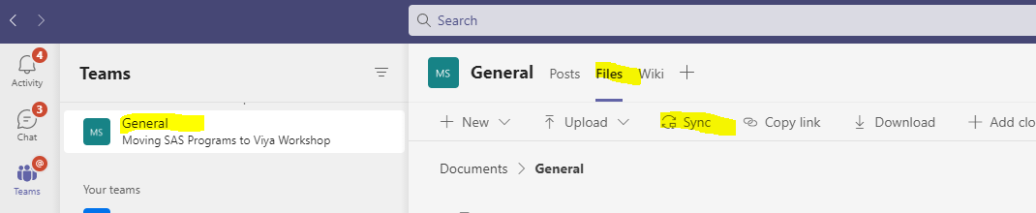

After syncing, you get a SAS icon in Windows Explorer containing your synced Team site folder. This makes it easier to upload to the SAS Viya environment.

