InfoGenie sections to be fixed.
25/05/2026
- Est. Ad Spend not populating – Ran a repair instruction and now working.
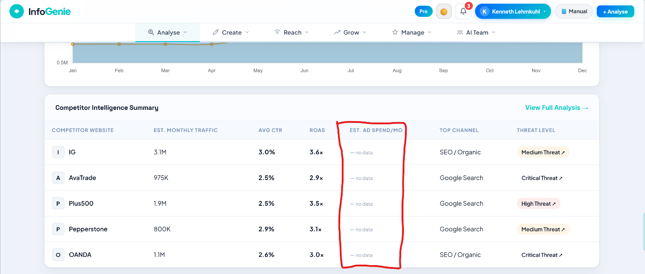

- System freeze when I click on ‘Ad Library Spy’ -
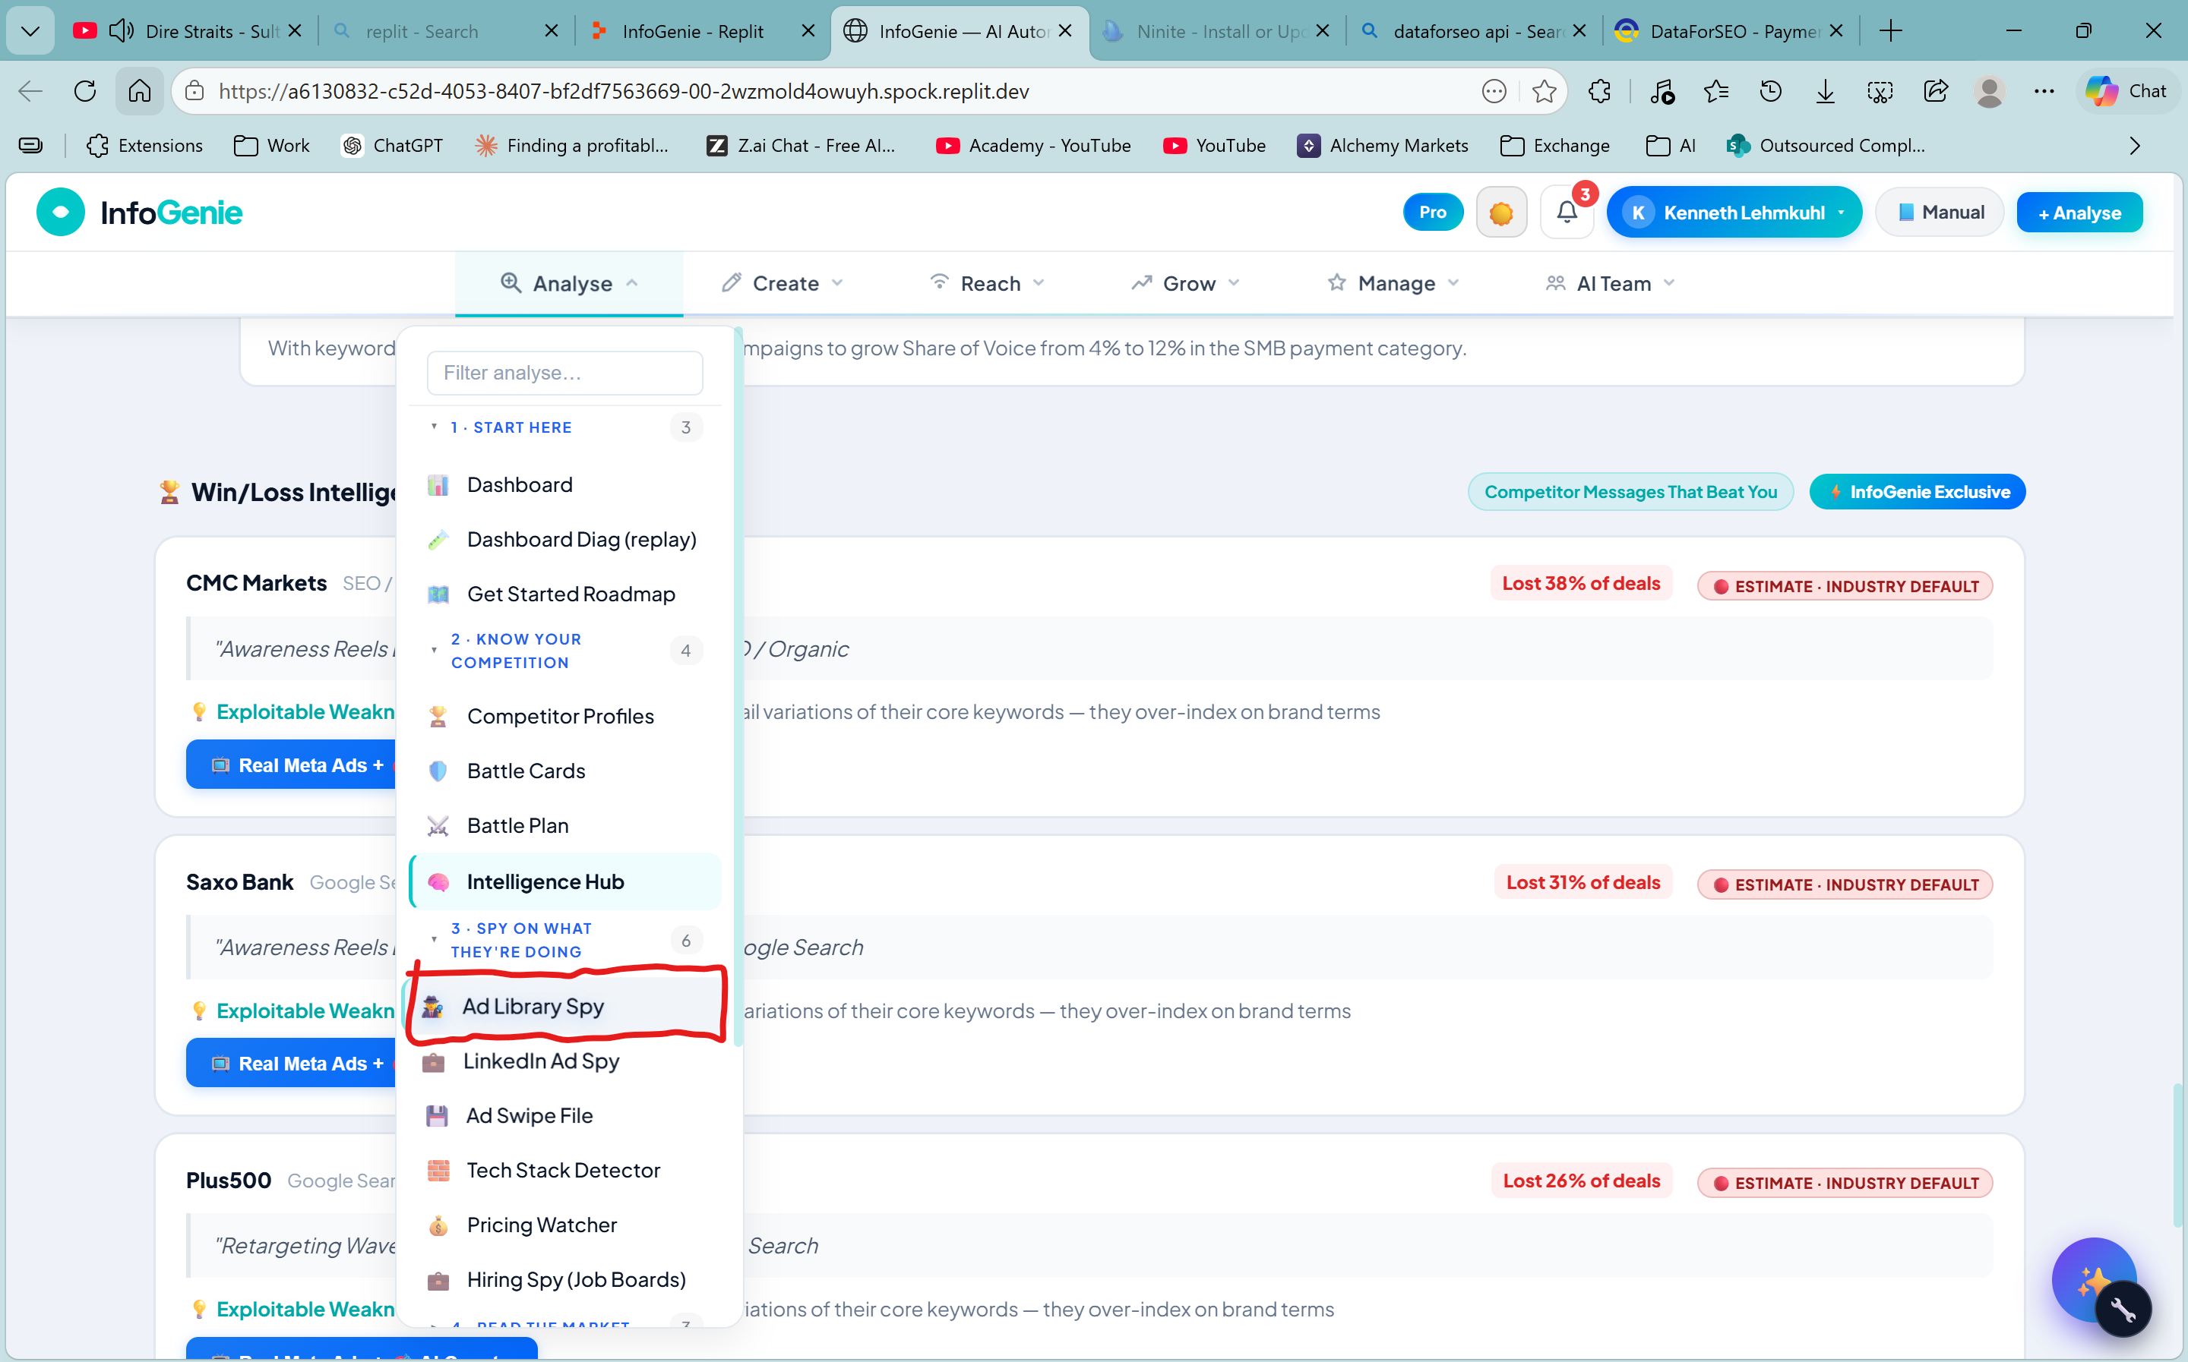

The app does not load

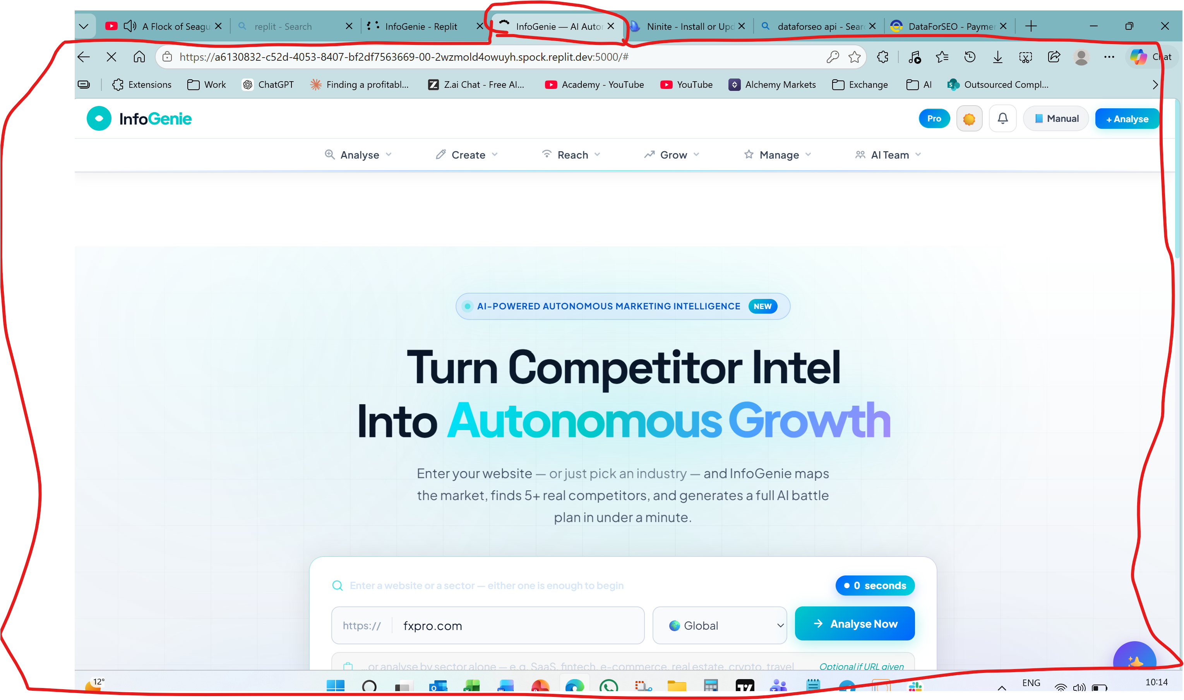

After repair still not functional 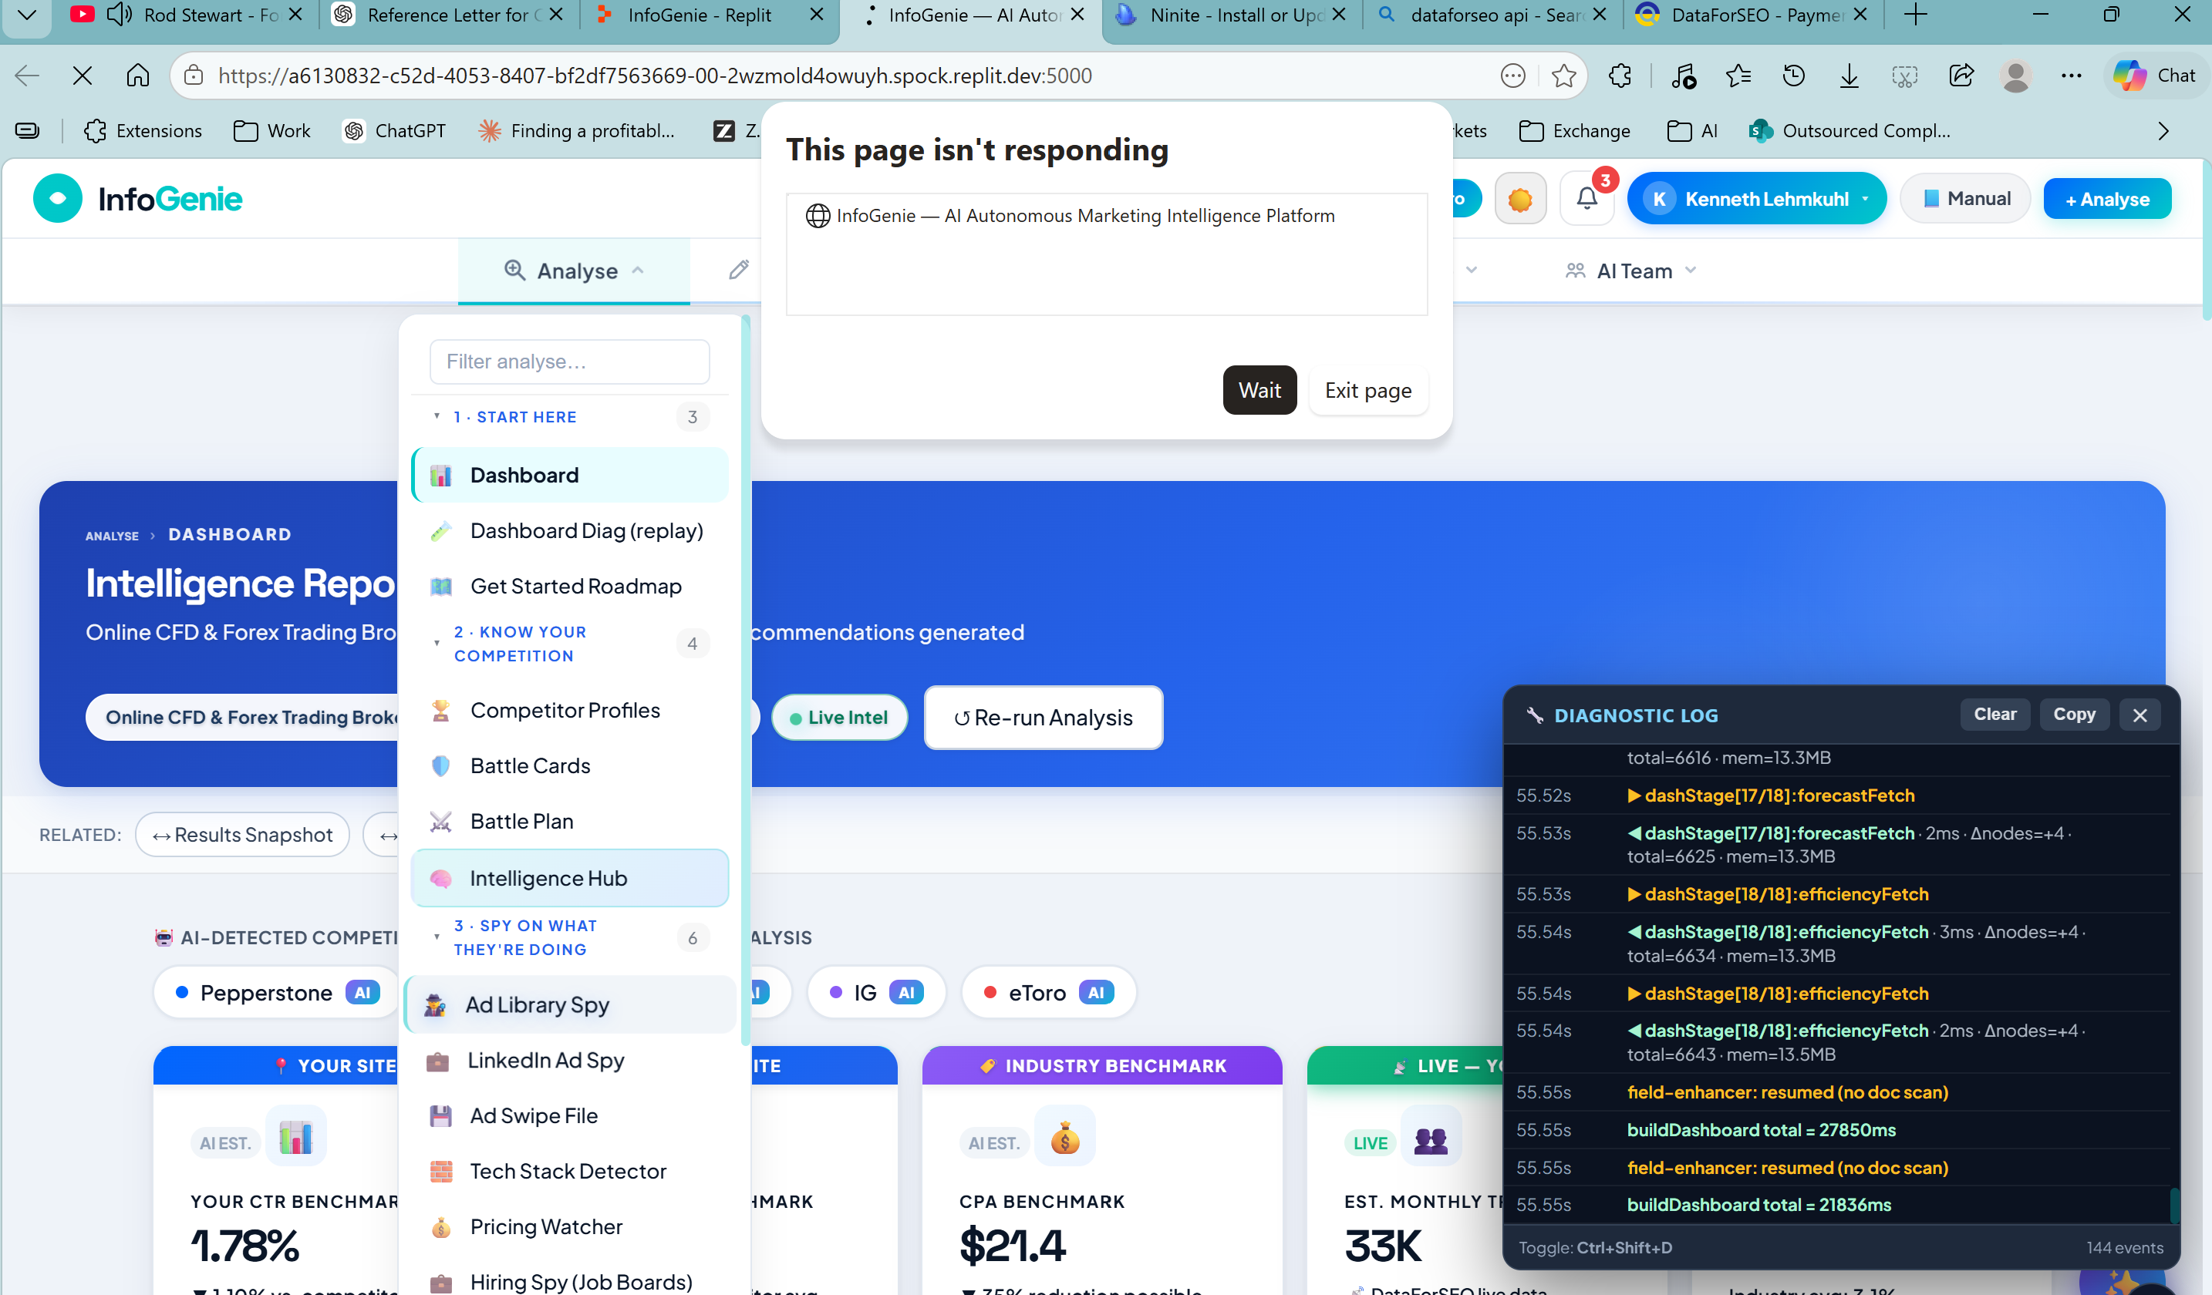

he 'ad swipe file' does not analyse whne I clieck filter. Also it should show a timer showing that the system is doing its analysis. see circled in red

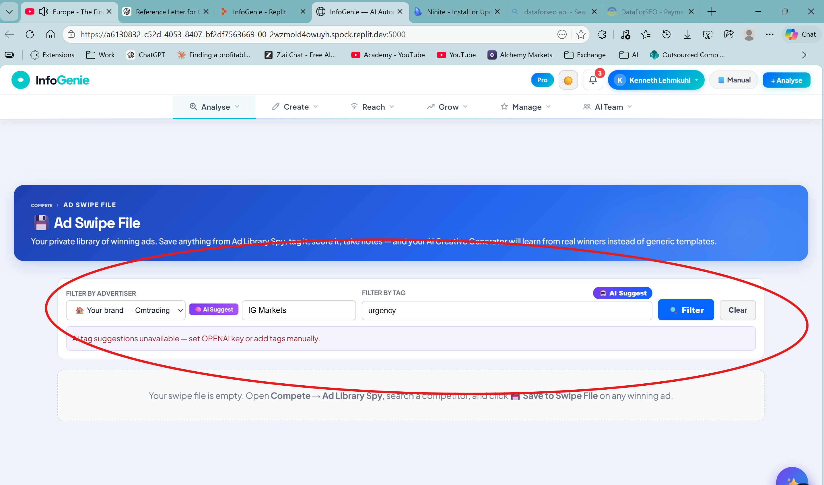

Hiring Spy freezes the app
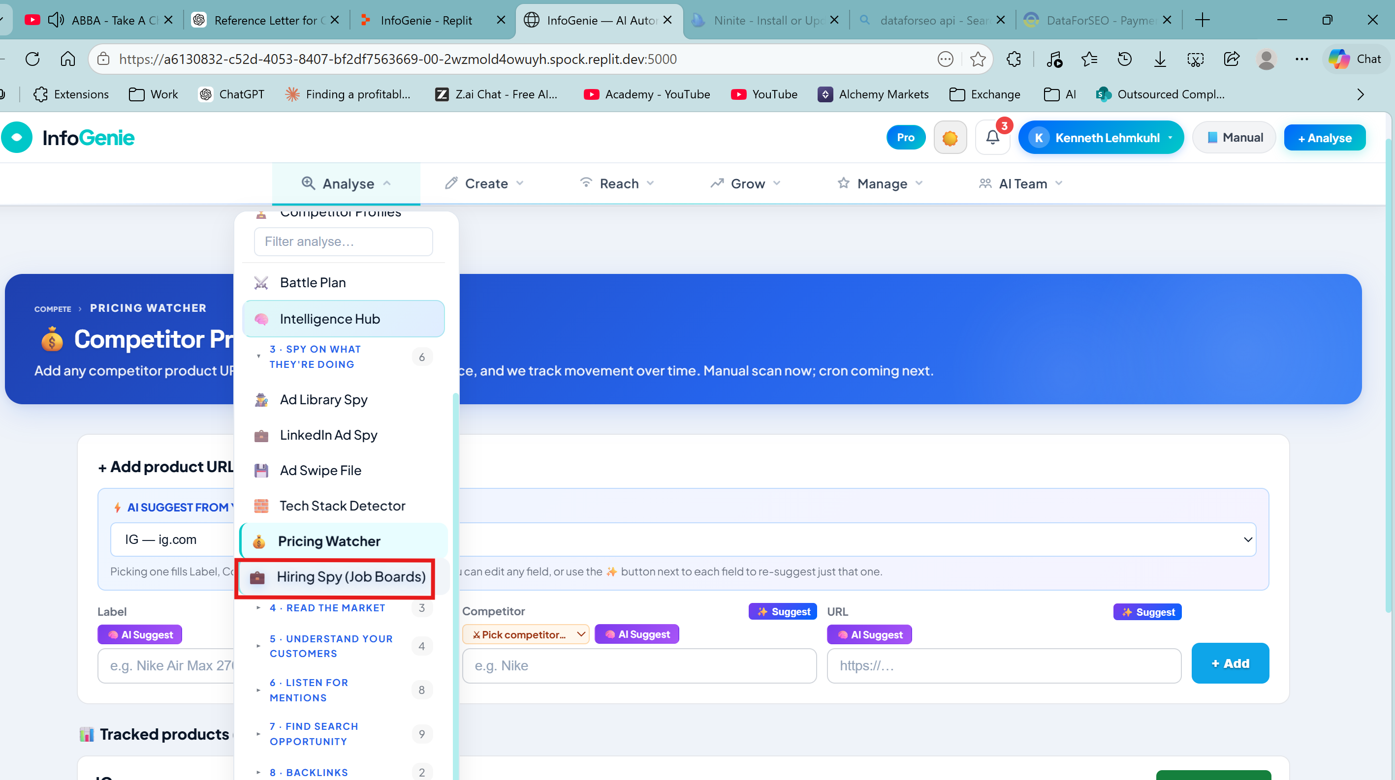

Page not responding 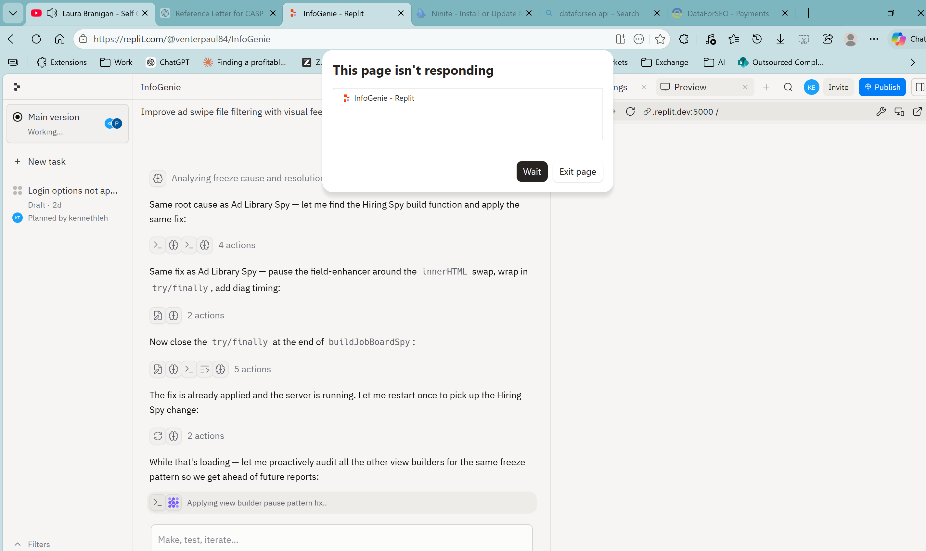

Need clarity on this function
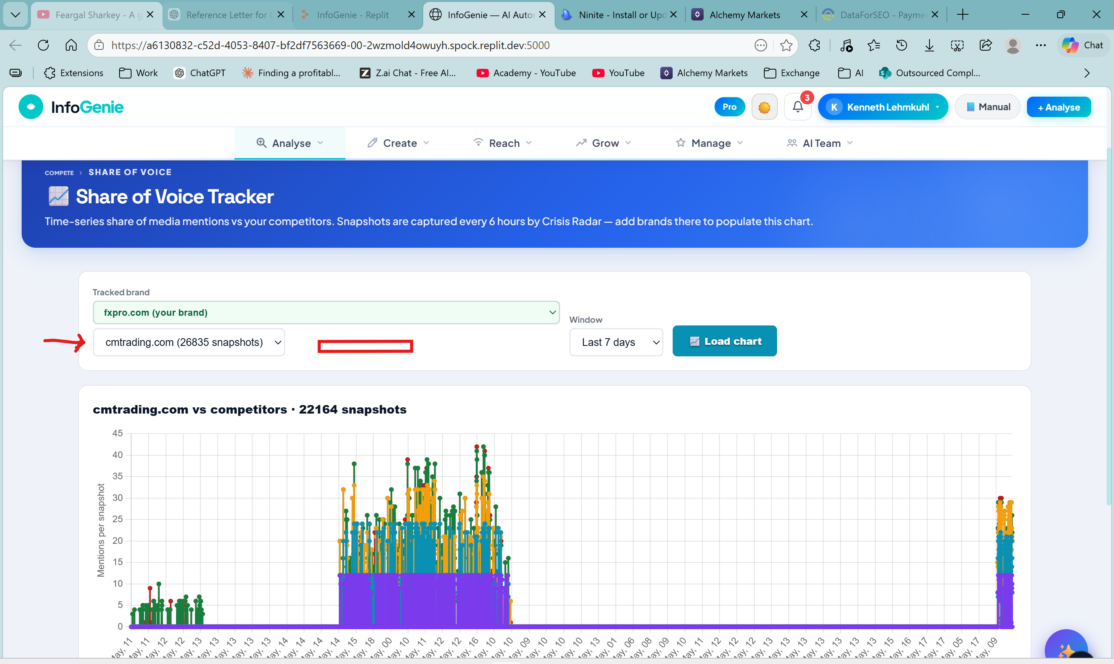

AI Suggest button must give ‘keywords’ from the keyword list already identified in the analysis.
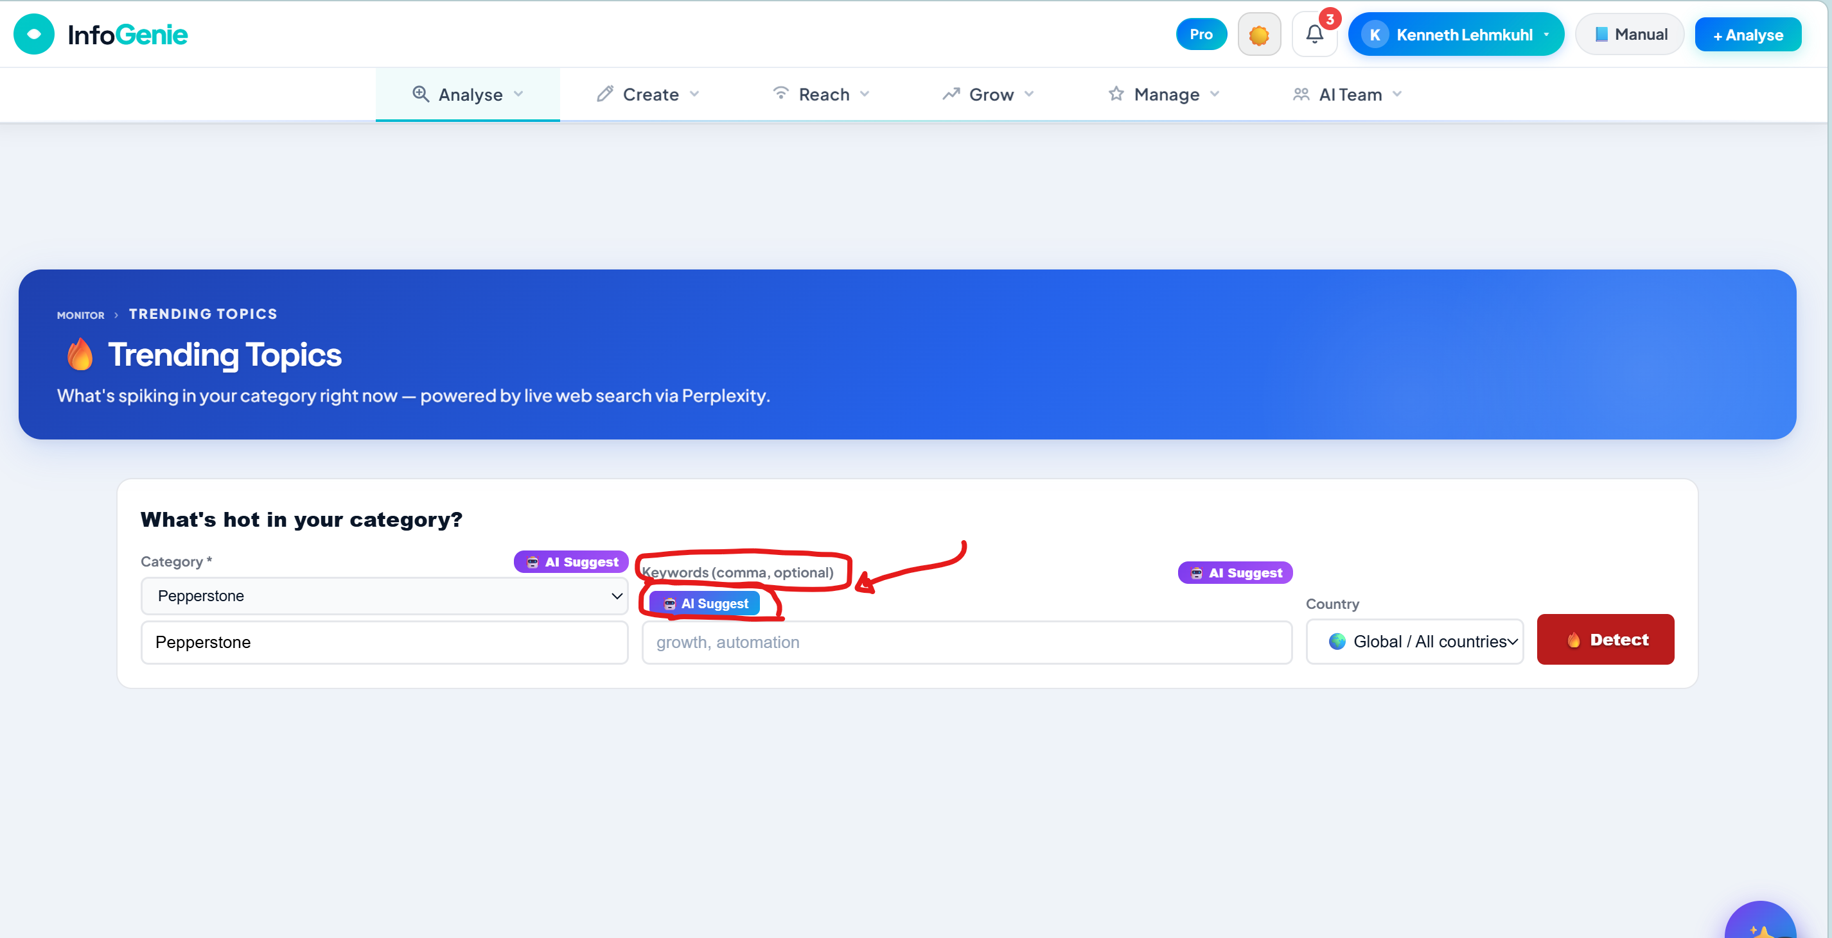

Change the country selection into a dropdown menu the same with all other pages. The ‘track’ button should show timer so that you can see that the system is working
The Brand entered into the ‘Brand’ field should be the same as the ‘Brand’of the analysis. In the screenshot the ‘Brand’ is cmtrading.com which is different to the brand in the ‘Brand’ field 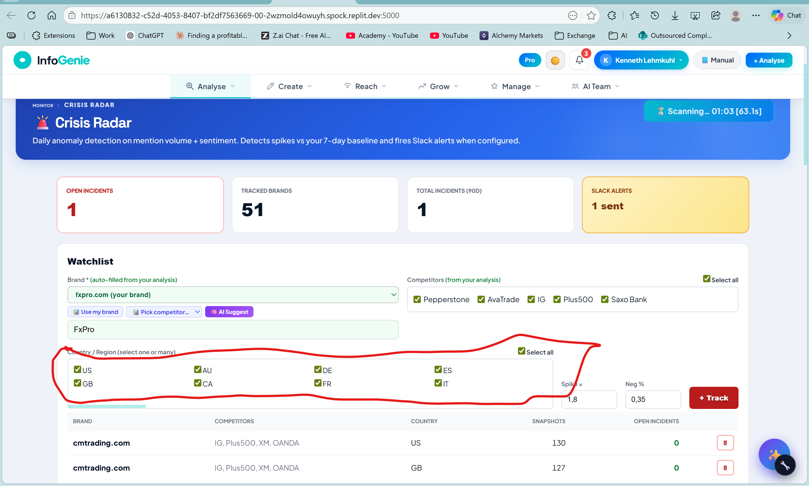

When I click on ‘Voice of Brand’ and ‘Review Aggregator’ and ‘Glassdoor Sentiment the platform freezes
