What is search intelligence?
Understand what your audience wants — before they tell you
Only 25% of marketers truly understand their audiences, making it difficult for most to plan ahead.
Search reveals what people want before they tell you. It’s the missing layer of insight that helps reveal needs consumers aren’t talking about.
With Search Intelligence you can:
- Reveal hidden intent behind search behaviour
- Detect emerging trends early
- Discover what drives consumer demand
- Track how your brand surfaces in AI
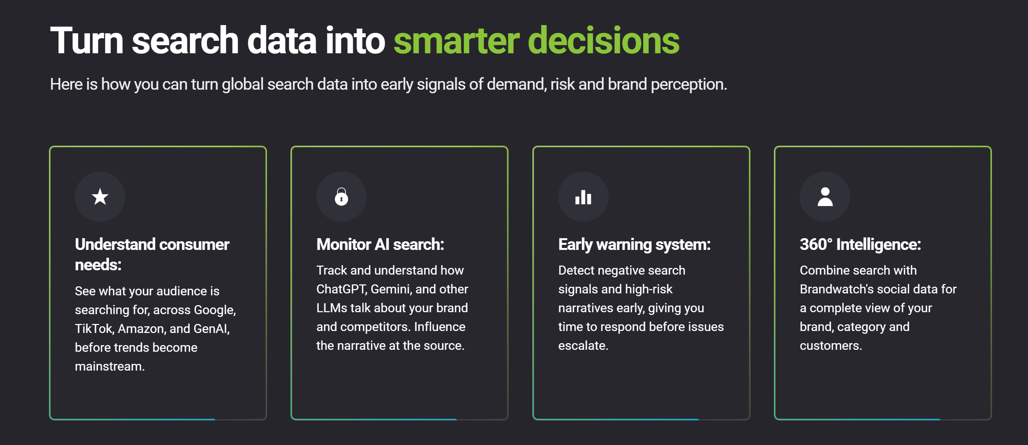
Search Intelligence, powered by Trajaan
Trajaan is an industry-leading search intelligence platform, monitoring what the world is searching for in more than 150 countries.
Monitor what the world is searching across:
- Traditional search (Google, Baidu, Bing)
- Generative AI (Gemini, Claude, OpenAI, Deep Seek)
- Social (Tik Tok, YouTube, Pinterest)
- Shopping (Amazon, Shopee, Walmart)
- Smartest artificial intelligence

Only Brandwatch has spent 17+ years developing industry-leading AI combining large language models with proprietary technology.
- Gen AI Assistant
- Iris, your AI assistant, turns data into human-readable insights instantly
- Image analysis
- Image analysis uncovers the objects, scenes, actions, and logos in every image
- Auto segmentation
- Machine learning classifiers automatically segment data to fit your needs
- AI-powered search
- Allowing anyone to instantly find relevant data on any brand or topic

Powerful analysis
Only Brandwatch gives you the speed and flexibility to craft compelling data stories at this scale.
Flexible
Flexible UI can be combined in thousands of ways to find any insight
Customizable
Choose from 50+ live visualizations to analyze data
Blendable
Upload your own data to spot sentiment, key topics, and historical trends
Scalable
Analyze vast data sets and overlay custom audiences of millions at speed

Instant reporting
Only Brandwatch combines all this with the tools to create a data-driven culture in your organization.
Exportable
Instantly share insights via Excel, PPT, PDF, or via the Brandwatch API
Trackable
Set up automated AI-powered email alerts to key stakeholders in your business
Visible
Send live data to any screen across your organization with Vizia
Measurable
Measure how many people view, engage with, and rate your reports with Vizia

Next-gen market research
Traditional market research can only get you so far. Leverage Brandwatch’s powerful audience analytics and survey social panels of millions to reveal deep qualitative insights at scale and discover trends you didn’t know to look for.

Real-time results

Collecting and analyzing data from surveys and focus groups can take weeks. Get insights with Brandwatch in real time so you can anticipate and adapt to change quickly.

Global trendspotting made easy
With access to the world’s largest archive of consumer opinions dating back to 2010, you can analyze trends in historical context. Whether it’s hair trends in Asia, an eco-movement in Europe, or changing diets in America, with Brandwatch you can understand and predict evolving consumer needs.

Impactful reporting beyond silos
Bring the voice of the customer to every department in your organization. Distribute insights directly to decision makers with flexible data storytelling capabilities and eye-catching, live reporting.
Grok 4.1 AI
Track brand health
Be the first to know when people are talking about your company. Learn how your brands, products, and logos are shared across millions of online, news, and broadcast sources. Conduct deep multi-year studies to find new strategic insights.
Analyze key trends around your business
Get the industry insight you need by monitoring key publications, regions, and influencers. Identify emerging opportunities and challenges, even when your brand is not mentioned directly.
Optimize your brand messaging
Align your brand voice with evolving consumer opinion and needs and ensure consistency across every touchpoint. Measure the impact of your marketing to identify what is and isn’t working to optimize your strategy.
Understand competitive share of voice
Benchmark your brand awareness and performance within your industry over time and identify new competitors. Understand consumer perceptions and leverage brand strengths to grow market share.
Social Media Management
Managing your organization’s social media activities across networks, regions, and teams can be a painful process. Having an all-in-one solution helps you maximize your time, reach, and impact across social.

Save time and avoid silos with a unified content calendar
Collaborate, schedule, edit, preview, and publish all your organic and paid content in one place, across regions.
Easily engage with your audience
Maintaining a responsive, aligned brand voice is impossible without a collaborative platform. Make that easier by managing and automating cross-channel conversations in one customizable inbox.
Stay on topof trends withindustry-leadingsocial listening
Research and implement strategies to reach more of the people you want to attract and grow your audience.
Get the fullpicture on your performance across networks
Measure your performance across networks with easily customizable dashboards, and benchmark against competitors.
Integrate yourcontent planning
Manage, preview, and schedule your campaigns in one content calendar. Align everyone on your team with collaborative workflows and shareable live reporting.
Create contentthat resonates
Research your target audiences and monitor key trends to give your content marketing activities more relevance. Measure performance to optimize your social strategy.
Optimizeworkflows for consistency
Save time and resources by repurposing assets from a centralized content library. Approval flows ensure everything going out is authorized and on-brand.
Extend reach withpaid ads
Use paid promotion to increase the reach of your best-performing posts. Publish makes it easy to convert posts to Facebook, Instagram and LinkedIn ads.

Influencer Marketing
Finding the right influencer can be tricky, and managing those relationships can be even harder. Equip yourself with a solution that can handle the whole process, from influencer discovery through to campaign measurement.

Find the right influencers
Search and segment 50m+ global creators to pinpoint the perfect influencers across YouTube, Instagram, and TikTok for your next campaign.
Manageinfluencer relationships
Build a thriving private influencer network and easily access important information like payment details and contracts.
Measurecampaign success
Easily generate sales materials, track deliverables, create real-time reports, and measure your ROI on any campaign you’ve created.
Identify thought leaders
Research your key audiences and industry to discover the trusted influencers, employees, experts, and journalists that can help your brand amplify authentic messaging.

