E-paper on Raspberry PI

Table of Contents
1. Background 2
2. Setup 3
2.1 Hardware 3
2.2 Software 3
2.3 Installation 4
2.3.1 Install BCM2835 library 4
2.3.2 Install the program 4
2.3.3 Compile options 4
3. Development 5
3.1 Experience 5
3.2 Memory layout 5
3.3 Panel Pixel data 6
3.4 Internal thermometer 6
4. Program usage 7
4.1 Script layout 7
4.2 Instruction on command line 7
4.3 Instruction from file 7
4.3.1 script file layout 7
4.4 Instruction with inter-process communication 8
4.4.1 Special commands 8
5. Create a bitmap with Paint on Windows 9
Appendix A : formatted instructions 10
Appendix B: example inter-process communication 12
High level description 12
Appendix C: E-paper HAT 14
Display Config Switch 14
Interface Config Switch 15
Appendix D. E-Paper 17

1. Background

Time to better understand Epaper or E-ink paper. At least for a project. Many of the E-readers use this display as it is stable, does not require power after updating and is mild for your eyes. So how does that work in practice and how does software and hardware work together.
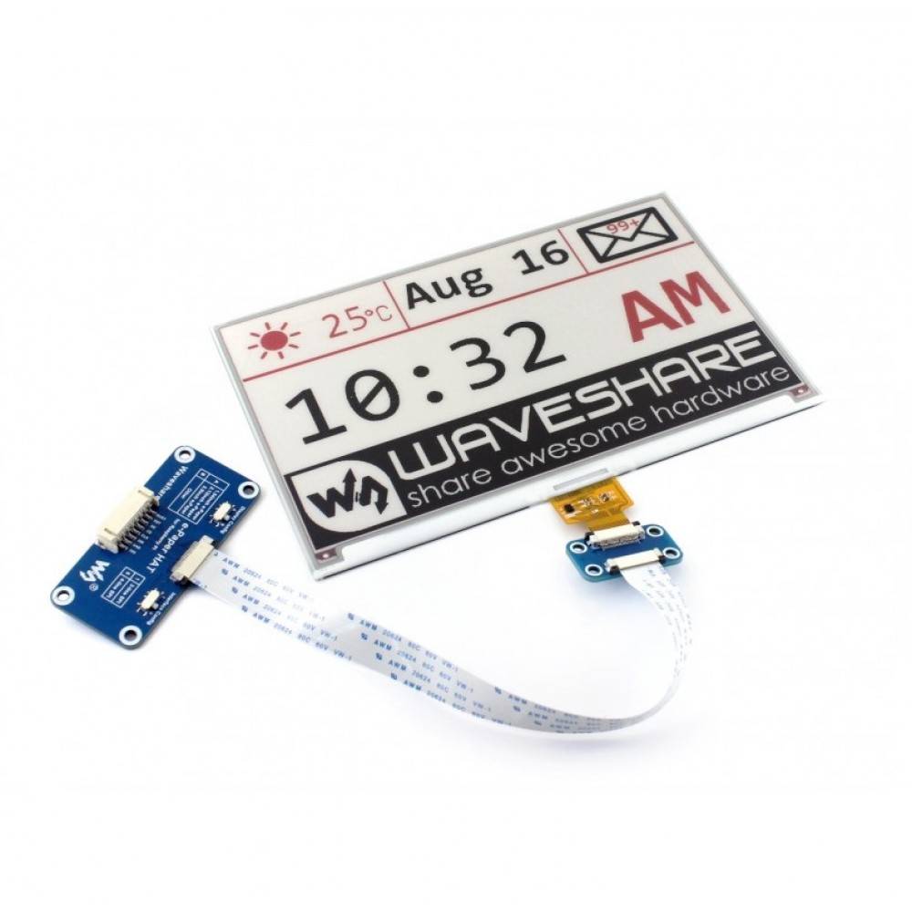
I decided on the Waveshare 7.5 inch E-Ink E-Paper Display - 3 colors. It has an interface (HAT) that fits perfectly on a Raspberry Pi, which I wanted to use again after many projects on ESP32, MEGA2560, UNO and ESP8266. You need to keep changing the menu to keep eating :-)

To be honest… it was a bit off disappointment. While I can sent data, update the display and understand the basics of the screen with great youtube videos, there a number of short-falls:

1. THIS DISPLAY IS SLOW. It takes 16 seconds, just to refresh with the content that has been sent. Yes, there is code around leveraging undocumented options to increase speed, but I could not get that to work on this display. Also NOT when connecting to Arduino and variants.

2. DOCUMENTATION IS LIMITED. It feels as if the makers for this display want to keep a lot of the interface description, the lookup tables, part of the instruction set secret and also like to talk a different language with a large number of unknown abbreviations among themselves.

3. SOFTWARE examples limited and NOT explained anywhere.

Honestly…. I had to force myself to finish this project and create something that would make me feel “I got it” and created something that could be used. To be fair.. I am glad it is done.

One advice to the WaveShare : IMPROVE YOUR DOCUMENTATION FOR DEVELOPERS

Regards

Paul van Haastrecht
July 2019

2. Setup

2.1 Hardware

I had ordered the 640x384, 7.5inch E-Ink display HAT for Raspberry Pi. The connector fits will directly on the Raspberry Pi and provides a separate connection + cable in case to connect to other device. You need to be aware however that, unlike the HAT for an Arduino, this one does expect 3V3 (and not 5V) .

I have tried to connect that HAT, with the separate cable provided to both an ESP32 and MEGA2560, using a downloaded code from (https://github.com/ZinggJM/GxEPD) . BUT without success as the HAT is for the Raspberry Pi. I have used the loose wire to connect and made all kind of adjustment for the 5V to 3.3V, but could not make it to work.

2.2 Software

I have downloaded the Waveshare code (version 2019-04-08), from https://www.waveshare.com/wiki/7.5inch_e-Paper_HAT which relies on the BCM2835 library to connect to the hardware. I have used that BCM2835 library many times before as it is fast and stable.

The top level is demo software, just clears the screen and show some boxes etc.

The top level software that I have developed is making use of the underlying libraries and takes instructions from a user to position and display circles, lines etc. See chapter 4, program usage

2.3 Installation

2.3.1 Install BCM2835 library
Install latest from BCM2835 from : http://www.airspayce.com/mikem/bcm2835/

1. wget http://www.airspayce.com/mikem/bcm2835/bcm2835-1.56.tar.gz
2. tar -zxf bcm2835-1.56.tar.gz // 1.56 was version number at the time of writing
3. cd bcm2835-1.56
4. ./configure
5. sudo make check
6. sudo make install

2.3.2 Install the program

Find the following files (part of the basic package) in the epaper directory

epaper.c : the top level program
epaper.h : header file for the top level program
remotepr.c : sample program for inter-process communication (see Appendix B)
create_pipes: create named pipes for inter-process communication (see Appendix B)
car_instruction : script to create a car on the display.
clock_instruction : script to display a clock.
sample_instruction : script with example to display.
Makefile : to compile the top level program.

The following directories and files are included :

back : will contain the original EPD demo program and makefile
pic : holds to BMP files that can be used to display
obj : holds the original driver
Fonts : holds the original fonts to display text
bin : holds the compile version of obj and Fonts

2.3.3 Compile options
cd epaper
To create the epaper executable : make
To clean : make clean

note: you might can missing braces around initializer for font12CN and font24CN. Ignore those that is a known compiler error

The BCM2835 library needs to run as Root for the I2C communication to work.

sudo ./epaper -h will display help

3. Development

3.1 Experience

The simple demo program combined with really bad documentation, makes this developers hell.
There is a user manual on https://www.waveshare.com/wiki/7.5inch_e-Paper_HAT , but that explains only part of the library calls.

There is also a datasheet, that shows different instructions. At least the 4wire or 3wire SPI protocol was very well explained. But for instance WHAT and HOW to use the the different LUT(s), and different commands VCOMLUT (LUTC) or how to do a partial update or what is BoosterSoftStart(BTST) or ImageProcessCommand(IPC) ???? WHO KNOWS and that list goes on and on and on.

You are depending a lot on others who have crossed this path before. There is a really good detailed library (https://github.com/ZinggJM/GxEPD) and forum (https://forum.arduino.cc/index.php?topic=487007.0) to connect to E-ink to an Arduino.

BUT even then… it does not have all the answers. I was not able to increase the update speed by implementing partial update, as others have done with other displays, on this display. I have taken the code and examples from the Arduino library, the code was accepted by the display, it just did not make a difference in update speed.
After many tries, I was loosing patience and decided to accept the speed as it is… although ~16 seconds is very slow for a display update.

I suspect we only make half use of the capability of the screen due to a lack of good documentation.

3.2 Memory layout
The driver has 2 buffers:

BlackImage : holds whether a pixel should be set to WHITE or BLACK.
RedImage : holds whether a pixel should be set to is RED.

P.s. RED could be YELLOW depending on the kind of 3 color display you bought.

The data is stored an buffer which size is WIDTH / 8 (each byte can hold 8 pixels) * HEIGHT
Assume 640 x 384 each buffer is 640 / 8 * 384 = 30720 bytes

The buffer is starting with the first byte the bit for pixel 1 of line 1, then pixel 2 of line 1 etc to the bit for last pixel on the last line.

During display the driver first checks whether the bit is set for the pixel in RedImage buffer, if so it will set RED0 as color, if not it will check BlackImage buffer. If the bit for the pixel is set it will set to BLACK else it will set for WHITE.

This means you can NOT display anything over colored object.

3.3 Panel Pixel data
Action W/R C/D D7 D6 D5 D4 D3 D2 D1 D0
START DATA 0 0 0 0 0 1 0 0 0 0
0 1 X KPixel12 KPixel11 KPixel10 X KPixel22 Kpixel21 Kpixel20
0 1 X ... …. … … … …
0 1 X Kpixel Kpixel Kpixel X Kpixel Kpixel Kpixel
(2M-1)2 (2M-1)1 (2M-1)0 (2M)2 (2M)1 (2M)0

X= DUMMY

After sending the START DATA (0x10) each pixel color is set with 3 bits Kpixel[1~2M][2:0] :
So each byte that is sent after START DATA command data will hold the color information for 2 pixels :
D6 – D4 pixel1 bit 2, pixel1 bit 1, pixel1 bit 0
D2 – D0 pixel2 bit 2, pixel2 bit 1, pixel2 bit 0

Source Driver Output
DDX=1(default) DDX=0
LUT LUT
000 Black White
001 Gray1 Gray2
010 Gray2 Gray1
011 White Black
100 Red0 Red3
101 Red1 Red2
110 Red2 Red1
111 Red3 Red0

DDX (data polarity) is set to 1 during EPD_INIT() as part VCOM_AND_DATA_INTERVAL_SETTING.

3.4 Internal thermometer

While the datasheet indicates the presence of an internal thermometer, it not possible to read that with SPI as on MOSI is connected to the SDA line. Of course you can connect a wire between MOSI (19) and MISO (21), but given the way SPI work, that does not work. Another example about the lack of good documentation

4. Program usage

The program will read a script and display the results on the Electronic Panel Display (EPD). The formatted instructions can be provided either directly on the command line (following -T), read from a file (-F) or with inter-process communication using named pipes (-P)

For debug one can add the optional -D options on the command line.

4.1 Script layout
A script always starts with ‘<’ and ends with ‘>’. The instructions are separated with a comma (,). Some examples :
<d=b> Set display/foreground color to black
<!=C, d=c, p=40:50> Clears display, display to color, start position to 40 on x-As, 50 on Y-as

In Appendix A there is a complete overview of the instructions available.

4.2 Instruction on command line

This is achieved with -T option on the command line, e.g.

sudo ./epaper -T “<!=C, d=c, p=40:50, t=’test information’>”

In Appendix A there is a complete overview of the instructions available.

4.3 Instruction from file
This is achieved with the -F option on the command line e.g.
sudo ./epaper -F car_instruction

4.3.1 script file layout
The complete instructions MUST start with ‘<’ and end with ‘>’
Empty lines, spaces, tabs will be skipped, unless they are within single quotes (‘) as used for text or font etc, The ‘>’ can be included as long as within single quotes.
If a hash (#) is detected the character and following information on the same line is discarded. This can be used to include comments for the user. Unless the # is within single quotes (‘) as used for text.
Otherwise all the instructions are the same as in Appendix A. For reference 3 example files are included car_instruction, clock_instruction and sample_instruction

4.4 Instruction with inter-process communication
This is achieved by starting with the -P command, e.g.
sudo ./epaper -P
By default epaper will read from pre-created the named pipe “ EPD_to” and write status back on named pipe “EPD_from”. You can overrule the defaults by adding -r and/or -w. e.g.
sudo ./epaper -P -r “pipename_to_read_from” -w “pipename_to_write_to”
or only changing the read pipename
sudo ./epaper -P -r “pipename_to_read_from”
Note : named-pipe filename can be maximum 100 characters. (MAXFILENAME)

4.4.1 Special commands
The remote program can sent any of the instructions from Appendix A. The ‘>’ can be NOT be included within single quotes, it will always start execution
Some special instructions can be sent by remote program :
<<NEW>> discard any information that has been sent.
<<CLOSE>> close the epaper program.

The epaper program will sent some responses to the remote program:
<<OVERRUN>> Number of character in instructions has exceeded MAXINSTRUCTIONS.
The received information is discarded.
<<MORE>> The received instructions did not contain terminator. Need more data.
<<START>> Received the instruction terminator (>) and now start execution.
<<OK>> Execution was successful.
<<ERROR-1>> Error during execution of instructions.
<<ERROR-2>> Syntax error in the instructions.

Errors can be debugged by adding the -D option to the command-line e.g. sudo ./epaper -P -D
More information about the sample remote program and using the name pipes is in appendix B.

5. Create a bitmap with Paint on Windows

One nice aspect is the ability to display black & white .BMP files. The instructions below are a guideline in case you want to create such a BMP file yourself.

- Obtain a picture or make a scan as you normally would do this.
- Open the picture with Paint in Windows
- Select the part you want and copy (CNTRL – C)
- Select file, new
- Select file, properties, select pixels, and select the wanted size (max 640 Width, 380 Height)
- Observe the size of the window on the screen carefully (maybe use some tape on the screen)
- Paste the selected part. The Paint window will now increase to the size of the selected part, now resize to the observed Paint window size from step 6.
- Repeat step 5. Hopefully the picture will fit otherwise repeat from step 5 or 4.
- You can now edit the picture as with any other Paint activity.
- Select file, save-as, BMP. Select the folder and the name and as type : MONOCHROME BITMAP

Now copy the BMP on a USB stick and install it on your Raspberry Pi.

Appendix A : formatted instructions

< start of instructions (always first character)
--------- format options ----------
d=#, set foreground color : # = B(black), W(white) or C(color)
b=#, set background color: # = B(black), W(white) or C(color)
B=#, set Border color : # = B(black), W(white) or C(color)
f='#', set font to use (# = name font as in Font-directory)
Available font8, font12, font16, font20, font24 and Chinese font12CN, font24CN
p=x:y, set start position to display
r=#, rotate display 0, 90, 270, 360
m=#, mirror image
# = N MIRROR_NONE
# = H MIRROR_HORIZONTAL
# = V MIRROR_VERTICAL
# = O MIRROR_ORIGIN
--------- display options ----------
T=#, display time : # = s (include seconds), n = (not include)
D=#, display date : # = n (as numbers) or w (as words)
P=#, draw a Point : # = pixel size: 1 - 8
c=r:s, draw empty circle : r = radius, s = pixel size: 1 - 8
C=r:s, draw filled Circle : r = radius, s = pixel size: 1 - 8
q=X:Y:s, draw empty rectangle X end, Y end, s = pixel size: 1 - 8
Q=X:Y:s, draw filled rectangle X end, Y end, s = pixel size: 1 - 8
l=X:Y:Z:s, drawline X end, Y end, Z = style, s = size: 1 - 8
Z = 0 : constant line, Z = 1 : dotted line
i='filename', load image (BMP) on current position
t='text', display text
n='number', display number
note: make sure to use single quotes where indicated !
------- special Instructions ------
!=#, special instruction header
# = C perform a Clear screen and image memory
# = c perform a clear image memory
# = d display the current X / Y positions in terminal
# = s save the current X / Y positions
# = r restore the saved X / Y positions
# = p set screen to deepsleep
# = i initialise screen

> end of instructions (ALWAYS)

Some examples :

sudo ./epaper -T “<!=C, d=c, p=100:150, f=’font24’, t=’Test text to display’>”
Will clear screen and image memory, set for color text, position starting point to X=100 Y=150, font-size is 24 and display text : test text to display.
sudo ./epaper -T “<!=C, p=50:10, l=100:90:0:5>”
Will clear screen and image memory, position starting point to X=50, Y=10 and draw a constant line to position X=100, Y= 90
sudo ./epaper -T “<p=50:60,i=’./pic/2CV.bmp’>”
Will position starting point to X=50, Y= 60 and read and display the 2CV.bmp file from the pic directory.

Appendix B: example inter-process communication
As an example remotepr.c program has been included. It will display a round clock with the current time. This clock is updated every minute and with each update it will move horizontal on the display. Underneath the clock is the time and date in digital format and it will move every minute vertical.
To compile just do : cc -o remote remotepr.c
By default remote will write to the named pipe “EPD_to” and read status back on named pipe “EPD_from”. To create those pipes type
./create_pipes
You can create you own and overrule the defaults by adding -r and/or -w. e.g.
./remote -r “pipename_to_read_from” -w “pipename_to_write_to”
or only changing the read pipename
./remote -r “pipename_to_read_from”
Note : Just be aware the EPD_FROM is used as INPUT for the remote and EPD_TO as output (so just the opposite of epaper.c)
Note : named-pipe filename can be maximum 100 characters. (MAXFILENAME)
Other options are ‘-d’ for debug messages and ‘-h’ for help.
To run :
open a terminal and go the the directory where epaper is stored
To start the epaper daemon type: sudo ./epaper -P
open another terminal and go the the directory where epaper is stored
To start the remote (clock) program type: ./remote
Now watch the display.

High level description
epaper.c:
With -P option, after parsing the command-line, it will start Comm_over_pipe(). This will call connect_pipes() to open the name-pipes for reading and writing. In this case the default names are used, but they could have been adjusted with ‘ -r’ and/or ‘-w’ option on the command line.

Back in Comm_over_pipe() there is an endless loop whether it will read (blocking) from the read pipe, waiting on the remote program. It will parse for the special instructions (see chapter 4.4). When the instruction terminator ‘>’ has been received, it will inform the remote program it is starting and parse_string_instruction() is called to execute. If any instruction was to display an item, parse_string_instruction() will have turned on the power and refresh. If that was the case, it will be put back to deepsleep. Based on the return code from parse_string_instruction() a responds is sent to the remote program.
remotepr.c
After parsing the command-line from main it will start Comm_over_pipe(). This will call connect_pipes() to open the name-pipes for reading and writing. In this case the default names are used, but they could have been adjusted with ‘ -r’ and/or ‘-w’ option on the command line.
It will now call start_clock(), which will have an endless loop. It will read the local time and get the hours. As the minutes within the hour increase from 0 to 60, the hours indicator will move along. So we first determine what the X and Y are if the minutes are 0. Then add the offset for X and Y depending on how many minute have passed within the hour to come the position used.
The X and Y position of the hours and minutes indicator on the round clock have been determined by testing and changing the clock_instruction file. It assumes a middle point of 150:150 (X:Y)
The minutes X and Y positions have been determined for each 5 minutes (thus minpos has 12 positions). We first determine how often 5 minutes have been passed in this hour. Then we based on the number of minutes MORE than the last 5 boundary ( e.g. if currently 19 minutes, 19 – (3 x 5) = 4) and use that to calculate the offset.
display_time_day() is used to determine the digital time and date to display.
Finally this all comes down to a single buffer where we add the instructions together and call send_EPD() (see below). Next is to the determine the position for the next horizontal position for the round clock and vertical position for the digital clock. Last we wait for about 1 minute before repeating.
Send_EPD() will first remove any responds that could have been left over from previous connection and then loop to sent the instruction. A maximum chunk-size to sent is defined as 300 (although epaper can take 512 by default). It will send chunk by chunk (although the clock instruction all fit within one chunk, but this sample code could be adjusted to be used for other purpose). After each chunk sent, it will check for responds by reading from the pipe. Depending on the return code it will take action. read_EPD() will translate any of the response from epaper into a return code to react on

Appendix C: E-paper HAT

Source : https://www.waveshare.com/wiki/E-Paper_Driver_HAT
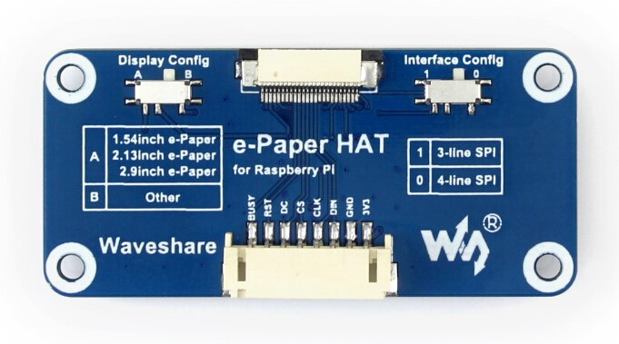
VCC | 3.3V
GND | GND
DIN | SPI MOSI pin
CLK | SPI SCK pin
CS | SPI chip select (low active)
DC | Data/Command control pin (high for data, and low for command)
RST | External reset pin (low active)
BUSY | Busy state output pin (low active)

Display Config Switch
The Display Config switch on e-Paper Driver HAT is made for being compatible with various SPI interface e-Ink raw panels from Waveshare. This switch has A and B sides. For connecting to different e-Paper raw panels, you can set the Display Config switch refer to the table below:
Switch to B | Switch to A
1.54inch e-Paper (B) | 1.54inch e-Paper
2.13inch e-Paper (B) | 2.13inch e-Paper
2.7inch e-Paper | 2.9inch e-Paper
2.7inch e-Paper (B)
2.9inch e-Paper (B)
4.2inch e-Paper
4.2inch e-Paper (B)
7.5inch e-Paper
7.5inch e-Paper (B)

Interface Config Switch
With Interface Config, you can change the SPI interface of e-Paper to 3-line SPI or 4-line SPI
Switch to 0 | Switch to 1
4-line SPI | 3-line SPI
Note: Examples we provide use 4-line SPI by default
layout

R=0

Y0 ------------------------------------------------
! !
! !
! !
! !
! !
! !
Y360---------------------------------------------
X0 !!!!!! x620

R=90

X0---------------------------------------------
! !
! !
! !
! !
! !
X360 ----------------------------------------------
Y360 !!!!!! Y0

R=180

Y360---------------------------------------------
! !
! !
! !
! !
! !
Y0 ----------------------------------------------
X620 !!!!!! x0

R=270

X360---------------------------------------------
! !
! !
! !
! !
! !
X0 !--------------------------------------------- !
Y0 !!!!!! Y360

Appendix D. E-Paper
Source :https://www.waveshare.com/wiki/7.5inch_e-Paper_HAT

Note: Besides the display color, this e-paper is same as the 7.5inch e-Paper HAT (B), for information and instructions, you can refer to the wiki page of 7.5inch e-Paper HAT (B)

