HS420516K – 4 X7 LED DRIVER
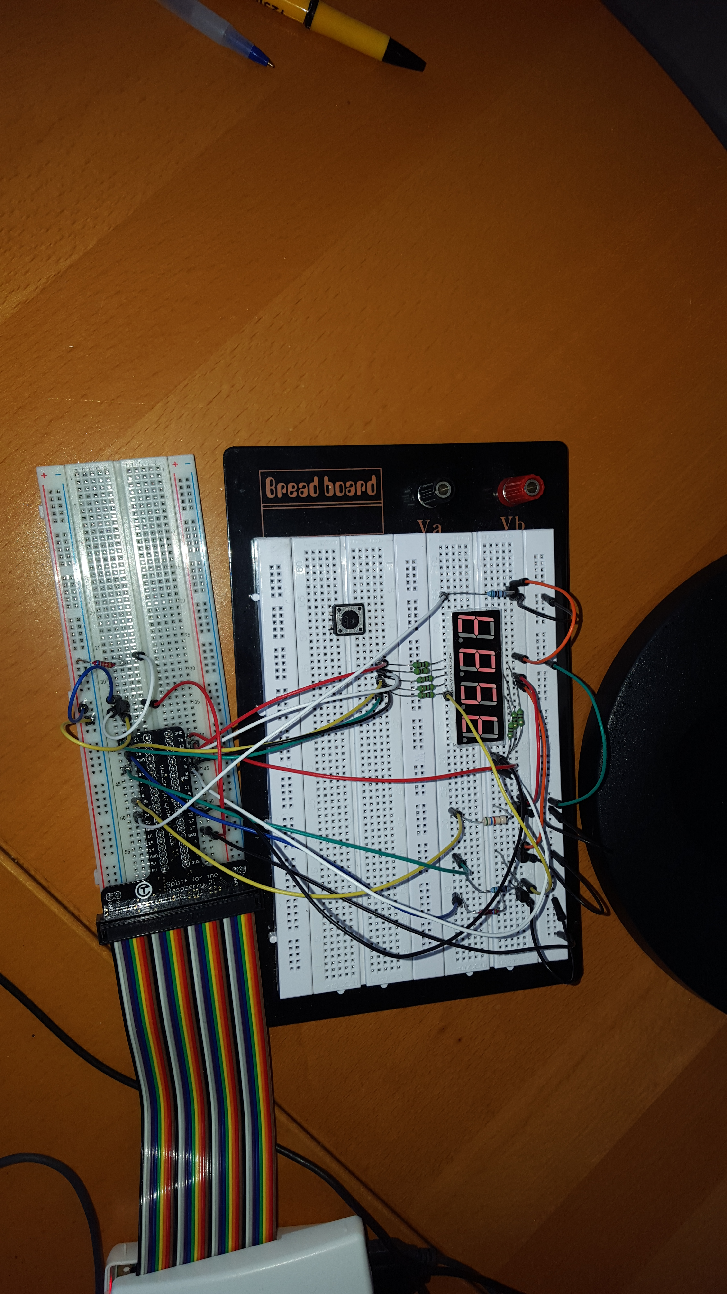

Background

A part of my learning of the Internet Of Things (IOT), I am focused to understand the place where “hardware meets software”. One element is the display on digits/leds: how do you set and keep them displayed. This project is around that.
One of the big learnings is around program signals. For the refresh I am using a background timer, but that is using SIGALRM, which in combination with sleep() does not work well. Actually it is warned in many documentation (so I found later) to not mix the use itimer(), alarm() and sleep mixed. Found a good way to handle that as documented with software-sectoin

Table of Contents
Background 1
1.0 Hardware 2
2.0 Software 5
2.1 What is the fastest refresh rate? 5
2.2 How to handle sleep? 6
2.3 How to handle keyboard input ? 6
2.4 Connecting with 18B20 7
2.5 Install the software 7
2.6 Files in hs42led directory 8
2.7. High-level description 9
2.8 examples in led_ex.c 9
Appendix 1: Supported characters 11
Appendix 2: Specifications H420561K 12
Appendix 3 : connection with 18B20 13

1.0 Hardware

There are 2 formats of led-digits display (see table 1):

- Common Cathode (CC) : means common GND for the leds
single digit : HS12xxxx, triple digit HS42xxxxx

- Common Anode (CA) : means common +vdd for the leds
single digit :HS11xxxxx, triple digit HS41xxxxx

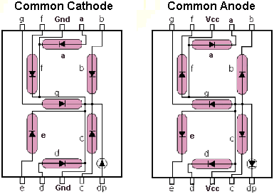
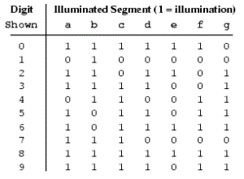

table 1 table 2

To show a number on a digit you have to trigger the led segments individually to form a character as shown in table 2. Where is shows a '1' you either pull to low (CA) or setting high (CC).

In my project I used the 4 x 7 display ( HS420516K – 32). This is a 4-digit common female red 0.56 inch/ 14.2mm, it is Common Cathode, Hi-red the max current is 20mA.

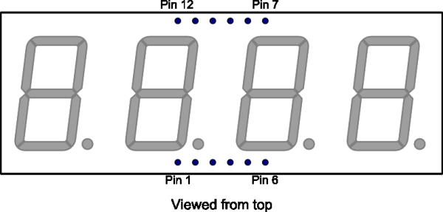

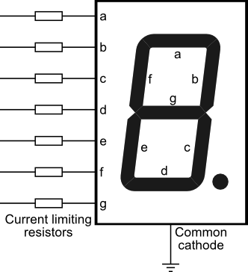
The LED segments of this display require a current-limiting resistor to max 20 mA. However as the Raspberry can deliver 16mA best to start with 470 (3.3-2.1)/470 ~ 3mA). Honestly that was enough for the whole project, but for more brightness you can use 220 or 120 ohm resistors.

Th common cathode is not directly connected to ground on this display, as you to be able to select the digit to set the number. A transistor will be need to drive the common ground as that is LOW = “floating” on the Raspberry. Following schema comes from Internet :

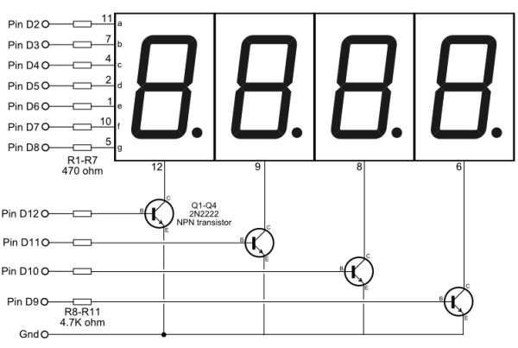

(source: http://electronics.stackexchange.com/questions/34815/using-4-digit-7-segment-led)

A B C D E

D2 GPIO22 11 15 a
D3 GPIO05 7 29 b
D4 GPIO06 4 31 c
D5 GPIO13 2 33 d
D6 GPIO19 1 35 e
D7 GPIO26 10 37 f
D8 GPIO21 5 40 g
D1 GPIO20 3 38 dp

D9 GPIO16 6 36 dig4
D10 GPIO12 8 32 dig3
D11 GPIO25 9 22 dig2
D12 GPIO24 12 18 dig1

A = Pin on drawing (D1 the dp is missing !!)
B = GPIO on Raspberry Pi
C = Pin number on led display
D = Pin number on 40-pin raspberry connector
E = Description

You connect the segments a..g, dp via 8 series resistors to 8 I/O pins of the Raspberry. Driving a pin high will light that LED on the selected digit. To select any of the 4 digits you make the corresponding common cathode low via an NPN transistor, which you drive from an I/O pin via a resistor.

2.0 Software
The approach :
To drive the full display 1, you first make pin 12 on the led (dig1) low by driving its transistor with a high level, and set the I/Os for the segments of that digit. Some time later you switch pin 12 and the segments off, and switch 9 (dig2) on the led on, and again the segments for the second digit. And so on. If you go from 1 digit to another in less than 2.5 ms, then the whole display cycles at 10 ms, or 100 Hz, which is enough to avoid noticeable flicker.
(source: http://electronics.stackexchange.com/questions/34815/using-4-digit-7-segment-led)
So the refresh-rate (how often to refresh) is important and the core to achieve stable display. The only real way I found was using timer_settime(). Where you can set a background timer that will interrupt on a regular interval and call a specific routine: refresh_disp() in my case. This timer is using SIGALRM as the signal to trigger that time has expired. Although I could have created my own code, the open source from http://www.teuniz.net/Timer_code/ was already a good working example that I have included.

2.1 What is the fastest refresh rate?

This is based on a combination of brightness, the amount of code and number of digits.

Brightness : The leds are set with certain refresh-rate and need to stay 'on' for some time to provide the right power to light-up. That power is = current * time-on.
- As I have taken 470 ohm resistor, the current is ~3mA: (3.3v source – 2.0v(led)) / 470. That is a save value for Raspberry which can handle 16mA per GPIO to a maximum of 50mA of the whole. I don't want to push the limit and burn the Raspberry, but indeed the time-on can be reduced by providing more current, e.g. with 220 ohm.
- I found that setting a time between 0.5 and 2ms was giving me the right results, with 1ms as default.
Code : I have done the best to reduce the code to the minimum and measured the elapse time: it takes 4us in rest (nothing to display) to 150 -200 usec when all segments + dp on. (that is on 600mhz CPU clock)

The total refresh-time is mainly based on the brightness:

(brightness-time) 0.5ms + (code) 200us = 0.7ms * 4 digits = 2.8ms refresh-time
(brightness-time) 1.0ms + (code) 200us = 1.2ms * 4 digits = 4.8ms refresh-time
(brightness-time) 1.5ms + (code) 200us = 1.7ms * 4 digits = 6.1ms refresh-time
(brightness-time) 2.0ms + (code) 200us = 2.2ms * 4 digits = 8.8ms refresh-time

With the default setting of refresh-rate of 10ms (100hz) and default brightness of 1ms, we are save.
However if the refresh-rate would be set to 5ms, the maximum allowed brightness is 1000. That has been included in the code.

While that works good, I run into 2 issues:
- Sleep() does not work as expected. Between displaying different numbers on a digit, I want to wait/sleep to make sure we can read what is on the digit. The normal sleep() call however is also using SIGALRM on Debian, same as the background itimer is using. So sleep() call is interrupted as timer was triggered, so very fast... (~100 times per second). The normal sleep call is not usable. (this is documented and warned for, so I found later, in the different documents about both system calls)

- To get input from a keyboard (getchar()) is also not working with a timer signal is triggering as needed. Normally it waits for enter..... but when the timer interrupts, performs the refresh_disp() and returns, Linux will restart the interrupted system call. Even if I had not entered anything getchar() returns.

2.2 How to handle sleep?
To get around the sleep() issue I had tried the nanosleep() call, which handles better with interrupts and can be restarted. I could not get that stable however and had too many times that I had to restart because of the signal on the thread. Next to that: working with 2 clocks on the same program is never a good idea.
The better and easier way was to build a programmed sleep (psleep()) routine. In this routine a counter is set which is decremented every time the itimer triggers in refresh_disp().
As I allow the fastest refresh-rate of 5ms, giving 200Hz, the wait time = value * 5ms. If the refresh-rate is changed (with set_refresh()), the routine psleep() will adjust the counter value to keep wait time close to value * 5ms.

Note 1: I know this may not sound perfect, but the aim is to display digits and not to be perfect. Working in 5ms interval is easy to do for display and waiting.

Note 2: As Linux is not a real-time operating system, there can be some variance in the timer trigger. It is not guaranteed to to be interrupting on 5ms exactly. (see documentation about setitimer())

Note 3: Of course when you sent a low value (say 1 = 5ms), it is not possible to make adjustments, but you should question yourself asking for a sleep of 5ms...... (although if you could use the BCM2835 you could use their bcm2835_delayMicroSeconds())

2.3 How to handle keyboard input ?
Actually this is done with a check that ALWAYS should be done when using getchar()... testing on 0xff ('-1'). As long as the returned character does not equal 0xff it is a valid character.
Included are 3 routines: (See hs42led.h)
get_line() t o get a buffer filled (to a maximum) and terminated with '\0'
get_char() get a character followed by newline '\n' (make sure to capture that)
get_ch() get a character, no <enter> needed and (not displayed)

2.4 Connecting with 18B20
In a separate follow-on project I connected 18B20 temperature sensor to my own 1-wire driver program, thus NOT making use of device tree not modprobe. I wanted to display the outcome to the digits. Timing is extremely critical (microsecond precision) and in order to achieve that I have used the faster BCM2835 library. Still I had to be able to suspend the refresh of the display as that takes milliseconds and of course that interfered with the capture on 1-wire depending on microseconds. I have added 2 options to support:
1. a variable capture_busy , if set by the 1-wire 18B20 program as close as possible around the code that is depending on the critical timing, the refresh-disp() will return without update of the digits. Once past the critical timing, the capture_busy is reset by the 18B20 program. You see some hick-up as a result, but with refresh-rate on 5 is is more than acceptable.
2. The original code was build using wiringPi library, but the 1-wire is build on BCM2835 library, which is now the default. However if you want to use the wiringPi library instead, make sure to define “_wiring”. This can be done either by removing the comments before the line ://#define _wiring in hs42led.h OR by the gcc option “-D_wiring=1” . The later is included in ./build_led (see installation instructions)
For more information around this, look at appendix 3.

2.5 Install the software

Depending on the library you want to use either first install BCM2835 library or the wiringPI.

wiringPi library
- cd /home/pi
- git clone git://git.drogon.net/wiringPi

- #make the utilities
- cd wiringPi
- ./build
- #to copy the library to the right place !!!! important !!!!
- cd wiringPi
- make static
- sudo make install-static

….OR...

BCM2835 library
Install latest from BCM2835 from : http://www.airspayce.com/mikem/bcm2835/
- wget http://www.airspayce.com/mikem/bcm2835/bcm2835-1.50.tar.gz
- tar -zxf bcm2835-1.50.tar.gz // 1.50 was version number at the time of writting
- cd bcm2835-1.50
- ./configure
- sudo make check
- sudo make install

Install the HS42 utilities
- cd /home/pi

- tar -xzvf hs42led.tar.gz

- cd hs42led

To use the BCM2835 : ./build_led bcm

OR

To use the wiringPI library : ./build_led pi

./testled will start ONE of the examples: ask for a your string to display and will show that rolling on the display

There are more examples in led_ex.c, but these have been commented out and can be used for your references (see 2.8)

2.6 Files in hs42led directory

hs42led.c source for the different routines
hs42led.h header file with information about hs42 routines
timer.c handles the itimer call
timer.h header file for itimer

build_led compile led_ex.c
led_ex.c has a number of examples to use
led_ex compiled version of led_ex.c (after build)
timer.tar.gz original timer information from

2.7. High-level description

As explained earlier the core of the program is the refresh-cycle for the digits. Displaying and refreshing is handled by refresh_disp(), which is called by a background timer with a certain refreshrate. The subroutines that are normally accessed by the user fill structures and buffers, but don't display directly (although you could access them as defined in hs42led.h).

MUST do routines:
do_init() will set the GPIO, timer for the correct working.
do_exit() will handle controlled close down.

Manage digit content :
set_value() sets a 4 digit numeric value on the display
set_char() set a character on a specific digit
clr_digit(0 blank a specific digit
set_dot() set/reset a dp/dot on a specific segment

Display option:
set_brightness() sets the brightness of the display
set_blink() set/reset a specific digit to blinking
set_refresh() refresh-rate of display

Extra's
flash_dot() do a flash of the dots from left > right or right < left.
do_selftest() display different characters on a specific digit
move_digits() move content of digits from left > right or right < left.
swap_digit() swap content between 2 digits
psleep() provide a working to sleep()

Read keyboard:
get_line() get line from keyboard
get_char() get character from keyboard (after enter)
get_ch() get character from keyboard (no enter needed)

2.8 examples in led_ex.c

They can be activated in main() by removing the comment-slash '//' in front.

/* initialize and set control-c on.*/
// MUST ALWAYS BE DONE FIRST !!
do_init(CTRLC);

/* Set brightness higher */
//set_brightness(1500);

/* move dot to last digit (e.g. to show init was done)*/
flash_dot(RIGHT);

/* set blink digit 0 with default speed (200) */
//set_blink(0, SET, 0);

/* set blink digit 1 with speed 300 */
//set_blink(1, SET, 300);

/* set blink digit 2 with speed 100*/
//set_blink(2, SET, 100);

/* set blink digit 3 with default speed (200) */
//set_blink(3, SET, 0);

/* set dot on digit 3 FIXED (will not move with move_digits()*/
//set_dot(0,FIXED);

/* get keyboard line input and display on move display*/
//test_line();

/* keyboard character (waiting for enter) */
// test_char(LEFT);

/* keyboard character (waiting for enter)on fixed digit*/
//test_char(FIXED);

/* keyboard character on moving display*/
test_ch(LEFT);

/* keyboard character on fixed digit*/
//test_ch(FIXED);

/* wobble the value over the digits */
//wobble(1234);

/* get a number value and display */
//get_value();

/* do a self_test on digit0 */
//do_selftest (1);

/* display a buffer of test moving over the display */
//test_string();

/* ALWAYS PERFORM do_exit at the end */
do_exit(1);

Appendix 1: Supported characters

The following characters can be supported.

0 - 9 (numbers)
a - z (except m,w,x) some will display upper case
A - Z (except M,W,X) some will display lower case

Special characters / signs :
space
- minus
_ underscore
~ upperscore
( [ { opening brackets
) ] } closing brackets
< less than
> greater than
^ to the power off
\ backward slash
/ forward slash
@ degree symbol
' quote
" double quote
= equal
! exclamation mark
. dot, digital point

Appendix 2: Specifications H420561K

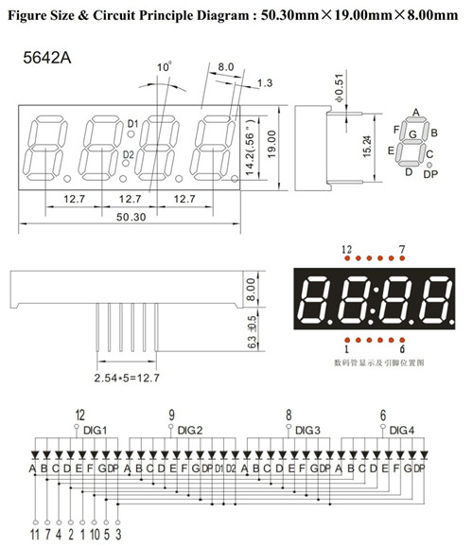

Appendix 3 : connection with 18B20

As part of a follow-on project I wanted to understand 1-wire and build my own driver interface. The timing with 1-wire is SUPER critical (microseconds) and it took a long time to make a user level program that was able have a decent fault rate ( 1 error out of 20 readings). It is documented in a separate project.

However in order to combine :

Install 1wusr as documented.

Copy all the files from 1wusr into the SAME directory as hs42led.

In pbed.h change the line
//#define _hs42led
to
# define _hs42led (so remove the comment //)

compile: ./build_with

run: ./tt

