Microphone Sound Sensor on Arduino

Table of Contents
1. The Board 2
2. Principle of operation. 3
3. Board in action 4
4. Software sketch 6
5. How can we improve? 6
5.1 Hardware solution 6
5.2 Software solution 6
6. Three claps ON/OFF 7
7. What is the best board setup ? 7
Appendix A. schema 8
Appendix B. sample sketch 9
Appendix C. optimized sketch 10
Appendix D. Three claps on/off 11

Just because this KY-038 board was part of a experiment-kit that I had bought 2 years ago, I decided to give it try. I was turned out to be a fun exercise.

Paul van Haastrecht
paulvha@hotmail.com

Disclaimer

This program is free software / information : you can redistribute it and/or modify it under the terms of the GNU General Public License as published by the Free Software Foundation, either version 3 of the License, or (at your option) any later version.

This information is distributed in the hope that it will be useful, but WITHOUT ANY WARRANTY; without even the implied warranty of MERCHANTABILITY or FITNESS FOR A PARTICULAR PURPOSE. See the GNU General Public License for more details.

1. The Board

Source picture: http://microcontrollerslab.com/wp-content/uploads/2018/07/?SD

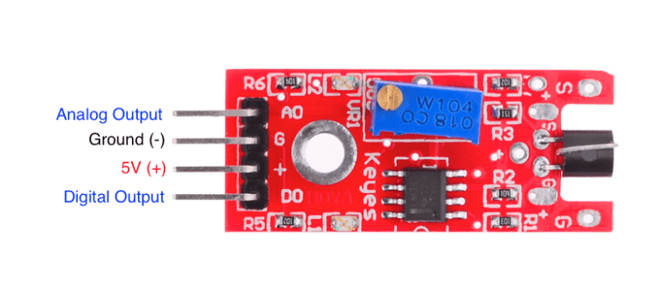
The board is mend to provide output to the Arduino that changes based on sound level recorded by the on-board microphone. The analog output is the signal that is coming directly from the microphone, the digital output is changing level if the signal from the microphone is louder than a preset value. The on-board potentiometer (VR1) can be used to set the preset value.

2. Principle of operation.

The schema is attached in appendix A

The board is powered with 5V. To show there is power on the board, led L1 will lit up with current controlled by R5.

LM393 is housing 2 comparators . If the voltage on ‘-’ is lower than the voltage on the ‘+’ input the output is high, else the output is low.

R6 and R2 are both 100K, so the voltage on pin 3 of the LM393 is 2.5V. This is called the reference voltage. As long as the voltage on pin 2 is higher than 2.5V the output on pin 1 is 0V. If the voltage on pin 2 is LOWER than 2.5V the output on pin 1 is 5V, also pulled-up by the R1 / 10K resistor. The digital output is connected to pin 1.

The signal from the microphone does not reach the level of 2.5V by itself. With VR1 however we can offset the level on pin 2, through resistor/voltage divider VR1, R3 and microphone.
Now assume we adjust the voltage with VR1 to just higher than 2.5V (say 2.55V) that will cause pin 1 to be 0V. Now if we tick on the microphone, due the small change in resistance in the microphone, the voltage divider will now cause a different voltage on pin 2. If that now drops below 2.5V the pin 1 will be driven high. The opposite is true as well. If we pre-set the voltage on pin 2 to just below 2.5V ( say 2.45V), pin 1 is driven high. If we now tick on the microphone and it exceeds 2.5V on pin 2, pin 1 will be driven low.

The closer the pin 2 offset to the 2.5V, the more sensitive as soft sounds will cause enough resistance change in the microphone to change the level of pin 1.

R3 is there to protect the microphone and power supply in case of we turn the VR1 to zero resistance. The microphone would then have to deal with 5V and could be damaged. A short circuit could also cause the power supply to be damaged

To display on the board that the digital value has changed, they have used the second comparator. The ‘+’, pin 5, is 2.5V. The ‘-’, pin 6, is the digital output. If the digital output is low, it will cause the output (pin 7) to be 5V. As the L2 is connected to 5V as well there is no current and the led does not lit. As soon as pin 6 is high, the output on pin 7 is low and the L2 will lit with current controlled by R4.

3. Board in action

I have adjusted with VR1 the voltage offset to 2.56V. Using a scope we can see what happens.
The yellow signal is the analog output, the red the digital output.

The yellow signal in rest is showing 2.56V straight line, the red signal is not negative, but have adjusted the base line for red signal where is say 1> in the left hand side.

Now I started ticking on the microphone and you see the analog (yellow) signal spike gooes up with about 2V. The digital output (red line) does not change. The voltage is now 2.56V + 2V ~ 4.56V still above the 2.5V reference voltage.
However the microphone resistance is now dropping and causes the analog to go below the 2.5V, just for a moment. You see a spike on the digital output.

On the point where the analog voltage stays below the 2.5V for a longer time, it is generating a steady digital pulse of 18ms. However you also see a lot of short spikes following that. Here the analog 2.5V is extremely close and the comparator is constant switching low/high. Followed by some spikes cause by small sounds on the microphone.

So it works... BUT…. The current setup is very sensitive and we never get a single spike in reaction of sound, but always a large number. Also the pulse is short 18ms and will be a lucky shot to capture (as we will see later on).

I have now adjusted the offset to 2.8V. Similar tick on the microphone

The digital output is much cleaner, BUT the pulse has now reduced from 18ms to 5ms, making the challenge of capturing even larger. The other aspect is that I need to tick harder on the microphone to have the analog signal drop below the 2.5V.

4. Software sketch

There are a number of sketches around, but they basically all do the same thing. I have copied an example in appendix B.

They define what pin(s) to use as input, setup the pin for input and loop to read the input values (analog and digital) and then display the results of what has been read.

With this sketch you can read the offset on the analog line and adjust with VR1 to the level you want. (e.g. 2.7V).

Then tick on the microphone. If you look on the board you will see the L2 led lit up regular, as an indication that the digital level has changed.

BUT………. the sketch keep telling “Extreme value:0 not reached yet ” and only sometimes it indicates “Extreme value:1 reached ”. However it you look at the analog voltage, it might not show that is below 2.5V.

WHY ??? … well….. you have seen the scoped signals. The Arduino can only show the value that was on the input when it made the read. With pulses of 18ms or even 5ms… it is a lucky shot..

5. How can we improve?

Somehow we need to get less dependent on the “one-lucky-shot”. A sound level that is longer and more stable can help, but otherwise we need to look at hardware or software solution.

5.1 Hardware solution
One could build a hardware solution with a flip/flop, which will remember there was a pulse raised. A single pulse from the board will cause a “flip” and the output can be read by the sketch when it is ready to read. Then the sketch should send a signal on another pin to reset and “flop” it back. The advantage is that Arduino will only see ONE pulse and a more stable operation. The disadvantage: extra hardware, extra work and a (little) extra cost.

5.2 Software solution
There is standard included a package called “softwareserial”. Normally that is used for implementing an extra serial communication port (like a UART). However we can use it in this case as well.

The RX line is interrupt driven. So every time a level change happens on the input, an interrupt is raised and reading starts: the levels (“bits”) are read and then 8 bits are stored as a byte. A single pulse will generate a byte. We are NOT interested in the byte value, we are only interested that a pulse from the board had triggered a level change. As a result the speed of the “softwareserial” setup is not relevant for us in this case, we just keep it on 9600.

An optimized sketch is in appendix C. We are setting up “softwareserial” on pin 3 and 11 (the last should be free and not used) with a speed of 9600. In the loop, instead of reading the input pin 3, we check whether any byte was received. If so, that means a pulse or pulses have happened. As every pulse is generating a byte, we just read and discard all the bytes to have a correct start for the next loop. There is an optional de-bounce routine. As we have seen that a single event might cause multiple pulses, we just wait 100ms and try to read and discard again. This can be fine-tuned or removed if you want.

6. Three claps ON/OFF

Let’s say you want to use this board to make it switch on a light with 3 claps.

Starting with the code from Appendix C, I have changed this to the code in Appendix D. Connect a 1K resistor to pin 5, connect the other end of the resistor to the longest leg on a LED. Then connect the shorter leg of the LED to GND. The led should go on after 3 claps were detected and switch off after the next 3 claps. Replacing the led with a relais can switch on/off and lamp.

7. What is the best board setup ?

First make sure that the voltage on pin 2 is set ABOVE 2.5V. Turn VR1 COUNTER-clock to increase the voltage. You can read the value with the sketch as you set it. BUT don’t set the pre-set voltage TOO high, else a change in resistance from the microphone would not cause a the voltage on pin 2 to drop below 2.5V. It is a matter of experimenting on what sounds level you want the digital signal to trigger. I would expect a level between 2.55V and 2.8V to do the trick.

Appendix A. schema

Source : https://easyeda.com/adrirobot/KY_038_Microphone_sound_sensor_module-283a631354c24d129bca349e77da0d18

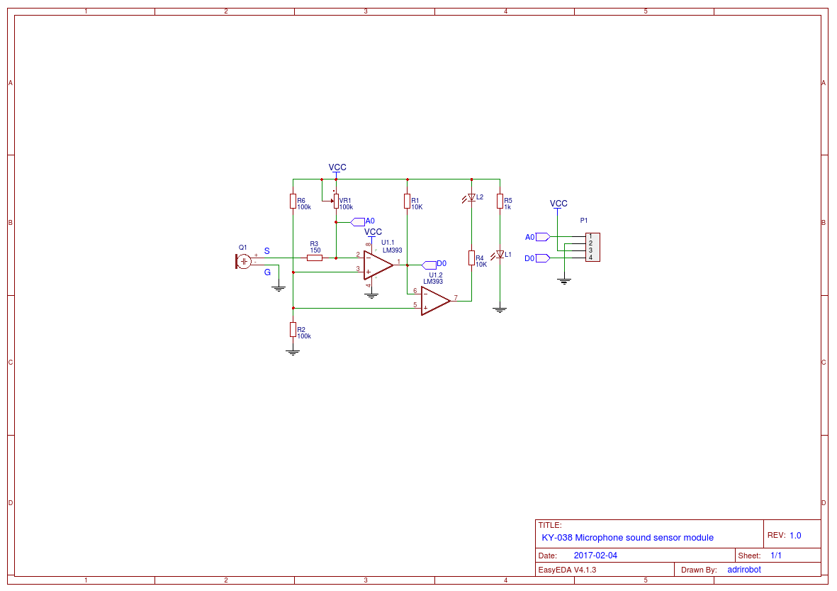

Appendix B. sample sketch

Source : http://sensorkit.en.joy-it.net/index.php?title=KY-038_Microphone_sound_sensor_module

// Declaration and initialization of the input pin
int Analog_Eingang = A0; // X-axis-signal
int Digital_Eingang = 3; // Button

void setup ()
{
pinMode (Analog_Eingang, INPUT);
pinMode (Digital_Eingang, INPUT);

Serial.begin (9600); // Serial output with 9600 bps
}

// The program reads the current value of the input pins
// and outputs it via serial out
void loop ()
{
float Analog;
int Digital;

// Current value will be read and converted to voltage
Analog = analogRead (Analog_Eingang) * (5.0 / 1023.0);
Digital = digitalRead (Digital_Eingang);

//... and outputted here
Serial.print ("Analog voltage value:"); Serial.print (Analog, 4); Serial.print ("V, ");
Serial.print ("Extreme value:");
Serial.print ( Digital);
if(Digital==1)
{
Serial.println (" reached");
}
else
{
Serial.println (" not reached yet");
}
Serial.println ("----------------------------------------------------------------");
delay (200);
}

Appendix C. optimized sketch

/* example of optimized sketch. paulvha / October 2018 */

#include <SoftwareSerial.h>

// Declaration of the input pins
#define Analog_pin A0
#define Digital_pin 3

// Digital_pin is used to connect the board, pin 11 should not be used
SoftwareSerial mySerial(Digital_pin, 11); // RX, TX

void setup ()
{
pinMode (Analog_pin, INPUT);
Serial.begin (9600); // Serial output with 9600 bps

mySerial.begin(9600); // speed is not relevant
}

// The program reads the current value of the input pin and outputs it via serial out
void loop ()
{
// Current value will be read and converted to voltage
float Analog = analogRead (Analog_pin) * (5.0 / 1023.0);
Serial.print ("Analog voltage value:"); Serial.print (Analog, 4); Serial.print ("V, ");

Serial.print ("Extreme value:");

// if any data is available a level change has happened on the RX
if(mySerial.available())
{
Serial.println (" reached");

// every pulse causes a byte. We now just read them all and discard them
while (mySerial.read() != -1); // read until all has been read

// maybe more pulses might still come in as a result of the previous loud sound
// to prevent another trigger from the same event, we wait a little
// and try to read and discard again. BUT maybe you do not want that...
delay(100);
while (mySerial.read() != -1); // read until all has been read
}
else
{
Serial.println (" not reached yet");
}
Serial.println ("----------------------------------------------------------------");
delay (200);
}

Appendix D. Three claps on/off

/* example to show how to turn on an off a light with 3 claps
* paulvha / October 2018 */

#include <SoftwareSerial.h>

// Declaration of the input pins
#define Analog_pin A0
#define Digital_pin 3

// declare the output pin
#define out_pin 5

// number of claps needed
#define NEEDED 3

////////////////////////////////////////////////////////////////
/// no changes needed beyond this point
////////////////////////////////////////////////////////////////

// indicate light status 1= on, 0 = off
int light_status = 0;

// count pulse events
int count = 0;

// Digital_pin is used to connect the board, pin 11 should not be used
SoftwareSerial mySerial(Digital_pin, 11); // RX, TX

void setup ()
{
pinMode (Analog_pin,INPUT);
pinMode (out_pin, OUTPUT);

Serial.begin (9600); // Serial output with 9600 bps

mySerial.begin(9600); // speed is not relevant
}

// The program reads the current value of the input pin and outputs it via serial out
void loop ()
{
// if any data is available a level change has happened on the RX
if(mySerial.available())
{
Serial.println ("\t\tClap detected");

// every pulse causes a byte. We now just read them all and discard them
while (mySerial.read() != -1); // read until all has been read

// maybe more pulses might still come in as a result of the previous loud sound
// to prevent another trigger from the same event, we wait a little
// and try to read and discard again.
delay(100);
while (mySerial.read() != -1); // read until all has been read

// count and check we have enough claps
if (++count == NEEDED)
{
// turn led off or on;
if (light_status) digitalWrite(out_pin, LOW);
else digitalWrite(out_pin, HIGH);

// indicate status
light_status = 1 - light_status;

// reset counter
count=0;
}
}
else
Serial.println ("Clap not detected");

Serial.println ("----------------------------------------------------------------");
delay (200);
}

