SEN6x Family

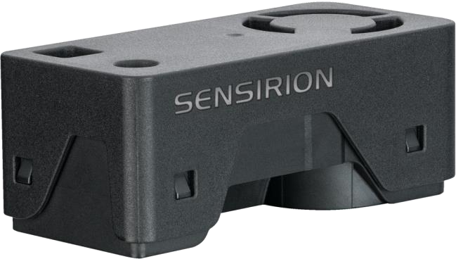

Table of Contents
Foreword.. 2
1. Major differences earlier sensors 3
Hardware 3
Software 3
2. First results 5
3. Power supply sensitive 6
How about connecting to 5V ???? 9
BUT.. there is more about the ripples. 10
For now my early assumptions 12
Appendix A : Internal pictures 13
Appendix B : Example1 SEN66 output (5v) 16
Appendix C : Example20 SEN66 (5V) & SPS30 output 17
Appendix D: example 21 SEN6x(3v3), SEN55 & SPS30 18
Appendix E example 21 SEN6x(5V), SEN55 & SPS30 19
Appendix F: example 22 SEN6x (5v) and SEN55 20

Foreword..

For a long time I have tested and have been creating libraries for different sensors. Most sensors have to do with air quality and conditions: Particle in the air, Co2, temperature, humidity etc. Every so often a new sensor enters the market and this time around the SEN6x from Sensirion caught my attention. I have worked on the SPS30 and SEN55 from Sensirion before and was interested to find out the sensor.

Sensirion is now integrating multiple of their sensors into a single housing. The SEN5x is already a family combining the PM sensor and RH&T and VOC sensor, depending on the version. The SEN6x family is taking this a step further and using the same form factor.

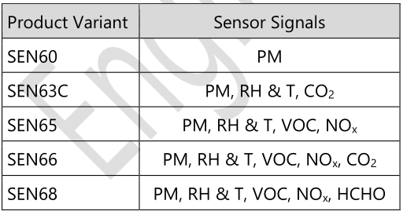
The CO2 sensor is an SCD41, the VOC/NOx sensor is an SGP43 (a next level of the SGP41) and an SHT4x Humidity and temperature sensor.

In this document you will find the experience I had with a pre-production version of the SEN66 and how that compared to other sensors I have available.

December 2024

Paul van Haastrecht

Paulvha@hotmail.com

1. Major differences earlier sensors

Hardware

The SEN6x sensors have a small form factor, which is completely different than the SEN5x and also different to SPS30. Like with SEN5x and SPS30, the SEN6x does not have an easy way to mount it. There is no mounting hole of something like that.

The SEN6x is using the same connector as SEN5x, but which is different connector than on the SPS30. The pin-out is a little different between SEN6x and SEN5x. On the SEN6x pin 5 is already connected to GND and pin 6 to VDD.

As with the SEN5x, the SEN6x only works on I2C. The SPS30 was able to connect either I2C or serial. This can have complication as you need to connect with short wires. It is advised to Use
as short as possible (< 10 cm) and/or well shielded connection cables. Another implication is the need to pull-up resistors (10K) on both SDA and SCL line to the VDD.

A major difference for the SEN6x is that fact that it runs on 3.3V instead of 5V for both the SEN5x and SPS30. Thus it can connected with a Qwiic or STEMMA QT connector to a board.

That said, like with the SEN55, you need a VERY good stable power supply. With 3.3V even more, see the chapter ‘power supply sensitive’. Actually I run the SEN6x on 5V as it is much more stable.

The SEN6x complies with Ready for California Title 241, RESET®2 and WELL Building Standard™3.

Software

Here is a puzzle and challenge. The SEN6x family has a large number of API calls, but not all calls work on all the SEN6x sensors. If a SEN6x family member does not have the sensor (e.g. no CO2), that is understandable, but for a same command ( e.g. Read measured values) each SEN6x or combination of different family members is using a different opcode to send. This makes a library needlessly complex. I really don’t understand why a new family has not been designed using the same opcodes for the same API calls.

Another important aspect is that the according to the datasheet “clock stretching is not used, the sensor NACKs when busy with processing” This means another complexity as you need to wait for the sensor to be ready else the read request will fail. BUT the time to wait is different between the different API’s AND can also be different time depending on WHICH SEN6x sensor you have.

I get the feeling firmware of the SEN6x family has not been designed from scratch with an end-to-end design, but different parts and code has been adopted along from other developments and now glued together. This could (and should) have been much better in my mind...

While the SPS30 and SEN5x family have the same I2C address (0x69) the SEN6x family uses different. The SEN60 uses 0x6C, where the other SEN6x sensors use 0x6B. But they can not used next each other as the one is 3.3v and the other is 5V.
Compared to the SPS30 and SEN55:

A number of API/functionalities have been removed e.g.
setting/getting the autoclean interval for the PM sensor,
Only read RH&T values, do not start laser to save power.
Save and restore warmstart values
No status on fan cleaning in progress

Some API’s have been changed e.g.
set custom temperature compensation parameters
RH&T correction

Some have been added e.g.
Get Raw values (SEN63C, SEN65, SEN66, SEN68)
Get custom temperature acceleration parameters
Forced recalibration (FRC) of the CO2 signal. (SEN63C, SEN66)
The status of the CO2 sensor automatic self-calibration (ASC) (SEN63C, SEN66)
Obtain HCHO percentage
Activate the heater in the SHT4x to improve the humidity reading

2. First results

Time to start measurement. Based on the previous SEN5x work, adjusted the library while waiting for the SEN6x to arrive. So all depending on the data-sheet. to get connected to the SEN6x.

Given there are a number of different sensors part of the SEN6x family, I want to check on the product name. It returned empty. After checking with Sensirion it turned out that pr-production versions do not have the name populated. Something to test later. For now the sensor can be set from the sketch, else per default it is assumed an SEN66

As indicated in the major differences chapter, coding API/opcode for the different sensors was a challenge. For timing I have taken enough time for the command to be executed. Who cares about couple of milliseconds ??

Also kept the GetVersion() function, although not documented in the data-sheet, the opcode oxD100, as with SEN55, still worked on the SEN66. Not sure about the others…

Time to compare… why not ?

Example1 : SEN6x see Appendix B
Example20 : SEN66 & SPS30 see Appendix C
Example 21 : SEN66, SEN55 & SPS30 see Appendix D & E
Example 22 : SEN66 & SEN55 see Appendix F

Todo : add remarks
Stable results?
how connected ?
Long time to get stable results/!!!!!!!

ADD COMPARE WITH OTHER SENSOR SCD30, BMP280 ETC.

3. Power supply sensitive

Often during my testing the SEN66 sensor is “lost in space”. After starting immediately or after a couple of seconds, it only produced 0xffff and not recovery. Or starting with 0xffff and have ‘some’ recovery, but those PM values do not make sense. (very high). A complete reset (power off/power on) would recover to normal working or a couple of resets. WHY ? ??

The SEN6x is mend to have a 3v3 power supply, but this looks VERY sensitive for the readings.

According to the data-sheet:


I have connected the SEN66 to Wire1 / Qwiic on the Arduino UNOR4 Wifi.

When nothing is connected the 3v3 from the connector is actually 3.2V. I expect the resettable fuse (MF-MSMF050-2-W2) that is in between the power line causes some voltage drop. So this is already VERY close to the minimum of 3.15V. With the SEN66 connected, but not started, it is 3.18V.
As soon as “start measurement” is sent, the voltage drops to 2.91V. (See below, the orange lines is SCL, the white is SDA and read line is the voltage)

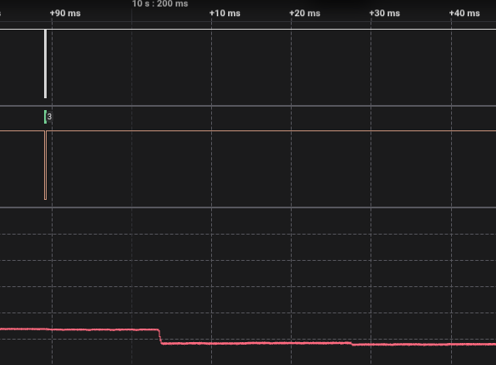
The sensor now starts and a little later the fan will stop. The output continues to only present rubbish (0xFFFF) for all values, including temperature, humidity etc.

Instead of powering from the Qwiic connector, but now directly from the 3v3 pin, the starting voltage is 3.2V. The GND, SDA and SCL are still connected to the Qwiic connector. As soon as “start measurement” is sent, the voltage drops to 3.06V.
(See below, the orange lines is SCL, the white is SDA and read line is the voltage)

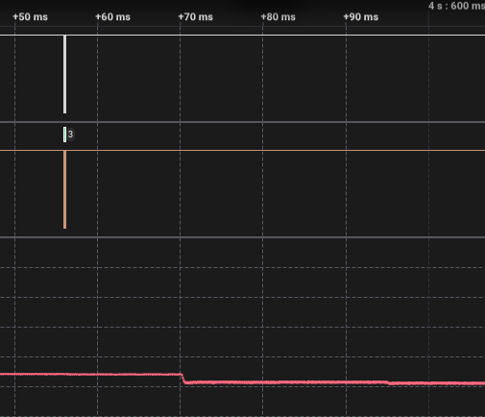
Now the sensor continues to provide sensible information.

BUT I WONDER.. how much luck this is? AND Is it possible to apply a higher voltage???

The internal structure looks to be (according to the data-sheet)

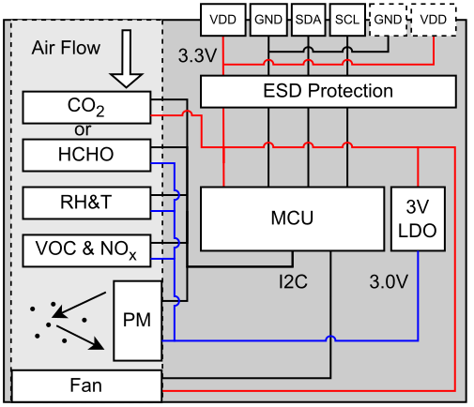
So there are 2 devices directly connected to VDD: the CO2 sensor and fan.

Looking at Appendix A, the internal pictures, an SCD41 for CO2 measurement. This sensor can handle 2.4V – 5.5V.

The FAN is an YCCFAN, YDH2010C05F / dc 5V = 0.2A / www.yccfan.com. So also 5v….

How about connecting to 5V ????
I connected again to the Arduino UNOR4, connected GND, SDA and SCL to Wire1 / Qwiic, but the VDD is now connected to 5V.

Actually it shows 4.62V. WHY ? The 5V USB is connected to the VDD with a PMEG6020AELR , a 60 V /2 A low leakage current Schottky barrier rectifier. So there is some voltage loss always.

As soon as “start measurement” is sent, the voltage drops to 4.47V.
(See below, the orange lines is SCL, the white is SDA and read line is the voltage)

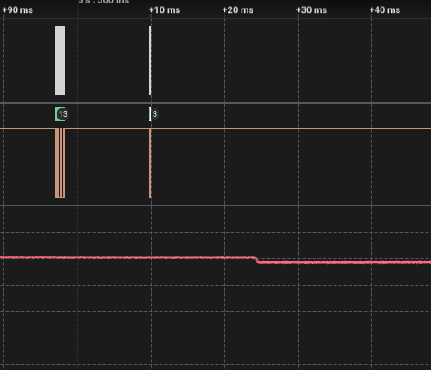
Of course the sensor continues to provide sensible information.

The SDA and SCL lines will be 3.3V (or actually 3.2V) as the on-board pull-up resistors on the board are connected to 3.3V. As such no issues either….

BUT.. there is more about the ripples.
I wondered about the remark in the data-sheet “including ripples”. Why is that ?

So clearly there is an impact on the voltage line when the SEN6x starts, but what about during normal working.
The red and yellow horizontal analog lines show the same voltage, but on different scales.
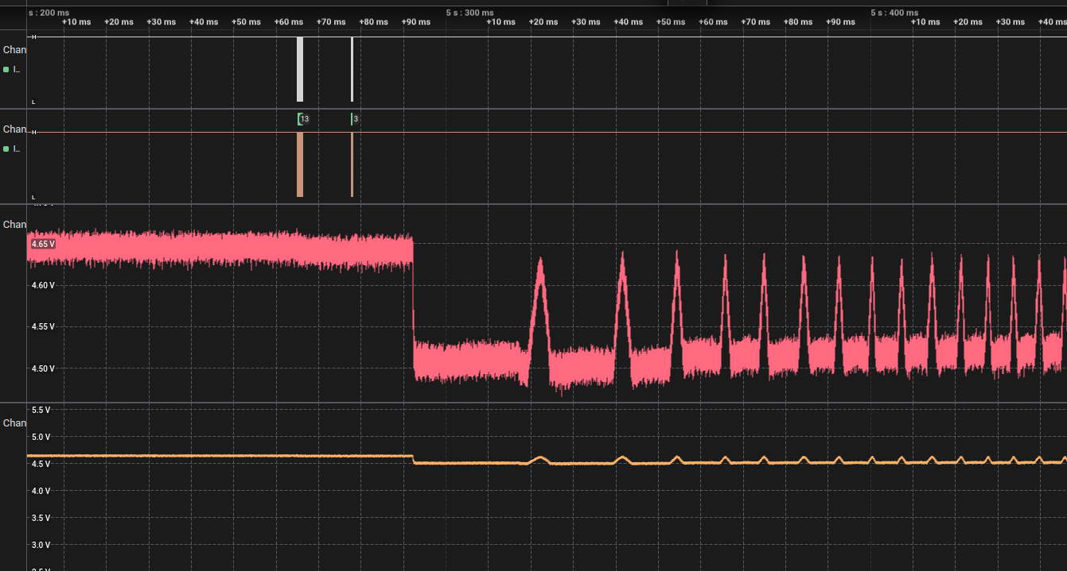
After the “start measurement” the dip on the 4.65V (5v) line to 4.50V or a drop of 0.15V.

The sensor is starting and then the starting of ripples. In my case the top of the ripple is ~4,61V and bottom ~4.5V.

The ripples will NOT stop and continue all the way. A couple of seconds after the start the timing between the pulses is ~5mS, so the ripple has a frequency of about ~200Hz. But after more seconds it becomes ~2.5mS so about 400hz and stays around that frequency

HOWEVER the longer you let it run, you get another ripple. Every 3.5 seconds a 1.2 second ripple as can be seen in the picture below
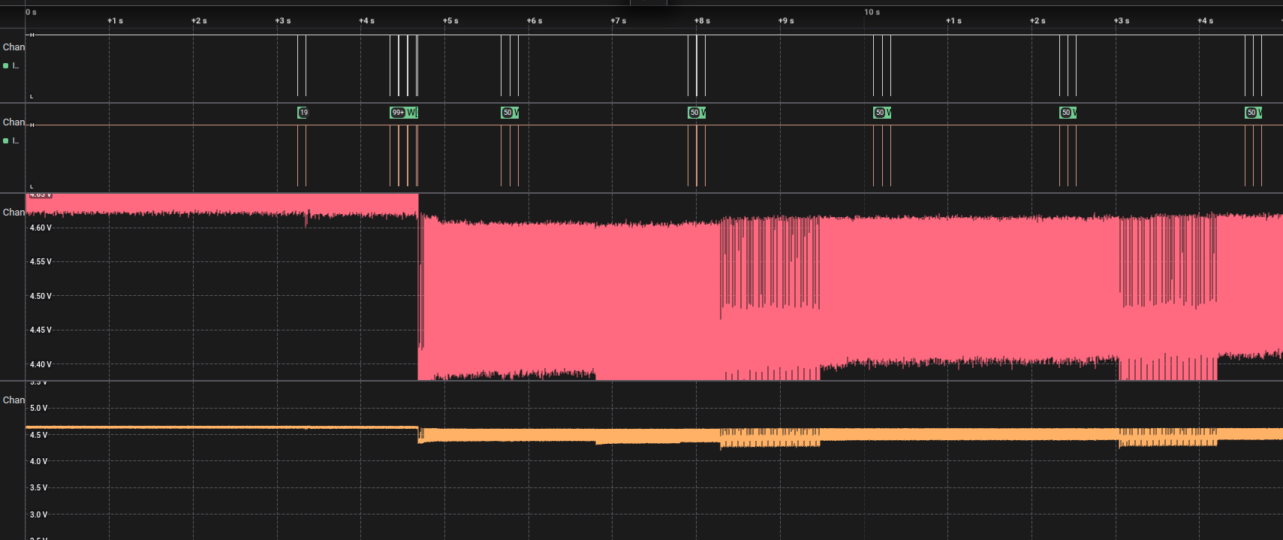
The bottom voltage of the ripple is then 4.2V, so a drop of 0.4V. Apparently another measurement is performed every 5 seconds.

Doing the same, but now the 3.3V from the side pin.
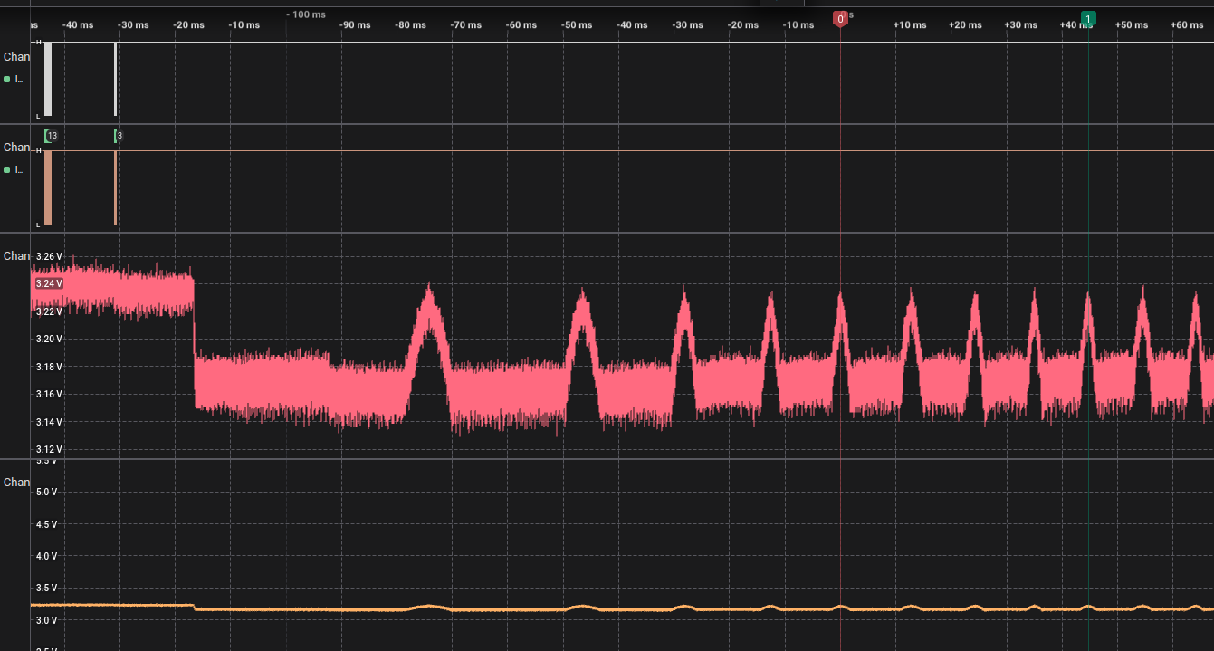
After the”start measurement” the drop from 3.25V to 3.13V, so 0.12V. The ripple is 3.24V and 3.14V. The ripple timing of the pulse and the frequency is the same as with 5V.

Same as with the 5V, the longer you let it run, you get another ripple. Every 3.5 seconds a 1.2 second ripple.
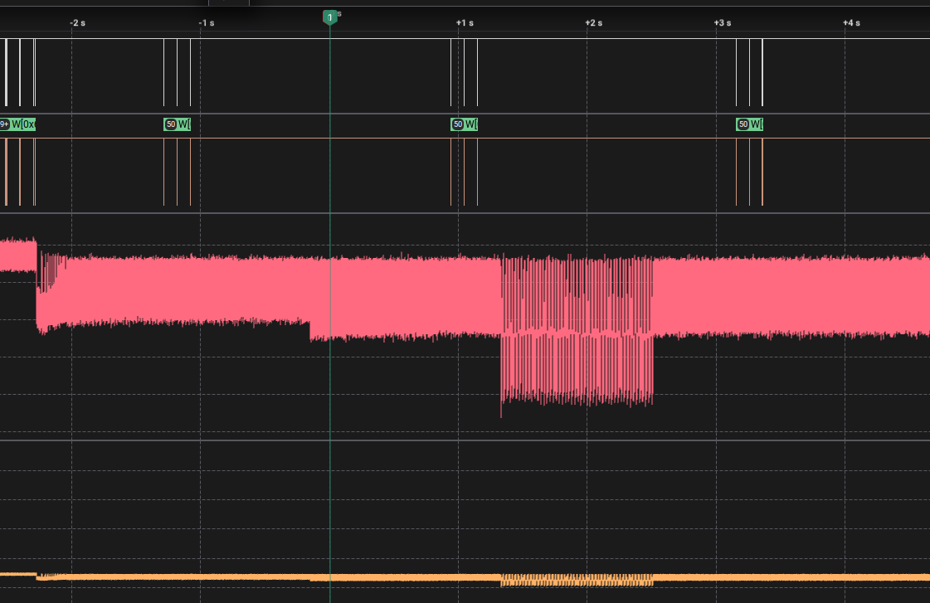
The bottom value of the second ripple is around 3.04V, so a drop of 0.21V every 3.5 seconds for 1.2 seconds.

For now my early assumptions

The ripple with a interval 3.5 seconds is causing the major issue. Also because when my SEN66 failed (and send continued rubbish), it often first worked for couple seconds / some readings. It “looks” like this ripple is the result of the temperature measurement with an SH4x, which has a response time of 4 seconds. The temperature measurement, during continues measurement, also changes most of the time after 5 seconds, but not always !

I assume / predict the 3v3 has been chosen to make an easy connection to STEMMA QT/Qwiic . But that is assuming there is really at least 3.3V stable and strong.

I rather have the SEN66 work on 5V instead. It works MUCH more stable, the fan is providing better flow. I had it run for hours, no issues !!! I have tested the output BOTH on 3v3 and 5V, comparing against SPS30 and SEN55 (see other chapters) and the measured results are the same independent of the voltage

Given that the other SEN6x sensors (PM, HCHO, RH&T and VOC, Nox) work behind the SEN6x LDO, I would not expect a problem either. The only issue could be the LDO, the Low-Dropout (regulators), which is turning the VDD into internal voltage for those sensors. BUT after many hours over working… NO issues

Appendix A : Internal pictures

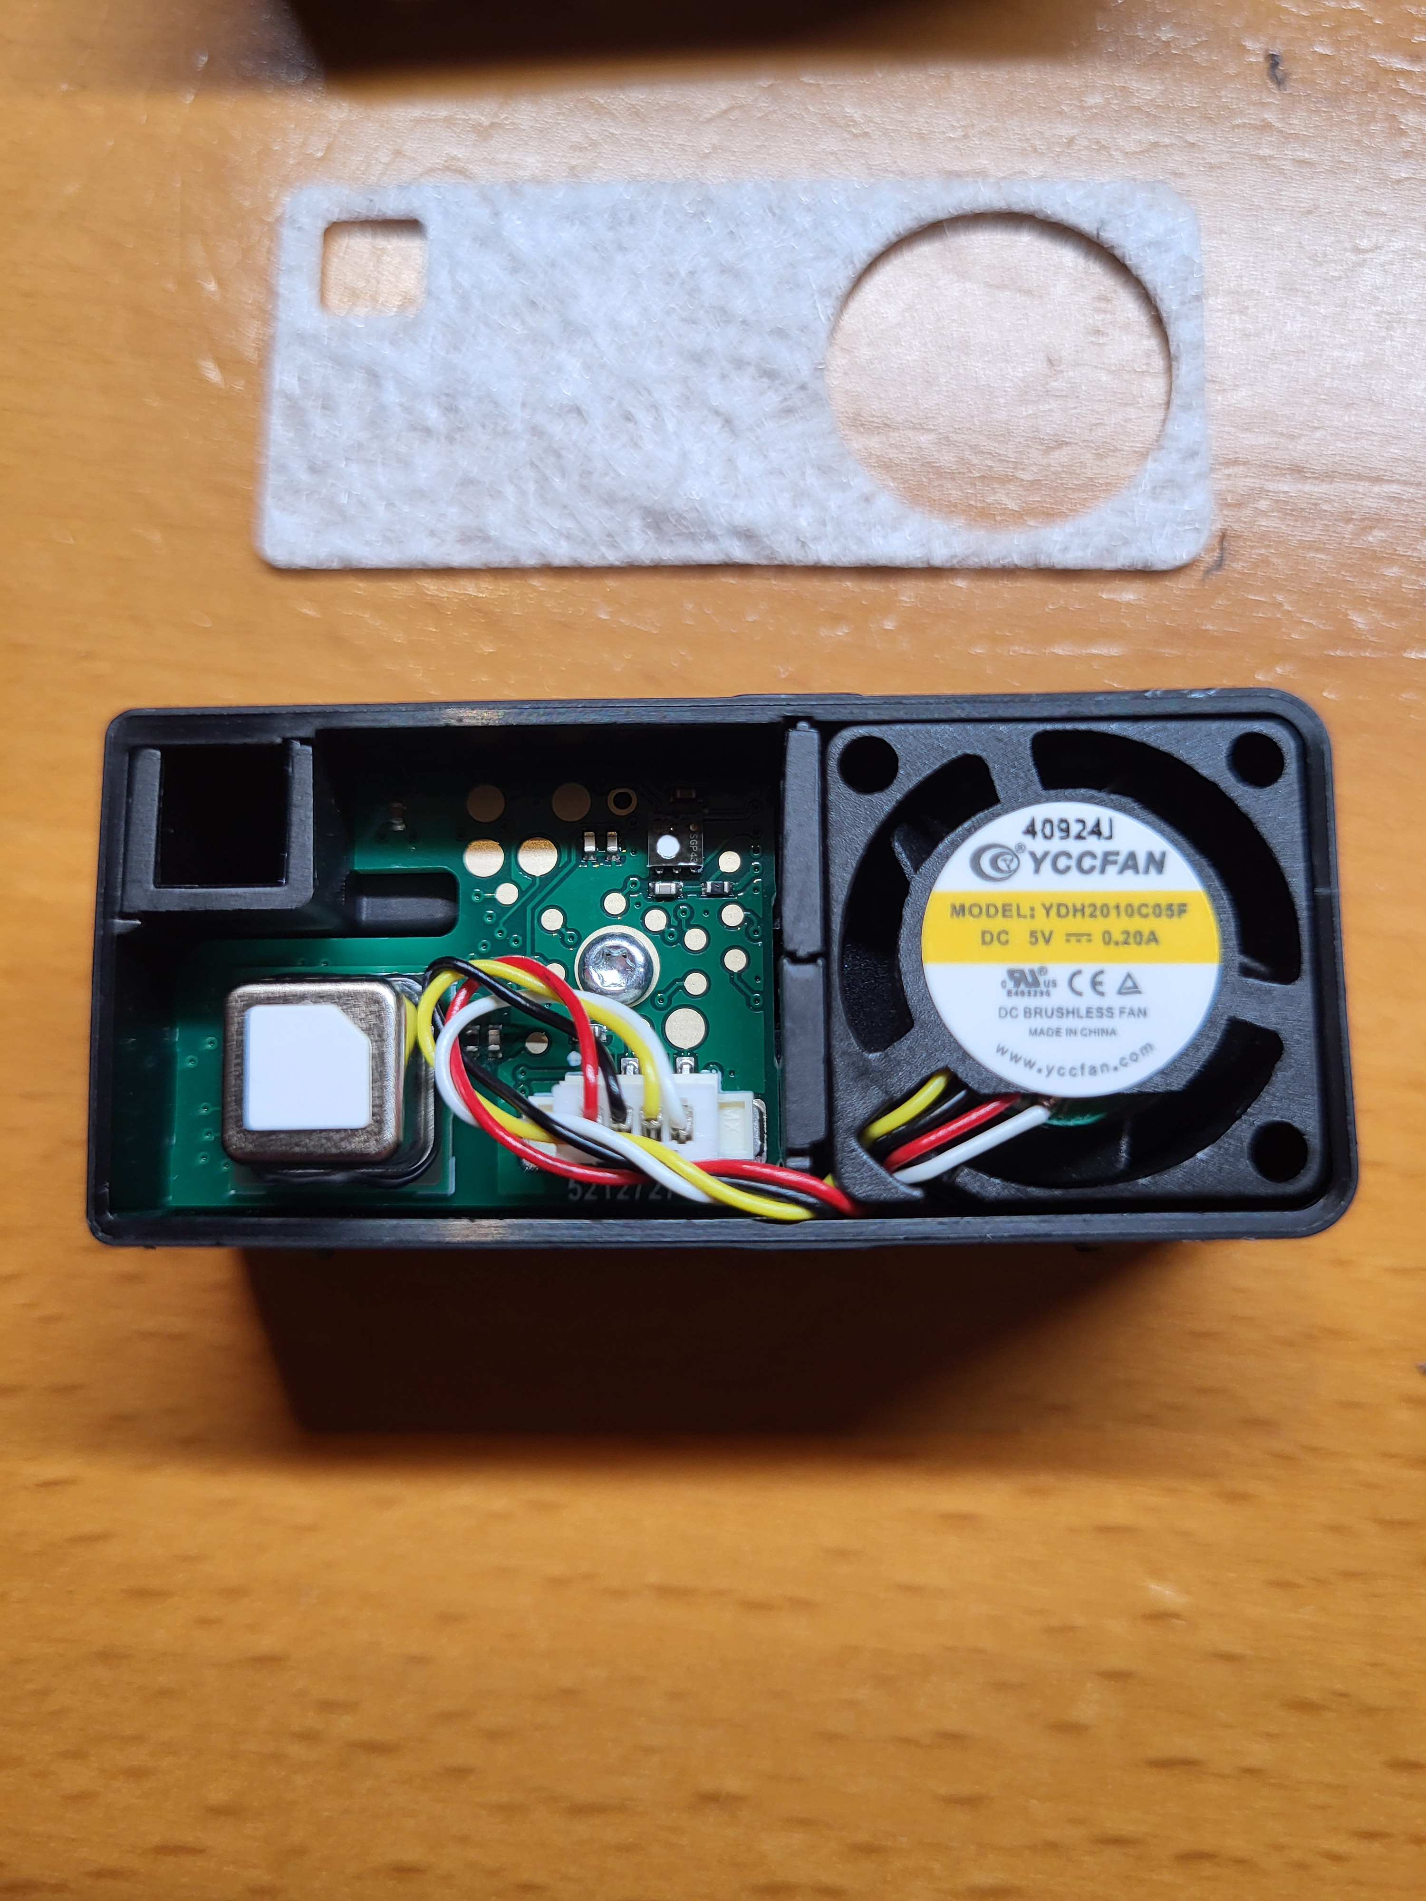

You can clearly see the SCD41 (bottom left) for CO2, the fan and a bit harder the SGP43 (the white dot top right on the top right). The SGP43 is used for VOC and NOX and apparently a successor to the SGP41.
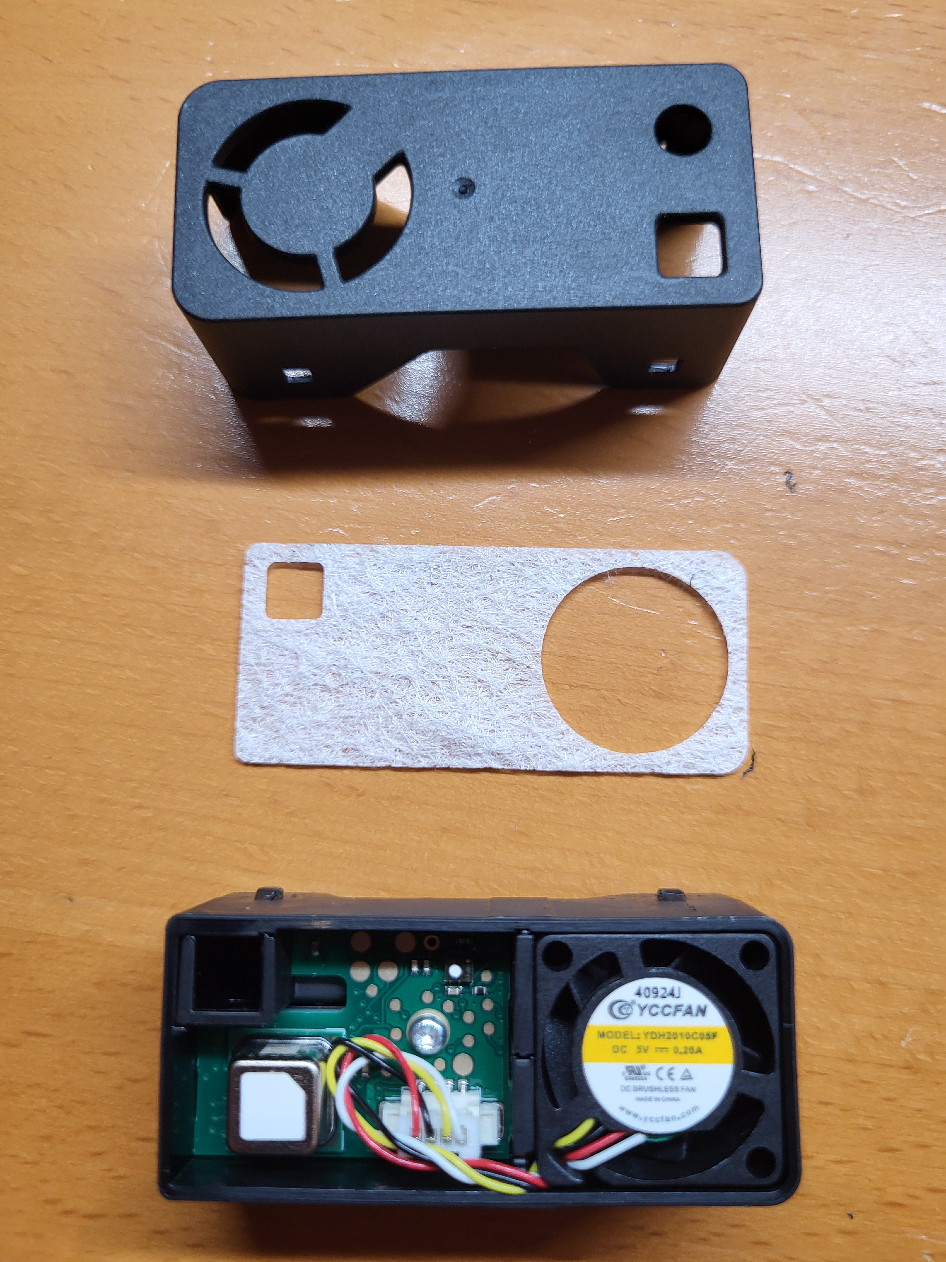

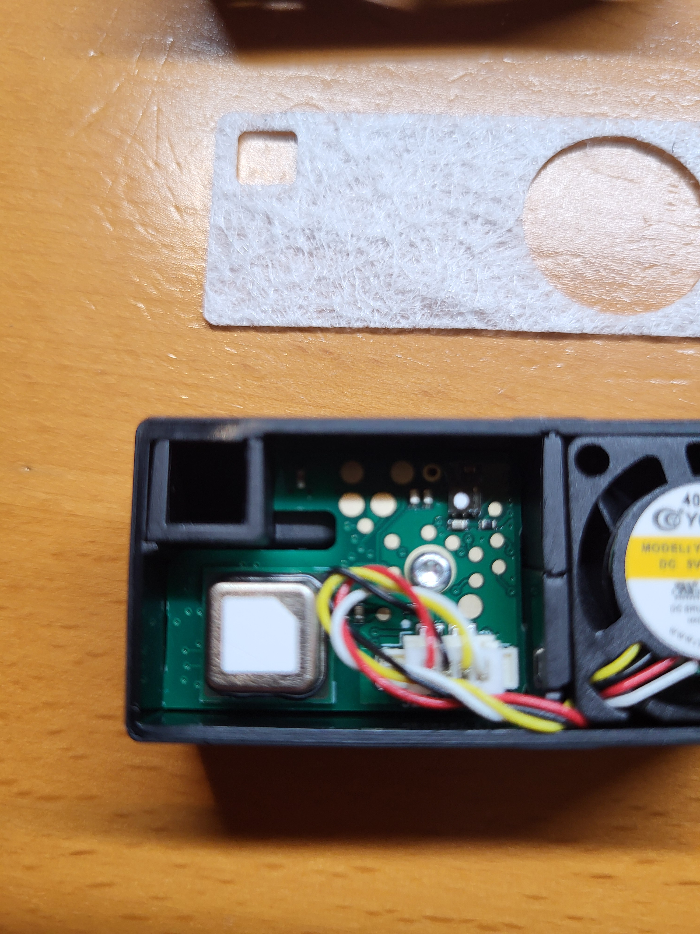

Appendix B : Example1 SEN66 output (5v)

The Temperature en humidity match very close the external meter next to the SEN6x

-------------Mass ----------- ------------- Number --------------
Concentration [μg/m3] Concentration [#/cm3]
P1.0 P2.5 P4.0 P10 P0.5 P1.0 P2.5 P4.0 P10

1.30 1.60 1.80 1.90 8.60 10.60 10.90 10.90 10.90
1.30 1.60 1.80 1.90 8.60 10.50 10.80 10.90 10.90
1.30 1.60 1.80 1.90 8.60 10.50 10.80 10.90 10.90
1.30 1.60 1.80 1.90 8.60 10.50 10.80 10.90 10.90
1.30 1.60 1.80 1.90 8.60 10.50 10.80 10.90 10.90
1.30 1.60 1.80 1.90 8.60 10.50 10.80 10.90 10.90
1.40 1.80 2.00 2.10 9.20 11.30 11.70 11.70 11.70
1.40 1.80 2.00 2.10 9.20 11.30 11.70 11.70 11.70
1.40 1.80 2.00 2.10 9.20 11.30 11.60 11.70 11.70
1.40 1.80 2.00 2.10 9.20 11.30 11.60 11.70 11.70
1.40 1.80 2.00 2.10 9.20 11.30 11.60 11.70 11.70
1.40 1.80 2.00 2.10 9.20 11.30 11.60 11.70 11.70

-------------Mass ----------- VOC: NOX: Humidity: Temperature: CO2:
Concentration [μg/m3] index index % [*C] [ppm]
P1.0 P2.5 P4.0 P10

1.40 1.80 2.00 2.10 99.00 1.00 50.53 19.00 851
1.40 1.80 2.00 2.10 98.00 1.00 50.50 19.00 851
1.40 1.80 2.00 2.10 98.00 1.00 50.47 19.00 851
1.40 1.80 2.00 2.10 97.00 1.00 50.45 19.00 850
1.40 1.80 2.00 2.10 96.00 1.00 50.40 19.00 848
1.40 1.80 2.00 2.10 96.00 1.00 50.37 19.00 848
1.40 1.80 2.00 2.10 96.00 1.00 50.34 19.00 848
1.40 1.80 2.00 2.10 96.00 1.00 50.32 19.00 848
1.40 1.80 2.00 2.10 95.00 1.00 50.30 19.00 848
1.40 1.80 2.00 2.10 95.00 1.00 50.29 19.00 848
1.40 1.80 2.00 2.10 96.00 1.00 50.30 19.00 848
1.40 1.80 2.00 2.10 96.00 1.00 50.32 19.00 849

Appendix C : Example20 SEN66 (5V) & SPS30 output

Hit <enter> to start reading.
-------------Mass ----------- ------------- Number -------------- -Average-
Concentration [μg/m3] Concentration [#/cm3] [μm]
P1.0 P2.5 P4.0 P10 P0.5 P1.0 P2.5 P4.0 P10 PartSize

SPS30 1.08 1.29 1.41 1.43 7.06 8.43 8.62 8.66 8.67 0.68

SEN6x 1.50 1.80 2.00 2.10 9.70 11.90 12.20 12.20 12.20
SPS30 1.11 1.32 1.44 1.46 7.22 8.62 8.81 8.85 8.85 0.68

SEN6x 1.50 1.80 2.00 2.10 9.70 11.90 12.20 12.20 12.20
SPS30 1.15 1.37 1.49 1.51 7.54 9.00 9.19 9.23 9.24 0.68

SEN6x 1.50 1.80 2.00 2.10 9.70 11.90 12.20 12.20 12.20
SPS30 1.15 1.36 1.49 1.51 7.49 8.94 9.14 9.17 9.18 0.68

SEN6x 1.50 1.80 2.00 2.10 9.70 11.90 12.20 12.20 12.20
SPS30 1.12 1.33 1.45 1.47 7.32 8.74 8.93 8.96 8.97 0.68

SEN6x 1.50 1.80 2.00 2.10 9.00 11.00 11.30 11.40 11.40
SPS30 1.10 1.31 1.43 1.46 7.20 8.60 8.79 8.83 8.83 0.68

SEN6x 1.40 1.70 1.80 1.90 9.00 11.00 11.30 11.40 11.40
SPS30 1.13 1.34 1.45 1.48 7.40 8.82 9.01 9.04 9.05 0.67

SEN6x 1.40 1.70 1.80 1.90 9.00 11.00 11.30 11.40 11.40
SPS30 1.13 1.34 1.46 1.48 7.38 8.80 8.99 9.03 9.04 0.67

SEN6x 1.40 1.70 1.80 1.90 9.00 11.00 11.30 11.40 11.40
SPS30 1.13 1.33 1.44 1.47 7.41 8.83 9.01 9.05 9.05 0.66

SEN6x 1.40 1.70 1.80 1.90 9.00 11.00 11.30 11.40 11.40
SPS30 1.12 1.32 1.43 1.45 7.35 8.75 8.93 8.97 8.97 0.66

SEN6x 1.40 1.70 1.80 1.90 9.00 11.00 11.30 11.40 11.40
SPS30 1.06 1.25 1.35 1.37 6.92 8.24 8.42 8.45 8.46 0.66

SEN6x 1.40 1.70 1.80 1.90 9.00 11.00 11.30 11.40 11.40
SPS30 1.02 1.21 1.32 1.34 6.70 7.99 8.17 8.20 8.20 0.67

SEN6x 1.40 1.70 1.80 1.90 9.00 11.00 11.30 11.40 11.40
SPS30 0.98 1.16 1.26 1.28 6.41 7.64 7.81 7.84 7.84 0.67

Appendix D: example 21 SEN6x(3v3), SEN55 & SPS30

-------------Mass ----------- ------------- Number -------------- -Average-
Concentration [μg/m3] Concentration [#/cm3] [μm]
P1.0 P2.5 P4.0 P10 P0.5 P1.0 P2.5 P4.0 P10 PartSize

SEN6x 1.30 1.60 1.80 1.90 8.20 10.10 10.40 10.50 10.50 ---
SEN5x 1.50 1.60 1.60 1.60 10.20 12.00 12.10 12.10 12.10 0.47
SPS30 1.20 1.27 1.27 1.27 8.19 9.54 9.58 9.59 9.59 0.49

SEN6x 1.30 1.60 1.80 1.90 8.20 10.10 10.40 10.50 10.50 ---
SEN5x 1.60 1.60 1.60 1.60 10.40 12.20 12.30 12.30 12.30 0.47
SPS30 1.21 1.28 1.28 1.28 8.24 9.60 9.64 9.65 9.65 0.49

SEN6x 1.30 1.60 1.80 1.90 8.20 10.10 10.40 10.50 10.50 ---
SEN5x 1.60 1.60 1.60 1.60 10.30 12.20 12.20 12.20 12.20 0.47
SPS30 1.24 1.31 1.31 1.31 8.43 9.82 9.86 9.87 9.87 0.49

SEN6x 1.30 1.60 1.80 1.90 8.20 10.10 10.40 10.50 10.50 ---
SEN5x 1.50 1.60 1.60 1.60 10.20 12.10 12.10 12.10 12.10 0.46
SPS30 1.26 1.33 1.33 1.33 8.60 10.02 10.07 10.07 10.07 0.49

SEN6x 1.20 1.50 1.70 1.80 7.60 9.30 9.60 9.70 9.70 ---
SEN5x 1.50 1.60 1.60 1.60 9.80 11.60 11.60 11.60 11.60 0.46
SPS30 1.29 1.36 1.36 1.36 8.78 10.23 10.28 10.28 10.28 0.49

SEN6x 1.20 1.50 1.70 1.80 7.60 9.30 9.60 9.70 9.70 ---
SEN5x 1.40 1.50 1.50 1.50 9.60 11.30 11.40 11.40 11.40 0.47
SPS30 1.30 1.37 1.37 1.37 8.87 10.33 10.38 10.38 10.38 0.49

SEN6x 1.20 1.50 1.70 1.80 7.60 9.30 9.60 9.70 9.70 ---
SEN5x 1.50 1.50 1.50 1.50 9.70 11.40 11.40 11.50 11.50 0.46
SPS30 1.31 1.38 1.38 1.38 8.92 10.39 10.44 10.44 10.44 0.49

SEN6x 1.20 1.50 1.70 1.80 7.60 9.30 9.60 9.70 9.70 ---
SEN5x 1.50 1.50 1.50 1.50 9.70 11.50 11.50 11.50 11.50 0.46
SPS30 1.27 1.34 1.34 1.34 8.66 10.09 10.13 10.14 10.14 0.49

SEN6x 1.20 1.50 1.70 1.80 7.60 9.30 9.60 9.70 9.70 ---
SEN5x 1.40 1.50 1.50 1.50 9.50 11.20 11.30 11.30 11.30 0.47
SPS30 1.24 1.31 1.31 1.31 8.42 9.82 9.86 9.86 9.87 0.49

SEN6x 1.20 1.50 1.70 1.80 7.60 9.30 9.60 9.70 9.70 ---
SEN5x 62.60 65.90 66.20 66.30 414.70 490.00 491.60 491.80 492.00 0.57
SPS30 11.65 12.32 12.32 12.32 79.47 92.61 93.01 93.05 93.08 0.47

Appendix E example 21 SEN6x(5V), SEN55 & SPS30

-------------Mass ----------- ------------- Number -------------- -Average-
Concentration [μg/m3] Concentration [#/cm3] [μm]
P1.0 P2.5 P4.0 P10 P0.5 P1.0 P2.5 P4.0 P10 PartSize

SEN6x 1.30 1.60 1.80 1.90 8.30 10.20 10.50 10.60 10.60 ---
SEN5x 1.50 1.60 1.60 1.60 10.20 12.10 12.10 12.10 12.10 0.43
SPS30 0.92 0.98 0.98 0.98 6.29 7.33 7.36 7.36 7.36 0.53

SEN6x 1.20 1.50 1.70 1.80 7.70 9.40 9.70 9.80 9.80 ---
SEN5x 1.50 1.60 1.60 1.60 10.20 12.10 12.10 12.10 12.10 0.43
SPS30 0.90 0.96 0.96 0.96 6.17 7.19 7.22 7.23 7.23 0.53

SEN6x 1.20 1.50 1.70 1.80 7.70 9.40 9.70 9.80 9.80 ---
SEN5x 1.60 1.70 1.70 1.70 10.50 12.30 12.40 12.40 12.40 0.43
SPS30 0.91 0.96 0.96 0.96 6.20 7.22 7.25 7.25 7.26 0.52

SEN6x 1.20 1.50 1.70 1.80 7.70 9.40 9.70 9.80 9.80 ---
SEN5x 1.60 1.70 1.70 1.70 10.70 12.60 12.70 12.70 12.70 0.44
SPS30 0.93 0.98 0.98 0.98 6.31 7.35 7.38 7.39 7.39 0.52

SEN6x 1.20 1.50 1.70 1.80 7.70 9.40 9.70 9.80 9.80 ---
SEN5x 1.60 1.70 1.70 1.70 10.80 12.80 12.80 12.80 12.80 0.44
SPS30 0.93 0.99 0.99 0.99 6.36 7.41 7.44 7.45 7.45 0.52

SEN6x 1.20 1.50 1.70 1.80 7.70 9.40 9.70 9.80 9.80 ---
SEN5x 1.60 1.70 1.70 1.70 10.90 12.80 12.90 12.90 12.90 0.43
SPS30 0.92 0.98 0.98 0.98 6.29 7.33 7.36 7.36 7.36 0.52

SEN6x 1.20 1.50 1.70 1.80 7.70 9.40 9.70 9.80 9.80 ---
SEN5x 1.60 1.70 1.70 1.70 10.70 12.70 12.70 12.70 12.70 0.43
SPS30 0.87 0.92 0.92 0.92 5.91 6.89 6.92 6.92 6.92 0.52

SEN6x 1.10 1.40 1.50 1.60 7.00 8.70 8.90 9.00 9.00 ---
SEN5x 1.60 1.70 1.70 1.70 10.60 12.50 12.60 12.60 12.60 0.43
SPS30 0.84 0.89 0.89 0.89 5.71 6.65 6.68 6.68 6.69 0.52

SEN6x 1.10 1.40 1.50 1.60 7.00 8.70 8.90 9.00 9.00 ---
SEN5x 1.50 1.60 1.60 1.60 10.20 12.10 12.10 12.10 12.10 0.43
SPS30 0.85 0.90 0.90 0.90 5.81 6.78 6.80 6.81 6.81 0.53

SEN6x 1.10 1.40 1.50 1.60 7.00 8.70 8.90 9.00 9.00 ---
SEN5x 1.50 1.60 1.60 1.60 9.90 11.70 11.70 11.70 11.70 0.43
SPS30 0.86 0.91 0.91 0.91 5.85 6.82 6.85 6.85 6.85 0.53

Appendix F: example 22 SEN6x (5v) and SEN55

-------------Mass ----------- ------------- Number --------------
Concentration [μg/m3] Concentration [#/cm3]
P1.0 P2.5 P4.0 P10 P0.5 P1.0 P2.5 P4.0 P10

sen6x 1.30 1.70 2.00 2.10 8.40 10.50 10.80 10.90 10.90
sen55 0.90 1.10 1.20 1.20 6.10 7.30 7.40 7.40 7.40

sen6x 1.30 1.70 2.00 2.10 8.40 10.50 10.80 10.90 10.90
sen55 0.90 1.10 1.20 1.20 6.00 7.20 7.40 7.40 7.40

sen6x 1.30 1.70 2.00 2.10 8.40 10.50 10.80 10.90 10.90
sen55 0.90 1.10 1.10 1.20 6.00 7.20 7.30 7.30 7.30

sen6x 1.30 1.70 2.00 2.10 8.40 10.50 10.80 10.90 10.90
sen55 0.90 1.10 1.10 1.20 5.90 7.10 7.20 7.20 7.20

sen6x 1.30 1.70 2.00 2.10 8.40 10.50 10.80 10.90 10.90
sen55 0.90 1.00 1.10 1.20 5.80 7.00 7.10 7.10 7.10

-------------Mass ----------- VOC: NOX: Humidity: Temperature: CO2:
Concentration [μg/m3] index index % [*C] [ppm]
P1.0 P2.5 P4.0 P10

sen6x 1.30 1.70 2.00 2.10 101.00 1.00 46.86 19.89 806
sen55 0.80 0.90 1.00 1.00 99.00 1.00 53.04 19.14 -----

sen6x 1.30 1.70 2.00 2.10 101.00 1.00 46.85 19.90 805
sen55 0.80 0.90 1.00 1.00 99.00 1.00 53.04 19.14 -----

sen6x 1.30 1.70 2.00 2.10 100.00 1.00 46.84 19.89 804
sen55 0.80 0.90 1.00 1.00 99.00 1.00 53.03 19.14 -----

sen6x 1.30 1.70 2.00 2.10 100.00 1.00 46.84 19.90 804
sen55 0.80 0.90 1.00 1.00 99.00 1.00 53.04 19.14 -----

sen6x 1.30 1.70 2.00 2.10 100.00 1.00 46.84 19.90 804
sen55 0.80 0.90 1.00 1.00 98.00 1.00 53.03 19.14 -----

sen6x 1.30 1.70 2.00 2.10 100.00 1.00 46.85 19.90 804
sen55 0.80 1.00 1.00 1.10 98.00 1.00 53.04 19.14 -----

