SN-GCJA5 Panasonic

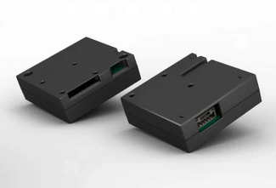

Table of Contents
1. Foreword 3
2. Hardware connection 4
2.1 Pin-out 4
2.2 Wiring 5
2.3 Auto Calibration Function 5
2.4 Look and feel 6
3. Software 6
4. Communication 7
4.1 I2C 7
4.1.1 Mass-density value 7
4.1.2 Particle count 8
4.1.3 Status register 8
4.2 Serial 9
4.2.1 Data format 9
4.2.2 Mass density register 10
4.2.3 Particle count 10
4.2.4 Status byte 10
4.2.5 XOR / FCC byte 10
4.2.6 Errors 10
4.3 Compare I2C and Serial output 12
4.3.1 PM10 Serial versus I2c 12
5. Compare against SPS30 13
5.1 Hardware Connection 14
5.2 Software 14
5.3 Average values 14
5.4 Mass Density 15
5.4.1 PM1.0 15
5.4.2 PM2.5 15
5.4.3 PM10 16
5.5 Particle count 17
5.5.1 PM0.5 17
5.5.2 PM1.0 17
5.5.3 PM2.5 18
5.5.4 PM10 18
5.5 Reaction 19
5.5.1 A match 19
5.5.2 Cigarette smoke 20
6. Compare SDS011 21
7. Compare against Dylos DC1700 22
7.1 Dylos definition 22
7.2 Results 22
8. Personal observations 23
8.1 Plus 23
8.2 Minus 23
9. Library 24
9.1 Sparkfun 24
9.2 Additions 25
Appendix A: Inside SN-GCJA5 26
Appendix B: Other registers 27

1. Foreword

In 2019 a new particle sensor SN-GCAJ5 was announced from Panasonic.

It uses a laser and photo-diode to detect the particles with light scattering. It has an inside fan, which is very silent, to force air-movement.

Having worked on other particle sensors in the past (like the SPS30) I wanted to check out this device and understand how it compares to the others.

Regards,
Paul van Haastrecht
paulvha@hotmail.com

Version 1.0 / November 2020 / paulvh
- initial version

2. Hardware connection

Source : 8815_fileversion.pdf from Panasonic (issue JA5-SSP-E1.0)

The SN-GCJA5 can be connected with I2C and/or Serial communication. Both can be used at the same time.

2.1 Pin-out
Source : 8815_fileversion.pdf from Panasonic (issue JA5-SSP-E1.0)
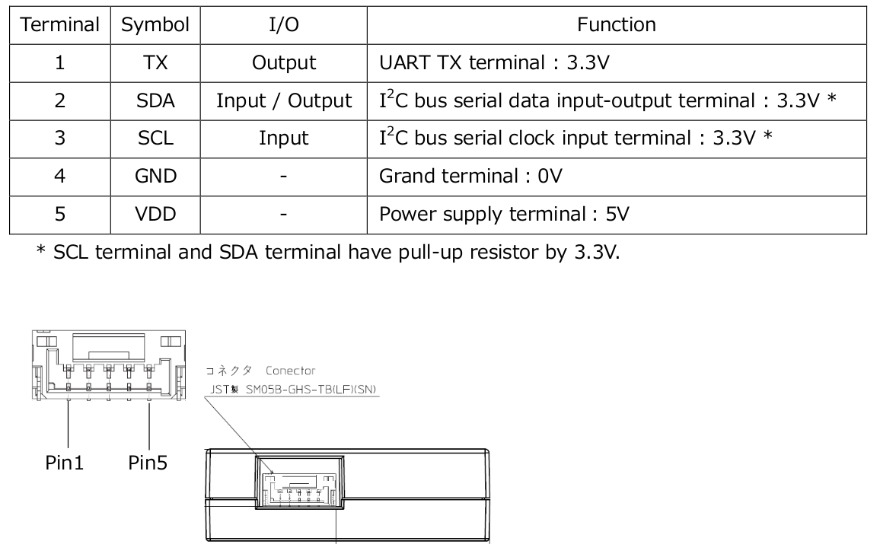
The connector is a SM05B-GHS-TB(LF)(SN)(J.S.T. Mfg. Co., Ltd.)

It is very important to note that the sensor already has on-board 10K pull-up resistor to 3V3. No need for external resistors. BUT if you have multiple devices on the same I2C channel, each with their own pull-up resistors the parallel resistance might become too low and cause damage !!

Note: the Sparkfun library / examples warn that you need a level converter for SCL and SDA when connecting to a 3V3 device (like ESP32). That is NOT correct. The pull-up is to 3V3 NOT to 5V.

Note: I bought the Sparkfun version which is delivered with a cable to connect (https://www.sparkfun.com/products/17123)

2.2 Wiring
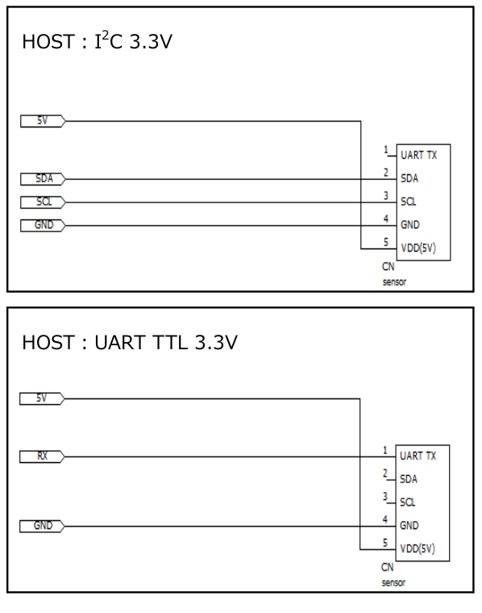
Taken from the same document it describes the easy connection for I2C and Serial.
You can use Serial at the same time as I2C. But Serial has a drawback described later.

In case you really need 5V output for your MCU, look at the document on page 5 or just buy a level converter.

2.3 Auto Calibration Function

The document 8815_fileversion.pdf from Panasonic describes the auto calibration function. It seems that the build-in MCU has stored the performance of the laser diode and rotational speed of fan at start of usage. It is using that information to compare the current performance of the sensor and apply s/w correction if needed to optimise the performance. The claim is that the sensor will have less degradation compared to competition. The status register can be read to see whether s/w correction is applied.

2.4 Look and feel

The sensor does not feel robust. It is very light (13 gr) and has a plastic cover. The internal fan hardly makes any noise, but can not be switched off. It is not clear which side of the sensor is up, which can have an impact on the lifetime of the fan and air flow. The expected lifespan of the fan is 5 years, although for the fan (ASB0205LP.00) the lifetime is between 60000 and 80000 hours ( 6 – 9 years). There are no mounting holes to easily secure/fix the sensor. In Appendix A I have put pictures of the inside of the sensor. See chapter 8 about my observations after testing the sensor for over a week.

3. Software

As a starting point, I actually only found the Sparkfun library available for this sensor.

Note: We've created an Arduino library to make reading this sensor super easy. Find it in the library manager by searching SparkFun Particle.
Source : https://www.sparkfun.com/products/17123

The library provides bare-bone basic I2C communication and 3 examples. The examples output is not well formatted and only represents the numbers as they are read. BUT the library does work and I have used that as a starting point and made addtitions, see chapter 9.

4. Communication

The communication information is based on 8814_fileversion.pdf from Panasonic (issue JA5-SSP-COMM-E1.0). The document is not very clear about the interpretation of the numbers (especially the serial interface)

4.1 I2C
- I2C communication of this sensor complies with 400kbps (FastMode).
- The sensor communicates operate as a slave of the I2C communication.
- SCL terminal of I2C communication is responsible for communication operation from the master side.
- Data structure of I2C communication, the slave address is 7bit, and the memory address is 8bit.
- The I2C address is fixed at 0x33.
- SCL terminal and the SDA terminal of I2C communication has been pulled up with a 10kΩ of resistance by the sensor internal voltage 3.3V.
- Data sequence of when the output data in I2C communication there is more than one byte, is arranged from low byte to upper byte, in mind “Little-Endian”. Low byte first then upper
- Data in each byte is output in the sequence of MSB → LSB

4.1.1 Mass-density value
- There are 3 density register PM1, PM2.5 and PM10 where the mass-density conversion data is stored.
- The mass-density value conversion output register is updated every 1 seconds, can be read out the same data until the next update
- The mass-density value conversion data is the 3-byte data in 20 bit.
- The sensor output a 1000 times the value. With reading as a 16-bit variable signed and by 1/1000, the mass-density value data is output.
- Output example: 15.370 ⇒ 15370 ⇒ 0011 1100 0000 1010 ⇒ 0x3C0A

Actually each density register is 4 bytes long, but only the first 3 (LL, LH, HL) bytes are used, with the LL ( 0x0A in this case) sent first, then LH (0x3C). From the HL potentially only the lower 4 bits could be used and HH bytes are zero. Maybe there was an intention to use floats and hence the 4 bytes.

4.1.2 Particle count
- The particle count data is updated every 1 second, can be read out the same data until the next update.
- It is stored in chunks in separate registers :
  - Particle count (0.3-0.5μm)
  - Particle count (0.5-1.0μm)
  - Particle count (1.0-2.5μm)
  - Particle count (2.5-5.0μm)
  - Particle count (5.0-7.5μm)
  - Particle count (7.5-10.0μm)
- In order to get the PM10 particle count you need to add all the different values before.

The register values are 16 bit unsigned.

4.1.3 Status register
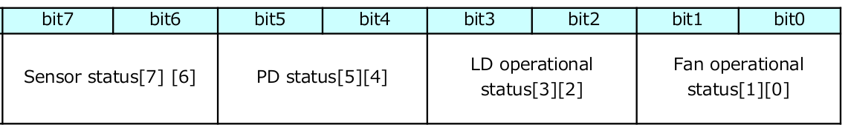
Sensor status 2 bits
Indicates how many sensors have a status issue. 0 (no issues), 1, 2 or 3 sensors have an issue

PD status 2 bits
indicates the status of the Photo Diode.
0:Normal status
1:Normal status (within -80% against initial value), with S/W correction
2:Abnormal (below -90% against initial value), loss of function
3: Abnormal (below -80% against initial value), with S/W correction

LD status 2 bits
Indicates the status of the Laser Diode
0:Normal status
1:Normal status (within -70% against initial LOP), with S/W correction
2:Abnormal (below -90% against initial LOP) or no LOP, loss of function
3:Abnormal (below -70% against initial LOP), with S/W correction

LOP = Light OutPut

Fan status 2 bits
Indicates the status of the fan
0:Normal status
1:Normal status (1,000rpm or more), with S/W correction
2:In initial calibration
3:Abnormal (below 1,000rpm), out of control

4.2 Serial
- UART communication complies with 9600bps.
- The transmitted data packet contains “start bit”(1bit), “data”(8bit), “evenness parity”(1bit) & “stop bit”(1bit), and the data are transmitted by LSB first.
- The data frame contains “header”(1 byte), “data”(several byte), ”FCC” (1 byte) & “trailer” (1 byte):
  - The header transfers 0x02 (start of text).
  - Then the data “PM1.0”, “PM2.5”, “PM10” with each 16bit, 2 byte will be output sequentially.
  - Output 1 byte XOR on FCC
  - The trailer transfers 0x03(end of text).
- Each data will be updated every 1 second and can be read constant
- Be aware that on an Arduino the default is NO-parity. So to set the Serial port use : Serial.begin(9600, SERIAL_8E1);

4.2.1 Data format
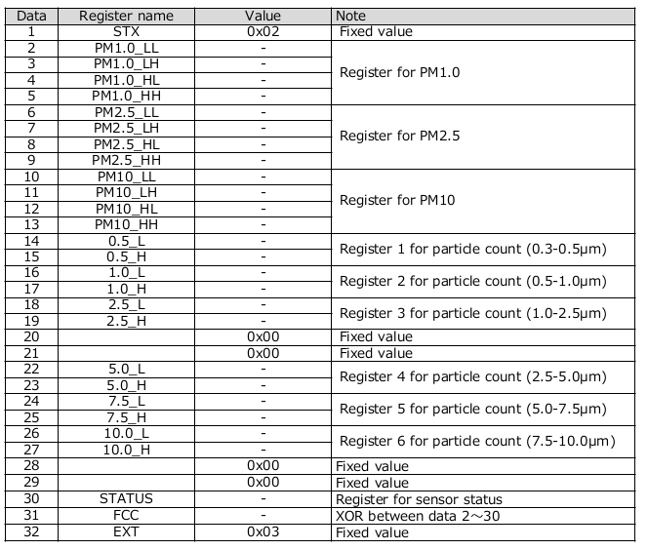

4.2.2 Mass density register

4 bytes are reserved for PM value, but on the first 2 (LL and LH) bytes are used. They store an 16 bit unsigned value. Different to the I2C PM density value, this value contains only the value before the decimal point.
E.g. where I2C communication will show 1.23456, the serial will only show 1. In chapter 4.3 an output from a sketch that clearly shows that.

4.2.3 Particle count
The particle counts are the same as described in chapter 4.1.2

4.2.4 Status byte
The Status byte is the same as described in chapter 4.1.3

4.2.5 XOR / FCC byte
This is an Xor function of the data that has been sent between after the STX byte and before the Xor byte. The formula is straight forward:

uint8_t FCC = 0;
for ( int i = 1 ; i < 30 ; i ++ )
FCC = FCC ^ data[i];

4.2.6 Errors
Many packet errors were happening on a regular base. A packet error is where FCC byte does not match the received data or the ETX (0x3) is not received. The sensor is sending every second a bunch of data :

Zooming in on the data, is looks to be 45ms long :

Data is send at 9600 baud => 0.104uS, but measured on the oscilloscope I see a bit time of 0.128uS

With each byte taking 11 bits (1 start + 8 data + 1 parity + 1 stop) => 0.128 * 11 = 1.408 ms

45ms / 1.408 => ~32 bytes. So 32 bytes are send each second.

Given the serial buffer size on the MCU, a half message might be pending causing a ‘while(Serial.available()) - loop’ to break before enough new data has arrived (each second). The best way is to first empty the serial buffer, wait 1.1 second for new data and then read the data. Now new data is available 99.9% of the time.

4.3 Compare I2C and Serial output

With sketch example10 you can select I2C and/or Serial output at the same time. Here it is very clear to see that the Serial PM value is only the number before the decimal point.

------------------Mass ------------- -------------- Number --------------------------------- -- status --
Concentration [μg/m3] Concentration [#/cm3] [μm]
PM1.0 PM2.5 PM10 PM0.5 PM1.0 PM2.5 PM10 Average
Ser 5.00000 5.00000 6.00000 17.00 77.00 83.00 84.00 25.93 0
I2c 5.44700 5.77600 6.49800 15.00 72.00 76.00 77.00 25.94 0
Ser 5.00000 5.00000 6.00000 15.00 72.00 76.00 77.00 25.94 0
I2c 4.96600 5.13000 5.77100 11.00 69.00 73.00 74.00 25.91 0
Ser 4.00000 5.00000 5.00000 11.00 69.00 73.00 74.00 25.91 0
I2c 5.49200 5.49200 6.17800 13.00 76.00 79.00 80.00 25.94 0
Ser 5.00000 5.00000 6.00000 13.00 76.00 79.00 80.00 25.94 0
I2c 5.74500 5.74500 6.46300 14.00 79.00 82.00 83.00 25.95 0
Ser 5.00000 5.00000 6.00000 14.00 79.00 82.00 83.00 25.95 0
I2c 5.63000 5.63000 6.33300 13.00 78.00 81.00 82.00 25.94 0
Ser 5.00000 5.00000 6.00000 13.00 78.00 81.00 82.00 25.94 0
I2c 5.99600 6.16000 6.93000 14.00 78.00 81.00 82.00 25.95 0
Ser 5.00000 6.00000 6.00000 14.00 78.00 81.00 82.00 25.95 0
I2c 6.15700 6.15700 6.92600 14.00 84.00 87.00 88.00 25.95 0
Ser 6.00000 6.00000 6.00000 14.00 84.00 87.00 88.00 25.95 0
I2c 6.40800 6.57200 7.39300 14.00 84.00 87.00 88.00 25.95 0
Ser 6.00000 6.00000 7.00000 14.00 84.00 87.00 88.00 25.95 0
I2c 6.95700 7.12100 8.01100 15.00 91.00 94.00 95.00 25.96 0
Ser 6.00000 7.00000 8.00000 15.00 91.00 94.00 95.00 25.96 0
I2c 7.09500 7.25900 8.16600 14.00 93.00 95.00 96.00 25.96 0
Ser 7.00000 7.00000 8.00000 14.00 93.00 95.00 96.00 25.96 0
I2c 6.84300 6.84300 7.69800 13.00 89.00 90.00 91.00 25.97 0
Ser 6.00000 6.00000 7.00000 13.00 89.00 90.00 91.00 25.97 0
I2c 6.82000 6.82000 7.67200 15.00 90.00 91.00 91.00 26.07 0

4.3.1 PM10 Serial versus I2c

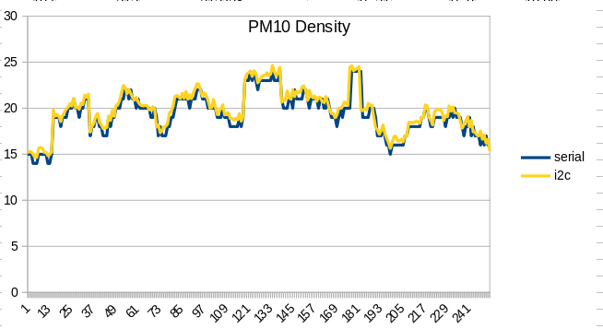

5. Compare against SPS30

The SPS30 is a similar device. It uses a laser and photo-diode to measure the particle with light scattering. It has an inside fan to force air-movement.
The sensor can communicate over Serial or I2C, which you need to select with a separate wire. You can not run Serial and I2C at the same time on an SPS30.
The SN-GCJA5 has for I2C it has already 10K pull-up resistors on-board (unlike the SPS30 which needs external)
The SPS30 communication protocol is much more comprehensive and has more options
Description | SPS30 | SN-GCJA5 | Remark
PM1 (ug/m3) | Yes | Yes
PM2.5 (ug/m3) | Yes | Yes
PM4.0 (ug/m3) | Yes | No
PM10 (ug/m3) | Yes | Yes
Particle count (0.3-0.5μm) | Yes | Yes
Particle count (0.5-1.0μm) | Yes | Yes
Particle count (1.0-2.5μm) | Yes | Yes
Particle count (2.5-5.0μm) | No | Yes
Particle count (5.0-7.5μm) | No | Yes
Particle count (7.5-10.0μm) | No | Yes
Particle count (2.5-4.0μm) | Yes | No
Typical Particle Size | Yes | No
Status register | Yes | Yes
VDD 5V | Yes | Yes
I2C | Yes | Yes
Serial | Yes | Yes
Internal pull-up resistor I2C | No | Yes
Expected Life-time | > 10 years | 5 years
Extended command set | Yes | No
Power consumption | 80mA | 100mA < | SPS30 after fanstart
Power saving | Yes | No
Size | 41 x 41 x 12 mm | 37 x 37 x 12 mm
Typical startup time | 8s | 8s
Time between sample | 1s | 1s
Fan manual /auto clean | Yes | No
Auto Calibration Function | No | Yes

5.1 Hardware Connection
I have used an MEGA2560 and connected the SPS30 to serial (in order to get all the particle count numbers without changing the Wire-buffer size) and SN-GCJA5 to I2C.

SPS30 SN-GCJA5 Mega2560
VCC -------- VCC ------ 5V
GND --------- GND ------ GND
TX ------------------------ RX1
RX ------------------------ TX1
Select (not connected, serial comms selected)
SDA ------ SDA
SCL ------ SCL
Serial (not connected)

I have used my SPS30 library the Sparkfun library to compare the results.

5.2 Software
I have created an example to combine the values from both the SPS30 and SN-GCJA5 in a single output. The example has been included as example13 and selected spreadsheet output.

5.3 Average values
I have let the program run for a 2 hours and to the last samples. Average number over 1150 examples. With SPS30 and SN-GCJA5 next to each other on the table

 | Mass Density |  |  | Particle count
 | PM1.0 | PM2.5 | PM10 | PM0.5 | PM1.0 | PM2.5 | PM10
GCJA5 | 4,920 | 5,970 | 7,390 | 12,642 | 64,505 | 76,351 | 76,934
SPS30 | 5,764 | 6,634 | 7,158 | 38,136 | 45,201 | 45,967 | 46,133
difference | 85,36% | 89,99% | 103,24% | -66,85% | 42,71% | 66,10% | 66,77%

Looking at this numbers a couple of observations :

1. The density numbers are close. The PM2.5 and PM1.0 are in the 85% to 90% range. The PM10 number is a little higher, but the SPS30 is known to be under estimating these and it looks that the SN-GCJA5 is doing the same.

2. The particle counts however are very much off. The SN-GCAJ5 has much lower on < 0.5um and much higher on the larger numbers.

3. With many larger numbers of the large particles, one should expect much higher density results. Why is that not happening ?? Maybe they apply a different size ( e.g. not particles/m3 ?)

5.4 Mass Density

5.4.1 PM1.0
The average mass density around PM1.0 is on average 85% the same, but looking at the samples the SPS30 is much more stable than the SN-GCJA5. Looking at the chart the number of lower drops is much higher than peaks. (opposite to PM10 value)

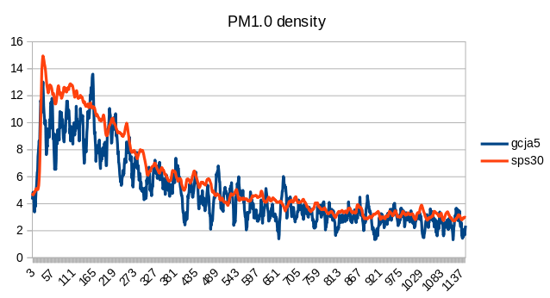
5.4.2 PM2.5
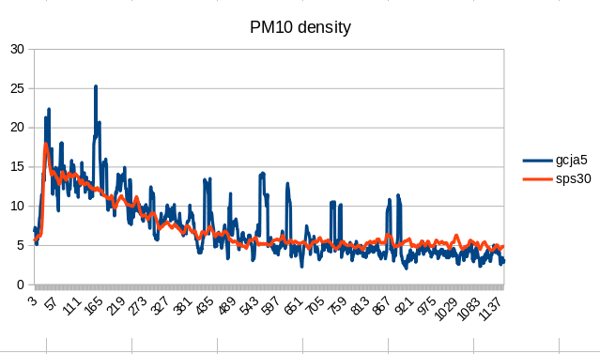
The average mass density around PM2.5 is on average 90% the same, but looking at the samples the SPS30 is much more stable than the SN-GCJA5.

5.4.3 PM10
The average mass density around PM10 is on average 103% the same, but looking at the samples the SPS30 is much more stable than the SN-GCJA5. The PM10 values from the SN-GCJA5 continue to be unstable, but with higher peaks. (opposite to PM1.0)

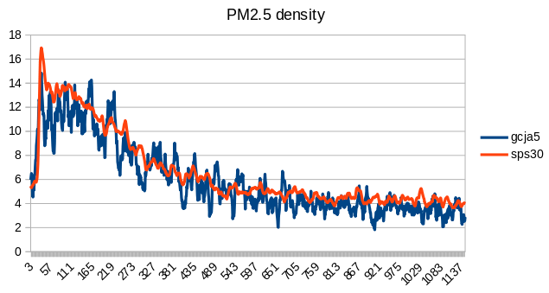
Also normally PM2.5 of the PM10 (about 70%), but in this case the SN-GCJA5 PM10 output is very different than the PM2.5 number. Actually some peaks (like around sample 57 and sample 165) are NOT seen on PM10 ?? Also compared to an SDS011 they are too low and look to be “calculated”.

5.5 Particle count

5.5.1 PM0.5
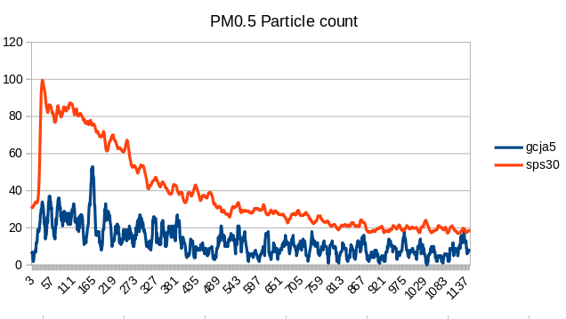
Again we see the nervous output of SN-GCJA5, but also the structural LOWER amount of PM0.5 (0.3 – 0.5um) particle count. On average it is about 66% LESS of the count of the SPS30.

5.5.2 PM1.0
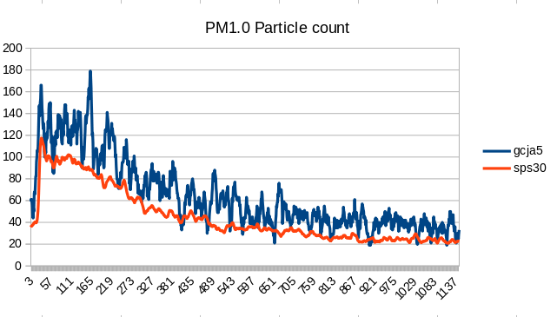
Nervous output, but even more interesting that the SN-GCJA5 is counting about 40% MORE than the SPS30.

5.5.3 PM2.5
The SN-GCJA5 is counting on average 66% more than the SPS30. That is a constant behavior and not the result of a few big deviation.
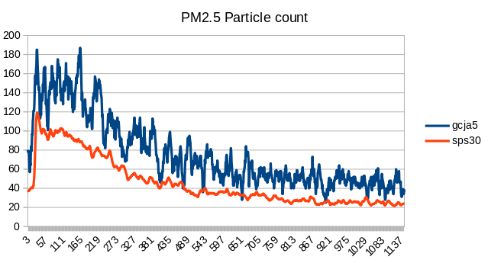

5.5.4 PM10
This shows the same behavior as the PM2.5 as hardly any new particles were detected by both the SPS30 and SN-GCJA5. (so why is the PM10 density output so different ??)

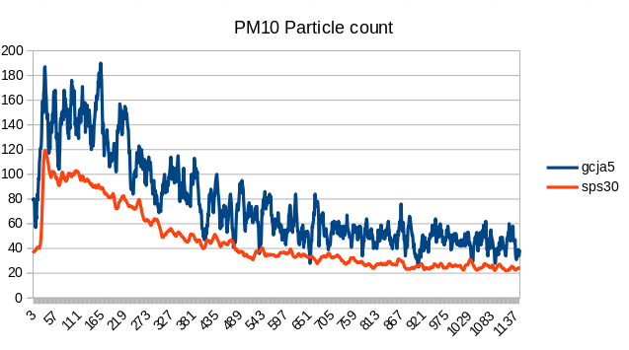

5.5 Reaction
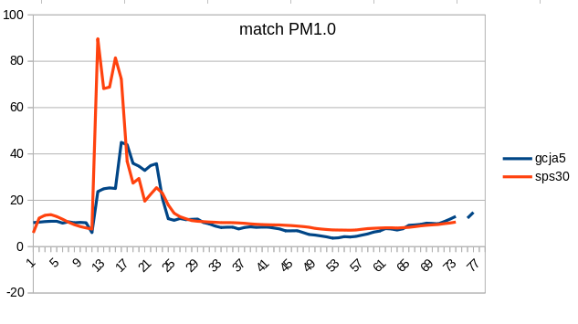

5.5.1 A match
Lighting a match near the sensors gave this reaction

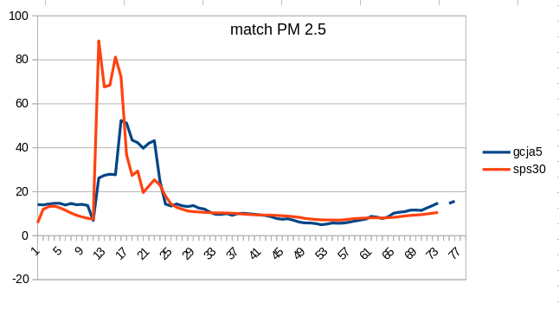

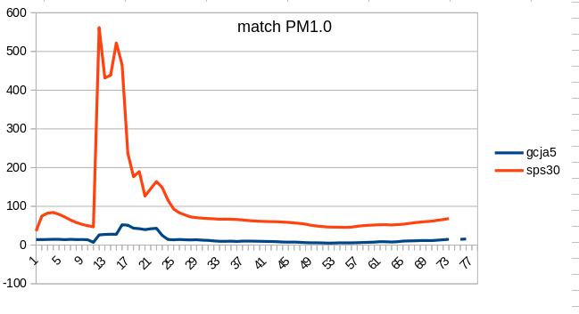

In general the SN-GCJA5 has slower in response. Maybe due to the smaller fan capacity?

Actually the PM10 reaction on SPS30 was in the 2000 – 3000. I have deleted some rows to show / compare the performance. It is also very interesting to see the very low reaction on the SN-GCJA5 on the PM 10 values.

5.5.2 Cigarette smoke
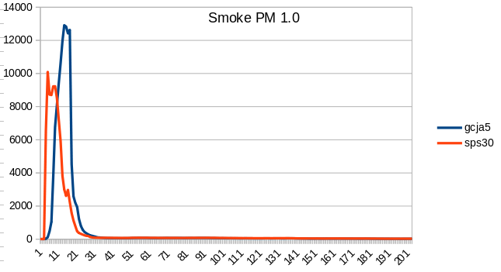

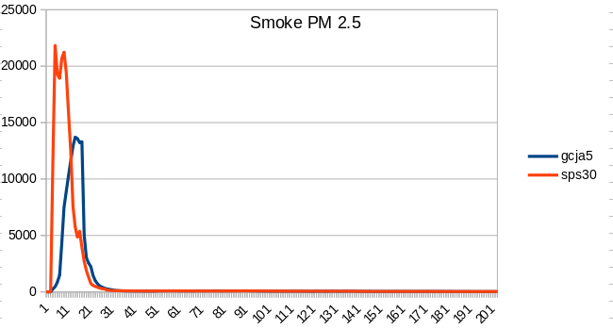

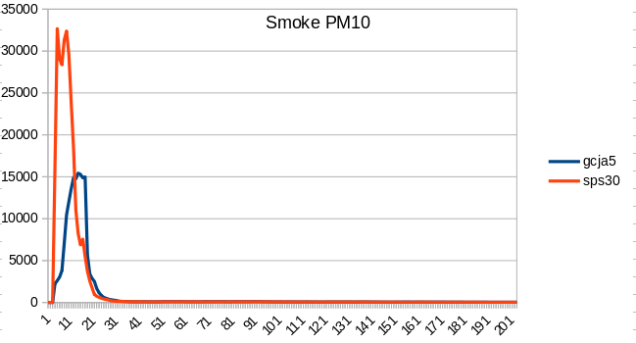

In general the SN-GCJA5 has slower in response. Maybe due to the smaller fan?

6. Compare SDS011
The SDS011 sensor is long time in use and tested many times. I have created a single sketch (example12) to compare the SDS011, SPS30 and SN-GCJA5 at the same time.
Over 200 samples, taken after running for 15 min, we see that the density number of PM2.5 is very close, but a huge difference on PM1.0. This makes me believe that, as with the SPS30 , the PM10 values are “calculated” somehow.

 | PM2.5 | PM10
SN-GCA5 | 3,32 | 4,07
SPS30 | 3,43 | 3,55
SDS011 | 4,70 | 11,25

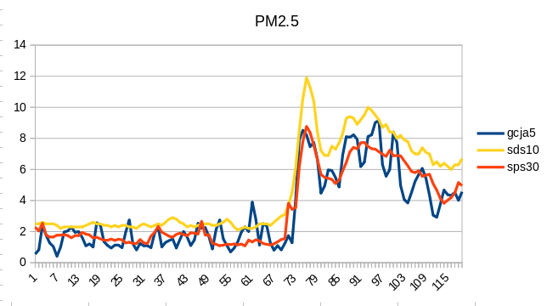

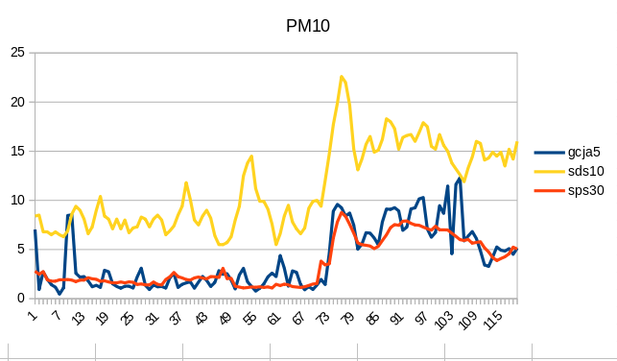

7. Compare against Dylos DC1700

I have been trying to reconcile the particle count against a Dylos DC1700. I can’t make that happen.

7.1 Dylos definition
A DYLOS-1700 is providing information particle information per 0.01 cubic foot. It has 2 numbers:
A. Particle count > 0.5 μm
B. Particle count > 2.5 μm. This is a good representation of the PM10 value.(different tests)
From this you can calculate the Particle count between 0.5 μm and 2.5 μm: C = A - B
DYLOS numbers from cubic feet to cm3: DYLOS 0.01 ft³ / 283.1685 => cm³

7.2 Results
I have left the 3 sensors running next to each other for 30 min and took the average numbers. There were NO big peaks or lows. The air was very stable and the PM10 and Pm2.5 particle count numbers were close on both the SN-GCJA5 and SPS30.

The Dylos measurement is starting at 0.5 so I have removed the 0.3 – 0.5 measurement for both the SN-GCJA5 and SPS30. ( the > 0.5 columns). The SPS30 numbers are close, but the SN-GCAJ5 numbers are far off.
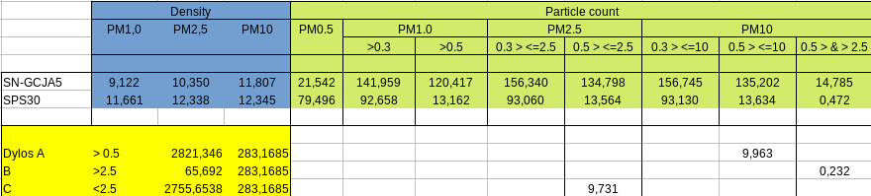

I have NO idea what these particle count number represent or how they are defined. Also I still do no understand if you have SO many more heavy particle (PM10), why is the PM10 density value so close ???

8. Personal observations
The SN-GCAJ5 is “just another” sensor which uses light scattering with a laser diode and photo-diode and a fan.

8.1 Plus
Very simple protocol and command set to obtain the values. Simple interface.
Onboard pull-up resistors for I2C for easy connection to MCU boards.
Cheaper than SPS30 (about half in US).
Auto calibration function for laser diode and rotation speed fan.

8.2 Minus
Very nervous output values, jumps up and down in both I2C and Serial communication. If you want to drive an action on the output (e.g. higher fan power) you will need to include a longer time-out or different threshold to refer back and not directly react on “the next value” which might be much lower. None of the sensors I have worked with show this behavior.
On serial communication on PM density values are ONLY those before the decimal point.
Particle count numbers can not be correlated to other sensors (e.g. SPS30 and Dylos).
No definition of the particle numbers anywhere, besides the size it would represent as a value.
PM10 density values do not seem to be in line with the PM2.5 density output.
Shorter lifetime than many other sensors. While cheaper in sensor cost it will take more cost to replace during life-time in an overall solution.
Available documentation is the bare minimum and incomplete. (particle count)
No mounting capabilities to securely fasten the sensor. How difficult is that to consider ?
Always difficult to get / produce the right DIST-connector, why not include for the 2cts a connector with small wires?
The name !! Why such a crazy name SN-GCJA5 ?? Is there NO marketing department ?

9. Library

9.1 Sparkfun
As mentioned before Sparkfun has delivered a library with the basic I2C communication and 3 examples.
Given the very simple documentation the I2C communication is no more than providing the values from the different registers. It works and works well. There is not more it although when request other register addresses values are returned. It is not known however what those values represent. See appendix B.
All the sketches have the same heading :
The SN-GCJA5 requires 5V for power and 3.3V I2C lines.
We recommend using a Black Board running at 3.3V: https://www.sparkfun.com/products/16282 or a level converter: https://www.sparkfun.com/products/12009
Connect the red/black wires of the SN-GCJA5 to 5V/GND
Connect the Yellow wire to SCL (board must be set to 3.3V to avoid damage to sensor)
Connect the Blue wire to SDA (board must be set to 3.3V to avoid damage to sensor)
Actually the SN-GCJA5 has internal pull-up to 3v3. No need actually for external pull-up can be used directly without level converter to nearly any board. ONLY if you have somewhere (e.g. on another board on the same I2C line) pull-up to 5V you need to be careful.

The following sketches are part of the standard Sparkfun library (November 2020)
Example1_Basic Readings : provides comma separated the density and Particle count values.
Example2_Status : provides information about the Status byte
Example3_AdvancedI2C : same as example1 but now on 400Khz instead of 100Khz and using Wire1, instead of Wire. (which will fail if you do not have Wire1)

9.2 Additions
I have added the following sketches (November 2020) and only tested those on a Mega2560. The hardware connections are documented in the top of the sketches.
Example10_ Basic Readings_Serial_I2C: provides the possibility to select I2C AND/or Serial communication with the sensor. (can be selected in the sketch). You can select whether you want a nice formatted output or a tab-separated out for easily copy/paste in spreadsheet.
Example11_sps30_GCJA5 : provides the possibility to have SPS30 and SN-GCJA5 output in a single sketch. You can select the communication interface for the SPS30 and you can select whether you want a nice formatted output or a tab-separated out for easily copy/paste in spreadsheet.
Example12_comp_sps30_GCJA5_SDS011 : provides the possibility to have SPS30 and SN-GCJA5 and SDS011 output in a single sketch. You can select the communication interface for the SPS30 and you can select whether you want a nice formatted output or a tab-separated out for easily copy/paste in spreadsheet.
Example13_Serial_I2C_LCD : provides the possibility to select I2C AND/or Serial communication with the sensor. (can be selected in the sketch). You can select whether you want a nice formatted output or a tab-separated out for easily copy/paste in spreadsheet.
The output is also displayed on an LCD (https://www.sparkfun.com/products/16396).
Next to normal output you can set the following :
- A low PM2.5 limit, if exceeded the LCD background will turn blue.
- A high PM2.5 limit, if exceeded the LCD background will turn red.
- Set a threshold below the limits before the LCD background will return to previous color.
- Only display on a limit exceeded.
- Only display when a button is pressed and /or a limit is exceeded.

Appendix A: Inside SN-GCJA5
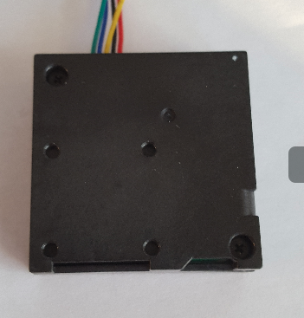
Remove the 2 screws

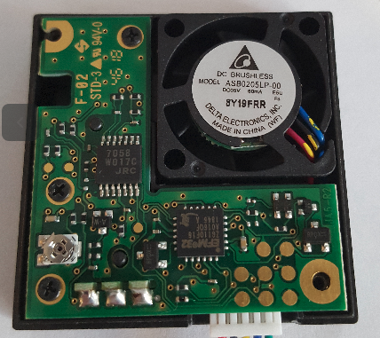
Remove the 3 small screws:

Carefully open up
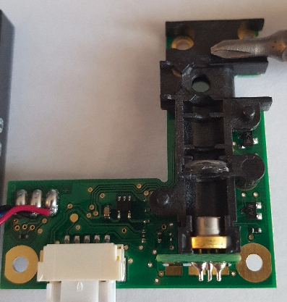
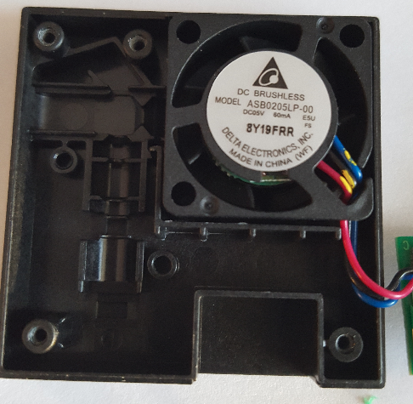

Appendix B: Other registers
found on register: 0x20 value 0xAD char ⸮
found on register: 0x21 value 0x15
found on register: 0x22 value 0x3F char ?
found on register: 0x23 value 0x0
found on register: 0x24 value 0x0
found on register: 0x25 value 0x0
found on register: 0x27 value 0x0
found on register: 0x28 value 0xFF char ⸮
found on register: 0x29 value 0xFF char ⸮
found on register: 0x2A value 0xFF char ⸮
found on register: 0x2B value 0xFF char ⸮
found on register: 0x2C value 0xFF char ⸮
found on register: 0x2D value 0xFF char ⸮
found on register: 0x2E value 0xFF char ⸮
found on register: 0x2F value 0xFF char ⸮
found on register: 0x30 value 0x0
found on register: 0x31 value 0x10
found on register: 0x32 value 0xC7 char ⸮
found on register: 0x33 value 0x17
found on register: 0x34 value 0x3
found on register: 0x35 value 0x33 char 3
found on register: 0x36 value 0xA
found on register: 0x37 value 0xA
found on register: 0x38 value 0xA
found on register: 0x39 value 0xFF char ⸮
found on register: 0x3A value 0xFF char ⸮
found on register: 0x3B value 0xFF char ⸮
found on register: 0x3C value 0xFF char ⸮
found on register: 0x3D value 0xFF char ⸮
found on register: 0x3E value 0xFF char ⸮
found on register: 0x3F value 0xFF char ⸮
found on register: 0x40 value 0x10
found on register: 0x41 value 0x27 char '
found on register: 0x42 value 0x0
found on register: 0x43 value 0x0
found on register: 0x44 value 0x0
found on register: 0x45 value 0x0
found on register: 0x46 value 0x0
found on register: 0x47 value 0x0
found on register: 0x48 value 0x10
found on register: 0x49 value 0x27 char '
found on register: 0x4A value 0x0
found on register: 0x4B value 0x0
found on register: 0x4C value 0x2A char *
found on register: 0x4D value 0x2A char *
found on register: 0x4E value 0x36 char 6
found on register: 0x4F value 0x36 char 6
found on register: 0x50 value 0x10
found on register: 0x51 value 0x27 char '
found on register: 0x52 value 0x10
found on register: 0x53 value 0x27 char '
found on register: 0x54 value 0x0
found on register: 0x55 value 0x0
found on register: 0x56 value 0x0
found on register: 0x57 value 0x0
found on register: 0x58 value 0x0
found on register: 0x59 value 0x0
found on register: 0x5A value 0x10
found on register: 0x5B value 0x27 char '
found on register: 0x5C value 0x0
found on register: 0x5D value 0x0
found on register: 0x5E value 0x85 char ⸮
found on register: 0x5F value 0x0
found on register: 0x60 value 0x63 char c
found on register: 0x61 value 0x3
found on register: 0x62 value 0x10
found on register: 0x63 value 0x27 char '
found on register: 0x64 value 0x60 char `
found on register: 0x65 value 0x40 char @
found on register: 0x66 value 0xA6 char ⸮
found on register: 0x67 value 0x35 char 5
found on register: 0x68 value 0xB5 char ⸮
found on register: 0x69 value 0x2C char ,
found on register: 0x6A value 0x69 char i
found on register: 0x6B value 0x1E
found on register: 0x6C value 0x57 char W
found on register: 0x6D value 0x19
found on register: 0x6E value 0x1E
found on register: 0x6F value 0x15
found on register: 0x70 value 0x3C char <
found on register: 0x71 value 0x1
found on register: 0x72 value 0x60 char `
found on register: 0x73 value 0x1
found on register: 0x74 value 0xF2 char ⸮
found on register: 0x75 value 0x6
found on register: 0x76 value 0x48 char H
found on register: 0x77 value 0xD
found on register: 0x78 value 0x5C char \
found on register: 0x79 value 0x0
found on register: 0x7A value 0x6B char k
found on register: 0x7B value 0x0
found on register: 0x7C value 0x97 char ⸮
found on register: 0x7D value 0x2
found on register: 0x7E value 0x48 char H
found on register: 0x7F value 0xD

